September 10, 2024

For Immediate Release
Contact: Mike Ruzicka
414.778.4929 or 414.870.1874
mike@gmar.com

August Home Sales Down 3.0%

Highlights
- Sales Down 3% in August, But Up 4.3% for 2024
- Prices Up 9.0%
- Listings Down 2.3%

August Sales
County | 2023 | 2024 | % Change
Milwaukee | 925 | 882 | -4.6%
Waukesha | 503 | 497 | -1.2%
Ozaukee | 110 | 118 | 7.3%
Washington | 159 | 149 | -6.3%
Metro Area | 1,697 | 1,646 | -3.0%
Racine | 239 | 232 | -2.9%
Kenosha | 180 | 165 | -8.3%
Walworth | 156 | 161 | 3.2%
SE WI Area | 2,272 | 2,204 | -3.0%
August Listings
County | 2023 | 2024 | % Change
Milwaukee | 1310 | 1211 | -7.6%
Waukesha | 539 | 571 | 5.9%
Ozaukee | 132 | 132 | 0.0%
Washington | 189 | 206 | 9.0%
Metro Area | 2,170 | 2,120 | -2.3%
Racine | 269 | 289 | 7.4%
Kenosha | 199 | 223 | 12.1%
Walworth | 188 | 197 | 4.8%
SE WI Area | 2,826 | 2,829 | 0.1%
Market Summary
The Metropolitan Milwaukee housing market saw a 3.0% drop in August compared to the same period in 2023.

The last time August was this low was in 2012 (1,619 sales) as the market was emerging from the Great Recession. But this August was only the second month of 2024 with negative sales.

Since interest rates increased in mid-2022 the market has been slow and the implementation of new disclosure rules on August 17th, which may explain some hesitancy by sellers and buyers, could explain the slow month.

January to August sales totaled 10,737 in 2023. This year the total for the period was 11,200. The market will most likely see an additional 5,700 units sell through the remainder of 2024, which will bring the total to around 16,900 units.

16,900 unit sales would be anemic compared to recent years. From 2016 to 2022 the market saw over 20,000 unit sales per year.

We can’t rule out the increase in interest rates as partly to blame for the decrease in sales, however, lackluster listings are more likely to be the cause.

Demand for homes continues to outpace supply. We can tell demand is strong from the increase in average sales price in the market. The average sale price in the four-county area went up 9% in August, from $389,772 in 2023 to $424,731 this August.

The market simply does not have enough homes to meet demand, resulting in prices being pushed up as buyers bid up prices. This is a frustrating and unsustainable trend for REALTORS® trying to help buyers.

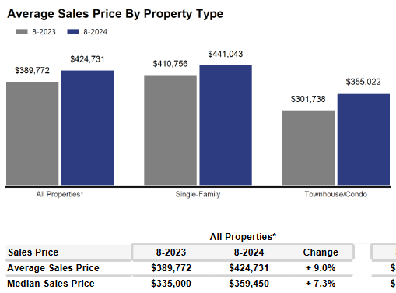
The supply of inventory on hand was only enough to satisfy 3.1 months of buyer demand in August. If we subtract units with an offer that level drops to 1.4 months, significantly below the balanced market concept of 6 months.


As we have been highlighting for several years

– REALTORS® have had an exceedingly challenging time helping home buyers find ownership opportunities in the form of condos and single-family houses.

There is a significant, long-term danger if we do not create additional supply in the form of single-family and condominium units: Thousands of would-be homeowners will be forced to stay in rental units, unable to save for a down payment and foregoing the opportunity to build wealth through a home’s equity – as well as all of the other benefits of homeownership.

That will result in problems decades down the road when families do not have enough home equity to tap into for college expenses, to remodel their home, or for emergencies.

Where to go
Buyers should seek the counsel of a REALTOR® in determining their best housing options, and sellers need a REALTORS® expert advice in making correct marketing decisions for their home.

The Greater Milwaukee Association of REALTORS® is a 5,500-member strong professional organization dedicated to providing information, services, and products to help REALTORS® help their clients buy and sell real estate. Data for this report was collected by Metro MLS, Inc. a wholly owned subsidiary of GMAR.

* Sales and Listing figures differ between the “Monthly Stats” and quarter or year-end numbers, because the collection of Monthly Stats ends on the 10th of each month, whereas quarters are a continuous tally to 12/31. For example, if a sale occurred on the 29th of the month, but an agent does not record the sale until the 5th of the next month, that sale would not be included in the sales figures of the reported month (or any subsequent month’s total) but would be added to the quarterly and annual total sales figures.

** All references to the “metropolitan” area denotes the four counties of Milwaukee, Waukesha, Ozaukee, and Washington Counties. The “region” or “Southeast Wisconsin” refers to the four metropolitan counties (Milwaukee, Waukesha, Ozaukee, and Washington), plus Racine, Kenosha, and Walworth Counties, to the south.
* * * * *

Seasonally adjusted inventory tells us how many months it would take to sell the existing homes on the market. The seasonally adjusted inventory level for August was 3.1 months. Subtracting listings that have an “active offer” from those available for sale (about 80% of listings with an offer sell) yields 2,945 listings, which equals 1.4 months of inventory.

With 4,346 current listings providing 3.1 months of inventory, the market would need an additional 4,025 units to push inventory to six months. Six months of inventory is considered a “balanced” market. If inventory falls below six months, the market favors sellers, and when inventory exceeds six months, it is a buyer’s market.

