August 11, 2022

For Immediate Release
Contact: Mike Ruzicka
414.778.4929 or 414.870.1876
mike@gmar.com

July Home Sales Down 17.2%

Highlights
- Comparing ’22 to ’21 Accounts for Decline
- Plenty of Buyers in the Market
- Lack of Listings Pushed Prices Up 10.2%

July Sales
County | 2021 | 2022 |  | % Change
Milwaukee | 1405 | 1137 |  | -19.1%
Waukesha | 663 | 599 |  | -9.7%
Ozaukee | 151 | 126 |  | -16.6%
Washington | 246 | 178 |  | -27.6%
Metro Area | 2,465 | 2,040 |  | -17.2%
Racine | 332 | 275 | -17.2%
Kenosha | 270 | 194 | -28.1%
Walworth | 190 | 155 | -18.4%
SE WI Area | 3,257 | 2,664 | -18.2%
July Listings
County | 2021 | 2022 |  | % Change
Milwaukee | 1773 | 1382 |  | -22.1%
Waukesha | 773 | 650 |  | -15.9%
Ozaukee | 136 | 122 |  | -10.3%
Washington | 260 | 212 |  | -18.5%
Metro Area | 2,942 | 2,366 |  | -19.6%
Racine | 398 | 337 |  | -15.3%
Kenosha | 346 | 235 |  | -32.1%
Walworth | 256 | 205 |  | -19.9%
SE WI Area | 3,942 | 3,143 |  | -20.3%
Market Summary
Home sales were down 17.2% in July compared to the same time a year ago. While that appears to be a big drop, some perspective will help explain the decrease.

First, the 2021 market was the best ever. Year-to-date sales through July were only down 6.3% (12,718 in ’21 versus 11,923 this year).

Looking back to the first seven months of 2020, the 2022 market was up 6% comparatively.

Second, July sales were negotiated in June, when interest rates were starting to climb. That undoubtedly scared a few buyers away.

Finally, while some buyers stood on the sideline, brokers have been reporting very strong interest among buyers looking for homes all summer. Especially first-time buyers.

And many of those first-time buyers are still getting out-bid on properties.

Nonetheless, the real estate market is still operating at a remarkably high level.

We cannot tell if interest rates will fluctuate in the near-term, but rates in the 5% to 6% range are historically normal. REALTORS® will work with buyers to find properties that fit their budget accounting for a normal interest rate.

Curiously, listings were down across the metropolitan area and region. Listings usually do slow later in summer, but the current decline is unusual.

The lack of inventory is a huge millstone around the market’s neck and is costing would-be homeowners thousands.

New listings were down 19.6% in July, continuing a year’s long trend of not enough homes available to satisfy buyers’ needs.

To reach a balanced market (commonly understood to be 6 months of inventory) the four county area needed 6,625 additional units in July. That month there was only enough inventory to satisfy 2.5 months of buyer demand, and if we subtract units with an offer on them that level drops to 1.0 month.

The limited supply of housing has pushed average prices up 10.2% in the 4-county real estate market.
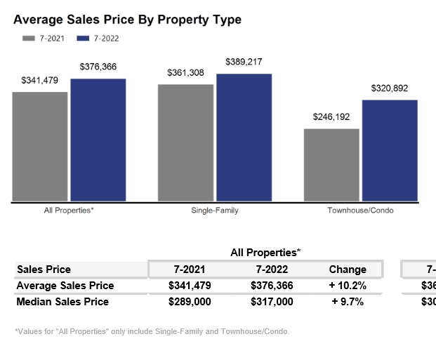

The systemic problem with the market is the lack of new construction of single-family houses and condominiums, and over production of apartments. That bottleneck combined with the demographic surge of Millennial and GenZ buyers and historically good interest rates have all contributed to an historically tight market.

Apartment rents have been increasing 8%+, not because of overall economic inflation, but because new households only have one option if they cannot find a home.

If the region does not create additional supply in the form of more single-family and condominium units, thousands of would-be homeowners will be forced to continue to rent, foregoing the opportunity to build wealth through a home’s equity and all of the other benefits of homeownership.

National Association of REALTORS® Chief Economist, Lawrence Yun, presented the graph below at a conference on August 9, 2022. It explains the abject gap in wealth between the average renter and homeowner. If the Milwaukee market does not create more ownership opportunities (inventory), we are in danger of becoming a “renter society” lacking in all of the important benefits that goes along with homeownership.
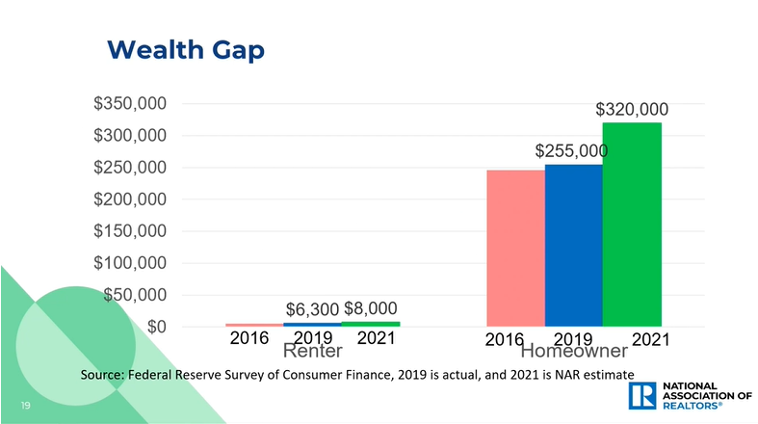

Where to go
Buyers should seek the counsel of a REALTOR® in determining their best housing options, and sellers need a REALTORS® expert advice in making correct marketing decisions for their home.

The Greater Milwaukee Association of REALTORS® is a 5,500-member strong professional organization dedicated to providing information, services, and products to help REALTORS® help their clients buy and sell real estate. Data for this report was collected by Metro MLS, Inc. a wholly owned subsidiary of the GMAR.

* Sales and Listing figures differ between the “Monthly Stats” and quarter or year-end numbers, because the collection of Monthly Stats ends on the 10th of each month, whereas quarters are a continuous tally to 12/31. For example, if a sale occurred on the 29th of the month, but an agent does not record the sale until the 5th of the next month, that sale would not be included in the sales figures of the reported month (or any subsequent month’s total) but would be added to the quarterly and annual total sales figures.

** All references to the “metropolitan” area denotes the four counties of Milwaukee, Waukesha, Ozaukee, and Washington Counties. The “region” or “Southeast Wisconsin” refers to the four metropolitan counties (Milwaukee, Waukesha, Ozaukee, and Washington), plus the three counties to the south, Racine, Kenosha, and Walworth Counties.

* * * * *

Seasonally adjusted inventory tells us how many months it would take to sell the existing homes on the market. The seasonally adjusted inventory level for July was 2.5 months. Subtracting listings that have an “active offer” from those available for sale (about 80% of listings with an offer sell) yields 2,633 listings, which equals 1.0 month of inventory.

With 4,833 current listings providing 2.5 months of inventory, the market would need an additional 6,625 units to push inventory to 6 months. Six months of inventory is considered a “balanced” market. If inventory falls below six months, the market favors sellers, and when inventory exceeds six months, it is a buyer’s market.

Looking at the various price point of sales, the only category that increased in sales in the 4-county and 7-county markets was properties over $500,000.

These tables show that the most critical need is for properties priced between $100,000 and $399,000, the range primarily occupied by first-time and middle class buyers.

