November 16, 2022

For Immediate Release
Contact: Mike Ruzicka
414.778.4929 or 414.870.1876
mike@gmar.com

October Home Sales Down 29.0%

Highlights
- 2021 Comparison & Rising Interest Rates Account for Decline
- Lack of Listings & Buyer Interest Pushed Prices Up 9.4%
- The Market Still Needs More New Construction

October Sales
County | 2021 | 2022 | % Change
Milwaukee | 1198 | 853 | -28.8%
Waukesha | 557 | 399 | -28.4%
Ozaukee | 127 | 91 | -28.3%
Washington | 219 | 149 | -32.0%
Metro Area | 2,101 | 1,492 | -29.0%
Racine | 300 | 256 | -14.7%
Kenosha | 231 | 172 | -25.5%
Walworth | 187 | 158 | -15.5%
SE WI Area | 2,819 | 2,078 | -26.3%
October Listings
County | 2021 | 2022 | % Change
Milwaukee | 1354 | 1038 | -23.3%
Waukesha | 559 | 472 | -15.6%
Ozaukee | 113 | 125 | 10.6%
Washington | 171 | 136 | -20.5%
Metro Area | 2,197 | 1,771 | -19.4%
Racine | 341 | 287 | -15.8%
Kenosha | 288 | 179 | -37.8%
Walworth | 158 | 156 | -1.3%
SE WI Area | 2,984 | 2,393 | -19.8%
Market Summary
Home sales were down 29.0% in October compared to the same time a year ago. The drop in sales can be attributed to two major factors in today’s market.

First, the 2021 market was the best ever and it would have been very difficult to repeat or surpass it. Year-to-date, there were 17,300 homes sold, compared to 19,403 a year ago, and 18,188 in 2020.

Second, the upturn in interest rates that began in earnest last summer have started weighing down the market. Rates are 6% - 7% currently and were around 5% in June.

Some market-watchers may be expecting prices to decline as a result of recent headlines, but that is not the case.

REALTORS® have been reporting solid interest among buyers, although first-time buyer searches have cooled down. Also, listings in October were down across the metropolitan area and region – with one exception, Ozaukee County.

That combination has pushed average sale prices up 9.4%.

There are certainly inefficiencies in today’s market (i.e. lack of new inventory), however, we are nowhere near the start of another Great Recession in housing, because buyers have excellent credit, we do not have any speculative inventory, and employment is strong, among other factors.

There are certainly inefficiencies in today’s market …, however, we are nowhere near the start of another Great Recession in housing.

New listings were down 19.4% in October, continuing a years’ long trend of not enough homes available to satisfy buyers’ needs.

To reach a balanced market (commonly understood to be 6 months of inventory) the four county area needed 6,075 additional units in October. That month there was only enough inventory to satisfy 2.3 months of buyer demand, and if we subtract units with an offer on them that level drops to 1.1 months.

The limited supply of housing has pushed average prices up 9.4% in the 4-county real estate market.

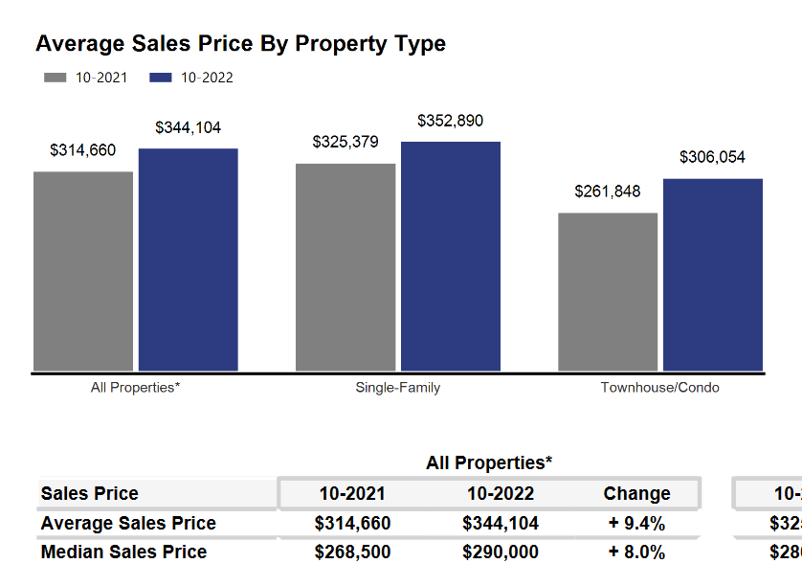

The systemic problem with the market is the lack of new construction of single-family houses and condominiums, and over production of apartments. That bottleneck combined with the demographic surge of Millennial and GenZ buyers and historically good interest rates have all contributed to an historically tight market.

If the region does not create additional supply in the form of more single-family and condominium units, thousands of would-be homeowners will be forced to continue to rent, foregoing the opportunity to build wealth through a home’s equity and all of the other benefits of homeownership.

Where to go
Buyers should seek the counsel of a REALTOR® in determining their best housing options, and sellers need a REALTORS® expert advice in making correct marketing decisions for their home.

The Greater Milwaukee Association of REALTORS® is a 5,500-member strong professional organization dedicated to providing information, services, and products to help REALTORS® help their clients buy and sell real estate. Data for this report was collected by Metro MLS, Inc. a wholly owned subsidiary of the GMAR.

* Sales and Listing figures differ between the “Monthly Stats” and quarter or year-end numbers, because the collection of Monthly Stats ends on the 10th of each month, whereas quarters are a continuous tally to 12/31. For example, if a sale occurred on the 29th of the month, but an agent does not record the sale until the 5th of the next month, that sale would not be included in the sales figures of the reported month (or any subsequent month’s total) but would be added to the quarterly and annual total sales figures.

** All references to the “metropolitan” area denotes the four counties of Milwaukee, Waukesha, Ozaukee, and Washington Counties. The “region” or “Southeast Wisconsin” refers to the four metropolitan counties (Milwaukee, Waukesha, Ozaukee, and Washington), plus the three counties to the south, Racine, Kenosha, and Walworth Counties.

* * * * *

Seasonally adjusted inventory tells us how many months it would take to sell the existing homes on the market. The seasonally adjusted inventory level for October was 2.3 months. Subtracting listings that have an “active offer” from those available for sale (about 80% of listings with an offer sell) yields 2,732 listings, which equals 1.1 months of inventory.

With 4,195 current listings providing 2.3 months of inventory, the market would need an additional 6,075 units to push inventory to 6 months. Six months of inventory is considered a “balanced” market. If inventory falls below six months, the market favors sellers, and when inventory exceeds six months, it is a buyer’s market.

