December 14, 2022

For Immediate Release
Contact: Mike Ruzicka
414.778.4929 or 414.870.1876
mike@gmar.com

November Home Sales Down 30.3%

Highlights
- Not Nearly As Bad As It Looks! 2021 Was A Record Year
- Low Listings & High Buyer Interest Pushed Prices Up 7.6%
- Market Desperately Needs More New Construction

November Sales
County | 2021 | 2022 | % Change
Milwaukee | 1087 | 777 | -28.5%
Waukesha | 529 | 378 | -28.5%
Ozaukee | 124 | 87 | -29.8%
Washington | 193 | 106 | -45.1%
Metro Area | 1,933 | 1,348 | -30.3%
Racine | 310 | 229 | -26.1%
Kenosha | 240 | 128 | -46.7%
Walworth | 141 | 116 | -17.7%
SE WI Area | 2,624 | 1,821 | -30.6%
November Listings
County | 2021 | 2022 | % Change
Milwaukee | 1044 | 766 | -26.6%
Waukesha | 331 | 357 | 7.9%
Ozaukee | 82 | 78 | -4.9%
Washington | 109 | 118 | 8.3%
Metro Area | 1,566 | 1,319 | -15.8%
Racine | 241 | 174 | -27.8%
Kenosha | 187 | 146 | -21.9%
Walworth | 131 | 106 | -19.1%
SE WI Area | 2,125 | 1,745 | -17.9%
Market Summary
Home sales in the Metropolitan Milwaukee area were down 30.3% in November compared to the same month in 2021.

The decrease in unit sales can be explained in two phases. The first was a natural slowdown as the market exited the pandemic fueled era that led to the best sales market ever in 2021, one that was virtually impossible to repeat. Year-to-date, there were 18,648 homes sold, compared to 21,336 a year ago.

Then, last summer rising mortgage interest rates kicked a little sand in the market’s gears, causing some buyers to reassess their ability to purchase a home, lowering unit sales further. However, buyers today are among the highest quality credit risks ever, so rising rates have not wiped them out entirely.

Typically, decreasing sales leads to lower prices, but with exceptionally tight inventory that is not the case. Average prices were up in November by 7.6%.

So, REALTORS® are dealing with a very dynamic market: interested buyers (some of whom incorrectly believe a “buyers’ market” is coming), very few listings, little new construction, and rising prices. Additionally, we are on the front end of the winter market when all activity is reduced.

New listings were down 15.8% in November, continuing a years’ long trend of not enough existing homes available to satisfy buyers’ needs.

To reach a balanced market … the four county area needed 6,925 additional units in November.

To reach a balanced market (commonly understood to be 6 months of inventory) the four county area needed 6,925 additional units in November. That month there was only enough inventory to satisfy 2.1 months of buyer demand, and if we subtract units with an offer on them that level drops to 1.0 month.

The limited supply of housing has pushed average prices up 7.6% in the 4-county real estate market.

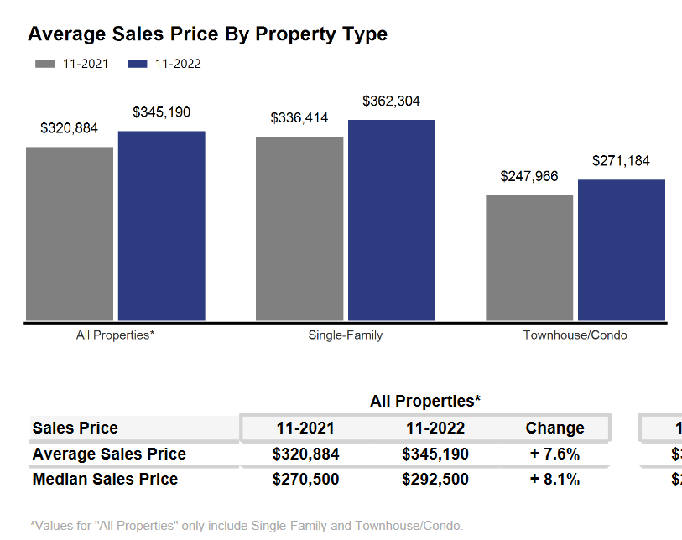

The systemic problem with the market is the lack of new construction of single-family houses and condominiums, and over production of apartments. That bottleneck combined with the demographic surge of Millennial and GenZ buyers and good interest rates have all contributed to an historically tight market.

If the region does not create additional supply in the form of more single-family and condominium units, thousands of would-be homeowners will be forced to continue to rent, foregoing the opportunity to build wealth through a home’s equity and all of the other benefits of homeownership.

Where to go
Buyers should seek the counsel of a REALTOR® in determining their best housing options, and sellers need a REALTORS® expert advice in making correct marketing decisions for their home.

The Greater Milwaukee Association of REALTORS® is a 5,500-member strong professional organization dedicated to providing information, services, and products to help REALTORS® help their clients buy and sell real estate. Data for this report was collected by Metro MLS, Inc. a wholly owned subsidiary of the GMAR.

* Sales and Listing figures differ between the “Monthly Stats” and quarter or year-end numbers, because the collection of Monthly Stats ends on the 10th of each month, whereas quarters are a continuous tally to 12/31. For example, if a sale occurred on the 29th of the month, but an agent does not record the sale until the 5th of the next month, that sale would not be included in the sales figures of the reported month (or any subsequent month’s total) but would be added to the quarterly and annual total sales figures.

** All references to the “metropolitan” area denotes the four counties of Milwaukee, Waukesha, Ozaukee, and Washington Counties. The “region” or “Southeast Wisconsin” refers to the four metropolitan counties (Milwaukee, Waukesha, Ozaukee, and Washington), plus the three counties to the south, Racine, Kenosha, and Walworth Counties.

* * * * *

Seasonally adjusted inventory tells us how many months it would take to sell the existing homes on the market. The seasonally adjusted inventory level for November was 2.1 months. Subtracting listings that have an “active offer” from those available for sale (about 80% of listings with an offer sell) yields 2,561 listings, which equals 1.0 months of inventory.

With 3,665 current listings providing 2.1 months of inventory, the market would need an additional 6,925 units to push inventory to 6 months. Six months of inventory is considered a “balanced” market. If inventory falls below six months, the market favors sellers, and when inventory exceeds six months, it is a buyer’s market.

