February 15, 2023

For Immediate Release
Contact: Mike Ruzicka
414.778.4929 or 414.870.1876
mike@gmar.com

January Home Sales Down 32.9%

Highlights
- Market Has Slowed, But Buyers Are Still Looking
- Low Listings & High Buyer Interest Pushed Prices Up 9.5%
- Market Desperately Needs More New Construction

January Sales
County | 2022 | 2023 | % Change
Milwaukee | 742 | 490 | -34.0%
Waukesha | 252 | 201 | -20.2%
Ozaukee | 73 | 59 | -19.2%
Washington | 121 | 47 | -61.2%
Metro Area | 1,188 | 797 | -32.9%
Racine | 168 | 114 | -32.1%
Kenosha | 137 | 99 | -27.7%
Walworth | 92 | 75 | -18.5%
SE WI Area | 1,585 | 1,085 | -31.5%
January Listings
County | 2022 | 2023 | % Change
Milwaukee | 1,075 | 659 | -38.7%
Waukesha | 315 | 287 | -8.9%
Ozaukee | 80 | 72 | -10.0%
Washington | 103 | 80 | -22.3%
Metro Area | 1,573 | 1,098 | -30.2%
Racine | 173 | 181 | 4.6%
Kenosha | 127 | 101 | -20.5%
Walworth | 120 | 90 | -25.0%
SE WI Area | 1,993 | 1,470 | -26.2%
Market Summary
Home sales in the Metropolitan Milwaukee area were down 32.9% in January compared to the same month in 2022.

Residential unit sales will most likely be down through the first half of the new year, because the first half of 2022 was still part of the “Pandemic Market.” That period was an unusually intense time marked by record sales. Any comparison to that stretch will most likely be down.

Additionally, in the summer of 2022 rising mortgage interest rates slowed demand and caused some buyers to reassess their ability to purchase a home, lowering unit sales.

Typically, decreasing sales leads to lower prices, but with exceptionally tight inventory that was not the case. Average prices were up in January by 9.5%.

To reach a balanced market …
the four county area needed
7,375 additional units.
When mortgage interest rates began to climb last summer, some buyers assumed the market was moving toward a “buyer’s market” – when buyers can demand lower prices.

However, the market is nowhere near becoming a buyer’s market in the near-term, despite new listings falling back 30.2% from January 2022. That is because the metropolitan market is contending with a years’ long trend of not creating enough new or existing homes to satisfy buyers’ needs.

To reach a balanced market (commonly understood to be 6 months of inventory) the four county area needed 7,375 additional units in January. That month there was only enough inventory to satisfy 1.7 months of buyer demand, and if we subtract units with an offer on them that level drops to 0.7 months.

The limited supply of housing has pushed average prices up 9.5% in the 4-county real estate market.

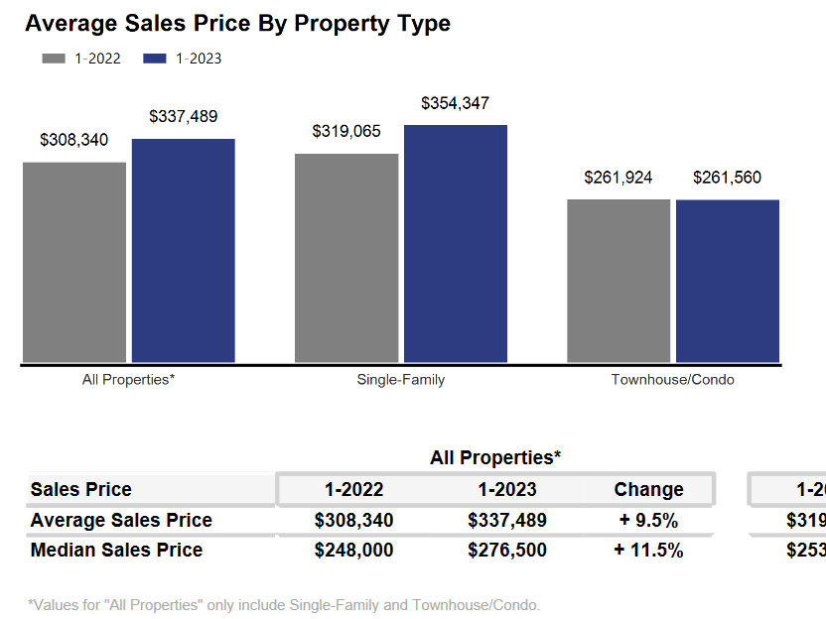

The systemic problem with the market is the lack of new construction of single-family houses and condominiums, and over reliance on apartments to satisfy demand. That bottleneck combined with the demographic surge of Millennial and GenZ buyers and good interest rates have all contributed to a historically tight market.

If the region does not create additional supply in the form of more single-family and condominium units, thousands of would-be homeowners will be forced to continue to rent, foregoing the opportunity to build wealth through a home’s equity and all of the other benefits of homeownership.

Where to go
Buyers should seek the counsel of a REALTOR® in determining their best housing options, and sellers need a REALTORS® expert advice in making correct marketing decisions for their home.

The Greater Milwaukee Association of REALTORS® is a 5,500-member strong professional organization dedicated to providing information, services, and products to help REALTORS® help their clients buy and sell real estate. Data for this report was collected by Metro MLS, Inc. a wholly owned subsidiary of the GMAR.

* Sales and Listing figures differ between the “Monthly Stats” and quarter or year-end numbers, because the collection of Monthly Stats ends on the 10th of each month, whereas quarters are a continuous tally to 12/31. For example, if a sale occurred on the 29th of the month, but an agent does not record the sale until the 5th of the next month, that sale would not be included in the sales figures of the reported month (or any subsequent month’s total) but would be added to the quarterly and annual total sales figures.

** All references to the “metropolitan” area denotes the four counties of Milwaukee, Waukesha, Ozaukee, and Washington Counties. The “region” or “Southeast Wisconsin” refers to the four metropolitan counties (Milwaukee, Waukesha, Ozaukee, and Washington), plus the three counties to the south, Racine, Kenosha, and Walworth Counties.

* * * * *

Seasonally adjusted inventory tells us how many months it would take to sell the existing homes on the market. The seasonally adjusted inventory level for January was 1.7 months. Subtracting listings that have an “active offer” from those available for sale (about 80% of listings with an offer sell) yields 1,778 listings, which equals 0.7 months of inventory.

With 2,803 current listings providing 1.7 months of inventory, the market would need an additional 7,375 units to push inventory to six months. Six months of inventory is considered a “balanced” market. If inventory falls below six months, the market favors sellers, and when inventory exceeds six months, it is a buyer’s market.

