September 11, 2025

For Immediate Release
Contact: Mike Ruzicka
414.778.4929 or 414.870.1874
mike@gmar.com

August Home Sales Flat, Down 0.3%

Highlights
- August Slightly Down, But Sales Ahead of 2024 YTD by 0.9%
- Inventory of Available Homes is Being Absorbed Quickly
- Metro Prices Up 5.9%, Averaging $448,898

August Sales
County | 2024 | 2025 | % Change
Milwaukee | 882 | 844 | -4.3%
Waukesha | 497 | 514 | 3.4%
Ozaukee | 118 | 92 | -22.0%
Washington | 149 | 191 | 28.2%
Metro Area | 1,646 | 1,641 | -0.3%
Sheboygan | 111 | 125 | 12.6%
Racine | 232 | 247 | 6.5%
Kenosha | 165 | 162 | -1.8%
Walworth | 161 | 157 | -2.5%
SE WI Area | 2,315 | 2,332 | 0.7%
August Listings
County | 2024 | 2025 | % Change
Milwaukee | 1211 | 1188 | -1.9%
Waukesha | 571 | 528 | -7.5%
Ozaukee | 132 | 108 | -18.2%
Washington | 206 | 186 | -9.7%
Metro Area | 2,120 | 2,010 | -5.2%
Sheboygan | 136 | 99 | -27.2%
Racine | 289 | 262 | -9.3%
Kenosha | 223 | 200 | -10.3%
Walworth | 197 | 193 | -2.0%
SE WI Area | 2,965 | 2,764 | -6.8%
Market Summary
Home sales for August in the Metropolitan Milwaukee market were essentially flat from August 2024, down 0.3%.

Year-to-date the market has been fairly flat as well, with 2025 just 0.9% (98 units) ahead of 2024.

There is an interesting trend in the housing market that shows just how strong buyer demand is. Over the past two years, total inventory has inched up, reaching 3.3 months in August – one of the highest levels since 2020.

But when we look only at homes that don’t already have an offer, inventory drops to just 1.6 months. That number hasn’t been higher than 1.6 months since 2019.

In other words, even though we see more listings come on the market, most are being snatched. The total inventory number is rising, but buyers are placing offers on most of those properties, pushing the inventory level of houses without offers down to 1.6 months.

Another gauge of high demand is pricing. And there again, due to high demand, prices rose 5.9% to an average price of $448,898 in August.

Ideally, we would like to see inventory levels somewhere in the 6-month range, which would provide a wider selection for buyers to choose from, price moderation, and offer more time for buyers to decide on a home.

However, the Metropolitan area needs an additional 3,840 units right now to reach that threshold, and so far in 2025 only about 1,000 units have been built.

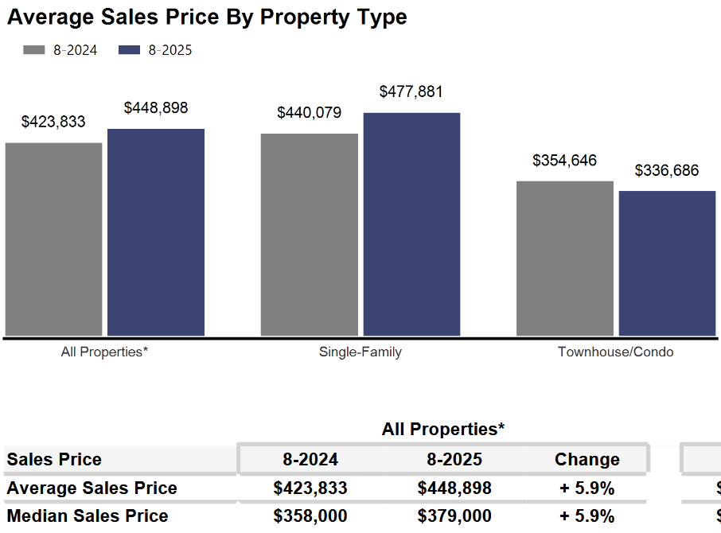
The demand side of the equation is a circumstance of generational pressures as Millennial and Gen Z first-time buyers compete with Baby Boomer Empty Nesters in the market at the same time.


As we have been highlighting for several years – REALTORS® have had an exceedingly tough time helping home buyers find ownership opportunities in the form of condominiums and single-family houses.

There is a significant, long-term danger if we do not create additional supply in the form of single-family and condominium units. Thousands of would-be homeowners will be forced into rental units, unable to save for a down payment and foregoing the opportunity to build wealth through a home’s equity – as well as all of the other benefits of homeownership.

This will result in problems decades down the road when families do not have enough home equity to tap into for college expenses, to remodel their home, or for emergencies.
Where to go
Buyers should seek the counsel of a REALTOR® in determining their best housing options, and sellers need a REALTORS® expert advice in making correct marketing decisions for their home.

The Greater Milwaukee Association of REALTORS® is a 5,500-member strong professional organization dedicated to providing information, services, and products to help REALTORS® help their clients buy and sell real estate. Data for this report was collected by Metro MLS, Inc., a wholly owned subsidiary of GMAR.

* Sales and Listing figures differ between the “Monthly Stats” and quarter or year-end numbers, because the collection of Monthly Stats ends on the 10th of each month, whereas quarters are a continuous tally to 12/31. For example, if a sale occurred on the 29th of the month, but an agent does not record the sale until the 5th of the next month, that sale would not be included in the sales figures of the reported month (or any subsequent month’s total) but would be added to the quarterly and annual total sales figures.

** All references to the “metropolitan” area denotes the four counties of Milwaukee, Waukesha, Ozaukee, and Washington Counties. The “region” or “Southeast Wisconsin” refers to the four metropolitan counties (Milwaukee, Waukesha, Ozaukee, and Washington), plus Racine, Kenosha, and Walworth Counties, to the south.

* * * * *

Seasonally adjusted inventory tells us how many months it would take to sell the existing homes on the market. The seasonally adjusted inventory level for August was 3.3 months. Subtracting listings that have an “active offer” from those available for sale (about 80% of listings with an offer sell) yields 3,637 listings, which equals 1.6 months of inventory.

With 4,612 current listings providing 3.3 months of inventory, the market would need an additional 3,840 units to push inventory to six months. Six months of inventory is considered a “balanced” market. If inventory falls below six months, the market favors sellers, and when inventory exceeds six months, it is a buyer’s market.

