October 13, 2025

For Immediate Release
Contact: Mike Ruzicka
414.778.4929 or 414.870.1874
mike@gmar.com

September Home Sales Up 7.3%

Highlights
- Healthy Uptick in Sales for September, 1.6% Ahead of 2024 YTD
- Listings Also Up A Solid 8.1%
- Metro Prices Up 10.7%, Averaging $446,397

September Sales
County | 2024 | 2025 | % Change
Milwaukee | 782 | 817 | 4.5%
Waukesha | 393 | 439 | 11.7%
Ozaukee | 106 | 95 | -10.4%
Washington | 139 | 172 | 23.7%
Metro Area | 1,420 | 1,523 | 7.3%
Sheboygan | 117 | 100 | -14.5%
Racine | 216 | 201 | -6.9%
Kenosha | 129 | 180 | 39.5%
Walworth | 125 | 121 | -3.2%
SE WI Area | 2,007 | 2,125 | 5.9%
September Listings
County | 2024 | 2025 | % Change
Milwaukee | 1156 | 1278 | 10.6%
Waukesha | 548 | 553 | 0.9%
Ozaukee | 108 | 127 | 17.6%
Washington | 206 | 224 | 8.7%
Metro Area | 2,018 | 2,182 | 8.1%
Sheboygan | 115 | 144 | 25.2%
Racine | 275 | 283 | 2.9%
Kenosha | 200 | 183 | -8.5%
Walworth | 172 | 187 | 8.7%
SE WI Area | 2,780 | 2,979 | 7.2%
Market Summary
Home sales for September in the Metropolitan Milwaukee market were up 7.3% compared to September 2024.

Year-to-date sales were up 1.6% despite only three months of 2025 being in positive territory.

As we mentioned last month, total inventory inched up over the last two years, reaching 3.4 months in September – the highest since September 2020.

But when we subtract homes that already have an offer on them, inventory drops substantially. In September it dropped to just 1.8 months. That number hasn’t been higher than 1.8 months since 2019.

Therefore, although we saw a few more listings come on the market, most are being absorbed. Total inventory is rising, but buyers are placing offers on most of those properties, pushing the inventory level of houses without offers down to 1.8 months.

This absorption is manifesting itself in the form of pricing as well. With the demand in the market, prices rose 10.7% from September ’24 to September ’25 to an average price of $446,397.

The Metropolitan Milwaukee area needed an additional 3,675 units in September to be considered a balanced market (six months of supply).
Reaching 6-month territory is important because it provides a wider selection for buyers to choose from, moderates price inflation, and offers more time for buyers to decide on a home.

New construction could help fill that void, but through July of this year only 1,151 units were built.

The demand side of the equation is a circumstance of generational pressures as Millennial and Gen Z first-time buyers compete with Baby Boomer Empty Nesters in the market at the same time.
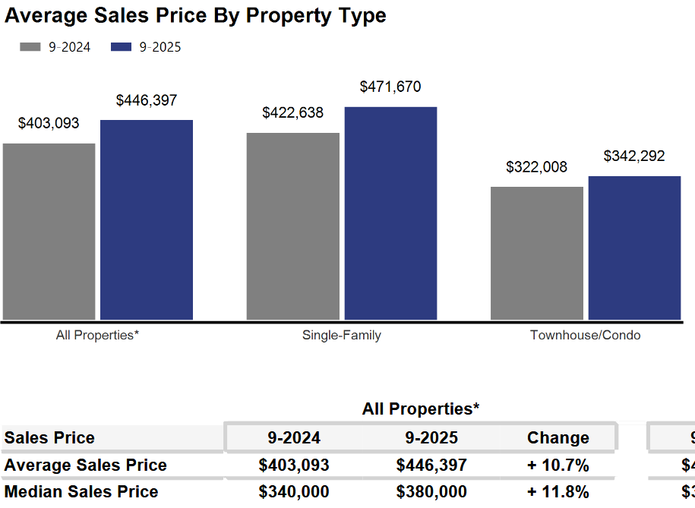
As we have been highlighting for several years – REALTORS® have had an exceedingly tough time helping home buyers find ownership opportunities in the form of condominiums and single-family houses.


There is a significant, long-term danger if we do not create additional supply in the form of single-family and condominium units. Thousands of would-be homeowners will be forced into rental units, unable to save for a down payment and foregoing the opportunity to build wealth through a home’s equity – as well as all of the other benefits of homeownership.

This will result in problems decades down the road when families do not have enough home equity to tap into for college expenses, to remodel their home, or for emergencies.
Where to go
Buyers should seek the counsel of a REALTOR® in determining their best housing options, and sellers need a REALTORS® expert advice in making correct marketing decisions for their home.

The Greater Milwaukee Association of REALTORS® is a 5,500-member strong professional organization dedicated to providing information, services, and products to help REALTORS® help their clients buy and sell real estate. Data for this report was collected by Metro MLS, Inc., a wholly owned subsidiary of GMAR.

* Sales and Listing figures differ between the “Monthly Stats” and quarter or year-end numbers, because the collection of Monthly Stats ends on the 10th of each month, whereas quarters are a continuous tally to 12/31. For example, if a sale occurred on the 29th of the month, but an agent does not record the sale until the 5th of the next month, that sale would not be included in the sales figures of the reported month (or any subsequent month’s total) but would be added to the quarterly and annual total sales figures.

** All references to the “metropolitan” area denotes the four counties of Milwaukee, Waukesha, Ozaukee, and Washington Counties. The “region” or “Southeast Wisconsin” refers to the four metropolitan counties (Milwaukee, Waukesha, Ozaukee, and Washington), plus Racine, Kenosha, and Walworth Counties, to the south.

* * * * *

Seasonally adjusted inventory tells us how many months it would take to sell the existing homes on the market. The seasonally adjusted inventory level for September was 3.4 months. Subtracting listings that have an “active offer” from those available for sale (about 80% of listings with an offer sell) yields 3,880 listings, which equals 1.8 months of inventory.

With 4,780 current listings providing 3.4 months of inventory, the market would need an additional 3,675 units to push inventory to six months. Six months of inventory is considered a “balanced” market. If inventory falls below six months, the market favors sellers, and when inventory exceeds six months, it is a buyer’s market.

