December 11, 2025

For Immediate Release
Contact: Mike Ruzicka
414.778.4929 or 414.870.1874
mike@gmar.com

November Home Sales Down 9.2%

Highlights
- Sales Were Down 9.2% in November
- November Listings Were Down 6.3%
- Metro Prices Up 8.7% With Averaging Sale Price of $428,531

November Sales
County | 2024 | 2025 | % Change
Milwaukee | 726 | 659 | -9.2%
Waukesha | 398 | 361 | -9.3%
Ozaukee | 89 | 74 | -16.9%
Washington | 130 | 126 | -3.1%
Metro Area | 1,343 | 1,220 | -9.2%
Sheboygan | 87 | 73 | -16.1%
Racine | 210 | 193 | -8.1%
Kenosha | 129 | 117 | -9.3%
Walworth | 106 | 134 | 26.4%
SE WI Area | 1,875 | 1,737 | -7.4%
November Listings
County | 2024 | 2025 | % Change
Milwaukee | 832 | 710 | -14.7%
Waukesha | 288 | 295 | 2.4%
Ozaukee | 68 | 81 | 19.1%
Washington | 109 | 129 | 18.3%
Metro Area | 1,297 | 1,215 | -6.3%
Sheboygan | 90 | 90 | 0.0%
Racine | 184 | 184 | 0.0%
Kenosha | 121 | 113 | -6.6%
Walworth | 112 | 115 | 2.7%
SE WI Area | 1,804 | 1,717 | -4.8%
Market Summary
Home sales for November were down 9.2% in Metropolitan Milwaukee compared to November 2024.

Year-to-date, there were 15,588 sales in the four-county area, up 0.6% from 2024.

For 2025 it is beginning to look like sales will be flat compared to 2024. If we take the average for December over the last three years, 2025 will end with 16,829 – 0.2% ahead of 2024.

Inventory has been creeping up this year but took a step back in November by 6.3%. For the year, the market is 3.6% ahead of 2024, year-to-date.

We estimate that 2025 will end with 3.3% more new listings compared to 2024, 21,360 versus 20,670, respectively. Way below what the market is demanding.

The Metropolitan Milwaukee area needed an additional 4,360 units in November to reach anything that could be considered a balanced market (six months of supply).

Reaching that 6-month threshold is important because it provides a wider selection for buyers to choose from, moderates price inflation and offers more time for buyers to decide on a home.

The absorption of available units is pushing prices up. In November, average prices rose 8.7% from November ’24 to an average price of $428,531. Year-to-date prices are up 7.7% with an average price of $431,363.
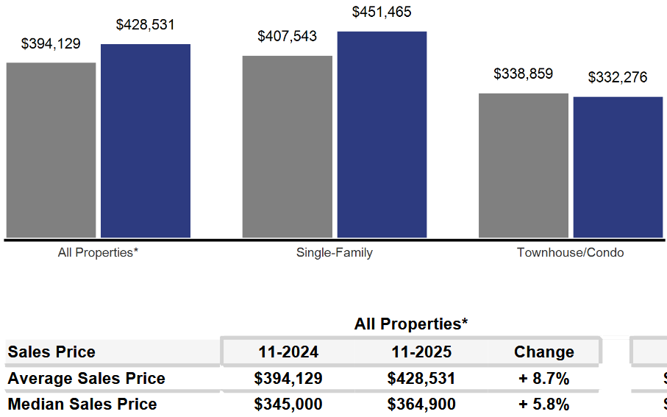
As we have been highlighting for several years – REALTORS® have had an exceedingly tough time helping home buyers find ownership opportunities in the form of condominiums and single-family houses.


There is a significant, long-term danger if we do not create additional supply in the form of single-family and condominium units. Thousands of would-be homeowners will be forced into rental units, unable to save for a down payment and foregoing the opportunity to build wealth through a home’s equity – as well as all the other benefits of homeownership.

This will result in problems decades down the road when families do not have enough home equity to tap into for college expenses, to remodel their home, or for emergencies.
Where to go
Buyers should seek the counsel of a REALTOR® in determining their best housing options, and sellers need a REALTORS® expert advice in making correct marketing decisions for their home.

The Greater Milwaukee Association of REALTORS® is a 5,500-member strong professional organization dedicated to providing information, services, and products to help REALTORS® help their clients buy and sell real estate. Data for this report was collected by Metro MLS, Inc., a wholly owned subsidiary of GMAR.

* Sales and Listing figures differ between the “Monthly Stats” and quarter or year-end numbers, because the collection of Monthly Stats ends on the 10th of each month, whereas quarters are a continuous tally to 12/31. For example, if a sale occurred on the 29th of the month, but an agent does not record the sale until the 5th of the next month, that sale would not be included in the sales figures of the reported month (or any subsequent month’s total) but would be added to the quarterly and annual total sales figures.

** All references to the “metropolitan” area denotes the four counties of Milwaukee, Waukesha, Ozaukee, and Washington Counties. The “region” or “Southeast Wisconsin” refers to the four metropolitan counties (Milwaukee, Waukesha, Ozaukee, and Washington), plus Racine, Kenosha, and Walworth Counties, to the south.

* * * * *

Seasonally adjusted inventory tells us how many months it would take to sell the existing homes on the market. The seasonally adjusted inventory level for November was 2.9 months. Subtracting listings that have an “active offer” from those available for sale (about 80% of listings with an offer sell) yields 3,155 listings, which equals 1.4 months of inventory.

With 4,155 current listings providing 2.9 months of inventory, the market would need an additional 4,360 units to push inventory to six months. Six months of inventory is considered a “balanced” market. If inventory falls below six months, the market favors sellers, and when inventory exceeds six months, it is a buyer’s market.

