GMAR Board Of Directors
Wednesday, January 14, 2026 • 11:00 AM
Embassy Suites Hotel • Brookfield, WI

Meeting Agenda

Welcome & Introductions  - Michael Cox, Johnson Financial Services  Consent Agenda | P 7 | Approval | 11:00 AM
Reports  - Chairman, Tom McCormick  - Secretary/Treasurer  - 2026 Budget  - November Financial Statements  - President’s Report  - Departments  - Professional Standards  - Government Affairs  - Membership  - SentriLock  - Tether RE  - Home & Garden Show  - Metro MLS, Inc. Update | P 14  P 17  P 23 | Information  Information  Approval  Approval  Information  Information  Information  Information  Information  Information | 5 Min  20 Min  10 Min  10 Min  10 Min  10 Min  10 Min  10 Min

Old Business
- None

New Business

None
Adjourn |  |  | 12:30 PM

Upcoming Meeting Dates

REALTOR® & Government Day • Tuesday, February 10th

GMAR Directors Meeting • Thursday, April 16th 12:00 PM

* Indicates hard-copy information will be available at the Directors meeting. Updated: 1/8/2026 1:26 PM
Directors’ Policies & Responsibilities

Fiduciary Duty
As a Greater Milwaukee Association of REALTORS® (GMAR) director, you are a fiduciary of the GMAR. This means you have a special legal responsibility in connection with the administration, investment, and care of GMAR and its assets. This requires you to make careful, good-faith decisions in the best interest of GMAR. Your decisions must be made independently and free of any undue influence from any person, organization, or brokerage.

Conflict of Interest Policy
A member of any Greater Milwaukee Association of REALTORS® (GMAR) decision-making body has a conflict of interest whenever that member is a principal, partner, or corporate officer of a business providing, or being considered as a provider of, products or services to GMAR.

Members with a conflict of interest must immediately disclose such conflict of interest prior to participating in any discussions or vote of a GMAR decision-making body that pertains to the GMAR. Such members may not participate in any discussions related to the GMAR other than to respond to questions asked of them by other members of the body. A member may not vote on any matter in which the member has a conflict of interest.

Antitrust Policy
The Greater Milwaukee Association of REALTORS® (GMAR) is a 501(c)(6) non-profit corporation with members belonging to varying brokerages and business models. Whenever competing (or potentially competing) businesses gather, there is the risk of antitrust liability or of the appearance of anti- competitive activity. Penalties for violating antitrust laws can include huge damage awards and even criminal liability. Just defending an antitrust suit or being the object of an investigation by antitrust regulators comes with remarkably high costs. Liability for violations of the antitrust laws could accrue to the GMAR and also to members accused of participating in alleged anticompetitive activity.

Consequently, responsibility for compliance with competition laws lies with the GMAR, its members, and their leaders. This policy is thus intended to prevent any anti-competitive conduct by the GMAR; but it also aims to reduce even the appearance of anti-competitive conduct.

The GMAR is committed to compliance with all international, national, and state/provincial antitrust and competition laws. This commitment includes the following objectives:

- GMAR’s activities will increase competition among its members by providing information to them regarding effective business practices. The GMAR’s actions must not function to reduce competition.
- GMAR provides a forum for members to discuss their industry and understand developments within it; but the GMAR will not be a forum for members to develop collective action plans that would reduce competition.
- GMAR will adhere to the procedures described below to minimize the risk of even the appearance of anticompetitive conduct.

Procedures for formal meetings
The following procedures apply to all meetings of the Greater Milwaukee Association of REALTORS® (GMAR) board of directors, committees authorized by the Association, and member meetings conducted under GMAR auspices, whether the meetings are held face to face or via technological means. Individuals charged with chairing Metro MLS meetings should be familiar with this policy.

- Each meeting should be preceded by the publication of notice of the meeting to those eligible to attend it and an agenda identifying a business subject for discussion at that meeting.
- Any person who receives an agenda for a GMAR meeting should review it to identify any agenda item that might give rise to concerns about competition or collective action; such items, if any, should be referred to legal counsel for review before the meeting.
- The meeting agenda should be adopted at the beginning of each meeting, and the meeting should follow the agenda.
- At the beginning of each meeting, the chair or counsel should remind participants of this antitrust policy in such a manner as to ensure that participants understand the parameters for appropriate discussions.
- Subject to this policy, every eligible participant in any meeting should be encouraged and permitted to express his/her views on any issue subject to deliberation before a decision is made.
- In the event that a discussion is, or is likely to become, inconsistent with this policy, the meeting chair or counsel shall recommend suspension of the discussion until review under applicable competition law can be conducted; the minutes will note any such suspension.
- After each meeting, GMAR should cause minutes of the meeting to be prepared. These minutes should include a record of the resolutions adopted at the meeting; any objections raised by meeting participants to the subject matter of a meeting, and any other annotations contemporaneously advised by counsel or the meeting chair.
- Minutes of all meetings will be prepared by GMAR staff and reviewed by the Secretary/Treasurer before circulation.
- All board members and GMAR members are asked to comment promptly, in writing, on any minutes circulated in the event that there appears to be any error, omission, or item in need of revision.

Guidelines for discussions
The following guidelines apply to discussions in formal meetings as well as to informal discussions in “breakout sessions” and roundtables and even in social contexts associated with Greater Milwaukee Association of REALTORS® (GMAR) meetings. Of course, no listing of DOs and DON’Ts can be complete, and some items can permissibly be discussed even if they appear in some categories below. However, board members and GMAR members should consult with counsel before engaging in discussion of any of the types described here:
- An agreement, or activity appearing to evidence an agreement, to fix prices, limit product or service offerings, or allocate geographical territory or customers.
- An agreement, or activity appearing to evidence an agreement, to refuse to deal with any third party or parties, whether a vendor or supplier of products or services, or a customer or class of customers.
- An agreement, or activity appearing to evidence an agreement, to limit innovation, product choices, or research relating to any of the foregoing.
- Sharing of recent, current, or planned fee structures; or data regarding operating “input” costs, especially if such costs could affect service prices. This does not prevent the GMAR from gathering and aggregating certain kinds of historical pricing information, subject to counsel’s review.
- Any suggestion that GMAR or its members should take collective action to force a vendor or service provider to change its business models, prices, or service offerings.

Anti-Harassment Policy
The Greater Milwaukee Association of REALTORS® does not tolerate harassment in the workplace. The GMAR expressly prohibits any form of unlawful discrimination and harassment based on race, color, religion, sex, sexual orientation, gender identity, national origin, age, disability, genetic information, military or veteran status, pregnancy, childbirth or related medical conditions, or status in any group protected by federal, state, or local law. This policy applies to all terms and conditions of employment, including but not limited to, hiring, training, promotion, discipline, compensation, benefits, and termination of employment. Further, this policy extends to all GMAR personnel, including officers, managers, administrators, supervisors, staff members, and co-workers, as well as the Board of Directors and members of the Board of Directors, vendors, contractors, customers, students, and suppliers.

Harassment Defined
Harassment includes unwelcome verbal, visual, or physical conduct creating an intimidating, offensive, or hostile work environment. Examples of harassment include verbal (including slurs, jokes, insults, epithets, gestures, or teasing), graphic (including offensive posters, symbols, cartoons, drawings, computer displays, or e-mails), or physical conduct (including physically threatening another, blocking someone’s way) that denigrates or shows hostility or aversion toward an individual because of any protected characteristic. Such conduct constitutes harassment when: (1) it has the purpose or effect of creating an intimidating, hostile, or offensive working environment; (2) it has the purpose of effect of unreasonably interfering with an individual’s work performance; or (3) it otherwise adversely affects an individual’s employment.

Sexual harassment is a form of harassment, and includes the following prohibited behaviors:
- Unwelcome sexual advances, requests for sexual favors, and all other verbal or physical conduct of a sexual or otherwise offensive nature, especially where:
- Submission to such conduct is made either explicitly or implicitly a term or condition of employment;
- Submission to or rejection of such conduct is used as the basis for decisions affecting an individual’s employment; or
- Such conduct has the purpose or effect of unreasonably interfering with an individual’s work performance or creating an intimidating, hostile, or offensive working environment.
- Offensive comments, jokes, innuendos, and other sexually oriented statements;
- Touching, such as rubbing or massaging someone’s neck or shoulders, stroking someone’s hair, or brushing against another’s body;
- Sexual suggestive touching;
- Grabbing, groping, kissing, or fondling;
- Violating someone’s “personal space”;
- Whistling;
- Lewd, off-color, sexually oriented comments or jokes;
- Foul or obscene language;
- Leering, staring, or stalking;
- Suggestive or sexually explicit posters, calendars, photographs, graffiti, or cartoons;
- Unwanted or offensive letters or poems;
- Sitting or gesturing sexually;
- Offensive e-mail or voice-mail messages;
- Sexually oriented or explicit remarks, including written or oral references to sexual conduct;
- Gossip regarding one’s sex life, body, sexual activities, deficiencies, or prowess;
- Questions about one’s sex life or experiences;
- Repeated requests for dates;
- Sexual favors in return for employment rewards, or threats if sexual favors are not provided;
- Sexual assault or rape;
- Any other conduct or behavior deemed inappropriate by the WRA. This list is illustrative only, and not exhaustive.

Reporting Harassment
It is the responsibility of the GMAR and each employee, vendor, customer, member, contractor, student, supplier, and board member to create an atmosphere free of harassment. In addition, it is the responsibility of each employee to respect the rights of their coworkers. If you experience or observe any hostile conduct or harassing behavior, you are required to immediately report the matter (orally or in writing, which is preferred) to the President/Chief Executive Officer, ideally within ten (10) days of the offending conduct. If the conduct involves the President/Chief Executive Officer, you can report the conduct to the Chairperson of the Board of Directors or GMAR leadership.

Complaints should be as detailed as possible, including the names of all individuals involved and any witnesses.

Investigations
Upon receipt of a complaint, the President/Chief Executive Officer will undertake a prompt and thorough investigation of the allegations. Where necessary and/or appropriate, GMAR will consult with legal counsel for assistance in conducting any investigation, especially where an investigation involves GMAR leadership or members of the Board of Directors.

While confidentiality can never be guaranteed, it shall be the policy of the GMAR that confidentiality will be maintained concerning the allegations and the investigation to the extent possible, and particularly when it is determined by WRA that any of the following factors are present:
• Witnesses need protection;
• Evidence is in danger of being destroyed; and/or
• Testimony is in danger of being fabricated or altered.

Employees who fail to cooperate with an investigation conducted pursuant to this Policy, or who breach confidentiality resulting in a threat to the integrity of the investigation, may be disciplined, up to and including termination.

If the investigation establishes that an individual has engaged in harassing, discriminatory, or other wrongful or inappropriate conduct, disciplinary or other corrective action, up to and including termination, will be taken against the offending employees.

The GMAR is committed to enforcing this policy against all forms of harassment. The effectiveness of our efforts depends largely on us being informed of any inappropriate workplace conduct. If harassing conduct is not reported, GMAR may not become aware of a possible violation of this policy and may not be able to take appropriate corrective action.

Retaliation Prohibited
The GMAR expressly prohibits any retaliation or other adverse action against any employee who makes a good faith complaint of discrimination, harassment, or retaliation, or participates in any investigation of such complaint in good faith.

Violations of this Policy
Any individual, regardless of position or title, whom GMAR determines has subjected an individual to harassment or retaliation in violation of this policy, will be subjected to disciplinary or other corrective action , up to and including termination of employment.

Administration of this Policy
The President/Chief Executive Officer is responsible for the administration of this policy. If you have any questions regarding this policy or questions about harassment that are not addressed in this policy, please contact the President/Chief Executive Officer.

All GMAR leadership and members of the Board of Directors shall be educated on this policy on an annual basis at the first meeting of the board of directors each year. The education will cover several topics including, but not limited to, definitions and examples of harassment, including sexual harassment, prohibited behaviors and consequences of engaging in prohibited behaviors, reporting procedures, and responding to reports of harassment.

Conduct Not Prohibited by this Policy
This policy is not intended to preclude or dissuade employees from engaging in legally protected activities/activities protected by state or federal law, including the National Labor Relations Act, such as discussing wages, benefits, or terms and conditions of employment, forming, joining, or supporting labor unions, bargaining collectively through representatives of their choosing, raising complaints about working conditions for their and their fellow employees' mutual aid or protection, or legally required activities.

GMAR Board Of Directors

Consent Agenda

Please note: if any director would like to consider an item in the Consent Agenda, please state that you would like to discuss the item when the Chair asks for a motion to approve the Consent Agenda.

- It is moved, seconded, and carried to approve the agenda of the Wednesday, January 14, 2026, meeting of the GMAR Board of Directors. p. 1

- It is moved, seconded, and carried to approve the minutes of the Board of Directors meeting from Wednesday, October 15, 2025. p. 8

- It is moved, second, and carried to approve of the 122 new members who have applied to become members of the GMAR and paid the appropriate fees. p. 11

GREATER MILWAUKEE ASSOCIATION OF REALTORS®
BOARD OF DIRECTORS MEETING MINUTES
Wednesday, October 15, 2025 • 12:00 PM
GMAR Headquarters • Wauwatosa, WI

- Call to Order
Chair Abby Hauke called the GMAR Directors meeting to order at 12:01 PM with a quorum present for the transaction of business.

Present: Abby Hauke, Chairwoman; Tom McCormick, Chair-Elect (via Zoom); Shawn Govern, Secretary/Treasurer; Sarah Cole, Past Chair; Sarah Venes, Tom Telderer, Arthur Mays, Scott Klaas, Jose Flores, Mark Kivley, Ryan Stefaniak, Dan Weber, James Krickeberg, Tonya Thomsen,

Staff Present: Mike Ruzicka, President; Scott Bush, VP Operations; Marne Stück, Government Affairs Director; Joanna Tusing, Director of Promotions; Laura Crowley, Communications Director, Sharon Heilman, Dir of Lasting Impressions

Guest(s): Chris Lambrou, CEO of Metro MLS, Inc.; Jenny Tarkowski, Wegner CPAs

Excused: John Horning, Theresa Dixon

- Consent Agenda
- Reappoint MLS directors Joe Horning, Dave Schmidt, Jr. and Tammy Maddente, for a (3) three-year term.
- It is moved, seconded, and carried to approve the agenda of the Wednesday, October 15, 2025, meeting of the GMAR Board of Directors.
- It is moved, seconded, and carried to approve the minutes of the Board of Directors meeting from Tuesday, July 8, 2025.
- It is moved, second, and carried to approve of the 196 new members who have applied to become members of the GMAR and paid the appropriate fees.

M/S/C unanimously, to approve the Consent Agenda.

- Reports
- Chairwoman’s Report
Ms. Hauke thanked the directors who will leave the board after today’s meeting. And she said that she was so happy to participate in Milwaukee Magazine’s Women of Distinction photo shoot recently.

- Treasurer’s Report
- 2026 GMAR Budget – Mr. Ruzicka presented the GMAR’s 2026 budget. He said the GMAR weathered the beginning of 2025 much better than expected. The GMAR’s two main sources of revenue are member dues, and the Home & Garden Show (HGS). Both were expected to be down in 2025, but much to our delight they outperformed initial expectations.

2026 looks to be a little tougher. We’re expecting renewals to be down $115,166, but the same number of new members as recent years. The Home & Garden Show will most likely be successful going into our 100th year. So, we are approaching the new year cautiously, trying to be as careful and conservative financially as possible.

Membership – A little history: In 2019 we raised dues from $207 to $380, in order to provide the SentriLock system to all members. In 2020 we lowered them to $350, and held steady for 2021. For 2022, we billed members $360. And for 2023 we increased dues $5 to $365, staying there for 2024. For 2025 we increased dues $40 to $405 (to create a dedicated legal action fund). And for 2026 we decreased dues to $400 (dedicating $30 to the legal action fund).

We are estimating down dues revenue to decrease by $115,166. Regarding new members we are copying 2025, estimating 500 new REALTOR® members, 50 Designated REALTORS® and 20 new Affiliate members.

The SentriLock system is a major expenditure in the Membership category, and we estimate spending $490,000 ($40,755/month) for the service.

Promotions – The Home & Garden Show (HGS) has recovered from the pandemic (after a two year hiatus in 2020 and 2021). It had a pretty solid 2022, better 2023, and the show netted over $300,000 in 2024. We budgeted net income of $241,400 for 2025 but ended up with $272,894. For 2026, our 100th anniversary, we’re budgeting $242,000.

Public Policy – The bulk of Public Policy expenses are personnel expenditures. Normal additional expenses include funds for a polls, RPAC, REALTOR® & Government Day, the NAR GAD Institute, and sponsorships (i.e., MMAC’s events in Washington DC and Madison).

Professional Standards – Similar to Public Policy, much of the expenditure in Professional Standards (PS) are personnel, and we are again subscribing to WRA PS program for 2026.

Leadership – We did not add back the NAR Consumer surveys we had purchased in the past, but did keep the Milwaukee Bucks’ tickets for the 2025-2026 season. We have increased expenses related to travel to NAR and a few other real estate events due to inflation.

Administration – We did add a $23,000 expense for a new building mortgage and $10,000 for new computers/software for some staff. In the personnel category, we’re holding salary related expenses flat.

The initial net number for the 2026 budget is ($27,715), but in a $3 million budget we can work our way into the black after we have a complete picture of dues and HGS income.

M/S/C to approve the 2026 GMAR Budget.

- August Financials – Mr. Ruzicka presented the August 2025 financials.

Statement of Financial Position – As of August 31, 2025, GMAR had $2,186,051 in Cash & Investment Balances, up $239,874 compared to last year.

Accounts receivable were down $2,502 compared to last year. Prepaid expenses were down $16,342 compared to 2024. Fixed assets increased by $328,989.

Total Assets were $4,208,092 which is up $534,598 compared to 2024.

On the Liability side, accounts payable were up $20,946 compared to last year. Long-term debt increased by $377,808 due to the loan taken out to remodel the GMAR offices. Overall, Total Liabilities were $506,819 which is up $398,754 compared to 2024.

GMAR has a Net Gain of $1,128,983 through August 31, 2025, up $41,992 from last year. Overall, Total Net Assets were $3,701,273; $135,844 higher than the same point in 2024.

Statement of Activities – Membership: Through August 2025, $2,143,984 was collected in dues. Last year through the end of August we collected $2,029,034 in dues, so dues are $114,950 ahead of last year at the same time. Renewals were down slightly with regards to membership numbers, but dues were increased by $40 in February 2024, so that increase being in effect for 2025 renewals more than made up for the membership drop and led to an increase in total renewal dues collected.

For 2025, GMAR had an 86% renewal based on number of members billed. Revised new member budget for 2025: 590 REALTORS®, 30 DRs and 14 Affiliates. Through August, actual new members: 570 REALTORS®, 28 DRs and 11 Affiliates.

Promotions: Through August, Home and Garden Show income is $727,285 and expenses are $457,076 for a net gain of $270,209. While probably close to final, these numbers will still change a bit throughout the next few months. The budgeted net gain for the Show is $241,650.

Expenses related to Public Policy are mostly personnel costs, incurring expenditures primarily in Labor and Overhead. The majority of Professional Standards expenses are related to the fair housing ads.

The Leadership section includes expenditures for meetings, committees, officer expenses, strategic planning, NAR surveys and NAR meetings. The main expenses recorded through August were travel for meetings, meeting costs, memberships, sponsorships, and Bucks tickets.

The Administrative section includes investment and rental income and expenses for professional fees, salaries, fringe benefits, building, insurance, occupancy, property taxes, general office expenses and depreciation.

The bottom line shows net income of $1,128,983. Last year net income was $1,086,991 for the same time period.

Administration – Added $20,000 expense for a new website development and $20,000 for new computers for most of the staff. Holding salary-related expenses in personnel flat.

Currently the bottom line shows gross income of $3,101,127 with expenses of $3,022,826, for a net ending balance of $78,301 for FY 2025, compared to $45,739 in the original 2025 budget.

M/S/C to approve the unaudited Statement of Financial Position (Balance Sheet) and Statement of Activities as of August 30, 2025 and recommend placing it on file for audit.

- President’s Report
Mike Ruzicka reported the following in addition to his written memorandum to the Board of Directors:

- 2025 GMAR Board of Directors Election – The GMAR Board of Directors election was held from October 5th – 11th. Ballots were sent out to all members on October 5th. the four finalists were: Casey Klickner, Beau Micham, Sheena Polachowski, and Angela Kallay.

M/S/C to certify the results of the 2025 GMAR Board of Directors election.

- Discover Milwaukee – The association had hoped to have the DiscoverMilwaukee.com website fully functional and full of ads by now. However, the project has faced some setbacks due to poor communication with the web design firm.

The GMAR’s goals are still attainable: to position DiscoverMilwaukee.com to be an essential resource for people looking to relocate to Milwaukee with a robust social media plan, advertising strategy, and strong community engagement. But the association needs to move quickly before we lose momentum among advertisers.

The site was designed in the Druple language, which we knew was outdated and the web firm we inherited with the side, Keystone Click, assured us they could update it and make it more user friendly. Our rep with Keystone Click dropped the ball several times over the summer.

Our plan is to get the site updated in the existing Druple language ASAP, sell ads on it, and push it out through social media channels. Once that happens and it starts generating some revenue we will plan on expanding its reach, ideally adding more robust advertising.

In about 12-18 months we will look at having the site revised in Wordpress, which is a more contemporary website language and more user-friendly, allowing us to update it ourselves. We will send out RFPs once we get to this point, rather than rely on Keystone Click.

- REALTOR® Safety/Tether RE – Our target date of October 1st as start date for Tether RE was pushed back to October 15th, and now to November 3rd.

The association initially had to delay because of some technical issues relating to how to process member payments. Going forward members will be able to pay for the service and it will be recorded directly in their membership record.

The second delay is the result of Tether RE wanting to host a membership-wide Zoom training session. We have been promoting Tether via social media and email telling members that more information would be coming. I believe we only identified a Oct 1 start date in one email.

In keeping with Tether RE’s pattern of roll outs, we will communicate and urge members to subscribe and sign up for the Nov 3rd Zoom session.

- SentriLock – The GMAR signed an extension of our current SentriLock contract to end on 12/31/2025, and a new one beginning 1/1/2026 for seven years providing us with 9,000 new boxes.

As the Board decided at the July 8th meeting, we entered into a full lockbox replacement agreement, which will provide new boxes to any member who wishes to use them.

SentriLock will run the show as far as issuing new boxes. They will hand out boxes at a multi-day event (7-10 days) at an off-site venue with SentriLock & GMAR Staff on hand. They will coordinate directly with members and have them sign up to pick up/drop-off boxes and take training on the new ones.

GMAR will determine the number of boxes to provide each member based on a formula of the average number of listings a member has had over the last 3 years. That is the basis we used in 2018 to distribute boxes. If a member feels they need more, we can give one or two to them, however we want to be very careful handing boxes out as generously as we did in 2018.

Also, the association has to be diligent in holding members accountable for lockboxes they have “lost” in the past. Some members have misplaced, lost, forgotten… up to three-quarters of the lockboxes they were issued. We’re contemplating various policies to implement that, generally, will limit the number of boxes we hand out during the conversion in January for those with egregious losses.

- Strat Plan – A copy of the GMAR’s current strategic plan was provided to the board as well as a copy of an updated version for 2026. The association should update it to reflect any new developments in the market or among our members. Mr. Ruzicka included a copy of the results of two focus groups the association conducted in August to the board members as well.

Mr. Ruzicka also reviewed members surveys the association sent out over the last few years, and offered some observations and trends he noticed:
- Consistently around 80% of our members say they are aware of the GMAR’s ethics and professional courtesies programs and communications.
- About 60% experience discourteous behavior from other members. The most common form was a lack of communication.
- Roughly 30% of members say they experienced unethical behavior. Although some characterize discourteous behavior for unethical behavior, based on how egregious the rudeness was.
- The need for broker supervision is a consistent theme and has been for years. This may be an area for the GMAR to make inroads to better member behavior.

Based on recent findings, Mr. Ruzicka suggested the following additions to the strategic plan:
- Administer an Ethics Test, Pathways to Professionalism Test, and SentriLock Test to new members
- Educate members on Fair Housing
- Advocate for more state funding for local government rather than relying on property taxes
- Advocate for more single-family and condo development vs. apartment construction

M/S/C to adopt the GMAR’s strategic plan for 2026

- Department Reports

- Government Affairs
Marne Stück reported:

  - 2025 Meetings with Elected Officials – Mrs. Stück listed the meetings GMAR had with municipal leaders over the course of the year. In most cases, A GMAR Board Member attended when it is in a municipality they reside in. The main purpose of these meetings is to introduce the GMAR, offer any assistance the association can provide as far as housing stats and other information that may be helpful to them.
  - January-Waukesha Mayor Shawn Reilly
  - April-Shorewood Village Manager Rebecca Ewald
  - May-Thiensville Village Manager Colleen Landisch-Hansen
  - July-Mukwonago Village President Fred Winchowky
  - August-Franklin Mayor John Nelson
  - September-Whitefish Bay Village Manager Kelsey McElroy
  - October-MPS Superintendent Brenda Cassellius

  - Mrs. Stück asked the directors to please save the date for REALTOR & Government Day 2026 to be held on Tuesday, February 10.

  - Mrs. Stück thanked everyone who contributed to RPAC and/or the Direct Giver Program in 2025. The fundraising requests from WRA are coming in hot and there doesn’t appear to be an end in sight with another election year looming.

- Professional Standards
Scott Bush reported:

  - Scott Bush reported that the GMAR will reform the Professional Standards Committee with the purpose of promoting professional courtesies and business ethics. There will also be a focus on self-policing and taking responsibility to file a complaint when there is believed to be an ethics violation.

- Metro MLS, Inc.
Metro MLS CEO, Chris Lambrou, updated the directors on:
- MLS is working on risk reduction options for members, protecting sellers
- WIREX has reached its 17th year in existence. Two pieces of the state are left to include.
- Madison and Milwaukee merger/data sharing discussions.
- Aligned Showings is being updated and will be able to sync with calendars.
- New product: Roovo, a virtual staging software.

- Old Business
- None

- New Business
- Election of 2026 Executive Committee
- Chair-Elect
M/S/C to appoint Shawn Govern as 2026 Chair-Elect.
- Secretary/Treasurer
M/S/C to appoint Ryan Stefaniak 2026 Secretary/Treasurer.

- Adjourn
Ms. Hauke thanked the directors their time this year. Mr. Ruzicka thanked Ms. Hauke for her year as a leader of the GMAR.

The meeting adjourned at 1:05 PM

Respectfully Submitted,

Mike Ruzicka
President/CEO

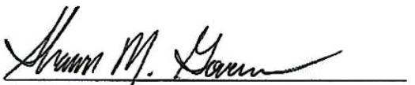
Shawn Govern
Secretary/Treasurer

New Member Report

122 New Members joined October 7, 2025 - January 7, 2026 for approval (DR's - 10, R's - 108, A's - 3)

FIRST | LAST | COMPANY
Brian | Altman | Lannon Stone Realty LLC
Kara | Amundson | Shorewest, REALTORS~West Bend
Milo | Bakos | Shorewest, REALTORS~N Oakland
Renita | Barken | Berkshire Hathaway HomeServices Metro Realty
Robin | Barraza | Shorewest, REALTORS~South Metro
Lucas | Bartaczewicz | Realty Executives Integrity~Brookfield
Travis | Bates | Gardner & Associates Real Estate
Amy | Becker | First Weber Inc~Mequon
Jackson | Behling | Map Realty Group LLC
Jodee | Benavides | Be Different Real Estate LLC
Gerry | Benton | Waukesha State Bank
Andrew | Bergholz | First Weber Inc~NPW
Stacey | Berndt | Keller Williams Realty~MKE
Tammy | Brennenstuhl | Ogden & Company, Inc.
Lindsay | Burkwald | Keller Williams Realty-MKE
Stacy | Caprioli | Opteon USA
Brittany | Carlone | RD Training Systems
Stephen | Carvelli | HomeLight Inc
David | Chikowski | Premier Point Realty LLC
Amanda | Crockett | Grapevine Realty
Dantwonette | Cross | Real Broker LLC
Marshall | Cruickshank | EXP Realty, LLC~MKE
Hudson | Curtin | Keller Williams Prestige Realty
Emily | Dawt Iang | Fathom Realty, LLC
Caterina | Demopoulos | Tim O'Brien Homes Inc
Terrence | Doyle | Kingfogl Construction & Realty
Amy | Draskovich | Century 21 Benefit Realty
Beverley | Drummond | Keller Williams Realty~MKE
Kirk | Dunlap | EXP Realty, LLC~MKE
William | Durkin | Keller Williams Realty Milw SW~New Berlin
Jacob | Eagon | Shorewest, REALTORS~Germantown
Brittany | Echols | EXP Realty, LLC~MKE
Charles | Eisenberg | RE/MAX Forward
Angela | Eisenhut | RE/MAX Service First
Colleen | Fait | Keller Williams Realty-MKE
Amy | Farruggio | Keller Williams Realty~MNS Wauwatosa
Ryan | Ferguson | Keller Williams Realty Milw SW~New Berlin
Eduardo | Ferreira | Coldwell Banker Realty~BRK
Nelson | Figueroa | LPT Realty
Samantha | Flamand | One Source Realty
Jessica | Fox | The Wisconsin Real Estate Group
Christina | Graham | The Difference Real Estate, LLC
Rashadeem | Gray | Keller Williams Realty~MKE
Patricia | Griffin-Hughes | PRC Realty LLC
Lorie | Hall | Coldwell Banker Realty~Racine
Brianna | Hall | Keller Williams Realty~MKE
Jason | Ho | Keller Williams Realty Milw SW~New Berlin
Markus | Horner | HNE Properties LLC
Leah | Horwitz | Keller Williams Realty~MNS Wauwatosa
Sheryl | Iverson | Fathom Realty, LLC
Lovely | Jackson | Keller Williams Realty Milw SW~New Berlin
Ara | Jackson | Lannon Stone Realty LLC
Cherie | Jarchow | Milwaukee Executive Realty
Kavion | Jefferson | Real Broker LLC
Gina Marie | John | Realty Executives Capital City
Daniel | Johnson | First Weber Inc~West Bend
Ashley | Kailing | Keller Williams South Shore
Brittany | Kaja | Keller Williams Prestige Realty
Arianna | Karow | The Stefaniak Group LLC
Chamanpreet | Kaur | Keller Williams Realty Milw SW~New Berlin
Yasser | Khaled | Elements Realty LLC
Caileigh | Klis | Shorewest, REALTORS~Meadowbrook
Kyle | Konetzke | Shorewest, REALTORS~Meadowbrook
Levi | Kossow | Shorewest, REALTORS~Germantown
Kaden | Kresnak | Keller Williams Realty-MKE
Adam | Kriete | Homestretch
Kathryn | Krzewina | Shorewest, REALTORS~Mukwonago
Nikolai | Kuvshinikov | EXP Realty, LLC~MKE
Andria | Kuykendall | Realty Dreams LLC
Nizong | Lee | EXP Realty, LLC~MKE
Javonte | LeFlore | Shorewest, REALTORS~Germantown
Sarah | Lessila | Realty Executives Integrity~Brookfield
Margaret | Liebner | Coldwell Banker HomeSale Realty~ Corporate
Morgan | Lilly | Compass Real Estate Wisconsin LLC~North Shore
Aniya | Lovett | Keller Williams Realty~MKE
Dawson | Mercier | Coldwell Banker Elite
Jeremy | Metzger | Midwest Realty Group LLC
Suliyat | Olagbenro | Homestead Realty Inc
Fabrizio | Olivares | Coldwell Banker Realty~BRK
Margaret | Olsen | Keller Williams Realty~MKE
Jessica | Olson | Keller Williams Realty Milw SW~New Berlin
Olusola | Oluwatosin | Tob Watsin LLC
Deserre | Ortiz | Flamboyant Real Estate Group
Samuel | Palser | Epique Realty
Sheri | Pape | Shorewest, REALTORS~South Metro
Amanda | Paulson | Dedrick Homes
Dane | Peplow | Berkshire Hathaway HomeServices Metro Realty
Da'Jon | Perique | Boardwalk Realty LLC
Erika | Perona | Keller Williams Realty~MNS Wauwatosa
Domonic | Phillips | Acquire Realty LLC
Philippa | Pinnington | First Weber Inc~BK
Katarina | Popov | Keller Williams Realty~MNS Wauwatosa
Vvilma | Pulos Tomaro | Keller Williams Realty~MKE
Amanda | Rahlf | Homestead Realty Inc
Kali | Restivo | Guardian Investment Real Estate Co Inc
Belinda | Rhoden | RE/MAX Lakeside-Central
Chantel | Riley | EXP Realty, LLC~Middleton Greenway
Grace | Rochon | Boss Realty LLC
Brendalis | Rodriguez-Suarez | Humbled Hands Real Estate
Alan | Ruiz Gonzalez | JC Realtors
Stephanie | Schettler-Cumming | Compass Real Estate Wisconsin LLC
David | Schultz | Avanti Realty LLC
Ian | Shoppach | Abundance Real Estate
Lisa | Soltesz | Opendoor Brokerage, LLC
DaiJian | Spears | Keller Williams Realty~MKE
Saige | Spiers | Compass Real Estate Wisconsin LLC~North Shore
Laurence | Trimble | Berkshire Hathaway HomeServices Metro Realty
Jasmine | Trotter | Keller Williams Realty Milw SW~New Berlin
Ashlynn | Verbeten | Berkshire Hathaway HomeServices Lake County Realty
Jerad | Wagner | Tim O'Brien Homes Inc
Joseph | Walker | EXP Realty, LLC~MKE
Eric | Walz | Smart Asset Realty Inc
Kaitlyn | Wartman | LPT Realty
Lisa | Wenzler | Compass Real Estate Wisconsin LLC~North Shore
Kelly | Williams | 808 Realty LLC
Ronnie | Williams | LPT Realty
Kellie | Yanke | Dedrick Homes
Mark | Zatz | Homesmart Connect LLC
Zani | Zeqiri | Lannon Stone Realty LLC
Kimberly | Ziegel | Keller Williams Realty Milw SW~New Berlin
Emari | Zollicoffer | Shorewest, REALTORS~Racine

Membership categories: DR = Designated REALTOR®, R = REALTOR®, RN = REALTOR® No National; A = Affiliate,
AC = Affiliate Corporate, LAC = Local Affiliate Corporate, LACC = Local Affiliate Corporate Contact
*Includes former GMAR members who had to rejoin the GMAR as new members.

Estimated total. Final membership numbers will not be available until after 1/20/26

2026 GMAR Budget

We weathered the beginning of 2025 much better than expected. The GMAR’s two main sources of revenue are member dues, and the Home & Garden Show (HGS). Both were expected to be down in 2025, but much to our delight they outperformed initial expectations.

2026 looks to be a little tougher. We’re expecting renewals to be down, but we expect the same number of new members as in recent years. The Home & Garden Show will most likely be successful going into our 100th year. So, we are approaching the new year cautiously, trying to be as careful and conservative financially as possible.

Membership – A little history: In 2019 we raised dues from $207 to $380, in order to provide the SentriLock system to all members. In 2020 we lowered them to $350, and held steady for 2021. For 2022, we billed members $360. And for 2023 we increased dues $5 to $365, staying there for 2024. For 2025 we increased dues $40 to $405 (to create a dedicated legal action fund). And for 2026 we decreased dues to $400 (dedicating $30 to the legal action fund).

We are estimating down dues revenue to decrease by $115,166. Regarding new members we are copying 2025, estimating 500 new REALTOR® members, 50 Designated REALTORS® and 20 new Affiliate members.

The SentriLock system is a major expenditure in the Membership category, and we estimate spending $490,000 ($40,755/month) for the service. Tether RE is also a Membership expense totaling $2,500/month.

Promotions – The Home & Garden Show (HGS) has recovered from the pandemic (after a two-year hiatus in 2020 and 2021). It had a solid 2022, better 2023, and the show netted over $300,000 in 2024. We budgeted net income of just $241,400 for 2025, due to some management changes, but ended up netting $272,894. For 2026, our 100th anniversary, we’re conservatively budgeting $242,000.

Public Policy – The bulk of Public Policy expenses are personnel expenditures. Normal additional expenses include funds for a polls, RPAC, REALTOR® & Government Day, the NAR GAD Institute, and sponsorships (i.e., MMAC’s events in Washington DC and Madison).

Professional Standards – With the GMAR entering the WRA’s PS program, we have very few expenses in this category other than a salary expense, which is included in the Administrative category.

Leadership – We did not add back the NAR Consumer surveys we had purchased in the past and eliminated the Milwaukee Bucks’ tickets in the future. We have increased expenses related to travel to NAR and a few other real estate events due to inflation.

Administration – We did add a $32,000 expense for a new building mortgage and $3,000 for new computers/software for some staff. In the personnel category, we’re holding salary-related expenses flat.

The initial net number for the 2026 budget is ($27,680), but in a $3 million budget we can work our way into the black after we have a complete picture of dues and HGS income.

GMAR Budget Spreadsheet

August 2025 Financial Statements

Statement of Financial Position – As of November 30, 2025, GMAR had $3,176,428 in Cash & Investment Balances, up $688,207 compared to last year. Accounts receivable were down $29,169 compared to last year. Prepaid expenses were down $88,129 compared to 2024.
Fixed assets increased by $116,888. Total Assets were $5,509,788 which is up $672,254 compared to 2024.

On the Liability side, accounts payable were up $52,548 compared to last year. Unearned revenue is up $82,264 compared to last year. Long-term debt increased by $377,114 due to the loan taken out to remodel the GMAR offices. Overall, Total Liabilities were $2,285,812 which is up $511,926 compared to 2024.

GMAR has a Net Gain of $651,686 through November 30, 2025, up $66,476 from last year. Overall, Total Net Assets were $3,223,977; $160,328 higher than the same point in 2024.

Statement of Activities – Membership: Through November 2025, $2,182,370 was collected in dues. Last year through the end of November we collected $2,057,271 in dues, so dues are $125,099 ahead of last year at the same time. Renewals were down slightly with regards to membership numbers, but dues were increased by $40 in February 2024, so that increase being in effect for 2025 renewals more than made up for the membership drop and led to an increase in total renewal dues collected. For 2025, GMAR had an 86% renewal based on number of members billed. Revised new member budget for 2025: 590 REALTORS®, 30 DRs and 14 Affiliates. Through November, actual new members: 682 REALTORS®, 35 DRs and 12 Affiliates.

Promotions: Through November, Home and Garden Show income is $728,964 and expenses are $459,272 for a net gain of $269,692. These numbers might be final, but they could still change a bit. The budgeted net gain for the Show is $272,894.

Expenses related to Public Policy are mostly personnel costs, incurring expenditures primarily in Labor and Overhead. The majority of Professional Standards expenses are related to the fair housing ads.

The Leadership section includes expenditures for meetings, committees, officer expenses, strategic planning, NAR surveys and NAR meetings. The main expenses recorded through November were travel for meetings, meeting costs, memberships, sponsorships, and Bucks tickets.

The Administrative section includes investment and rental income and expenses for professional fees, salaries, fringe benefits, building, insurance, occupancy, property taxes, general office expenses and depreciation.

The bottom line shows net income of $651,686. Last year net income was $585,210 for the same time period.
Statement of Financial Position (Balance Sheet)

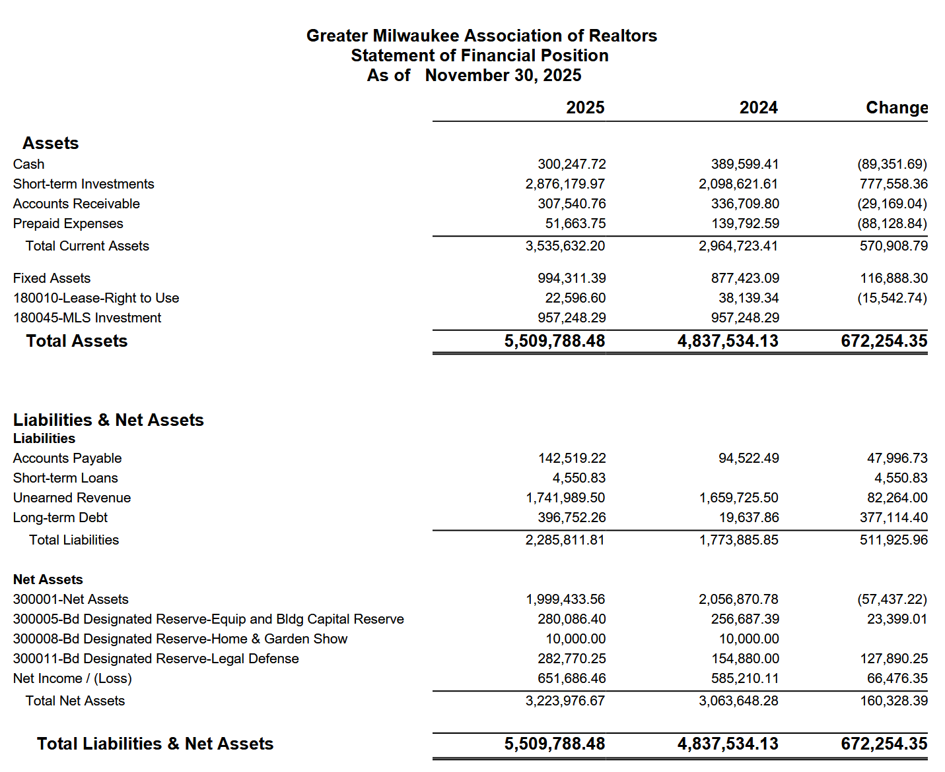

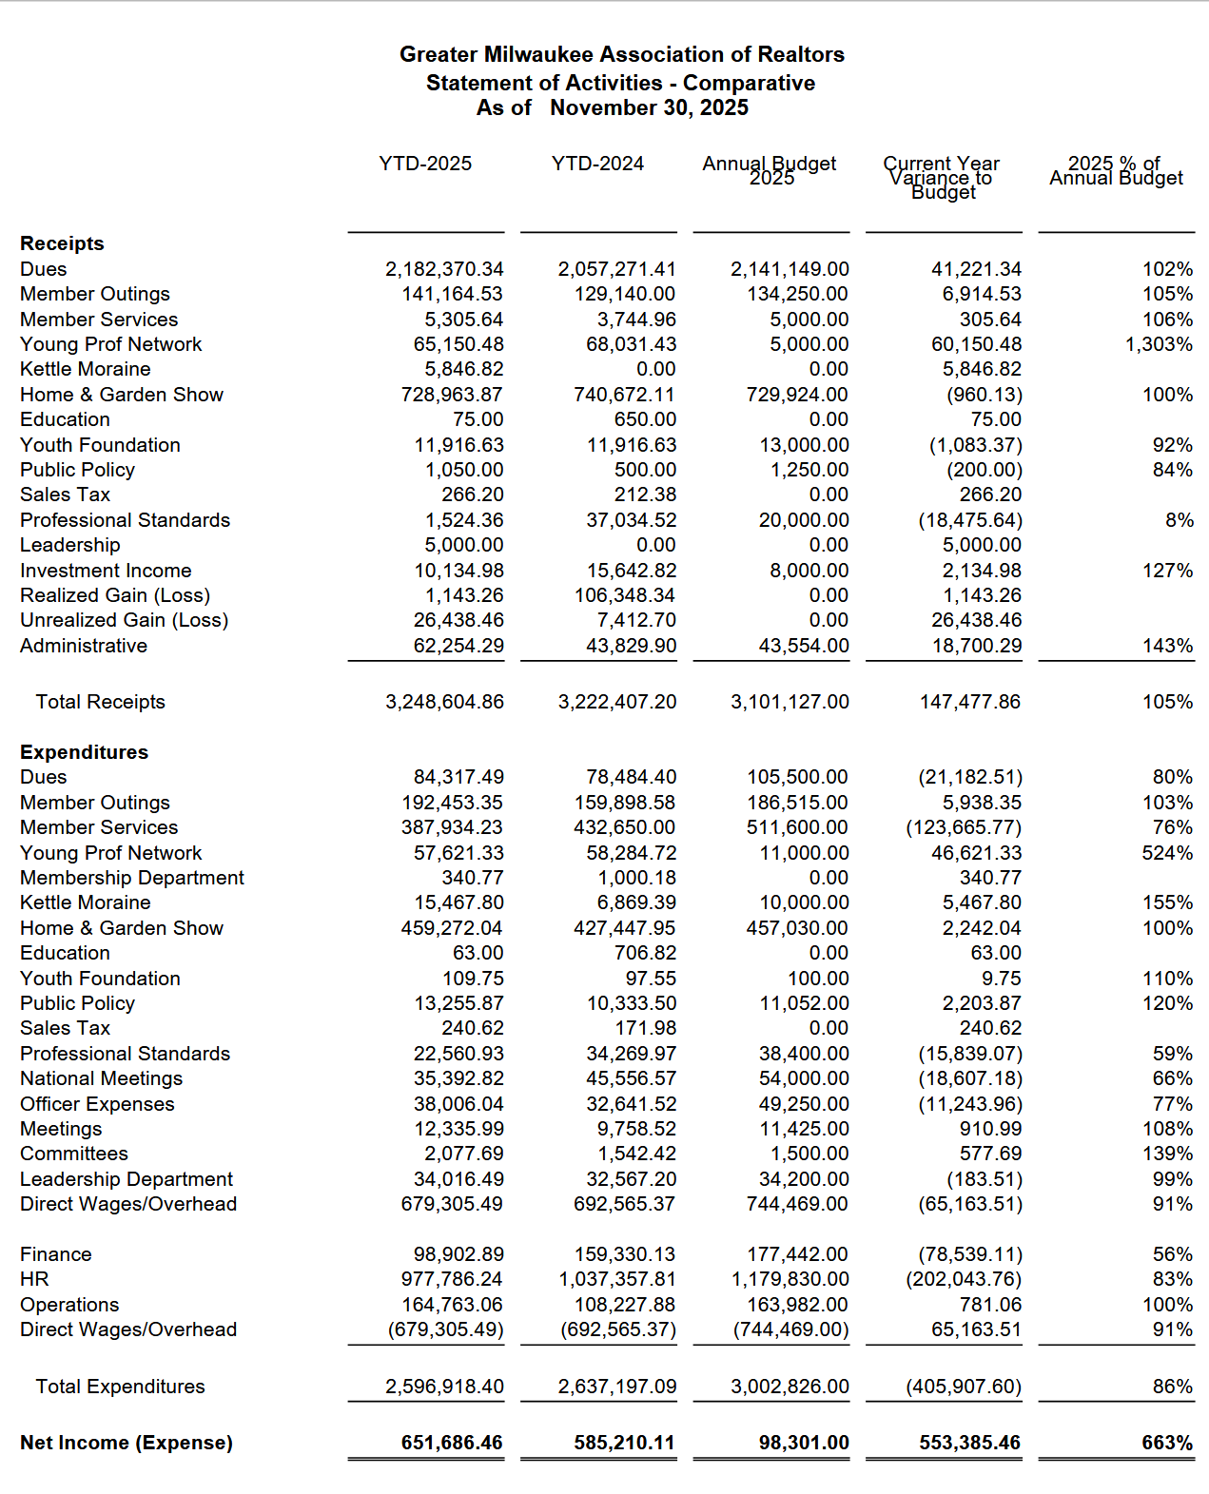
Statement of Activities

MEMORANDUM

To: GMAR Board of Directors

From: Mike Ruzicka, President

Re: President’s Report

Date: January 8, 2026

Bylaws Change
There is a provision in the GMAR Bylaws that is in need of clearing up. Currently, Article X Dues Assessments, Section 8. Executive Roundtable Election of Directors has a typo. The bylaws currently read, “…among the top ten (90) firms…” It should read, “…among the top ten (10) firms….”

Also, the criteria that the selection of the Roundtable representative occur in December of each year is not feasible. The GMAR calculates its membership in mid-January, after we have accounted for all the renewals, new members and those who have dropped their membership.

The staff generally drops non-dues paying members around the 10th of January and we calculate the top 10 brokers soon after. Ideally, we would perform these tasks before the first meeting of the year. However, using 2026 as an example, the calendar placed the directors meeting on the 14th and due to software complications with our membership system we are delaying dropping non-dues paying members to the 20th of January.

I would suggest we amend the bylaws as such:

Section 8. Executive Roundtable Election of Directors.

(a) The members of the Executive Roundtable shall be one (1) REALTOR® owner or corporate officer who holds primary membership in the Association and whose firm is among the top ten (90) (10) firms as determined in December January of each year based upon the total number of primary REALTOR® members in this Association under the firm’s broker license.

(1) Commencing in the year 2001 and no later than December 31st January 31st of each year, the Executive Roundtable shall elect one of its members to serve a three (3) year term as one of the five (5) new Directors elected to the Board of Directors for the following year.

2026 GMAR Board of Directors P 36
We have one open seat among the popularly elected positions, with the resignation of Sarah Venes. I would suggest that we move Abby Hauke from her current position as an Executive Roundtable representative, to fill Sarah Venes’ position.

That will result in two open Executive Roundtable (Top 10) Positions. As mentioned above, we are waiting until after January 20th to run a census of the members brokerages to find out which firms constitute the top 10.

Discover Milwaukee
Mary Beth Delforge, the person we purchased DiscoverMilwaukee.com from, recently sent a letter to each of the website and Relocation Handbook sponsors letting them know that GMAR purchased the site and will be running it.

Karen Brienzo on our staff has started soliciting those sponsors, mentioning that our goal is to position DiscoverMilwaukee.com to be an essential resource for people looking to relocate to Milwaukee with a robust social media plan, advertising strategy, and strong community engagement.

We have certainly faced some setbacks due to poor communication with the web design firm. I mentioned previously that the site is designed in the Druple language, which is outdated.

We’ve updated the site in the existing Druple language about as far as we can. There are some legacy problems, (like defunct email links for a copy of the Handbook) but our staff does not trust Keystone Click to execute any more updates in a timely manner and not disrupt the functioning of the site.

So, we are pushing to get some sponsors on the site and then we will, hopefully, move quicky to convert the site to WordPress – a more contemporary website language and more user-friendly. We already have an RFP in to do so.

Tether RE P 27
To be blunt, subscriptions to Tether RE are not going well. We signed a contract for 500 subscribers, beginning November 1st. So far, we have 20 subscribers.

Based on the survey we conducted last summer, we anticipated easily hitting the 500 mark in the first few months of offering Tether.

It only costs GMRA $2,500 per month ($30,000 annually), which won’t break the bank, but it is a missed opportunity for members and a drag on our finances.

We have promoted it through our normal channels, newsletter, direct email, social media, but we clearly need to do more. Attached is a list of the methods and platforms we have used to promote Tether so far.

Our next step is to contrast the app and the security benefits of it. We will alert members about past crimes against REALTORS® that have occurred in our area, and nationally. We will also create some quick, short videos for quick hits on social media.

We would love to hear your thoughts and ideas on how we can reach our goal.

SentriLock
Our new SentriLock contract began January 1st and will last for seven years providing us with 9,000 new boxes. We entered into a full lockbox replacement agreement, which will provide new boxes to any member who wishes to use them.

SentriLock will run the show as far as issuing new boxes. They will hand out boxes at a multi-day event from January 13th-15th at the Embassy Suites Hotel in Brookfield. There will be SentriLock and GMAR staff on hand. They will coordinate directly with members and have them sign up to pick up/drop-off boxes and take training on the new ones.

GMAR determined the number of boxes to provide each member based on a formula of the average number of listings a member has had over the last 3 years. That is the basis we used in 2018 to distribute boxes. If a member feels they need more, we will try to accommodate them, however we want to be very careful handing boxes out as generously as we did in 2018. No one will leave with fewer lockboxes than they have listings.

100th Home & Garden Show
For the 100th edition of the HGS we are unrolling some new features. Not the least of which is a new VIP Ticketing system. For much of the last 99 years we have used paper tickets, but we’re jumping into the 21st century this year.

There are many advantages to using Etix over printed tickets:
- Quick turnaround—submitting REALTORS® a spreadsheet with who redeemed their tickets within 7–10 days after show close, rather than the first week of May.
- Significant time savings by eliminating printing tickets, order fulfillment, mailing, and post-show data entry.
- Improved accuracy—attendees must enter their contact information to receive tickets, eliminating illegible handwriting or “Mickey Mouse” entries.
- Etix may appeal more to younger REALTORS®, especially since many used Eventbrite in the past.

For reference, the 2025 VIP Ticket summary is as follows:
- 2025 VIP Ticket Profit: $49,686.00
- Total revenue from ticket orders and redeemed tickets (including postage fee income and credit card surcharges) was $60,482.03
- We sold 84,700 tickets, and 7,687 were redeemed (a 9% redemption rate, consistent since 2023)
- Expenses (incl. ticket printing, postage, and post-show labor/data entry) totaled $10,796.03.

As for the four personalized lines of text that REALTORS® are accustomed to including, those would not appear on the Etix. However, we would provide a customizable flyer where they can add their own text or company logo (along with their coupon code for the free Etix), and distribute it to clients via email, mail, or even text.

We are somewhat hesitant that some members may prefer paper tickets or may be hesitant about switching to Etix. However, with most shows, events, and concerts now fully digital, we’re hopeful this won’t feel unfamiliar. Attendees can still print the digital tickets they receive from their REALTOR® if they prefer a paper version.

In order to match the 2025 VIP Ticket profit of $50,000, we would need to sell approximately 64,000 tickets at $25 per 100 tickets (2025 pricing for members was $28 per 100). Assuming the 9% redemption rate (5,760 redeemed tickets at $6 per redeemed ticket), the projected income would be $50,560. We believe these numbers are very achievable, but it will be important to clearly communicate how the process works so REALTORS® feel confident placing their orders.

NAR Insurance & Legal Action P 28
As you may know, the GMAR is covered by a massive insurance policy from NAR as long as we remain in good standing. One of the problems with the insurance policy is that there are limits to its coverage. And since its coverage extends to every eligible association in the country the millions of dollars the policy offers.

This has not been a significant concern for many years. However, since the recent proliferation of lawsuits against every level of the organization, it is back on the front burner.

My primary concern is coverage for directors, officers, and staff to protect any personal liability that a potential suit might bring. I do not believe volunteer directors should have to worry about being personally liable for actions of the collective association. There is some legal coverage in Wisconsin for volunteer boards, and I plan to explore additional coverage for directors.

Recurring Reports

2026 GMAR Strategic Plan P 31

2026 GMAR Organizational Chart P 35

2025 GMAR Board of Directors Roster P 36

2026 GMAR Calendar P 38

GMAR Promotion Summary: Tether RE Safety App
GMAR promotion efforts included:
- 8 independent, dedicated email blasts focused specifically on Tether RE
- Targeted email blast to brokers, specifically requesting broker participation and agent sign-ups
- 10+ weekly newsletter blurbs about Tether RE and how to sign up
- Chairwoman announcement - formally introduced by Abby Hauke during REALTOR® Safety Month (September)
- Official launch at the end of October via Zoom Meeting with Tether RE Founder and chairwoman Abby Hauke
- 10+ social media promotions across Facebook and Instagram. Etc. REALTOR® safety statistics, Partnership with Tether announcements, Member- Benefit Announcements emphasizing the discounted price
- Short-form video clips featuring Chairwoman Abby Hauke, intentionally created for high Instagram/Facebook performance
- Multiple “Park Bench” videos produced by Scott Bush, featuring John Gscheidmeier and a law-enforcement safety perspective. Abby was also featured in one.
- Holiday Gala visibility - Tether RE included on an on-screen slide during the event with QR code to sign up
- Dedicated page on the GMAR website created with full Tether RE details and enrollment information
- How-to and feature videos shared, demonstrating app usage and safety features
- Simplified access process created - an easy request form for individual payment links to reduce friction and eliminate the need to call the office
- Early, pre-launch outreach Survey - a Tether RE–specific email was sent to approximately 1,000 members who participated in GMAR’s summer survey and indicated interest in using Tether RE
Key Takeaway
GMAR promoted the Tether RE partnership early, often, and across every major communication channel, including targeted outreach to brokers, events, video, and website resources with intentional steps taken to remove barriers and increase accessibility.

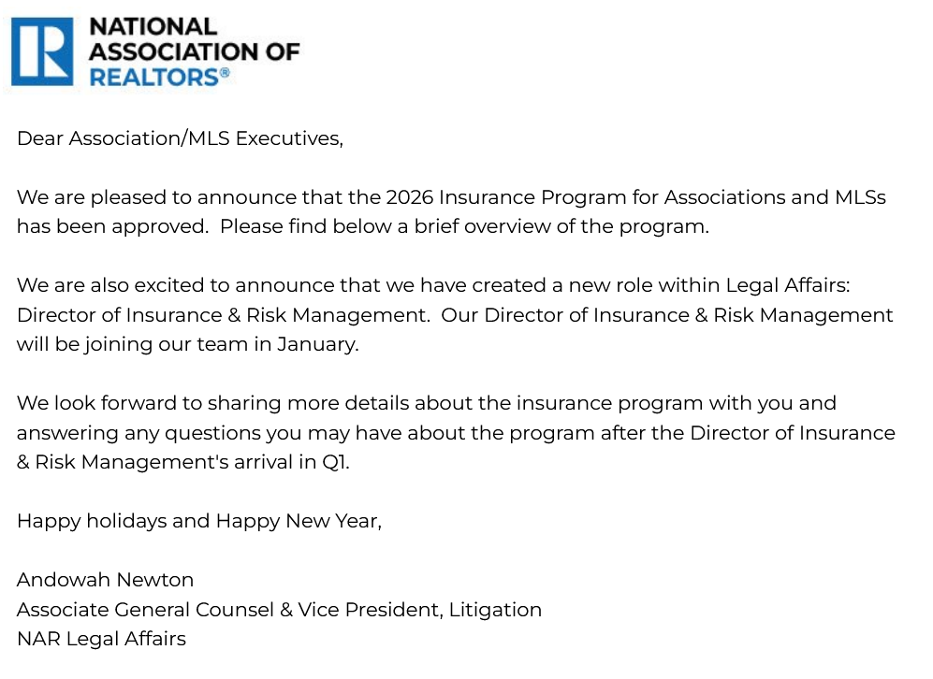

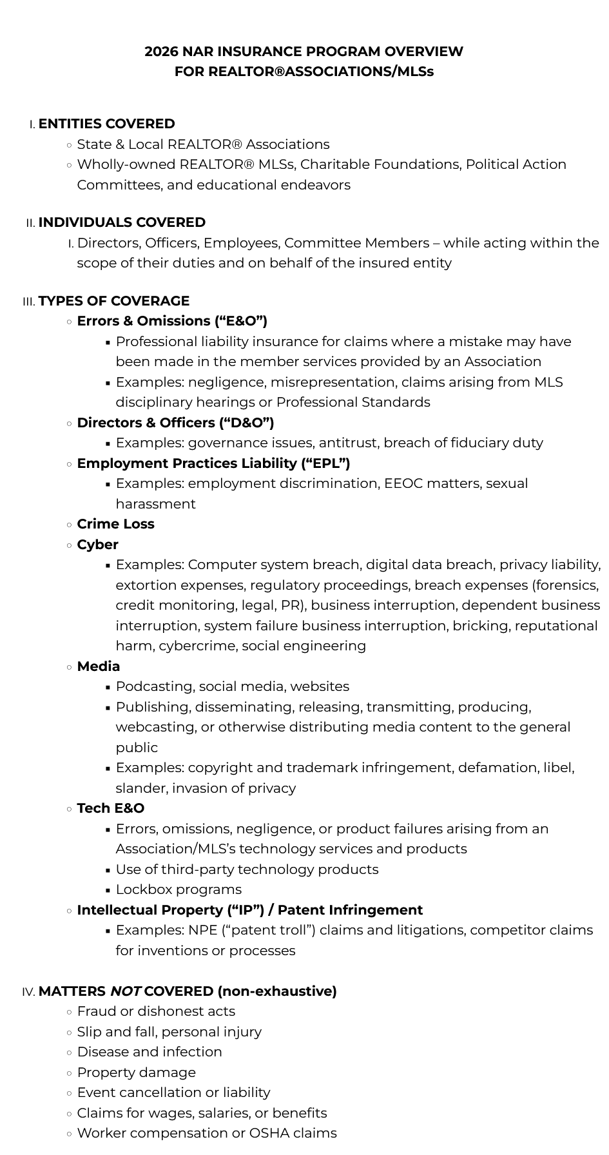
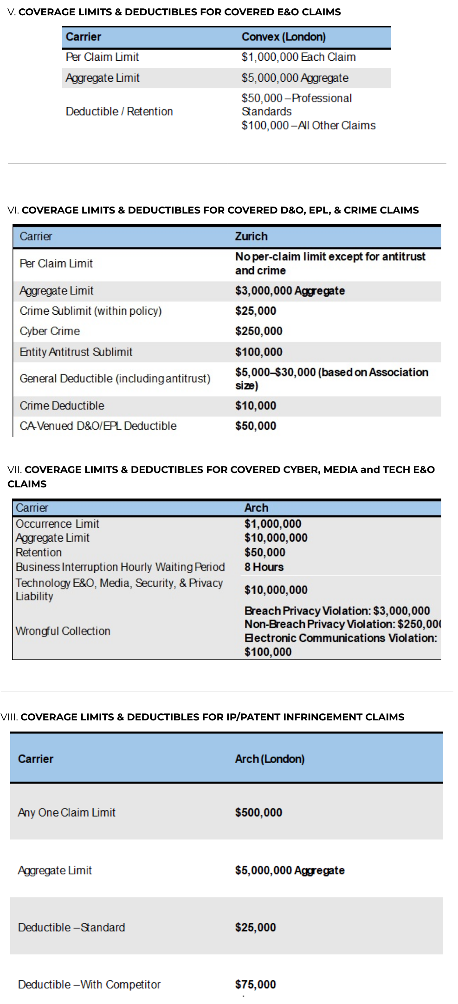

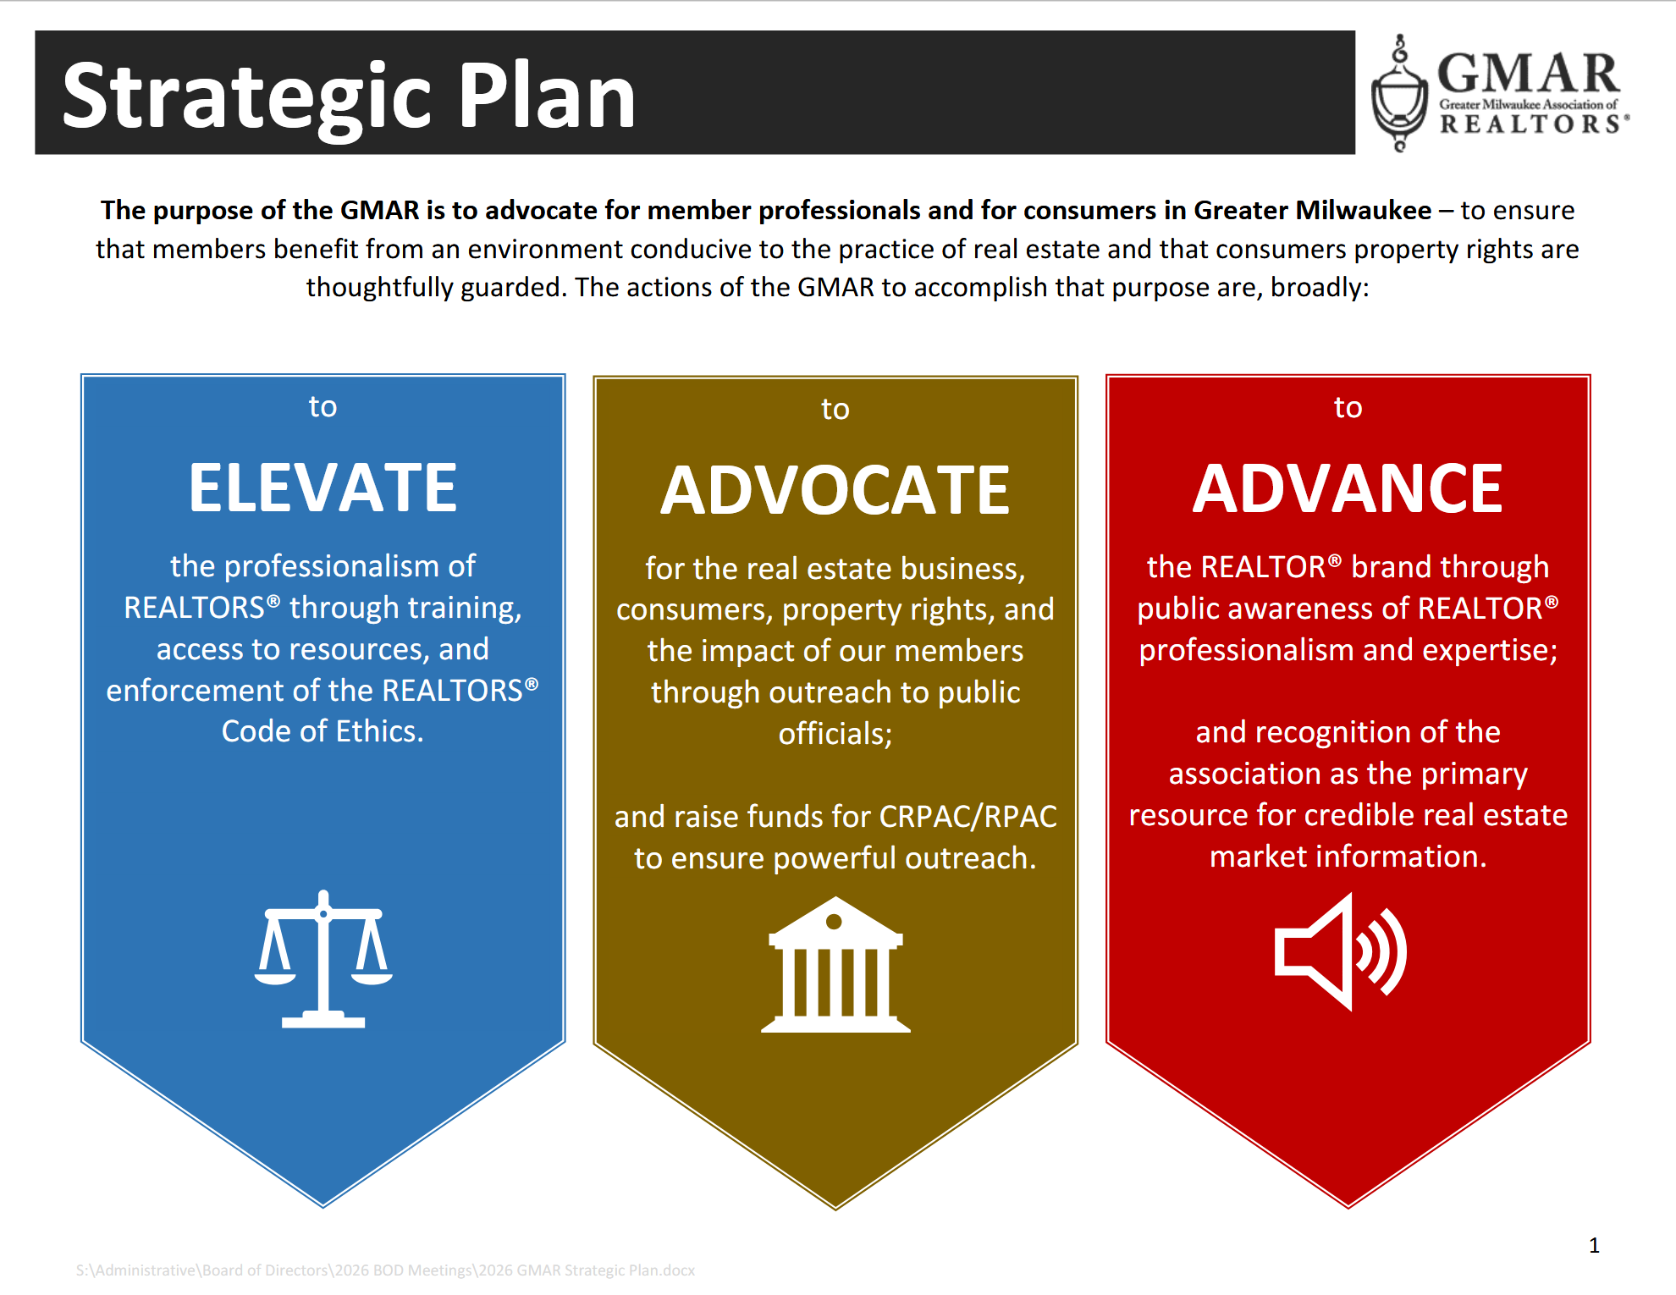

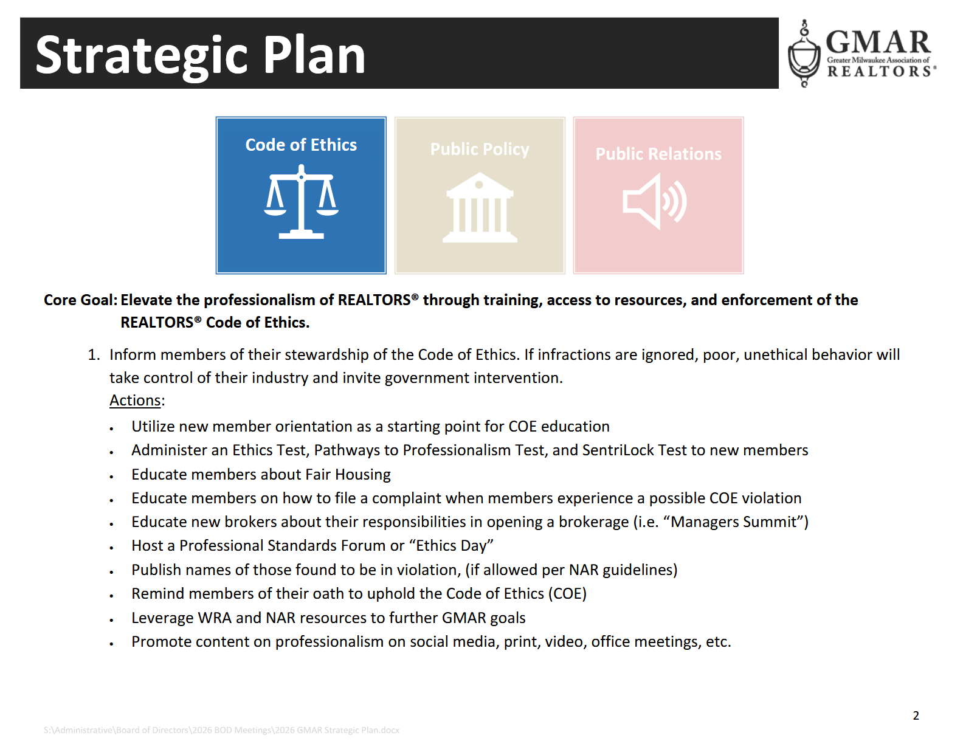

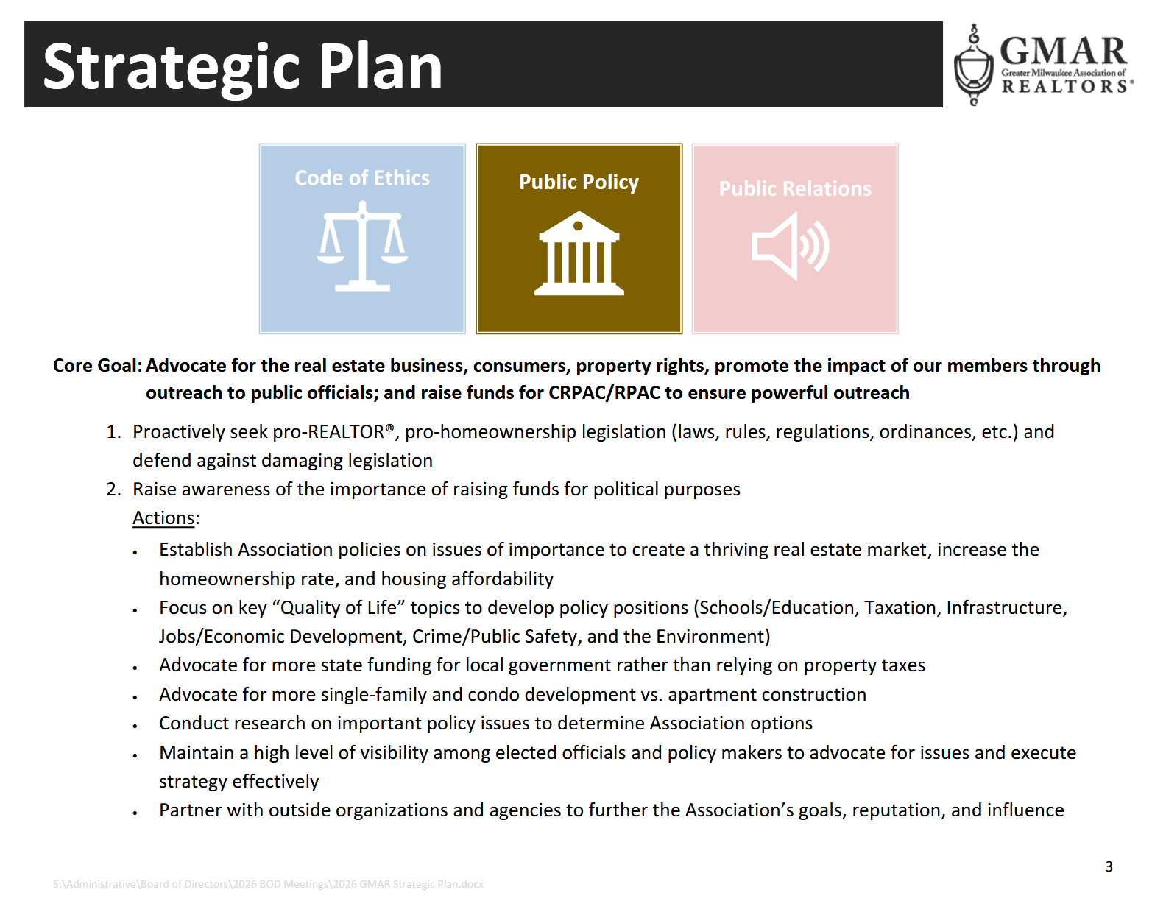
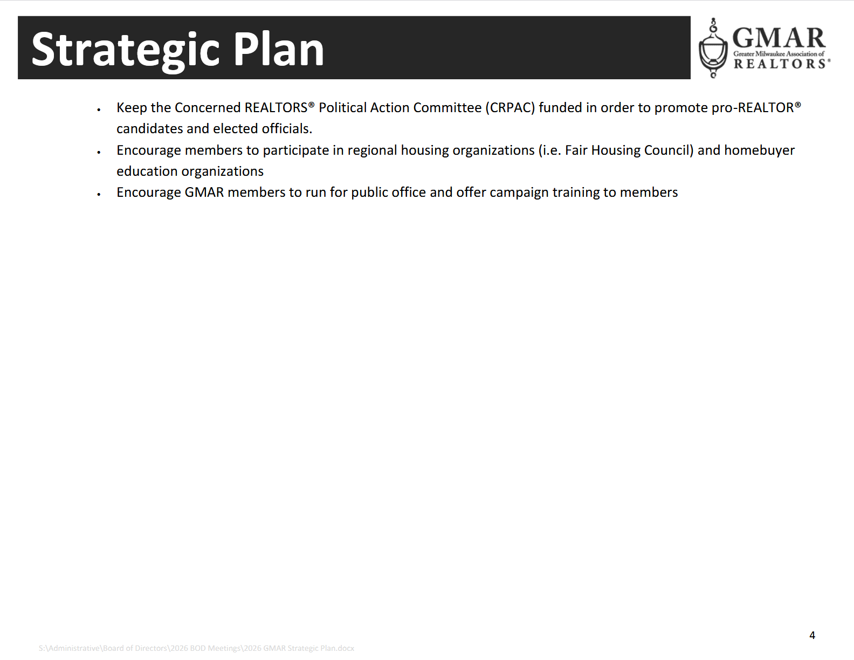

2026 GMAR Board of Directors

Terms expiring  12/31/2026 | Terms expiring  12/31/2027 | Terms expiring  12/31/2028
Scott Klaas  Keller Williams Realty  2665 S Moorland Rd, Suite 104  New Berlin, WI 53151  O 262.696.9884 M 262.347.9329  sklaas@kw.com  M1: 090121392  (3yr term from Exec Roundtable) | Abby Hauke, Past Chair  First Weber Inc. (2027)  2750 Golf Rd, Suite A  Delafield, WI 53018-2063  O 262.646.6800 M 262.468.6364  ahauke@firstweber.com  M1: 090148324  (3yr term from Exec Roundtable) | Vacant
Ryan Stefaniak, Secretary/Treasurer  The Stefaniak Group LLC (1st Term)  2234 S 108th Street  Milwaukee, WI 53227  M 414.881.5034  stefaniakryan@gmail.com  M1: 090144065 | Tom McCormick, Chairman  Exit Realty HGM  1417 N Wauwatosa Ave., Ste 201  Wauwatosa, WI 53213-2646  O 414.771.7144 M 414.241.2272  tmccormick@exithorizonswi.com  M1: 090070736 | Shawn Govern, Chair-Elect  Perfection Plus R E Services  3119 W Minnesota Ave  Franklin, WI 53132-8458  M: 414.617.7574  sgovern@wi.rr.com  M1: 090041059
Jose Flores (1st Term)  First Weber Inc.  10521 W Layton Ave  Greenfield, WI 53228  O 414.543.7800 M 414.704.4400  josefloreshomes@gmail.com  M1: 0885500352 | James Krickeberg (1st Term)  The Krickeberg Group, LLC  of Keller Williams Realty  2665 S Moorland Rd #104  New Berlin, WI 53151  M 262.442.4845  james.krickeberg@kw.com  M1: 090143038 | Casey Clickner (1st Term)  Shorewest Realtors  11622 W North Ave  Wauwatosa, WI 53226  M  cclickner@shorewest.com  M1: 090006765
Dan Weber (1st Term)  Shorewest Realtors  2419 W. Washington St.  West Bend, WI 53095  M 262.689.5827  dweber@shorewest.com  M1: 090058736 | Tonya Thomsen (1st Term)  Modern Realty Partners LLC  N16W23233 Stone Ridge Dr, Suite 200  Waukesha, WI 53188  O 262.424.3138  Tonya@ModernRPwi.com  M1: 090075411 | Beau Mitcham (1st Term)  Elements Realty LLC  1418 Clearwater Dr S  Oconomowoc, WI 53066  M 262.366.8699  beau@elementsrealtyllc.com  M1: 090064205
Vacant | Tom Telderer (1st Term)  RE/MAX Lakeside - The Benson Group  5341 S 27th Street  Greenfield, WI, 53221  M: 414.881.0058  tom@bensongrouprealtors.com  M1: 090026568 | Sheena Polachowski (1st Term)  Mahler Sotheby’s International Realty  250 E Wisconsin Ave., Suite 1610  Milwaukee, WI 53202  M 262.320.7828  sheena.polachowski@sothebysrealty.com  M1: 090140258
 | Theresa Dixon (1st Term)  Wisconsin Real Estate Group  250 S Executive Drive, Ste 225  Brookfield, WI 53005  M 414.332.1975  theresa@wrgpros.com  M1: 090171629 | Angela Kallay (1st Term)  Century 21 Benefit Realty  7044 S Ballpark Dr., Suite 303  Franklin, WI 53132  M 414.412.4088  akallay@benefit-realty.com  M1: 090095826

Mike Ruzicka – 885500353
Marne Stück – 090082562
Scott Bush – 885500171

2026 Calendar
Updated: Thursday, January 8, 2026
January
1 GMAR Fiscal Year begins
2 Schedule Member Focus Group
5 Send Out Member Survey (for BOD Mtg)
8 GMAR Executive Committee Meeting
10 Member Census/Top 10 Pick
13-15 SentriLock Training & Turn-In – Embassy Suites, Brookfield
14 MLS Stats Press Release
14 GMAR Financials / Update Dashboard
14 GMAR Board of Directors Meeting – 11:00 AM, Embassy Suites, Brookfield
For BOD Mtg:
- Membership Stats & Graphs
- Top 10 Representative
- Conflict of Interest/Harassment Policy
19 CBS Interview – 7:40 AM
22 GMAR Youth Foundation Board Meeting

February
3-5 Inman Connect New York
10 HousingWire Economic Summit – Dallas, TX
10 REALTOR® & Government Day – Madison, WI
12 MLS Stats Press Release
15 GMAR Financials / Update Dashboard
16 CBS Interview – 7:40 AM
17 Spring Primary Election Day
18 GMAR Public Policy Task Force Meeting
___ GMAR Past Chairs Luncheon – TBA

March
12 MLS BOD Meeting
12 MLS Stats Press Release
15 GMAR Financials / Update Dashboard
16 CBS Interview – 7:40 AM
20-29 100th REALTORS® Home & Garden Show – Wisconsin Expo Ctr, West Allis, WI

April
1 Directors Apply for NAR Committees
2 Schedule Member Focus Group
6 Send Out Member Survey (for BOD Mtg)
7 Spring General Election Day
9 GMAR Executive Committee Meeting
15 MLS Stats Press Release
15 GMAR Financials / Update Dashboard
16 GMAR Board of Directors Meeting – 12:00 Noon
20 CBS Interview – 7:40 AM
28 Brewers Bash – American Family Field, Milwaukee, WI
___ GMAR Youth Foundation Board Meeting
___ GMAR Audit – Wegner & Assoc.

May
7 Kettle Moraine REALTORS® Council RPAC FR
11 MLS Stats Press Release
15 GMAR Financials / Update Dashboard
18 CBS Interview – 7:40 AM
19 GMAR Public Policy Task Force Meeting
22 Deadline for NAR Committee Applications

June
11 MLS BOD Meeting
11 WomenStrong GMAR Women’s Conference
13-18 NAR REALTORS® Legislative Meetings – Washington, D.C.
15 BOD Snapshot
15 GMAR Mid-Year Budget Review
15 GMAR Financials / Update Dashboard
15 CBS Interview – 7:40 AM
30 Schedule Summer Strategic Planning Session
30 GMAR Executive Committee Meeting

July
1 GMAR BOD Candidate Applications available to members
2 Send Out Member Survey (for BOD Mtg)
7 GMAR Board of Directors Mtg – Ironwood Golf Course
For BOD Mtg:
- Budget Revision
- Dues Rate for Following Year
7 GMAR Summer Golf Outing – Ironwood Golf Course
14 MLS Stats Press Release
15 GMAR Financials / Update Dashboard
___ GMAR Youth Foundation Board Meeting
20 CBS Interview – 7:40 AM
31 Check in w/ Addendum A Committee
___ YPN A Night in White Party

August
11 Fall Primary Election Day
13 MLS Stats Press Release
___ New GMAR Chair Orientation
- NAR Organization Assessment Checklist
- Recruit Potential Board Directors
___ GMAR Nominating Committee Meeting
15 GMAR Financials / Update Dashboard
17 CBS Interview – 7:40 AM
19 GMAR Public Policy Task Force Meeting
24-25 NAR Leadership Summit – Chicago, IL (Chair-Elect)
31 Last day for GMAR BOD Candidates to submit Applications

September
1 Nominating Committee notification of BOD Candidates to membership
14 MLS Stats Press Release
15 GMAR Financials / Update Dashboard
21 CBS Interview – 7:40 AM
___ Veterans Committee Event
22-24 WRA Convention – Monona Terrace, Madison, WI
29-Oct 1 CMLS Annual Conference

30 GMAR Board of Directors Write-In Candidate Deadline

October
1 Schedule Member Focus Group
11-17 GMAR Board of Directors e-Election
13 MLS Stats Press Release
8 MLS BOD Meeting
8 GMAR Executive Committee Meeting
15 GMAR Financials / Update Dashboard
15 GMAR Board of Directors Meeting – 12:00 Noon
For BOD Mtg:
- Strategic Plan
- Bylaws Update
- Annual Budget
- MLS BOD Appointment(s)
- Executive Committee Election
19 CBS Interview – 7:40 AM
___ GMAR Youth Foundation Board Meeting

November
- Complete NAR Core Standards Application
3 Fall General Election Day
12 MLS Stats Press Release
4-8 NAR Convention – New Orleans, LA
15 GMAR Financials / Update Dashboard
16 CBS Interview – 7:40 AM
19 GMAR Public Policy Task Force Meeting

December
2 or 3 Chair’s Holiday Party & GMAR Annual Mtg – Italian Community Center (ICC)
10 MLS BOD Meeting
14 MLS Stats Press Release
___ New Director Orientation
___ GMAR Youth Foundation Annual Meeting
15 GMAR Financials / Update Dashboard
21 CBS Interview – 7:40 AM
31 GMAR Fiscal Year ends

