GMAR Board Of Directors
Thursday, January 16, 2024 • 12:00 PM
Metro MLS, Inc • Wauwatosa, WI

Meeting Agenda

Welcome & Introductions  New Directors  Alex Derenne, 2025 YPN Chair  Consent Agenda | P 7 | Approval | 12:00 PM
Reports  - Chairwoman, Abby Hauke  - Secretary/Treasurer  - Johnson Bank: Michael Cox & Anne Tidmore  - 2025 Budget  - November 2024 Financial Statements  - President’s Report  - Departments  - Professional Standards  - Government Affairs  - Membership  - Communications  - SentriLock  - Home & Garden Show  - Metro MLS, Inc. Update | P 17  P 22 | Information  Approval  Approval  Approval  Approval  Information  Information  Information  Information  Information | 10 Min  5 Min  5 Min  25 Min  20 Min  5 Min  5 Min  5 Min  5 Min  20 Min

Old Business
- None

New Business

None
Adjourn |  |  | 2:00 PM

Upcoming Meeting Dates

GMAR Directors Meeting • Wednesday, April 16th 12:00 PM

REALTOR® & Government Day • Thursday, April 17th
* Indicates hard-copy information will be available at the Directors meeting. Updated: 1/15/2025 5:59 PM
Directors’ Policies & Responsibilities

Fiduciary Duty
As a Greater Milwaukee Association of REALTORS® (GMAR) director, you are a fiduciary of the GMAR. This means you have a special legal responsibility in connection with the administration, investment, and care of GMAR and its assets. This requires you to make careful, good-faith decisions in the best interest of GMAR. Your decisions must be made independently and free of any undue influence from any person, organization, or brokerage.

Conflict of Interest Policy
A member of any Greater Milwaukee Association of REALTORS® (GMAR) decision-making body has a conflict of interest whenever that member is a principal, partner, or corporate officer of a business providing, or being considered as a provider of, products or services to GMAR.

Members with a conflict of interest must immediately disclose such conflict of interest prior to participating in any discussions or vote of a GMAR decision-making body that pertains to the GMAR. Such members may not participate in any discussions related to the GMAR other than to respond to questions asked of them by other members of the body. A member may not vote on any matter in which the member has a conflict of interest.

Antitrust Policy
The Greater Milwaukee Association of REALTORS® (GMAR) is a 501(c)(6) non-profit corporation with members belonging to varying brokerages and business models. Whenever competing (or potentially competing) businesses gather, there is the risk of antitrust liability or of the appearance of anti- competitive activity. Penalties for violating antitrust laws can include huge damage awards and even criminal liability. Just defending an antitrust suit or being the object of an investigation by antitrust regulators comes with remarkably high costs. Liability for violations of the antitrust laws could accrue to the GMAR and also to members accused of participating in alleged anticompetitive activity.

Consequently, responsibility for compliance with competition laws lies with the GMAR, its members, and their leaders. This policy is thus intended to prevent any anti-competitive conduct by the GMAR; but it also aims to reduce even the appearance of anti-competitive conduct.

The GMAR is committed to compliance with all international, national, and state/provincial antitrust and competition laws. This commitment includes the following objectives:

- GMAR’s activities will increase competition among its members by providing information to them regarding effective business practices. The GMAR’s actions must not function to reduce competition.
- GMAR provides a forum for members to discuss their industry and understand developments within it; but the GMAR will not be a forum for members to develop collective action plans that would reduce competition.
- GMAR will adhere to the procedures described below to minimize the risk of even the appearance of anticompetitive conduct.

Procedures for formal meetings
The following procedures apply to all meetings of the Greater Milwaukee Association of REALTORS® (GMAR) board of directors, committees authorized by the Association, and member meetings conducted under GMAR auspices, whether the meetings are held face to face or via technological means. Individuals charged with chairing Metro MLS meetings should be familiar with this policy.

- Each meeting should be preceded by the publication of notice of the meeting to those eligible to attend it and an agenda identifying a business subject for discussion at that meeting.
- Any person who receives an agenda for a GMAR meeting should review it to identify any agenda item that might give rise to concerns about competition or collective action; such items, if any, should be referred to legal counsel for review before the meeting.
- The meeting agenda should be adopted at the beginning of each meeting, and the meeting should follow the agenda.
- At the beginning of each meeting, the chair or counsel should remind participants of this antitrust policy in such a manner as to ensure that participants understand the parameters for appropriate discussions.
- Subject to this policy, every eligible participant in any meeting should be encouraged and permitted to express his/her views on any issue subject to deliberation before a decision is made.
- In the event that a discussion is, or is likely to become, inconsistent with this policy, the meeting chair or counsel shall recommend suspension of the discussion until review under applicable competition law can be conducted; the minutes will note any such suspension.
- After each meeting, GMAR should cause minutes of the meeting to be prepared. These minutes should include a record of the resolutions adopted at the meeting; any objections raised by meeting participants to the subject matter of a meeting, and any other annotations contemporaneously advised by counsel or the meeting chair.
- Minutes of all meetings will be prepared by GMAR staff and reviewed by the Secretary/Treasurer before circulation.
- All board members and GMAR members are asked to comment promptly, in writing, on any minutes circulated in the event that there appears to be any error, omission, or item in need of revision.

Guidelines for discussions
The following guidelines apply to discussions in formal meetings as well as to informal discussions in “breakout sessions” and roundtables and even in social contexts associated with Greater Milwaukee Association of REALTORS® (GMAR) meetings. Of course, no listing of DOs and DON’Ts can be complete, and some items can permissibly be discussed even if they appear in some categories below. However, board members and GMAR members should consult with counsel before engaging in discussion of any of the types described here:
- An agreement, or activity appearing to evidence an agreement, to fix prices, limit product or service offerings, or allocate geographical territory or customers.
- An agreement, or activity appearing to evidence an agreement, to refuse to deal with any third party or parties, whether a vendor or supplier of products or services, or a customer or class of customers.
- An agreement, or activity appearing to evidence an agreement, to limit innovation, product choices, or research relating to any of the foregoing.
- Sharing of recent, current, or planned fee structures; or data regarding operating “input” costs, especially if such costs could affect service prices. This does not prevent the GMAR from gathering and aggregating certain kinds of historical pricing information, subject to counsel’s review.
- Any suggestion that GMAR or its members should take collective action to force a vendor or service provider to change its business models, prices, or service offerings.

ANTI-HARASSMENT POLICY
The Greater Milwaukee Association of REALTORS® does not tolerate harassment in the workplace. The GMAR expressly prohibits any form of unlawful discrimination and harassment based on race, color, religion, sex, sexual orientation, gender identity, national origin, age, disability, genetic information, military or veteran status, pregnancy, childbirth or related medical conditions, or status in any group protected by federal, state, or local law. This policy applies to all terms and conditions of employment, including but not limited to, hiring, training, promotion, discipline, compensation, benefits, and termination of employment. Further, this policy extends to all GMAR personnel, including officers, managers, administrators, supervisors, staff members, and co-workers, as well as the Board of Directors and members of the Board of Directors, vendors, contractors, customers, students, and suppliers.

Harassment Defined
Harassment includes unwelcome verbal, visual, or physical conduct creating an intimidating, offensive, or hostile work environment. Examples of harassment include verbal (including slurs, jokes, insults, epithets, gestures, or teasing), graphic (including offensive posters, symbols, cartoons, drawings, computer displays, or e-mails), or physical conduct (including physically threatening another, blocking someone’s way) that denigrates or shows hostility or aversion toward an individual because of any protected characteristic. Such conduct constitutes harassment when: (1) it has the purpose or effect of creating an intimidating, hostile, or offensive working environment; (2) it has the purpose of effect of unreasonably interfering with an individual’s work performance; or (3) it otherwise adversely affects an individual’s employment.

Sexual harassment is a form of harassment, and includes the following prohibited behaviors:
- Unwelcome sexual advances, requests for sexual favors, and all other verbal or physical conduct of a sexual or otherwise offensive nature, especially where:
- Submission to such conduct is made either explicitly or implicitly a term or condition of employment;
- Submission to or rejection of such conduct is used as the basis for decisions affecting an individual’s employment; or
- Such conduct has the purpose or effect of unreasonably interfering with an individual’s work performance or creating an intimidating, hostile, or offensive working environment.
- Offensive comments, jokes, innuendos, and other sexually oriented statements;
- Touching, such as rubbing or massaging someone’s neck or shoulders, stroking someone’s hair, or brushing against another’s body;
- Sexual suggestive touching;
- Grabbing, groping, kissing, or fondling;
- Violating someone’s “personal space”;
- Whistling;
- Lewd, off-color, sexually oriented comments or jokes;
- Foul or obscene language;
- Leering, staring, or stalking;
- Suggestive or sexually explicit posters, calendars, photographs, graffiti, or cartoons;
- Unwanted or offensive letters or poems;
- Sitting or gesturing sexually;
- Offensive e-mail or voice-mail messages;
- Sexually oriented or explicit remarks, including written or oral references to sexual conduct;
- Gossip regarding one’s sex life, body, sexual activities, deficiencies, or prowess;
- Questions about one’s sex life or experiences;
- Repeated requests for dates;
- Sexual favors in return for employment rewards, or threats if sexual favors are not provided;
- Sexual assault or rape;
- Any other conduct or behavior deemed inappropriate by the WRA. This list is illustrative only, and not exhaustive.

Reporting Harassment
It is the responsibility of the GMAR and each employee, vendor, customer, member, contractor, student, supplier, and board member to create an atmosphere free of harassment. In addition, it is the responsibility of each employee to respect the rights of their coworkers. If you experience or observe any hostile conduct or harassing behavior, you are required to immediately report the matter (orally or in writing, which is preferred) to the President/Chief Executive Officer, ideally within ten (10) days of the offending conduct. If the conduct involves the President/Chief Executive Officer, you can report the conduct to the Chairperson of the Board of Directors or GMAR leadership.

Complaints should be as detailed as possible, including the names of all individuals involved and any witnesses.

Investigations
Upon receipt of a complaint, the President/Chief Executive Officer will undertake a prompt and thorough investigation of the allegations. Where necessary and/or appropriate, GMAR will consult with legal counsel for assistance in conducting any investigation, especially where an investigation involves GMAR leadership or members of the Board of Directors.

While confidentiality can never be guaranteed, it shall be the policy of the GMAR that confidentiality will be maintained concerning the allegations and the investigation to the extent possible, and particularly when it is determined by WRA that any of the following factors are present:
• Witnesses need protection;
• Evidence is in danger of being destroyed; and/or
• Testimony is in danger of being fabricated or altered.

Employees who fail to cooperate with an investigation conducted pursuant to this Policy, or who breach confidentiality resulting in a threat to the integrity of the investigation, may be disciplined, up to and including termination.

If the investigation establishes that an individual has engaged in harassing, discriminatory, or other wrongful or inappropriate conduct, disciplinary or other corrective action, up to and including termination, will be taken against the offending employees.

The GMAR is committed to enforcing this policy against all forms of harassment. The effectiveness of our efforts depends largely on us being informed of any inappropriate workplace conduct. If harassing conduct is not reported, GMAR may not become aware of a possible violation of this policy and may not be able to take appropriate corrective action.

Retaliation Prohibited
The GMAR expressly prohibits any retaliation or other adverse action against any employee who makes a good faith complaint of discrimination, harassment, or retaliation, or participates in any investigation of such complaint in good faith.

Violations of this Policy
Any individual, regardless of position or title, whom GMAR determines has subjected an individual to harassment or retaliation in violation of this policy, will be subjected to disciplinary or other corrective action , up to and including termination of employment.

Administration of this Policy
The President/Chief Executive Officer is responsible for the administration of this policy. If you have any questions regarding this policy or questions about harassment that are not addressed in this policy, please contact the President/Chief Executive Officer.

All GMAR leadership and members of the Board of Directors shall be educated on this policy on an annual basis at the first meeting of the board of directors each year. The education will cover several topics including, but not limited to, definitions and examples of harassment, including sexual harassment, prohibited behaviors and consequences of engaging in prohibited behaviors, reporting procedures, and responding to reports of harassment.

Conduct Not Prohibited by this Policy
This policy is not intended to preclude or dissuade employees from engaging in legally protected activities/activities protected by state or federal law, including the National Labor Relations Act, such as discussing wages, benefits, or terms and conditions of employment, forming, joining, or supporting labor unions, bargaining collectively through representatives of their choosing, raising complaints about working conditions for their and their fellow employees' mutual aid or protection, or legally required activities.

GMAR Board Of Directors

Consent Agenda

Please note: if any director would like to consider an item in the Consent Agenda, please state that you would like to discuss the item when the Chair asks for a motion to approve the Consent Agenda.

- It is moved, seconded, and carried to approve the agenda of the January 16, 2025 meeting of the GMAR Board of Directors p. 1

- It is moved, seconded, and carried to approve the minutes of the Board of Directors meeting from Thursday, October 17, 2024. p. 8

- It is moved, seconded, and carried to approve of the 98 new members who have applied to become members of the GMAR and paid the appropriate fees. p. 11

GREATER MILWAUKEE ASSOCIATION OF REALTORS®
BOARD OF DIRECTORS MEETING MINUTES
Thursday, October 17, 2024 • 12:00 PM
Alverno College • Milwaukee, WI

- Call to Order
Chairwoman Sarah Cole called the GMAR Directors meeting to order at 12:05 PM with a quorum present for the transaction of business.

Present: Sarah Cole, Chairwoman; Abby Hauke, Chair-Elect; Tom McCormick, Secretary/Treasurer; Judy Hearst, John Horning, Shawn Govern, Sarah Venes, Jose Flores, Scott Klaas, Ryan Stefaniak, Dan Weber, Suzanne Head, Mark Kivley

Present via Zoom: Angela Walters, Past Chair; Arthur Mays

Staff Present: Mike Ruzicka, President; Scott Bush, VP Operations; Marne Stück, GAD; Laura Crowley, Communications Director, Sharon Heilman, Dir of Lasting Impressions

Guest(s): Chris Carrillo, CEO of Metro MLS, Inc.

- Consent Agenda
- Approve the agenda of the October 17, 2024 meeting of the GMAR Board of Directors.
- Approve the minutes of the Board of Directors meeting from Monday, August 5, 2024.
- Approve of the nominations of Abby Hauke and Scott Heyerdahl to the Metro MLS Board of Directors.
- Approve of the 145 new members who have applied to become members of the GMAR and paid the appropriate fees.
- Approve of transferring the GMAR’s delegate votes to the Chairperson of the Wisconsin REALTORS® Association (per the GMAR bylaws) for the purpose of voting at the NAR NXT meeting in Boston, MA on Monday, November 11, 2024.

M/S/C unanimously, to approve the Consent Agenda.

- Reports
- Treasurer’s Report
- Mr. Ruzicka provided a summary of the GMAR’s September 30, 2024 financial report, in addition to the more detailed report included in the Directors Report emailed to all directors.

Statement of Financial Position (Balance Sheet)
As of September 30, 2024, GMAR had $2,021,745 in Cash & Investment Balances, down $208,139 compared to last year. Accounts receivable were down $106,150 compared to last year because next year's Home and Garden Show exhibitors have not yet been billed, whereas they were billed in September 2023. Prepaid expenses were down $19,791 compared to 2023. Fixed assets decreased by $38,041. Total Assets were $3,779,687 which is down $388,651 compared to 2023.

On the Liability side, accounts payable and short-term loans were down $18,836 compared to last year. Overall, Total Liabilities were $361,412 which is down $569,514 compared to 2023.
The primary reason for this change is that GMAR no longer has a mortgage. GMAR has a Net Gain of $939,837 through September 30, 2024, up $163,556 from last year. Overall, Total Net Assets were $3,418,275; $180,863 higher than the same point in 2023.

Statement of Activities
Membership: Through September 2024, $2,040,202 was collected in dues. Last year through the end of September we had collected $2,074,482 in dues, so dues are $34,280 behind last year at the same time. For 2024, GMAR had an 87% renewal based on number of members billed. New member budget for 2024: 500 REALTORS®, 50 DRs and 20 Affiliates. Through September, actual new members: 537 REALTORS®, 39 DRs and 9 Affiliates.

Promotions: Through September 30, Home and Garden Show income is $740,806 and expenses are $426,864 for a net gain of $313,942. Minor changes could still happen over the coming months, but these amounts should be close enough to “final” for almost any purpose. The budgeted net gain for the Show is $241,400.

Expenses related to Public Policy are mostly personnel costs, incurring expenditures primarily in Labor and Overhead. The majority of Professional Standards income and expenses are related to the Veteran’s Committee.

The Leadership section includes expenditures for meetings, committees, officer expenses, strategic planning, NAR surveys and NAR meetings. The main expenses recorded through September were travel for meetings, Bucks tickets, memberships and sponsorships.

The Administrative section includes investment and rental income and expenses for professional fees, salaries, fringe benefits, building, insurance, occupancy, property taxes, general office expenses and depreciation.

The bottom line shows net income of $939,837. Last year net income was $776,281 for the same time period.

M/S/C to approve the unaudited Statement of Financial Position (Balance Sheet) and Statement of Activities as of September 30, 2024 and recommend placing it on file for audit.

- President’s Report
Mike Ruzicka reported the following in addition to his written memorandum to the Board of Directors:

- REALTOR® Safety
Mike Ruzicka reported that John Gscheidmeier, Chair of the GMAR Safety Committee, has been reviewing two REALTOR® safety services for the GMAR to consider for our members. The first is FOREWARN, a service that can verify an incoming phone number against public records and reveal the callers identity. It also identifies criminal history for fraud and violent crimes, and several other crimes.

The other is a new product, Tether RE, which has more features. It verifies client identity, has a navigation feature, mileage and expense tracking, and detects when an agent arrives at a showing and monitors their safety (including calling emergency services).

Mr. Ruzicka said he has asked Mr. Gscheidmeier to give the board a thorough analysis of both services and determine whether the GMAR should offer it to members. The cost of each services is about $10 per member. He said the GMAR could subscribe for a limited number of members and see how it is received. The Association could also reroute $10 from the $20 dues increase. Then, assess whether to increase dues for it in 2026.

- Bylaws Changes
The directors have had to delve into the GMAR’s bylaws a few times this year when the GMAR exchanged properties with MLS legally and had the correct authorization to take out a remodeling loan. During that analysis GMAR attorneys noticed some irregularities in our bylaws that make it difficult for a casual reader to understand.

Mr. Ruzicka has asked that the attorneys review the association’s bylaws to make them easier to understand, and make sure they still comply with NAR’s mandated bylaws updates. We hope to have this analysis completed by the January directors meeting.

- Director of Professional Standards
Mr. Ruzicka reported that it looks like the GMAR is going to be able to keep Scott Bush from retiring after all – at least for a couple of years.

As was discussed at the July and special August Directors meetings, WRA has a state Professional Standards (PS) program that is offered to all local associations (there is no fee for local associations), paid for with state members’ dues, and administered by WRA staff.

After speaking with Tom Larson, CEO of WRA, Mr. Ruzicka reached an agreement that will keep Mr. Bush on the GMAR staff. The agreement makes Scott an independent contractor with WRA working approximately 15 hours a week. He will administer PS for the whole state along with an existing WRA employee and WRA will contribute to GMAR towards Mr. Bush’s salary. Mr. Bush will still be a GMAR employee.

Mr. Ruzicka and Mr. Bush believe this is a good compromise, and serve as a test period for the GMAR to determine if it wants to continue with WRA or, when Mr. Bush does retire, bring the service back in-house.

- GMAR Building Sale & Remodel
Mr. Ruzicka stated the GMAR was to sign the association’s construction and mortgage loan paperwork at US Bank prior to the directors meeting. However, US Bank cancelled the closing due to some technical glitches on their end. Mr. Ruzicka hopes to get the document signed in short order allowing the contractor, Dimension Design, Build, Remodel Inc. (an HGS exhibitor), to begin construction in the next 30-45 days

- SentriLock
Mr. Ruzicka stated that the GMAR signed a 7-year contract with SentriLock in 2018, and that agreement comes to an end in 2025. As the GMAR approaches that decision next summer Mr. Ruzicka outlined a few options for the directors to consider.

In examining the GMAR’s options, Mr. Ruzicka suggested the directors consider having members purchase boxes (possibly at a subsidized cost) to own. The current lockbox inventory that exists could be parceled out to members by averaging the three prior years of listing (similar to how the GMAR did it in 2018). Members would be allowed to own these boxes, and we would begin having them purchase new boxes from SentriLock.

Mr. Ruzicka stated he was mentioning this now so that the directors could think about the association’s options.

- Member Survey
Mr. Ruzicka reported that in September the GMAR hosted a focus group with eight members. Based on that conversation the staff created a member survey that went out October 3rd – 9th.

- Department Reports

- Professional Standards
Scott Bush reported the following:

  - An overview on the content of the GMAR’s new “vodcast,” “From the Park Bench.” Feedback has been favorable.

  - There was a recent arbitration award that was not paid. The complainant will present the costs of judicially enforcing the award to GMAR for consideration to assist in paying the legal fees. This process is recommended in the Code of Ethics and Arbitration Manual.

  - Mr. Bush facilitated a discussion and reported on the recent misunderstanding of procuring cause and how it relates to the settlement agreement. Procuring cause can still be the standard of performance by listing brokerages offering compensation to other brokers.

- Government Affairs
Marne Stück reported:

  - Meetings with BOD Elected Officials
GMAR met with three municipalities thus far in our quest to match each board member with their elected official: August – Brown Deer, September – Delafield, Fox Point, November – Shorewood. The purpose of the meetings is to introduce the GMAR to local leaders, offer any assistance the association can provide (i.e., housing statistics and other information) that may be helpful to a municipality.

- 18 days ‘til November 5/Election Day!
- The GMAR RPAC Trustees had a busy June/July interviewing 18 candidates running in 9 open Milwaukee area legislative seats. Mrs. Stück was busy raising RPAC and Direct Giver money for legislative candidates.

- Oak Creek Sign Ordinance
- The Oak Creek Common Council revamped their zoning code in July 2023 and made changes that had unintended consequences to REALTORS®, homeowners and taxpayers in Oak Creek. Effective Jan 1, 2024, Oak Creek required a permit application and fee of $55 for any temporary sign. The main frustration is that homeowners (buyers/sellers) are being penalized for something that isn’t a problem.
- The Call for Action GMAR did a few months ago yielded a dismal response from the Mayor and Alders.
- The Commercial Assoc of REALTOR Wisconsin (CARW) reached out and would like to partner with us to continue fighting this.

- YIMBY Initiative (Yes In My Back Yard)
- WRA is working on ways to increase YIMBY outreach and local advocacy participation through the Wisconsin Homeowners Alliance. They asked us to identify communities in the greater Milwaukee footprint that may be smart to start some outreach programming in. GMAR suggested Grafton and Menomonee Falls.

- Growing MKE
- The Milwaukee Department of City Development is rebranding this proposal after it was met with opposition (i.e., alleging gentrification) at the August city plan commission hearing.

- REALTOR & Government Day will be held on April 17, 2025

- Membership
- Communications
Laura Crowley reported on recent GMAR communications:

- GMAR Campaigns: From the Park Bench with Scott Bush: Latest series with guests like Cori Lamont (WRA) and David Kolesari (Homesight, Inc.). Previous campaigns: "Let’s Get Real" and "GMAR Podcast."
- Code of Ethics Series: Bi-weekly feature in our newsletter to highlight individual ethics articles.
- GMAR Blog: Latest post: October 16, 2024. Updated monthly.
- Housing Market Report: Latest report: October 14, 2024. Released monthly.
- Ongoing Projects:
• Videography: "Meet the GMAR Staff" video in progress
• Holiday Gala: Program under development
• Website: Enhancements ongoing via MarketIT

Social Media Campaigns
• A REALTOR® Can: Ran from July to October 2024.
• Consumer Guide of the Week: Ongoing weekly features.
• Upcoming focus: Ethics and professional standards.

- Home & Garden Show
Mr. Ruzicka reported that planning for the 2025 HGS is in full force. Sponsorships have reached $39,000 so far, and there will be 8 gardens in the show. The working theme right now is “Retro Americana.”

- Metro MLS, Inc.
Metro MLS CEO, Chris Carrillo, updated the directors on discussions related to changing the Clear Cooperation policy, problems with agents utilizing concessions vs. commission in determining compensation. He also stated the MLS is creating an option for member brokers to use ShowingTime. And, he said REALTOR.com is examining Aligned Showings as a showing option for their customers.

- Old Business
- None

- New Business
- GMAR Executive Committee
Mrs. Cole stated that Abby Hauke would assume the role of Chair in 2025, per the GMAR’s bylaws.

She then asked if any director was interested in being nominated to the Chair-Elect position for 2025 besides 2025 Secretary/Treasurer Tom McCormick. No one responded and Mr. McCormick will assume the role Chair-Elect in 2025.

Mrs. Cole then asked if anyone was interested in pursuing the Secretary/Treasurer position besides Arthur Mays and Shawn Govern. No one responded and, after both gentlemen spoke to their candidacy, a secret ballot vote was held. Mr. Govern prevailed.

- 2024 GMAR Election
Mr. Ruzicka stated that there was a tie for the fourth position on the GMAR Board of Directors for the term 2025 – 2027 between Angela Kallay and Theresa Dixon.

Mr. Govern moved to allow both members to occupy the fourth position on the board. The motion failed after no second was made.

Ms. Hauke moved to select one new director between the two. Mr. Weber seconded the motion. A secret ballot was held, and Theresa Dixon prevailed.

- Adjourn
Mrs. Cole thanked and congratulated three directors who are leaving the board: Suzanne Head, Angela Walters, and Judy Hearst

The meeting adjourned at 1:35 PM

Respectfully Submitted,

Mike Ruzicka
President/CEO

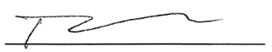

Tom McCormick
Secretary/Treasurer

New Member Report

98 New Members joined October 9, 2024 - January 9, 2025 for approval (DR's - 13, R's - 85)

FIRST | LAST | COMPANY
Zachary | Allen | Better Stewards Realty
Matthew | Amore | Real Broker LLC
Tyler | Bair | Coldwell Banker Realty~Ogden
Mark | Beierle | Patrick Bolger Realty Group
Amanda | Bett | M3 Realty
Thomas | Blackwell | First Weber Inc~MF
Christina | Borst | Keller Williams Realty Milw SW~New Berlin
Zoe | Brennan | NextHome My Way
Beau | Breske | Berkshire Hathaway HomeServices Metro Realty
Barbara | Bryan | Shorewest, REALTORS~Germantown
Crystal | Bucio | Keller Williams Realty~MNS Wauwatosa
Thomas | Casey | Berkshire Hathaway HomeServices Metro Realty
Briauhnna | Champagne-Hicks | Shorewest, REALTORS~W North
Phillip | Chojnacki | Whitten Realty
Allison | Darbo | Shorewest, REALTORS~Germantown
Deborah | DeMeyers | Shorewest, REALTORS~Germantown
Matthew | Denis | Keller Williams Realty~MKE
Alessandra | Dos Santos Freire Krieck | First Weber Inc~West Bend
Czad | Dziadosz | Real Broker LLC
Kamryn | Eberle | Harbor Homes Inc
Nicholas | Efferson | Keller Williams Realty~MKE
Wallace | Ellenson | Redefined Realty Advisors LLC
Ryan | Exley | Realty Executives Integrity~Hartland
Aaron | Feker | First Weber Inc~Greenfield
Frank | Franco | Realty Executives Southeast
Anita | Fuentes | Keller Williams Prestige Realty
Shea | Gajewski | NextHome My Way
Morgan | Gibbs | LPT Realty
Mikayla | Gill | Structure Properties LLC
Kevin | Gioia | Flyhomes Brokerage, LLC.
Uniqua | Glaude | Keller Williams Realty~MKE
Melissa | Guadalupe Arce | Keller Williams Realty~MNS Wauwatosa
Matthew | Guinane | Realty Executives Integrity~Brookfield
Madeleine | Haim | Keller Williams Realty Milw SW~New Berlin
Archer | Hansen | Shorewest, REALTORS~Germantown
Allison | Hejdak | Keller Williams Prestige Realty
Lizzie | Henderson | Keller Williams Realty Milw SW~New Berlin
Myeshah | Hollis | Keller Williams Realty Milw SW~New Berlin
Kathleen | Holtzen | First Weber Inc~Mequon
Samuel | Horner | Ludo Realty Group
James | Hunt | Shorewest, REALTORS~Moreland
Beth | Ivey | The Real Estate Co, Lake & Country Inc
Justin | Jenkins | Above and Beyond Real Estate Partners
Andrew | Jenson | NextHome My Way
Carmen | Jock | Jock Team Real Estate LLC
Uma | Kodali | Keller Williams Realty-MKE
Cole | Kuslits | EXP Realty, LLC~MKE
Gavin | Landish | Keller Williams Realty Milw SW~New Berlin
Sam | Leaf | Sam Leaf
Nizong | Lee | EXP Realty, LLC~Middleton Greenway
Olivia | Leonard | Premier Point Realty LLC
Emily | Lopez | Homestead Realty Inc
Mary Grace | Lotz | Shorewest, REALTORS~OC
Quincy | Markee | EXP Realty, LLC~MKE
Seth | McGathey | Shorewest, REALTORS~South Metro
Sarah | McSorley | Shorewest, REALTORS~Downtown
Gabe | Mews | Keller Williams Realty Milw SW~New Berlin
Zoran | Miladinovic | RE/MAX Service First
San Dih | Moo | Fathom Realty, LLC
E | Na | Homestead Realty Inc
Anna | Nakonechna | NextHome My Way
Malcolm | Nieves | Realty Executives Integrity~Brookfield
Abigail | Noll | Shorewest, REALTORS~West Bend
Nicholas | Paoli | LG Unlimited LLC
Kimberly | Peavy | Coldwell Banker Realty~Ogden
Scott | Penniston | Shorewest, REALTORS~N Oakland
George | Petculescu | Real Broker LLC
Frederika | Poe | ACTS Community Development Corp
Amy | Provost | Shorewest, REALTORS~Downtown
Todd | Raygor | Shorewest, REALTORS~South Metro
Lakshmi | Reddy Peddagorla | Shorewest, REALTORS~Moreland
Sergio | Retana | The Kramer Group LLC
Elizabeth | Richter | Coldwell Banker Realty~Ogden
Esperanza | Rivera-Uriegas | NextHome My Way
De'arquise | Robinson | CYL Realty Group
Lydia | Rodrigues | Keller Williams Realty-MKE
Katherine | Rummler | Keller Williams Realty-MKE
Robert | Sabey | Jason Scott Realty & Management LLC
Zaneta | Sanders | Z Realty Group Co
James | Scandrett | NetWorth Realty of Milwaukee LLC
Emma | Schlueter | Real Broker LLC
Steven | Schmitt | Homestead Realty Inc
Matthew | Schmitz | Real Broker LLC
John | Siepmann | Siepmann Realty Corp.
Joshua | Spano | Keller Williams Realty Milw SW~New Berlin
Dane | Stenson | Powers Realty Group~Shorewood
Laura | Swenson | Blauhaus Flat Fee
David | Szymanski | Milwaukee Executive Realty
Russell | Tillmann | Real Broker LLC
Mykena | Traub | Shorewest, REALTORS~West Bend
Alexander | Vail | Realty One Group Luminous
Tong | Vang | Homestead Realty Inc
Sarah | Venes | First Weber Inc~DLF
Marlene | Wagner | Lake Country Home Realty LLC
Ajit | Walia | Continental A1 Corp
Anne | Werner | Keller Williams Realty~Milw N Shore
Phua | Xiong | EXP Realty, LLC~MKE
Nicole | Zimmer | First Weber Inc~DLF

Membership categories: DR = Designated REALTOR®, R = REALTOR®, RN = REALTOR® No National; A = Affiliate,
AC = Affiliate Corporate, LAC = Local Affiliate Corporate, LACC = Local Affiliate Corporate Contact
*Includes former GMAR members who had to rejoin the GMAR as new members.

2025 GMAR Budget

Similar to the early 2024 budget, the 2025 GMAR budget is kind of scarry. GMAR’s two main sources of revenue are member dues, and the Home & Garden Show (HGS). Both were expected to be down in 2024, but much to our delight they outperformed initial expectations.

For 2025, we don’t know what impact the NAR settlement, license renewal, higher dues, retirements, etc. will impact member renewals. So, we’re looking for 2025 dues revenue to be a bit like 2024, trying to be as careful and conservative as possible.

Membership – A little history: In 2019 we raised dues from $207 to $380, in order to provide the SentriLock system to all members. In 2020 we lowered them to $350, and held steady for 2021. For 2022, we billed members $360. And for 2023 we increased dues $5 to $365 and stayed there for 2024. For 2025 we increased dues $40 to $405 (to create a dedicated legal action fund).

In September 2024 we billed 5,269 members for FY 2025. We lowered the renewal forecast to 4,584 (87%) for 2025. Regarding new members, we are estimating 500 new REALTOR® members for 2024, 50 Designated REALTORS® and 20 new Affiliate members.

The SentriLock system is a major expenditure in the Membership category, and we estimate spending $480,000 ($40,000/month) for the service.

Promotions – We can say that the Home & Garden Show (HGS) has recovered from the pandemic (the show was on a two year hiatus in 2020 and 2021). It had a pretty solid 2022, better 2023 and the show netted over $300,000 in 2024. We’re budgeting net income of $241,400 for 2025. That’s a solid, but conservative number.

Public Policy – The bulk of Public Policy expenses are personnel expenditures. Normal additional expenses include funds for a poll, $5,000 RPAC contribution, REALTOR® & Government Day, the NAR GAD Institute, and sponsorships (i.e., MMAC’s events in Washington DC and Madison).

Professional Standards – Similar to Public Policy, much of the expenditure in Professional Standards (PS) are personnel, but this year we are subscribing to WRA PS program. So essentially all of the expenses associated with PS are covered by WRA. We added $10,000 for Scott’s “Bark Bench” ethics videos and a net expense of $3,000 for the Veterans Committee.

Leadership – We did not add back the NAR Consumer surveys we had purchased in the past, nor the Milwaukee Bucks’ tickets for the 2025-2026 season or Summerfest tickets back in. [We may add these back in at a later date.] We have preserved travel to NAR and a few other real estate events.

Administration – We did add a $20,000 expense for a new website development and $20,000 for new computers for most of the staff. In the personnel category, we’re holding salary related expenses flat.

Currently the bottom line shows gross income of $3,038,045 with expenses of $2,999,633, for a net ending balance of $38,412 for FY 2025.
November 2024 Financial Statements

Statement of Financial Position
As of November 30, 2024, GMAR had $2,488,221 in Cash & Investment Balances, down $180,028 compared to last year.

Accounts receivable were up $148,948 compared to last year. Prepaid expenses were up $65,860 compared to 2023.

Fixed assets increased by $174,597. Total Assets were $4,837,534 which is up $193,042 compared to 2023.

On the Liability side, accounts payable and short-term loans were down $25,449 compared to last year. Unearned revenue was up $113,469 compared to last year. The biggest reason for this change is a $97,620 increase in REALTOR dues collection over last year. Overall, Total Liabilities were $1,773,886 which is up $60,073 compared to 2023.

GMAR has a Net Gain of $585,210 through November 30, 2024, up $120,662 from last year. Overall, Total Net Assets were $3,063,648; $132,969 higher than the same point in 2023.

Statement of Activities
Membership: Through November 2024, $2,057,271 was collected in dues. Last year through the end of November we had collected $2,096,617 in dues, so dues are $39,346 behind last year at the same time. For 2024, GMAR had an 87% renewal based on number of members billed. New member budget for 2024: 500 REALTORS®, 50 DRs and 20 Affiliates. Through November, actual new members: 596 REALTORS®, 40 DRs and 9 Affiliates.

Promotions: Through November, Home and Garden Show income is $740,672 and expenses are $427,448 for a net gain of $313,224. Small changes could still happen through the end of the year, but these amounts should be close enough to “final” for almost any purpose. The budgeted net gain for the Show is $241,400.

Expenses related to Public Policy are mostly personnel costs, incurring expenditures primarily in Labor and Overhead. The majority of Professional Standards income and expenses are related to the Veteran’s Committee.

The Leadership section includes expenditures for meetings, committees, officer expenses, strategic planning, NAR surveys and NAR meetings. The main expenses recorded through November were travel for meetings, Bucks tickets, memberships and sponsorships.

The Administrative section includes investment and rental income and expenses for professional fees, salaries, fringe benefits, building, insurance, occupancy, property taxes, general office expenses and depreciation.

The bottom line shows net income of $585,210. Last year net income was $464,548 for the same time period.
Statement of Financial Position (Balance Sheet)
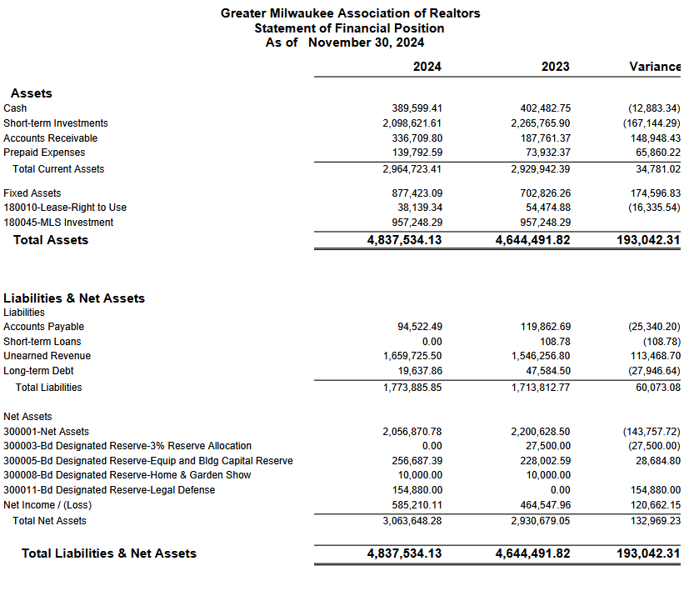

Statement of Activities

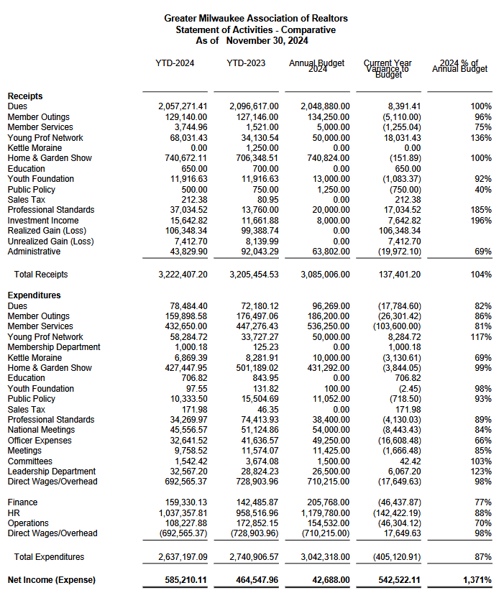
MEMORANDUM

To: GMAR Board of Directors

From: Mike Ruzicka, President

Re: President’s Report

Date: January 15, 2025

Discover Milwaukee Website
After over 30 years publishing the Milwaukee Relocation Handbook, Maribeth Delforge, has decided to retire. She approached the GMAR to see if we would be interested in purchasing the website associated with the handbook, Discover Milwaukee.

After examining the site, talking to a few relocation brokers, and determining how much work it would involve, the Executive Committee and staff believe the association should seriously consider purchasing the site.

Laura Crowley and I will lay out the pros and cons of purchasing the site. In the meantime, please check out https://www.discovermilwaukee.com/.

REALTOR® Safety
John Gscheidmeier, Chair of the GMAR Safety Committee, has been reviewing two REALTOR® safety services for the GMAR to consider for our members. The first is FOREWARN, a service that can verify an incoming phone number against public records and reveal the callers identity. It also identifies criminal history for fraud and violent crimes, and several other crimes.

The other is a new product, Tether RE, which appears to have more features. It verifies client identity, has a navigation feature, mileage and expense tracking, and detects when an agent arrives at a showing and monitors their safety (including calling emergency services).

Mr. Gscheidmeier will attend our directors meeting to give you a thorough analysis of both services and determine whether the GMAR should offer it to members. The cost of each services is about $10 per member. As I mentioned at our October meeting, I believe we could subscribe for a limited number of members and see how it is received. We could also reroute $10 from the $20 we increased dues this year to build up our legal defense fund.

Bylaws Changes
Last year, we had to delve into the GMAR’s bylaws to make sure we exchanged properties with MLS legally and had the correct authorization to take out a remodeling loan. During that analysis our attorney noticed some irregularities in our bylaws. For the most part it’s simply, “difficult for a casual reader to understand.”

Emily Selner, with Axley, reviewed our bylaws to make them easier to understand, and make sure they still comply with NAR’s mandated bylaws updates. Below are the preliminary changes Ms. Selner has proposed. I will have a thorough analysis for you at the directors meeting.

1. Article 3
a. I revised the territory jurisdiction language slightly to make the language clearer.

2. Article 4
a. I made a number of changes to this section. Most notably, I removed various types of membership. On the National standards webpage, they have the language for the membership section and that did not include a lot of the affiliate members that were listed in these bylaws. I removed the affiliates that were not included in the national language.

3. Article 5
a. I re-worked this section to make it easier to identify the qualifications for membership and include the new language regarding the Fair Housing Orientation that is required to be in your bylaws.

4. Article 6
a. In this section I removed the references to the categories of members that I previously removed.

5. Article 7
a. I revised this section to include all of the terms that outline how you continue to maintain qualifications for membership. This section now includes all of the terms related to the continuing education requirements. I think it made sense to add this to the section that lists out the responsibilities of members to enforce the Code of Ethics. The Fair Housing Training in this paragraph is the new language that is required by the National association.

6. Article 8
a. This section includes the added paragraph required by the National association.

7. Article 9
a. This section includes the language required by the National association. My one question with this section relates to the “Member Board.” That was the in the model language but I am not finding any reference to a Member Board in these Bylaws. Is this part of the National association?

8. Article 10
a. I removed language that should not be included in the Bylaws. There appears to be a number of places throughout these Bylaws that have a section entitled “NOTE:” with a note behind it. That language is not meant to be in the bylaws. It is just additional commentary for the association to note about the terms. I removed all references that were included with a “NOTE:”.

9. Article 11
a. This is the section that I need you to review closely to ensure that I have everything correct. I proceeded to make the most changes in this section because I believed some of the terms were not clear. I revised the sections regarding the qualifications for officers/board members, process for elections, and removal of officers. When we have a call, I would like to discuss this section at length to ensure the changes match the operations of the association.

10. Article 12
a. I revised this section to provide a 2 week notice period as opposed to the 1 week in the prior draft. I also dropped a note in the draft regarding the appropriate numbers to prove a quorum of the membership.

GMAR Building Remodel
The GMAR building remodeling project is moving along very well. Initially we expected it to be completed by the end of February, but that may be oved up a few weeks.

We’ve been thinking of how to decorate the space. We’re thinking about soliciting photos of listings from members. We can showcase some of the best photos of homes from around the region. WRA did this when they remodeled their space a few years ago.

SentriLock
This is one item we do not need to make a decision about right now, I just want to keep it front of mind for the whole board. Our current SentriLock contract comes to an end later this year. As summer approaches, we will have to decide if we are going to renew the contract, or what revisions we want to be made.

Here is the text I provided in last October’s Directors Report:

In 2018 the GMAR signed a 7-year contract with SentriLock that comes to an end in 2025. As we approach next summer, when we will have to decide if we are going to renew the contract, I would like to lay out a few options the association has relative to using electronic lockboxes.

First, we could let the contract expire and not renew with SentriLock, and let members go back to using combination boxes.

Second, we could look at other competing systems to see if there is a better product for our members.

Third, we could renew our contract with SentriLock with new lockboxes included (similar to the program we entered into in 2018).

Fourth, we could renew just the SentriLock service, which would be the software side of the lockboxes that makes them work with the SentriLock app.

In examining our options, our staff believes that if we choose option two, three, or four, rather than offer boxes to any member who feels they need one, we should allow them to purchase boxes (possibly at a subsidized cost). The reason being that over the course of our current contract, we have had a great deal of difficulty keeping track of the lockboxes in circulation in order to make sure we have enough for new and existing members who need them.

Additionally, the current lockbox inventory that exists could be parceled out to members by averaging the three prior years of listing (similar to how we did in 2018). Members would be allowed to own these boxes, and we would begin having them purchase new boxes from SentriLock.

I’m bringing this up now so that we can figure out what we don’t know or understand about our options. We have several months before we have to make a definite decision.

Strat Plan
Our current strategic plan is below. We often send out a member survey in advance of directors meetings in order to inform the board of the opinions and problems of our membership.

Due to the short period between the Holidays and our January directors meeting we did not have time to prepare a survey for this meeting.

I would like to review the questions we traditionally ask the members and see if we should adjust the scope of our survey to provide additional information to update the strategic plan at the April directors meeting.

I will provide a copy of the list of questions we have asked in the most recent survey at the board meeting, and we can evaluate them for the March/April survey.

Recurring Reports

GMAR Strategic Plan P 26

GMAR Snapshot(s) P 32

2025 GMAR Organizational Chart P 34

2025 GMAR Board of Directors Roster P 35

2025 GMAR Calendar P 36

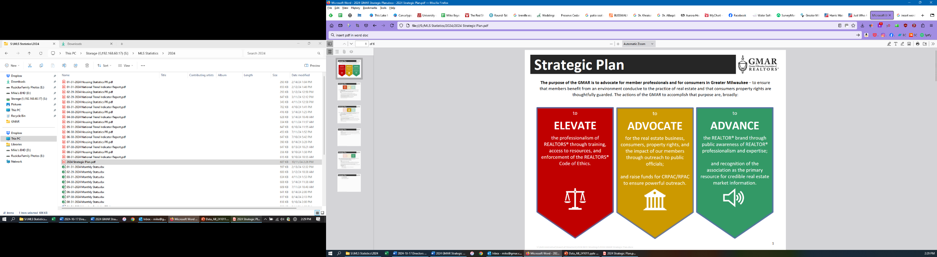

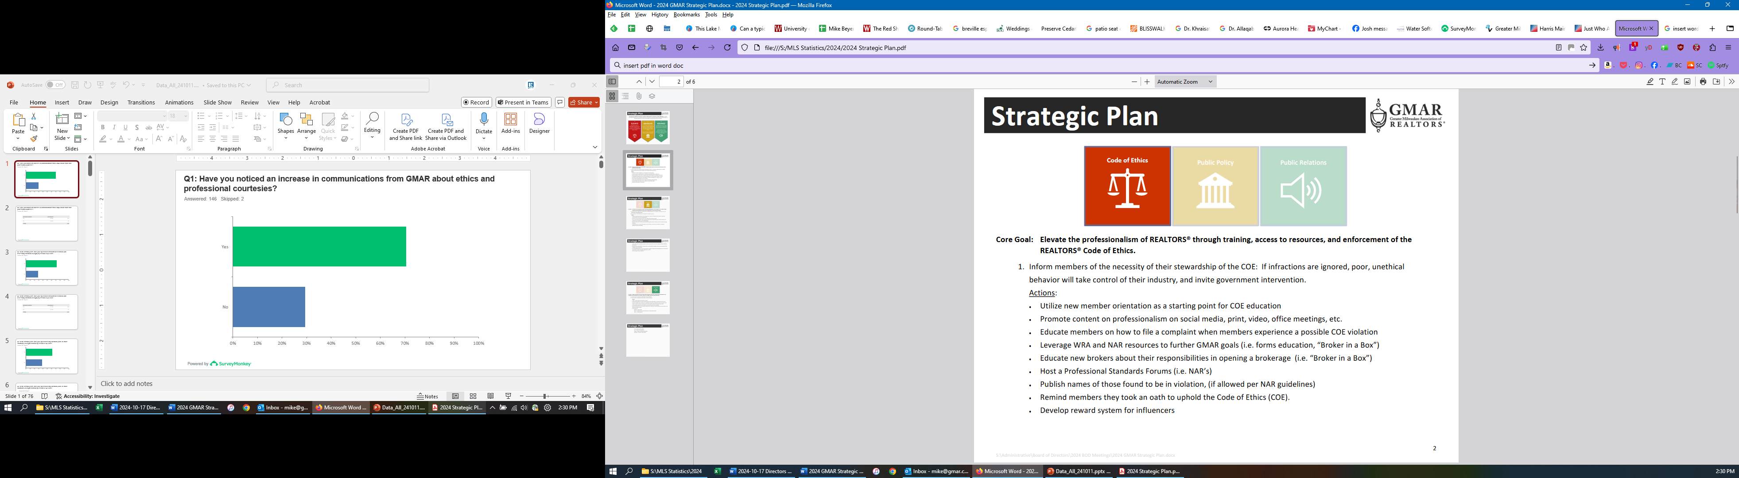

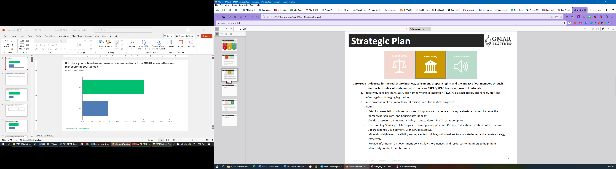

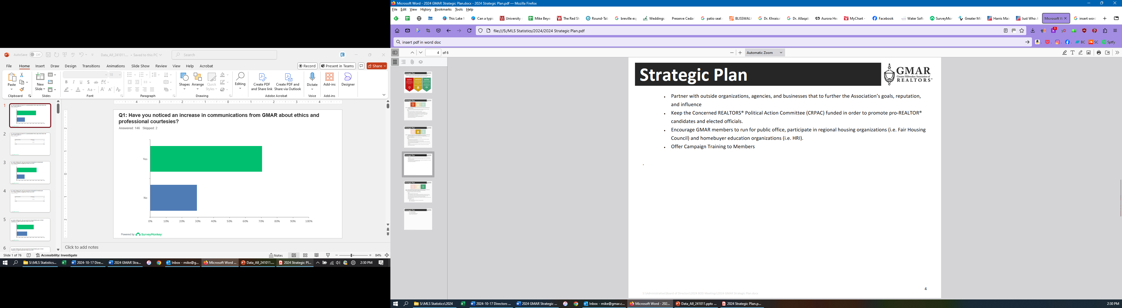

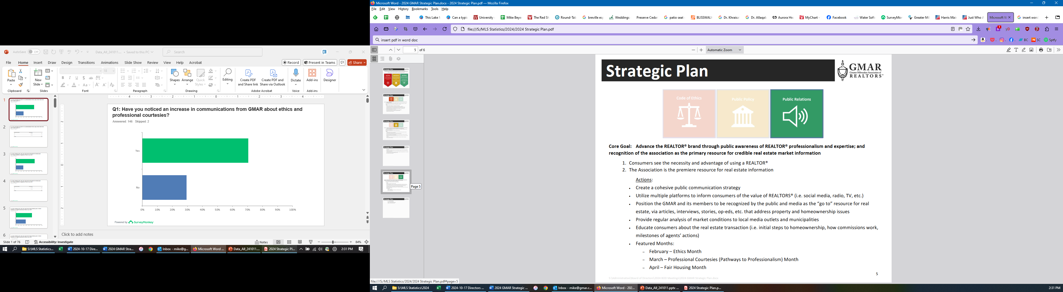

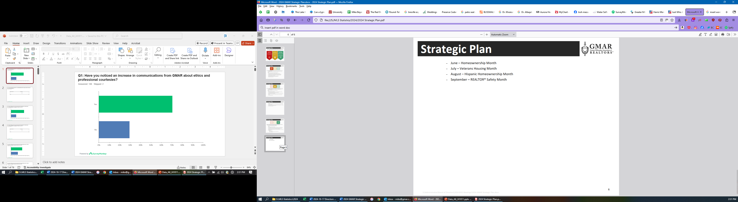
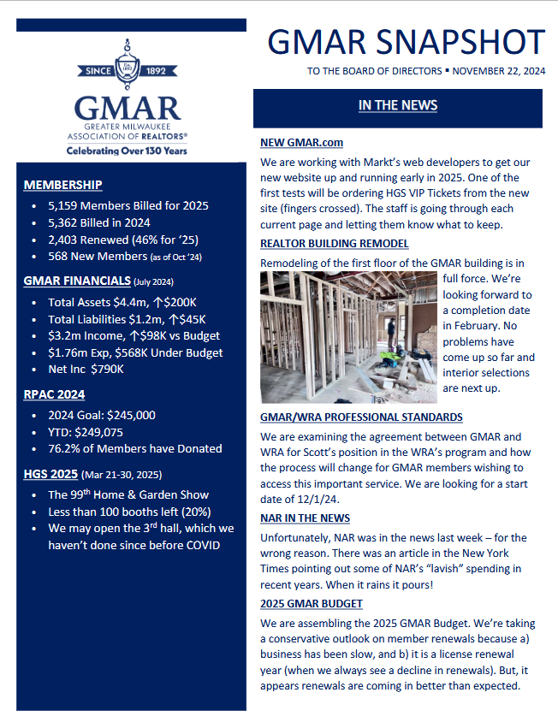
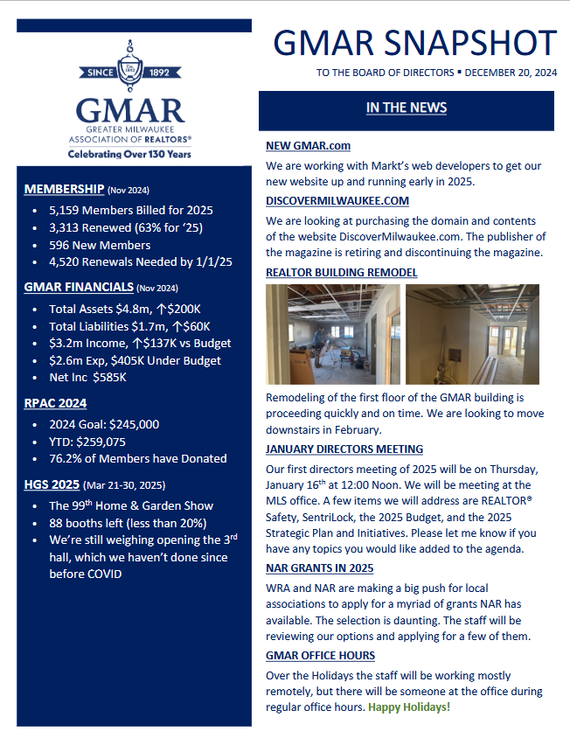

GMAR 2025 Organizational Chart

2025 GMAR Board of Directors

Terms expiring  12/31/2025 | Terms expiring  12/31/2026 | Terms expiring  12/31/2027
John Horning  Shorewest Realtors  17450 W North Avenue  Brookfield, WI 53045  O 262.827.4200 M 414.416.4505  jphorning@shorewest.com  M1: 090015743  (3yr term from Exec Roundtable) | Scott Klaas  Keller Williams Realty  2665 S Moorland Rd, Suite 104  New Berlin, WI 53151  O 262.696.9884 M 262.347.9329  sklaas@kw.com  M1: 090121392  (3yr term from Exec Roundtable) | M1:  (3yr term from Exec Roundtable)
Abby Hauke, Chairwoman  First Weber Inc.  2750 Golf Rd, Suite A  Delafield, WI 53018-2063  O 262.646.6800 M 262.468.6364  ahauke@firstweber.com  M1: 090148324  (3yr term from Exec Roundtable) | Tom McCormick, Chair-Elect  Exit Realty Horizons  1417 N Wauwatosa Ave., Ste 201  Wauwatosa, WI 53213-2646  O 414.771.7144 M 414.241.2272  tmccormick@exithorizonswi.com  M1: 090070736 | James Krickeberg (1st Term)  The Krickeberg Group, LLC  of Keller Williams Realty  2665 S Moorland Rd #104  New Berlin, WI 53151  M 262.442.4845  james.krickeberg@kw.com  M1: 090143038
Sarah Cole, Past Chair  Landmark Realty (2nd Term)  3800 S 97th St  Milwaukee, WI 53228  M 414.510.4903  colesarahb@gmail.com  M1: 090128495 | Jose Flores (1st Term)  First Weber Inc.  10521 W Layton Ave  Greenfield, WI 53228  O 414.543.7800 M 414.704.4400  josefloreshomes@gmail.com  M1: 0885500352 | Tonya Thomsen (1st Term)  Thomsen Team  N16W23233 Stone Ridge Dr, Suite 200  Waukesha, WI 53188  O 262.424.3138  Tonya@ModernRPwi.com  M1: 090075411
Shawn Govern, Secretary/Treasurer  Perfection Plus R E Services (1st Term)  3119 W Minnesota Ave  Franklin, WI 53132-8458  M: 414.617.7574  sgovern@wi.rr.com  M1: 090041059 | Sarah Venes (1st Term)  First Weber, Inc.  2750 Golf Rd, Suite A  Delafield, WI 53018-2063  O 262.646.6800 M 262.349.5083  venes@firstweber.com  M1: 090136786 | Tom Telderer (1st Term)  RE/MAX Lakeside - The Benson Group  5341 S 27th Street  Greenfield, WI, 53221  M: 414.881.0058  tom@bensongrouprealtors.com  M1: 090026568
Mark Kivley (2nd Term)  RE/MAX Lakeside  1200 E Capitol Dr Ste 200  Milwaukee, WI 53211  M 414.406.1840  kivleyteam@lakesiderealtors.com  M1: 090020696 | Dan Weber (1st Term)  Shorewest Realtors  2419 W. Washington St.  West Bend, WI 53095  M 262.689.5827  dweber@shorewest.com  M1: 090058736 | Theresa Dixon (1st Term)  Wisconsin Real Estate Group  250 S Executive Drive, Ste 225  Brookfield, WI 53005  theresa@wrgpros.com  M1: 090171629
Arthur Mays  Realty Among Friends LLC (1st Term)  8301 W Lisbon Ave  Milwaukee, WI 53222-3859  M: 414.975.7796  amays@realtyamongfriends.com  M1: 090051977 | Ryan Stefaniak (1st Term)  The Stefaniak Group LLC  2234 S 108th Street  Milwaukee, WI 53227  M 414.881.5034  stefaniakryan@gmail.com  M1: 090144065

Mike – 885500353
Marne – 090082562
Scott – 885500171

2025 Calendar

January
1 GMAR Fiscal Year begins
6 Schedule Member Focus Group
6 Send Out Member Survey (for BOD Mtg)
9 GMAR Executive Committee Meeting
10 Member Census/Top 10 Pick
14 MLS Stats Press Release
15 GMAR Financials / Update Dashboard
16 GMAR Board of Directors Meeting – 12:00 Noon
16 For BOD Mtg:
- Membership Stats & Graphs
- Top 10 Representative
- Conflict of Interest/Harassment Policy
16 Youth Foundation Paint & Wine Event
20 4th Quarter Home Affordability Report
22-24 Inman Connect New York
23 GMAR Youth Foundation Board Meeting

February
12 MLS Stats Press Release
17 GMAR Audit – Wegner & Assoc.
12 Public Policy Task Force Meeting
15 BOD Snapshot
15 GMAR Financials / Update Dashboard
__ GMAR Past Chairmen/women Luncheon
20-21 WRA Board of Directors Meeting – Madison Club, Madison, WI

March
13 MLS BOD Meeting
12 MLS Stats Press Release
15 BOD Snapshot
15 GMAR Financials / Update Dashboard
21-30 99th REALTORS® Home & Garden Show – Wisconsin Expo Ctr, West Allis, WI

April
3 Schedule Member Focus Group
7 Send Out Member Survey (for BOD Mtg)
10 GMAR Executive Committee Meeting
14 MLS Stats Press Release
14 Brewers Bash – American Family Field, Milwaukee, WI
15 GMAR Financials / Update Dashboard
16* (Wednesday) GMAR Board of Directors Meeting – 12:00 Noon
17 REALTOR® & Government Day – Madison, WI
21 1st Quarter Home Affordability Report
24 GMAR Youth Foundation Board Meeting

May
14 MLS Stats Press Release
15 BOD Snapshot
15 Public Policy Task Force Meeting
15 GMAR Financials / Update Dashboard
21 Kettle Moraine REALTORS® Council RPAC FR
23 Deadline for NAR Committee Applications
31 – June 5 NAR REALTORS® Legislative Meetings – Washington, D.C.

June
12 MLS BOD Meeting
13 WRA Board of Directors Meeting
15 BOD Snapshot
15 GMAR Mid-Year Budget Review
15 GMAR Financials / Update Dashboard
25 WomenStrong GMAR Women’s Conference – Brookfield Conference Center
30 Schedule Summer Strategic Planning Session

July
1 GMAR BOD Candidate Applications available to members
1 Send Out Member Survey (for BOD Mtg)
2 GMAR Executive Committee Meeting
8 GMAR Board of Directors Mtg – Ironwood Golf Course
8 For BOD Mtg:
- Budget Revision
- Dues Rate for Following Year
8 GMAR Summer Golf Outing – Ironwood Golf Course
15 MLS Stats Press Release
15 GMAR Financials / Update Dashboard
17 GMAR Youth Foundation Board Meeting
21 2nd Quarter Home Affordability Report
31 Check in w/ Addendum A Committee
__ YPN White Party

August
11-12 NAR Leadership Summit – Chicago, IL (Chair-Elect)
12 MLS Stats Press Release
__ New GMAR Chair Orientation
- NAR Organization Assessment Checklist
__ Recruit Potential Board Directors
__ GMAR Nominating Committee Meeting
13 Public Policy Task Force Meeting
15 BOD Snapshot
15 GMAR Financials / Update Dashboard
31 Last day for GMAR BOD Candidates to submit Applications

September
1 Nominating Committee notification of BOD Candidates to membership
12 MLS Stats Press Release
15 BOD Snapshot
15 GMAR Financials / Update Dashboard
__ Veterans Committee Event
__ Kettle Moraine REALTORS® Council Wine Tasting – Terrace 167, Richfield, WI
__ CMLS Annual Conference
TBA WRA Convention

30 GMAR Board of Directors Write-In Candidate Deadline

October
1 Schedule Member Focus Group (Ask Exec/BOD about topics)
12-18 GMAR Board of Directors e-Election
14 MLS Stats Press Release
9 MLS BOD Meeting
9 GMAR Executive Committee Meeting
15 GMAR Financials / Update Dashboard
16 GMAR Board of Directors Meeting – 12:00 Noon
16 For BOD Mtg:
- Strategic Plan
- Bylaws Update
- Annual Budget
- MLS BOD Appointment(s)
- Executive Committee Election
20 3rd Quarter Home Affordability Report
16-17 WRA BOD Meeting
23 GMAR Youth Foundation Board Meeting

November
1 Complete NAR Core Standards Application
12 MLS Stats Press Release
12-17 NAR Convention – Houston, TX
15 BOD Snapshot
15 GMAR Financials / Update Dashboard
20 Public Policy Task Force Meeting

December
__ Chair’s Holiday Party & GMAR Annual Mtg – TBA
12 MLS Stats Press Release
__ New Director Orientation
__ GMAR Youth Foundation Annual Meeting
15 BOD Snapshot
15 GMAR Financials / Update Dashboard
31 GMAR Fiscal Year ends

