GMAR Board Of Directors
Wednesday, April 16, 2025 • 12:00 PM
REALTOR® Building • Wauwatosa, WI

Meeting Agenda

Welcome & Introductions  Consent Agenda | P 7 | Approval | 12:00 PM
Reports  - Chairwoman, Abby Hauke  - Secretary/Treasurer  - 2025 Budget  - February 2024 Financial Statements  - President’s Report  - Departments  - Professional Standards  - Government Affairs  - Membership  - Communications  - SentriLock  - Home & Garden Show  - Metro MLS, Inc. Update | P 26  P 28  P 31 | Information  Information Approval  Approval  Approval  Information  Information  Information  Information  Information | 5 Min  25 Min  20 Min  5 Min  5 Min  5 Min  5 Min  20 Min

Old Business
- None

New Business

None
Adjourn |  |  | 2:00 PM

Upcoming Meeting Dates

GMAR Directors Meeting • Tuesday, July 8th 8:30 AM

GMAR Directors Meeting • Thursday, October 16th 12:00 PM
* Indicates hard-copy information will be available at the Directors meeting. Updated: 4/14/2025 3:18 PM
Directors’ Policies & Responsibilities

Fiduciary Duty
As a Greater Milwaukee Association of REALTORS® (GMAR) director, you are a fiduciary of the GMAR. This means you have a special legal responsibility in connection with the administration, investment, and care of GMAR and its assets. This requires you to make careful, good-faith decisions in the best interest of GMAR. Your decisions must be made independently and free of any undue influence from any person, organization, or brokerage.

Conflict of Interest Policy
A member of any Greater Milwaukee Association of REALTORS® (GMAR) decision-making body has a conflict of interest whenever that member is a principal, partner, or corporate officer of a business providing, or being considered as a provider of, products or services to GMAR.

Members with a conflict of interest must immediately disclose such conflict of interest prior to participating in any discussions or vote of a GMAR decision-making body that pertains to the GMAR. Such members may not participate in any discussions related to the GMAR other than to respond to questions asked of them by other members of the body. A member may not vote on any matter in which the member has a conflict of interest.

Antitrust Policy
The Greater Milwaukee Association of REALTORS® (GMAR) is a 501(c)(6) non-profit corporation with members belonging to varying brokerages and business models. Whenever competing (or potentially competing) businesses gather, there is the risk of antitrust liability or of the appearance of anti- competitive activity. Penalties for violating antitrust laws can include huge damage awards and even criminal liability. Just defending an antitrust suit or being the object of an investigation by antitrust regulators comes with remarkably high costs. Liability for violations of the antitrust laws could accrue to the GMAR and also to members accused of participating in alleged anticompetitive activity.

Consequently, responsibility for compliance with competition laws lies with the GMAR, its members, and their leaders. This policy is thus intended to prevent any anti-competitive conduct by the GMAR; but it also aims to reduce even the appearance of anti-competitive conduct.

The GMAR is committed to compliance with all international, national, and state/provincial antitrust and competition laws. This commitment includes the following objectives:

- GMAR’s activities will increase competition among its members by providing information to them regarding effective business practices. The GMAR’s actions must not function to reduce competition.
- GMAR provides a forum for members to discuss their industry and understand developments within it; but the GMAR will not be a forum for members to develop collective action plans that would reduce competition.
- GMAR will adhere to the procedures described below to minimize the risk of even the appearance of anticompetitive conduct.

Procedures for formal meetings
The following procedures apply to all meetings of the Greater Milwaukee Association of REALTORS® (GMAR) board of directors, committees authorized by the Association, and member meetings conducted under GMAR auspices, whether the meetings are held face to face or via technological means. Individuals charged with chairing Metro MLS meetings should be familiar with this policy.

- Each meeting should be preceded by the publication of notice of the meeting to those eligible to attend it and an agenda identifying a business subject for discussion at that meeting.
- Any person who receives an agenda for a GMAR meeting should review it to identify any agenda item that might give rise to concerns about competition or collective action; such items, if any, should be referred to legal counsel for review before the meeting.
- The meeting agenda should be adopted at the beginning of each meeting, and the meeting should follow the agenda.
- At the beginning of each meeting, the chair or counsel should remind participants of this antitrust policy in such a manner as to ensure that participants understand the parameters for appropriate discussions.
- Subject to this policy, every eligible participant in any meeting should be encouraged and permitted to express his/her views on any issue subject to deliberation before a decision is made.
- In the event that a discussion is, or is likely to become, inconsistent with this policy, the meeting chair or counsel shall recommend suspension of the discussion until review under applicable competition law can be conducted; the minutes will note any such suspension.
- After each meeting, GMAR should cause minutes of the meeting to be prepared. These minutes should include a record of the resolutions adopted at the meeting; any objections raised by meeting participants to the subject matter of a meeting, and any other annotations contemporaneously advised by counsel or the meeting chair.
- Minutes of all meetings will be prepared by GMAR staff and reviewed by the Secretary/Treasurer before circulation.
- All board members and GMAR members are asked to comment promptly, in writing, on any minutes circulated in the event that there appears to be any error, omission, or item in need of revision.

Guidelines for discussions
The following guidelines apply to discussions in formal meetings as well as to informal discussions in “breakout sessions” and roundtables and even in social contexts associated with Greater Milwaukee Association of REALTORS® (GMAR) meetings. Of course, no listing of DOs and DON’Ts can be complete, and some items can permissibly be discussed even if they appear in some categories below. However, board members and GMAR members should consult with counsel before engaging in discussion of any of the types described here:
- An agreement, or activity appearing to evidence an agreement, to fix prices, limit product or service offerings, or allocate geographical territory or customers.
- An agreement, or activity appearing to evidence an agreement, to refuse to deal with any third party or parties, whether a vendor or supplier of products or services, or a customer or class of customers.
- An agreement, or activity appearing to evidence an agreement, to limit innovation, product choices, or research relating to any of the foregoing.
- Sharing of recent, current, or planned fee structures; or data regarding operating “input” costs, especially if such costs could affect service prices. This does not prevent the GMAR from gathering and aggregating certain kinds of historical pricing information, subject to counsel’s review.
- Any suggestion that GMAR or its members should take collective action to force a vendor or service provider to change its business models, prices, or service offerings.

ANTI-HARASSMENT POLICY
The Greater Milwaukee Association of REALTORS® does not tolerate harassment in the workplace. The GMAR expressly prohibits any form of unlawful discrimination and harassment based on race, color, religion, sex, sexual orientation, gender identity, national origin, age, disability, genetic information, military or veteran status, pregnancy, childbirth or related medical conditions, or status in any group protected by federal, state, or local law. This policy applies to all terms and conditions of employment, including but not limited to, hiring, training, promotion, discipline, compensation, benefits, and termination of employment. Further, this policy extends to all GMAR personnel, including officers, managers, administrators, supervisors, staff members, and co-workers, as well as the Board of Directors and members of the Board of Directors, vendors, contractors, customers, students, and suppliers.

Harassment Defined
Harassment includes unwelcome verbal, visual, or physical conduct creating an intimidating, offensive, or hostile work environment. Examples of harassment include verbal (including slurs, jokes, insults, epithets, gestures, or teasing), graphic (including offensive posters, symbols, cartoons, drawings, computer displays, or e-mails), or physical conduct (including physically threatening another, blocking someone’s way) that denigrates or shows hostility or aversion toward an individual because of any protected characteristic. Such conduct constitutes harassment when: (1) it has the purpose or effect of creating an intimidating, hostile, or offensive working environment; (2) it has the purpose of effect of unreasonably interfering with an individual’s work performance; or (3) it otherwise adversely affects an individual’s employment.

Sexual harassment is a form of harassment, and includes the following prohibited behaviors:
- Unwelcome sexual advances, requests for sexual favors, and all other verbal or physical conduct of a sexual or otherwise offensive nature, especially where:
- Submission to such conduct is made either explicitly or implicitly a term or condition of employment;
- Submission to or rejection of such conduct is used as the basis for decisions affecting an individual’s employment; or
- Such conduct has the purpose or effect of unreasonably interfering with an individual’s work performance or creating an intimidating, hostile, or offensive working environment.
- Offensive comments, jokes, innuendos, and other sexually oriented statements;
- Touching, such as rubbing or massaging someone’s neck or shoulders, stroking someone’s hair, or brushing against another’s body;
- Sexual suggestive touching;
- Grabbing, groping, kissing, or fondling;
- Violating someone’s “personal space”;
- Whistling;
- Lewd, off-color, sexually oriented comments or jokes;
- Foul or obscene language;
- Leering, staring, or stalking;
- Suggestive or sexually explicit posters, calendars, photographs, graffiti, or cartoons;
- Unwanted or offensive letters or poems;
- Sitting or gesturing sexually;
- Offensive e-mail or voice-mail messages;
- Sexually oriented or explicit remarks, including written or oral references to sexual conduct;
- Gossip regarding one’s sex life, body, sexual activities, deficiencies, or prowess;
- Questions about one’s sex life or experiences;
- Repeated requests for dates;
- Sexual favors in return for employment rewards, or threats if sexual favors are not provided;
- Sexual assault or rape;
- Any other conduct or behavior deemed inappropriate by the WRA. This list is illustrative only, and not exhaustive.

Reporting Harassment
It is the responsibility of the GMAR and each employee, vendor, customer, member, contractor, student, supplier, and board member to create an atmosphere free of harassment. In addition, it is the responsibility of each employee to respect the rights of their coworkers. If you experience or observe any hostile conduct or harassing behavior, you are required to immediately report the matter (orally or in writing, which is preferred) to the President/Chief Executive Officer, ideally within ten (10) days of the offending conduct. If the conduct involves the President/Chief Executive Officer, you can report the conduct to the Chairperson of the Board of Directors or GMAR leadership.

Complaints should be as detailed as possible, including the names of all individuals involved and any witnesses.

Investigations
Upon receipt of a complaint, the President/Chief Executive Officer will undertake a prompt and thorough investigation of the allegations. Where necessary and/or appropriate, GMAR will consult with legal counsel for assistance in conducting any investigation, especially where an investigation involves GMAR leadership or members of the Board of Directors.

While confidentiality can never be guaranteed, it shall be the policy of the GMAR that confidentiality will be maintained concerning the allegations and the investigation to the extent possible, and particularly when it is determined by WRA that any of the following factors are present:
• Witnesses need protection;
• Evidence is in danger of being destroyed; and/or
• Testimony is in danger of being fabricated or altered.

Employees who fail to cooperate with an investigation conducted pursuant to this Policy, or who breach confidentiality resulting in a threat to the integrity of the investigation, may be disciplined, up to and including termination.

If the investigation establishes that an individual has engaged in harassing, discriminatory, or other wrongful or inappropriate conduct, disciplinary or other corrective action, up to and including termination, will be taken against the offending employees.

The GMAR is committed to enforcing this policy against all forms of harassment. The effectiveness of our efforts depends largely on us being informed of any inappropriate workplace conduct. If harassing conduct is not reported, GMAR may not become aware of a possible violation of this policy and may not be able to take appropriate corrective action.

Retaliation Prohibited
The GMAR expressly prohibits any retaliation or other adverse action against any employee who makes a good faith complaint of discrimination, harassment, or retaliation, or participates in any investigation of such complaint in good faith.

Violations of this Policy
Any individual, regardless of position or title, whom GMAR determines has subjected an individual to harassment or retaliation in violation of this policy, will be subjected to disciplinary or other corrective action , up to and including termination of employment.

Administration of this Policy
The President/Chief Executive Officer is responsible for the administration of this policy. If you have any questions regarding this policy or questions about harassment that are not addressed in this policy, please contact the President/Chief Executive Officer.

All GMAR leadership and members of the Board of Directors shall be educated on this policy on an annual basis at the first meeting of the board of directors each year. The education will cover several topics including, but not limited to, definitions and examples of harassment, including sexual harassment, prohibited behaviors and consequences of engaging in prohibited behaviors, reporting procedures, and responding to reports of harassment.

Conduct Not Prohibited by this Policy
This policy is not intended to preclude or dissuade employees from engaging in legally protected activities/activities protected by state or federal law, including the National Labor Relations Act, such as discussing wages, benefits, or terms and conditions of employment, forming, joining, or supporting labor unions, bargaining collectively through representatives of their choosing, raising complaints about working conditions for their and their fellow employees' mutual aid or protection, or legally required activities.

GMAR Board Of Directors

Consent Agenda

Please note: if any director would like to consider an item in the Consent Agenda, please state that you would like to discuss the item when the Chair asks for a motion to approve the Consent Agenda.

- It is moved, seconded, and carried to approve the agenda of the Wednesday, April 16, 2025 meeting of the GMAR Board of Directors. p. 1

- It is moved, seconded, and carried to approve the minutes of the Board of Directors meeting from Thursday, January 16, 2025. p. 8

- It is moved, seconded, and carried to approve of the 487new members who have applied to become members of the GMAR and paid the appropriate fees. p. 14

GREATER MILWAUKEE ASSOCIATION OF REALTORS®
BOARD OF DIRECTORS MEETING MINUTES
Thursday, January 16, 2025 • 12:00 PM
Metro MLS, Inc. • Wauwatosa, WI

- Call to Order
Chairwoman Abby Hauke called the GMAR Directors meeting to order at 12:05 PM with a quorum present for the transaction of business.

Present: Abby Hauke, Chairwoman; Tom McCormick, Chair-Elect; Shawn Govern, Secretary/Treasurer; Sarah Cole, Past Chair; Mark Kivley, Scott Klaas, Jose Flores, Sarah Venes, Ryan Stefaniak, Dan Weber, James Krickeberg, Tonya Thomsen, Tom Telderer, Theresa Dixon

Staff Present: Mike Ruzicka, President; Scott Bush, VP Operations; Marne Stück, GAD; Laura Crowley, Communications Director, Sharon Heilman, Dir of Lasting Impressions

Guest(s): Chris Carrillo, CEO of Metro MLS, Inc.; Alex Derenne, YPN Chair; Michael Cox, Johnson Financial Group; Anne Tidmore, Johnson Financial Group

Excused: John Horning, Arthur Mays

- GMAR Financial Report
- In order to accommodate Anne Tidmore and Michael Cox, with Johnson Financial Group, Ms. Hauke welcomed them and asked them to present their report on the GMAR’s investments with Johnson Financial Services. A copy of the Portfolio Review provided by Johnson Financial Group is on file.

- Welcome & Introductions
- New Directors
Ms. Hauke welcomed the four new directors who were elected to the board in October 2024: James Krickeberg, Tonya Thomsen, Tom Telderer, and Theresa Dixon
- Alex Derenne, 2025 YPN Chair
Mrs. Derenne provided a brief update on the events the Young Professionals Network (YPN) is planning for 2025. She invited all directors to any of the events they are hosting.

- Consent Agenda
- Approve the agenda of the January 16, 2025 meeting of the GMAR Board of Directors.
- Approve the minutes of the Board of Directors meeting from October 17, 2024.
- Approve of 98 new members who have applied to become members of the GMAR and paid the appropriate fees.

M/S/C unanimously, to approve the Consent Agenda.

- Reports
- Chairwoman’s Report
Ms. Hauke stated that she is excited for the year and plans to focus on enhancing the member experience. She plans to evaluate everything the directors do based on how it will help members.

- Treasurer’s Report
- Mr. Ruzicka provided a summary of the GMAR’s 2025 budget.

He stated that when drafting the budget, the impact of the NAR settlement, license renewal, higher dues, retirements, etc. was unknown. 2025 dues revenue is expected to be similar to 2024, estimating as carefully as possible.

Membership – In 2019 dues went from $207 to $380, in order to provide the SentriLock system to all members. In 2020 they were lowered to $350, and held steady for 2021. For 2022, members were billed $360. And for 2023 dues increased by $5, to $365. They remained at that level for 2024. In 2025 dues were increased by $40 to $405 (to create a dedicated legal action fund).

In September 2024 5,269 members were billed for FY 2025. The renewal forecast was lowered to 4,584 (87%) for 2025. New members are estimated at 500 new REALTOR® members for 2025, 50 Designated REALTORS® and 20 new Affiliate members.

The SentriLock system is a major expenditure in the Membership category, estimated to be $480,000 ($40,000/month) for the service.

Promotions – The Home & Garden Show (HGS) recovered from the pandemic (the show was on a two year hiatus in 2020 and 2021) with a pretty solid 2022, better 2023, and netting over $300,000 in 2024. 2025 net income is expected to be $241,400, a solid but conservative number.

Public Policy – The bulk of Public Policy expenses are personnel expenditures. Normal additional expenses include funds for a poll, $5,000 RPAC contribution, REALTOR® & Government Day, the NAR GAD Institute, and sponsorships (i.e., MMAC’s events in Washington DC and Madison).

Professional Standards – Similar to Public Policy, much of the expenditure in Professional Standards (PS) are personnel. With the agreement for professional standards services from WRA essentially all of the expenses associated with PS are covered by WRA. $10,000 was added for Scott’s “Park Bench” ethics videos, and a net expense of $3,000 for the Veterans Committee.

Leadership – The NAR Consumer surveys were eliminated, as well as the Milwaukee Bucks’ tickets for the 2025-2026 season and Summerfest tickets. Although they may be added back in. Travel to NAR and a few other real estate events has been preserved.

Administration – $20,000 for a new website development and $20,000 for new computers for most of the staff were added in 2025. In the personnel category, salary related expenses are flat.

Currently the bottom line shows gross income of $3,038,045 with expenses of $2,999,633, for a net ending balance of $38,412 for FY 2025.

M/S/C unanimously, to approve the 2025 budget as presented.

- Mr. Ruzicka provided a summary of the November 30, 2024 financial report, in addition to the more detailed report included in the Directors Report emailed to all directors.

Statement of Financial Position (Balance Sheet)
As of November 30, 2024, GMAR had $2,488,221 in Cash & Investment Balances, down $180,028 compared to last year.

Accounts receivable were up $148,948 compared to last year. Prepaid expenses were up $65,860 compared to 2023. Fixed assets increased by $174,597. Total Assets were $4,837,534 which is up $193,042 compared to 2023.

On the Liability side, accounts payable and short-term loans were down $25,449 compared to last year. Unearned revenue was up $113,469 compared to last year. The biggest reason for this change is a $97,620 increase in REALTOR dues collection over last year. Overall, Total Liabilities were $1,773,886 which is up $60,073 compared to 2023.

GMAR has a Net Gain of $585,210 through November 30, 2024, up $120,662 from last year. Overall, Total Net Assets were $3,063,648; $132,969 higher than the same point in 2023.

Statement of Activities
Membership: Through November 2024, $2,057,271 was collected in dues. Last year through the end of November we had collected $2,096,617 in dues, so dues are $39,346 behind last year at the same time. For 2024, GMAR had an 87% renewal based on number of members billed. New member budget for 2024: 500 REALTORS®, 50 DRs and 20 Affiliates. Through November, actual new members: 596 REALTORS®, 40 DRs and 9 Affiliates.

Promotions: Through November, Home and Garden Show income is $740,672 and expenses are $427,448 for a net gain of $313,224. Small changes could still happen through the end of the year, but these amounts should be close enough to “final” for almost any purpose. The budgeted net gain for the Show is $241,400.

Expenses related to Public Policy are mostly personnel costs, incurring expenditures primarily in Labor and Overhead. The majority of Professional Standards income and expenses are related to the Veteran’s Committee.

The Leadership section includes expenditures for meetings, committees, officer expenses, strategic planning, NAR surveys and NAR meetings. The main expenses recorded through November were travel for meetings, Bucks tickets, memberships and sponsorships.

The Administrative section includes investment and rental income and expenses for professional fees, salaries, fringe benefits, building, insurance, occupancy, property taxes, general office expenses and depreciation.

The bottom line shows net income of $585,210. Last year net income was $464,548 for the same time period.

M/S/C to approve the unaudited Statement of Financial Position (Balance Sheet) and Statement of Activities as of November 30, 2024 and recommend placing it on file for audit.

- President’s Report
Mike Ruzicka reported the following in addition to his written memorandum to the Board of Directors:

- Discover Milwaukee Website
Mr. Ruzicka stated that after 30 years publishing the Milwaukee Relocation Handbook, Maribeth Delforge, has decided to retire. She approached the GMAR about purchasing the website associated with the handbook, DiscoverMilwaukee.com.

After examining the site, talking to a few relocation brokers, and determining how much work it would involve, the Executive Committee and staff suggested the directors should seriously consider purchasing the site.

GMAR Communications Director, Laura Crowley, reviewed several aspects of the website and what it may offer to members. She explained that the website costs about $175 per month, has an intern that updates the site at a cost of $400 per month, and there may be some other costs related to updating the site annually.

Mrs. Crowley stated that the site has strong organic search traffic and consistent U.S. user base. On the negative side, she indicated the site has low engagement (37 seconds on average), untapped marketing channels, seasonal activity, and over 50% organic traffic.

Mr. Ruzicka stated he would like to try and recruit non-REALTOR® advertisers to the site, and put a link to WIHomes.com for visitors to look for new homes, directing the web traffic to members.

Mr. Carrillo offered to have MLS contribute to the purchase of the site.

Mr. Ruzicka said the cost of buying the site would be in the mid-$20,000. Several directors said the potential to capture new buyers exploring moving to Milwaukee would justify the expense of the site.

A motion was made by Mrs. Cole and seconded to authorize the executive committee to purchase the website.

- REALTOR® Safety
Mr. Ruzicka stated that John Gscheidmeier, Chair of the GMAR Safety Committee, has been reviewing two REALTOR® safety services for the GMAR to consider for our members.

Mr. Gscheidmeier gave the directors a presentation on the two main products on the market, Forewarn and Tether. He stated that Forewarn did not have the level of customer service he would expect. Rather, he found Tether a much better product with far superior service.

Both products can verify an incoming phone number against public records and reveal the callers identity, criminal history for fraud and violent crimes.

Tether has navigation, mileage and expense tracking features. It also detects when an agent arrives at a showing and monitors their safety (including calling emergency services).

Mrs. Cole asked which emergency service would be called if Tether called 911 on behalf of a member. Mr. Gscheidmeier stated that an EMS would be called rather than a police officer.

When discussing the cost of Tether, Mr. Gscheidmeier said he believes the association could offer the service for $5 per member. Mr. Ruzicka said he was thinking of offering it to all members – limiting it to 2,000 members – and paying for it by diverting the commensurate funds from the newly created legal defense fund.

Mr. Weber was opposed to using the legal defense fund, because he has been telling agents that he voted for the dues increase with the understanding that it would be limited and have a finite life. He was not in favor of allowing the dues increase to continue indefinitely.

After a lengthy discussion Mr. Krickeberg made a motion to authorize the association to pursue an agreement with Tether, the motion was seconded by Mr. Klass, and was carried unanimously.

- Bylaws Changes
Mr. Ruzicka reported that Emily Selner, with Axley, reviewed the bylaws for the GMAR and has made 10 suggested changes. He will follow up with Ms. Selner and have a final draft prepared for the April directors meeting.

- SentriLock
Mr. Ruzicka reviewed the decisions the GMAR will make by years’ end regarding the SentriLock system. He stated he wanted to add the item to the agenda in order to keep it front of mind with the directors.

The association signed a 7-year contract with SentriLock in 2018, and that agreement comes to an end in 2025.

In examining the GMAR’s options, Mr. Ruzicka suggested the directors consider having members purchase boxes (possibly at a subsidized cost) to own. The current lockbox inventory that exists could be parceled out to members by averaging the three prior years of listing (similar to how the GMAR did it in 2018). Members would be allowed to own these boxes, and we would begin having them purchase new boxes from SentriLock.

- Member Survey
Mr. Ruzicka stated that the association will conduct a member survey in advance of the April directors meeting, to inform the board as it reviews the GAMR strategic plan. The directors were given copies of the questions asked in the most recent survey, October 2024, and asked to provide Mr. Ruzicka with any additional questions they feel need asking.

- GMAR Building Remodel
Mr. Ruzicka stated the association’s headquarters should be completed in February, in time for the April board meeting. He said the staff will be soliciting member photos of homes in the region to place around the office.

- Department Reports

- Professional Standards
Scott Bush reported that too many members were likely in violation of the Code of Ethics, MLS rules, and state laws for harvesting and promoting other brokers’ listings without permission. The association plans to alert members about this practice and start vigorously enforcing the rules.

In additions there was a M/S/C to adopt the following ethics panel decisions:
  - E24-24 Luna v. Mora
  - E24-25 Waite v. Ploeckelmann

- Government Affairs
Marne Stück reported:

- In continuing with the four 2024 meetings with elected officials and GMAR Board Members, we have several meetings lined up in 2025. (Waukesha and New Berlin). The purpose of these meetings is to introduce ourselves, offer any assistance GMAR can provide as far as housing statistics and other information that may be helpful to a municipality.

- REALTOR & Government Day will be on Thursday, April 17 this year. Mrs. Stück reported that the bus has been secured for transportation to and from Madison. 37 legislators from the Greater Milwaukee area have been contacted for Capitol visits. WRA is finalizing the agenda and issues to discuss in the next few weeks. Please let the GMAR know if you plan to attend.

- The GMAR will apply for 2 NAR grants this year:
      - Fair Housing Grant (Take Root Milwaukee)
      - Issues Mobilization (to pressure Oak Creek’s sign ordinance Meetings with BOD Elected Officials

- Membership
- Communications
In the interest of time Laura Crowley reported was passed over.

- Home & Garden Show
Mrs. Tusing reported that the theme for the 2025 show is “Where Inspiration Takes Root.” There are $44,900 in sponsorships, eight gardens are taken including a 35-foot by 35-foot display by Aquatica. So far 215 companies have purchase booths. And Melinda Myers will be appearing on the Solutions Stage eight times over two weekends.

- Metro MLS, Inc.
Metro MLS CEO, Chris Carrillo, updated the directors on

- The Pheonix Association of REALTORS® offering services to non-REALTORS® in violation of their NAR charter. NAR is currently taking steps to revoke the association’s charter.
- The Cubi Casa floorplan feature MLS created is being used more and more.
- Clear Cooperation and possibly all NAR oversight of MLS policies may be a thing of the past.

- Old Business
- None

- New Business
- GMAR Executive Committee
Mrs. Dixon mentioned that the WRA was discontinuing the Military Relocation Professional (MRP) designation due to low attendance and increasing costs. She stated that the GMAR’s Veteran’s committee was looking for a way to continue offering the designation to it’s members.

- Adjourn
Ms. Hauke thanked the directors for a productive meeting. The meeting adjourned at 2:45 PM

Respectfully Submitted,

Mike Ruzicka
President/CEO

_________________________________________
Shawn Govern
Secretary/Treasurer

New Member Report

487 New Members joined January 10, 2025 - April 9, 2025 for approval (DR's - 54, R's - 429, A's - 4)

FIRST | LAST | COMPANY
Bailey | Addis | Keller Williams Realty Milw SW~New Berlin
Shqipe | Ademi | First Weber Inc~Greenfield
Amaris | Aguilar | @Properties~Lake Geneva
Larissa | Ako | Neighborhoods.com LLC
Mustafa | Ali | Keller Williams Realty~MKE
Yezen | Al-Ramahi | Coldwell Banker Realty~Ogden
Laura | Analla | Lannon Stone Realty LLC
Darrel | Anderson | Lannon Stone Realty LLC
Christina | Armstrong | First Weber Inc~West Bend
Dara | Atlija | Wyndham Realtors Group
Greg | Aukofer | Keller Williams Realty-MKE
Faiza | Awan | Shorewest, REALTORS~South Metro
Damien | Backstrom | RE/MAX Service First
Kona | Bahr | Coldwell Banker Realty~Ogden
Enrique | Balderas | Humbled Hands Real Estate
John | Barrett | Coldwell Banker Realty~Mequon
Dominic | Bauer | NetWorth Realty of Milwaukee LLC
Isaac | Beckley | EXP Realty, LLC~MKE
Rees | Beguhl | RE/MAX Forward
Carrie | Belanger | Venture Real Estate Goup LLC
Timothy | Bell | EXP Realty, LLC~MKE
Ian | Bennett | EXP Realty, LLC~MKE
Eric | Berg | HomeWire Realty
Shelby | Berlin | Coldwell Banker Realty~Mequon
Jennifer | Berndt | Berndt Realty LLC
James | Bertolli | Vinebrook Homes Realty Company Inc
Carlos | Betancourt | Realty Experts, LLC
Paige | Bevilacqua | Real Broker LLC - Milwaukee
Analise | Billings | Coldwell Banker Realty~Mequon
Brittney | Blackmon | Coldwell Banker Realty~Ogden
Christine | Blanchard | Shorewest, REALTORS~New Berlin
April | Blathers | Fathom Realty, LLC
Don | Bond | IDeal Realty
Sherri | Bond | Realty Executives Integrity~Brookfield
Jamie | Boneck | RE/MAX Service First
Jessica | Bonilla | Realty Executives Integrity~Brookfield
Lasharle | Borg | Compass Real Estate Wisconsin LLC~North Shore
Alexis | Bottomley | Keller Williams Realty~Milw N Shore
Nicholas | Bourdo | Keller Williams Realty Milw SW~New Berlin
Brianna | Bowman | Coldwell Banker Realty~BRK
Joe | Braier | Braier Investments LH, LLC
Jazmene | Brazil | Boardwalk Realty LLC
Terri | Breindel | Keller Williams Realty Milw SW~New Berlin
Edward | Brocker | The Brokerage LLC
Stephanie | Brunkhorst | First Weber Inc~BK
Ainsley | Budzinski | EXP Realty, LLC~MKE
Paul | Burbach | The Burbach Company
Danielle | Bustillos | Realty Executives Integrity~East Troy
Christopher | Buttrum | HomeWire Realty
Karshonn | Byirt | NextHome My Way
Mary Kate | Cahill | Century 21 Benefit Realty
Hannah | Callen | First Weber Inc~BK
Maria | Camacho | NextHome My Way
Michelle | Campbell | Coldwell Banker Realty~BRK
Phylis | Campbell | Keller Williams Realty~MNS Wauwatosa
Joseph | Cannizzo | Shorewest, REALTORS~W North
Kirsten | Capps | Forest Green Realty
David | Castillo | Realty of America, LLC
Luis | Castillo | ReThought Real Estate
Felix | Castro | Valcore Appraisal
Robert | Castro | Shorewest, REALTORS~Moreland
Merita | Celsula | Shorewest, REALTORS~South Metro
Angela | Cera | Real Broker LLC - Milwaukee
Brian | Cerda | Epique Realty
Pao | Cha | EXP Realty, LLC~MKE
Jacqueline | Chen-Hignite | Miracle Home Builders
Lori | Clark | EXP Realty, LLC~MKE
Samantha | Collins | Realty Executives Integrity~Brookfield
Luann | Collins | Paragon Homes Realty
Corey Jo | Compton | Shorewest, REALTORS~South Metro
Benjamin | Conlin | Coldwell Banker Realty~Ogden
Caitlin | Connelly | JC Realtors
Danielle | Connolly | The Wisconsin Real Estate Group
Lamika | Cook | T McNeal Real Estate Services
Yeng | Cooney | EXP Realty, LLC~MKE
Jacqueline | Cortes | Shorewest, REALTORS~South Metro
Jennifer | Cotteleer | EXP Realty, LLC~MKE
Jamie | Coulter | Homestead Realty~Wauwatosa
Alexandra | Court | First Weber Inc~BK
Brigid | Cox | Keller Williams Realty~MNS Wauwatosa
Rachel | Crable | Wind Point LLC
William | Craig | Realty Executives Integrity~Brookfield
Brianna | Crenshaw | Crenshaw Realty
John | Crichton | Shoreline Real Estate Co Inc
D'Quince | Crowell | Keller Williams Realty~MNS Wauwatosa
Jennessa | Cruz | NextHome My Way
Nathan | Cruz | Crenshaw Realty
Angelique | Cruz | NextHome My Way
Mark | Czarnecki | Berkshire Hathaway HomeServices Metro Realty
Alexandra | Daniels | Coldwell Banker Commercial Realty ~ Mequon
Mark | Dano | Coldwell Banker Realty~BRK
Clark | Darkow | RE/MAX Service First - Lake Country
Jose | De Anda | First Weber Inc~Greenfield
Elissa | De Anda | First Weber Inc~Greenfield
Ava | Decastro | NextHome My Way
Megan | Decker | Compass Real Estate Wisconsin LLC
Sharon | Deleon | Wind Point LLC
Scott | Dellenbach | SWD Realty LLC
Samantha | Devine | Crenshaw Realty
Gurpal | Dhaliwal | Berkshire Hathaway HomeServices Metro Realty
Christopher | Dietz | EXP Realty, LLC~MKE
Alec | Dishaw | Realty Executives Integrity~Brookfield
Shanice | Dison | Boardwalk Realty LLC
Jamie | Dittberner | Shorewest, REALTORS~Germantown
Amanda | Dornacker | Homestead Advisors
Dennis | Doucette | First American Staff Appraisals
Brooke | Drabek | Keller Williams Realty~MKE
Brianna Mae | Duke | NextHome My Way
Jessica | Dunn | Shorewest, REALTORS~New Berlin
David | Dunn | EXP Realty, LLC~MKE
Janet | Dzikowski | Dane County Real Estate
Jacob | Edmark | Premier Point Realty LLC
Margaret | Ehlert | Realty Executives Integrity~Hartland
Kalina | Eichstaedt | Keller Williams Realty~MNS Wauwatosa
Michelle | Ekes | NetWorth Realty of Milwaukee LLC
Michael | Esser | Valuation & Consulting Services of WI LLC
Corina | Eufinger | Premier Point Realty LLC
Kendall | Evans | Keller Williams Realty Milw SW~New Berlin
Kaiyla | Farrington | Above and Beyond Real Estate Partners
Robin | Fazio | Buyers Vantage
Charawn | Fells | Venture Real Estate Goup LLC
Brian | Fendry | Berkshire Hathaway HomeServices Metro Realty
Britney | Festge | Keller Williams Realty Milw SW~New Berlin
Julieta | Fife | Mindful Home Realty LLC
Blake | Fleischer | Homestead Realty Inc~Lake Geneva
Amanda | Fleischman | Shorewest, REALTORS~Grafton
Svetlana | Foley | Shorewest, REALTORS~New Berlin
Maximiliam | Font | Worth Clark Realty
Dimitrious | Foster | Compass Real Estate Wisconsin LLC
Stacy | Franke | Coldwell Banker Realty~Mequon
Lisa | Friedel | Shorewest, REALTORS~N Oakland
Jonathan | Frost | Frost Realty
Nolan | Fullington | Real Broker LLC
Joel | Galarza | Top Tier Realty
Richard | Garcia | Lannon Stone Realty LLC
Jayna | Garcia | EXP Realty, LLC~MKE
Dulce | Garcia Garcia | Realty of America, LLC
Steven | Garner | NextHome My Way
Kayla | Gaston | Empowerment Realty Group LLC
Tracey | Gazdik-Schmidt | Berkshire Hathaway HomeServices Metro Realty
Shannon | Gehringer | RE/MAX Forward
Michael | Getschow | Milwaukee Executive Realty
Maurice | Gibbs | Rich Hickles Real Estate
Andrea | Gilbert | Homestead Realty Inc
Jill | Gilmer | Shorewest, REALTORS~Mequon
Michelle | Glen | HSA Home Warranty
Ari | Godoy | Keller Williams Realty~MNS Wauwatosa
Graig | Goldman | RE/MAX Service First
Iris | Gomez | Compass Real Estate Wisconsin LLC~Lake Geneva
Regina | Gonzalez | Keller Williams Realty-MKE
Steven | Gozdowiak | Compass Real Estate Wisconsin LLC
Kai | Grebe | First Weber Inc~NPW
Karin | Green | Lannon Stone Realty LLC
Thomas | Groskopf | Premier Point Realty LLC
Kelly | Gruber | RSM Property Management & Realty LLC
Cheyanne | Gruetzmacher | Keller Williams Realty~Milw N Shore
Gage | Grush | Bielinski Homes Inc
Antwon | Guidry | Epique Realty
Obadah | Hamad | Coldwell Banker Realty - Downtown
Linda | Hansen | Shorewest, REALTORS~OC
David | Hanson | EXP Realty, LLC~MKE
Sally | Hanson | EXP Realty, LLC~MKE
Ralph | Harast | Coldwell Banker Realty~Ogden
Mario | Hardwick | Berkshire Hathaway HomeServices Metro Realty
Pedro | Hardy | Humbled Hands Real Estate
Logan | Hardy | Keller Williams Realty~MKE
Dee Renee | Harper | The Luxe Estates By Dee Renee
Nick | Harrington | Compass Real Estate Wisconsin LLC~North Shore
Remi | Harris | SIRA Realty
Ronald | Harris | RE/MAX Service First
William | Harvill | Modern MilwauKey Real Estate LLC
Blake | Hassler | Sophia Barry Realty Group LLC
Mellisa | Hayes | ReThought Real Estate
R Anthony | Hearn | Hearn Real Estate & Appraisal Company
Erik | Hekkers | V-Group, LLC
Jacob | Helland | First Weber Inc~DLF
William | Hemes | Compass Real Estate Wisconsin LLC
Keagan | Henderson | Epique Realty
Kinyata | Hendriex | Reign Realty
Amya | Henley | Keller Williams Realty~Milw N Shore
Vasana | Her | Homestead Realty Inc
Colleen | Hermann | Keller Williams Realty~MKE
Adrian | Hernandez | ReThought Real Estate
Monique | Hienz | Coldwell Banker Realty~BRK
Cindy | Hilbelink | Allied Realty Group LLC
Elizabeth | Hill | The Realty Company LLC
Julie | Hilleshiem | Premier Point Realty LLC
Cynthia | Hines | Realty Executives Integrity~Brookfield
Johvon | Holmes | Equity Wisconsin Real Estate LLC
Susan | Holtham | Abundance Real Estate
Josephine | Hood | Neighborhoods.com LLC
Joshua | Horning | Shorewest, REALTORS~South Metro
Angelica | Hostos Garro | Hanson & Co Real Estate
Calli | Hoyt-Diederich | Firefly Real Estate
Tkee | Htoo | Realty Executives Integrity~Cedarburg
Kimberly | Hubbard | Redfin Corporation
Hashona | Hunt | Lannon Stone Realty LLC
Beverly | Hunter | Leitner Properties
Natalia | Ibanez Marcos | Realty Executives Southeast
Adriana | Iljazi | RE/MAX Lakeside-South
Joel | Inden | First Weber Inc~BK
Mohammad | Ismail | EXP Realty, LLC~MKE
Leigh | Jackson | First Weber Inc~BK
Kayla | Jackson | Keller Williams Realty~MNS Wauwatosa
Hannah | Jakobi | Keller Williams Realty Milw SW~New Berlin
Michael | Jakus | Michael Realty
Scott | Janiszewski | Century 21 Affiliated~Wauwatosa
Geri | Jenkins | First Weber Inc~DLF
Steve | Johnson | Keller Williams Realty~MNS Wauwatosa
Brandy | Johnson | Rich Hickles Real Estate
Nyisha | Johnson | Keller Williams Realty~MKE
Dominique | Jones | EXP Realty, LLC~MKE
Princess | Jones | EXP Realty, LLC~Middleton Greenway
Kimberly | Jones | Compass Real Estate Wisconsin LLC
Salina | Judkins | Stapleton Realty
Nicholas | Juhl | Realty Executives Integrity~Brookfield
Blaze | Juza | Keller Williams Realty~MKE
Stephanie | Kaiser | Real Broker LLC
Yolanda | Karolewicz | Karisma Realty LLC
Charles | Karpfinger | RE/MAX Lakeside-West
Joshua | Kauffeld | Realty One Group Luminous
Amandeep | Kaur | Shorewest, REALTORS~South Metro
Dalton | Keeney | Jason Mitchell Real Estate
Leanne | Kelley | Lake Country Home Realty LLC
Anthony | Kersten | RE/MAX Service First
Brittny | Keys | Compass Real Estate Wisconsin LLC~North Shore
Lina | Khaddour | Shorewest, REALTORS~South Metro
Alexander | Kiefer | Realty Executives Integrity~Brookfield
Isiah | King | Boardwalk Realty LLC
Justus | Klink | Arkenstone Real Estate Experts
Cynthia | Knezic | Coldwell Banker Realty~Ogden
Christopher | Knight | Realty Executives Integrity~Brookfield
Daniel | Konicek | Paramount Realty LLC
Dylan | Konkel | First Weber Inc~DLF
John | Koshick | Port & Bay Real Estate Co LLC
Jonathan | Kowalske | EXIT Realty Horizons
Jake | Krajenka | Ludo Realty Group
Christina | Kremel | SJW Realty Advisors
Tyler | Krischan | Century 21 Affiliated~Delafield
Lisa | Krotts Erdmann | Keller Williams Realty-MKE
Colton | Krupp | Compass Real Estate Wisconsin LLC~North Shore
Haylee | Kusters | Roots Realty LLC
Andrea | Kwak | Keller Williams Realty~MNS Wauwatosa
Frederick | Kyles | 808 Realty LLC
William | LaFleur | Keller Williams Realty Milw SW~New Berlin
Matthew | Lane | EXP Realty, LLC~MKE
Elizabeth | LaVanway | Homestead Advisors
Jason | Layne | RE/MAX Lakeside-North
Bendell | Lee | Residual Acres Realty
LaTarshra | Lee | Keller Williams Realty Milw SW~New Berlin
Paul | Leszczynski | City Realty
Karah | Letherwood | Milwaukee's Best Real Estate Services LLC
Andrew | Lied | Venture Realty LLC
Jack | Lombardi | Shorewest, REALTORS~Moreland
Alivia | Londre | EXP Realty, LLC~MKE
Pluoa | Lor | EXP Realty, LLC~MKE
John | Lorenz | First Weber Inc~DLF
Marsha | Luckett | Coldwell Banker Realty~Ogden
Jaclyn | Luedtke | Rick Jaeger Real Estate
Arianna | Luna | Luna Listings
Scott | Lynch | Empire Today, LLC.
Maninder | Maangat | Keller Williams Realty Milw SW~New Berlin
Peter | Maccudden | Shorewest, REALTORS~Germantown
Vincent | Mack | Coldwell Banker Commercial Realty ~ Mequon
Amram | Madrid Hernandez | Real Broker LLC
Marian | Maher | LPT Realty
Hayley | Malone | RE/MAX Insight
Taylor | Mangini | First Weber Inc~DLF
Emily | Mangold | First Weber Inc~DLF
Gloria | Mariana Munesy | Realty of America, LLC
Shawn | Maringer | Bartsch Management LLC
Ian | Markolf | EXP Realty, LLC~MKE
Carlos | Martinez | Keller Williams Realty~MKE
Anthony | Mattice | First Weber Inc~Greenfield
Kassandra | Maurer | First Weber Inc~DLF
Mekhi | McCarthy | Keller Williams Realty Milw SW~New Berlin
Calvin | McClellan | Real Broker LLC - Milwaukee
Shalonda | McCrory | Real Broker LLC - Milwaukee
Mark | McCune | Homestead Realty Inc
Jennifer | McGeoghegan | Arrow Appraisals LLC
Briana | McGhee | Shorewest, REALTORS~W North
Marvin | McKay | All McKay Realty
Shawn | McKenzie | Premier Point Realty LLC
Liam | McQuown | Realty Executives Integrity~Brookfield
Ricardo | Medina | Coldwell Banker Realty~Ogden
Eric | Meils | Mahler Sotheby's International Realty
Giovanti | Melton | Premier Point Realty LLC
Christ | Mesoloras | Golden Oaks Realty LLC
Serena | Messer | American Realty LTD
Matthew | Meunier | Ogden & Company, Inc.
Jeffrey | Mierow | Mierow Realty
Brandon | Mies | Boss Realty LLC
Cole | Miller | Fathom Realty, LLC
Jeffrey | Mitchel | RE/MAX Lakeside-Central
Michelle | Monnat | Map Realty Group LLC
Jeremy | Montpas | RentMKE LLC
Tina | Moore | Keller Williams Realty Milw SW~New Berlin
John | Moore | Jump Start Realty LLC
Miesha | Moorer | Moorer Realty
Samantha | Mortensen | Mierow Realty
Dylan | Morzy | Realty Executives Integrity~Brookfield
Tamairo | Moutry | Milwaukee's Best Real Estate Services LLC
Jill | Mullane | HomeWire Realty
Susan | Muller | Land Title Services
Joseph | Mundo | World Property Management LLC
Adolfo | Munoz | Realty of America, LLC
Ulisses | Munoz | Real Broker LLC - Milwaukee
Mary | Muth | Western Estates Realty LLC
Onyeka | Nantomah
Amanda | Nash | Keller Williams Realty-MKE
Telena | Nash | Coldwell Banker Realty~Ogden
Adrian | Neff | Shorewest, REALTORS~Moreland
Michelle | Nehrbass | Keller Williams Realty~MKE
Keyon | Nelson | EXP Realty, LLC~MKE
Andrew | Nelson | Shorewest, REALTORS~W North
Katherine | Neville | Compass Real Estate Wisconsin LLC~North Shore
Katherine | Nevinski | EXP Realty, LLC~MKE
William | Newman | The Coterie Realty Group
Minh | Nguyen | RE/MAX Lakeside-South
Ashley | Nguyen | Cherry Home Realty LLC
Vincent | Nicols | EXIT Realty Horizons
Joseph | Niesen | Premier Point Realty LLC
Dejan | Nikitovic | DD Realty
Caroline | Noskowiak | Keller Williams Realty-MKE
Elizabeth | Novotny | Shorewest, REALTORS~N Oakland
Kalubi | Nsabaka | Premier Point Realty LLC
Dahir | Nur | Real Broker LLC
Jason | Ohlde | Jason Ohlde
Tasha | Olson | Realty Executives Integrity~Brookfield
Lauren | Orchard | Roots Realty LLC
Mary | Orlando | Better Stewards Realty
Ifeanyi | Osakwe | Coldwell Banker Realty~Mequon
Osmar | Ostos Golpe | Realty of America, LLC
Shareen | Othman | Newberry Properties
Amber | Otto | Venture Real Estate Goup LLC
Troy | Owen | North Shore Realty Group LLC
Jodi | Palmatier | Lannon Stone Realty LLC
Craig | Patch | Closing Time Realty LLC
Christel | Penn | Sophia Barry Realty Group LLC
Jose | Perea | Korpal & Associates LLC
Miguel | Perea De La Cruz | Realty of America, LLC
Norma | Perencevic | Keller Williams Realty Milw SW~New Berlin
Javier | Perez-Chavez | Premier Point Realty LLC
Melissa | Perry | Froemming Realty LLC
Kim | Peterson | Arrowood Builders, LLC
Samuel | Peterson | Compass Real Estate Wisconsin LLC~North Shore
Devin | Piehl | First Weber Inc~DLF
Kristy | Piszczek | Structure Properties LLC
Angela | Pitrof | Premier Point Realty LLC
Isabel | Plascencia | JC Realtors
Cole | Pohjala | EXP Realty, LLC~MKE
DeVon | Preyer | Homestead Realty~Wauwatosa
Amanda | Prodzinski | First Weber Inc~BK
Austin | Prusha | Tim O'Brien Homes LLC
Arvind | Ramachandran | Coldwell Banker Realty~BRK
Victoria | Ratliff | McKenna Real Estate LLC
Edward | Reader | Sophia Barry Realty Group LLC
James | Reed | EXP Realty, LLC~MKE
Ashley | Reed | Shorewest, REALTORS~W North
Adam | Reek | Compass Real Estate Wisconsin LLC
Sean | Reichelt | First Weber Inc~MF
Paul | Reis | Boss Realty LLC
Brandon | Rekowski | Keller Williams Realty Milw SW~New Berlin
James | Reuter | First Weber Inc~BK
Milton | Reyes Nolasco | Coldwell Banker Realty~Ogden
Jessica | Ricca | Premier Point Realty LLC
Stephanie | Riemer | EXP Realty, LLC~MKE
April | Riley | Realty Executives Southeast
Pedro | Rivera | ReThought Real Estate
Christian | Rivera | Cherry Home Realty LLC
Anabella | Rivera | Keller Williams Realty~Milw N Shore
Isabella | Rivera Hernandez | EXP Realty, LLC~MKE
Jordan | Robbins | Century 21 Affiliated~Delafield
Camille | Robinson | EXP Realty, LLC~MKE
Alexander | Rodriguez Aguilar | RE/MAX Lakeside-South
Elizabeth | Rodriguez Ramirez | EXP Realty, LLC~MKE
Rachel | Roethel | Homestead Realty Inc
Tyler | Rogers | Modern Realty Partners LLC
Charles | Rose | Smart Asset Realty Inc
Willow | Rosenau | Keller Williams Realty~MKE
Julianne | Roznik | Forward Realty Partners
Kimberly | Rummel | Boss Realty LLC
Felicia | Rush | Homestead Realty Inc
Felicia | Russ | Shorewest, REALTORS~Germantown
Amy | Russell | Stapleton Realty
Richard | Russell | Stapleton Realty
Shahnoza | Saadati | EXP Realty, LLC~MKE
Roel | Sanchez | Realty ONE Group Boardwalk
Martha | Sanchez Hernandez | Realty of America, LLC
Shyneice | Sanders | Keller Williams Realty Milw SW~New Berlin
Scott | Schampers | Alliance Real Estate Group
Steven | Schefus | HouseMaster Serving West Metro Milwaukee
Steven | Schemehorn | Integrated Appraisal Services, LLC
Meredith | Scheunemann | Boss Realty LLC
Krista | Schicker | Real Broker LLC
Ryan | Schilter | Forward Realty Partners
Alexis | Schliepp | Shorewest, REALTORS~OC
Zachary | Schmidt | Shorewest, REALTORS~New Berlin
Bret | Schmidtke | First Weber Inc~DLF
Dennis | Schramer | Nimius LLC
Scarlett | Schroeder | Keller Williams Realty-MKE
Elana | Schubert | Real Broker LLC
Ross | Schultz | Epique Realty
Elizabeth | Seaman | Real Broker LLC
Frederick | Seeley | Forward Realty Partners
David | Segerdahl | Compass Real Estate Wisconsin LLC~North Shore
Uma | Senthil | Keller Williams Prestige Realty
Donald | Shea | @Properties~Lake Geneva
Dylan | Sherman | Keller Williams Realty Milw SW~New Berlin
Luke | Sherwin | EXP Realty, LLC~MKE
Katee | Showers | Real Broker LLC - Milwaukee
Heather | Siade-Cox | Realty Executives Integrity~Hartland
Karen | Siepmann | Siepmann Realty Corp.
Zachary | Siewert | EXP Realty, LLC~MKE
Monique | Simmons | Synergy Real Estate Group
Mohanjeet | Singh | Coldwell Banker Realty~BRK
Matthew | Slaaen | Compass Real Estate Wisconsin LLC
Michael | Slavin | Compass Real Estate Wisconsin LLC~North Shore
Ramon | Sloan | Homestead Realty Inc
Samantha | Smith | Berkshire Hathaway HomeServices Metro Realty
Kevin | Smith | The Real Estate Co, Lake & Country Inc
Jason | Soloninka | JPS Real Estate Inc
Steven | Sova | Sophia Barry Realty Group LLC
Karen | Spiegelberg | Coldwell Banker Realty~BRK
John | Splittgerber | Moving Foward Realty
Brooke | Stangel | Verus Real Estate, Inc.
Franz | Steinbach | First Weber Inc~West Bend
Ibriea | Stewart | Keller Williams Realty~MKE
Jason | Strat | Rocket Homes Real Estate LLC
Matthew | Straveler | Allied Realty Group LLC
Mario | StreetDiaz | First West Realty LLC
Jena | Struck | RE/MAX Service First
Maura | Sullivan | Sullivan Appraisals
Justine | Swessel | Bartsch Management LLC
Joseph | Switalski | Coldwell Banker Realty~Ogden
Sheri | Szeklinski-Scott | Shorewest, REALTORS~South Metro
Michael | Szinte | The Real Estate Co, Lake & Country Inc
Armando | Talavera | Talavera Gonzalez Realty
Deanna | Taylor | First Weber Inc~WK
Manoj | Tewari | EXP Realty, LLC~MKE
Pang Foua | Thao | EXP Realty, LLC~MKE
Donece | Thomas | Mahler Sotheby's International Realty
Destinee | Thomas | Better Stewards Realty
Damion | Thompson | Empowerment Realty Group LLC
Mary | Thompson | Real Broker LLC
Marissa | Thoms | Shorewest, REALTORS~Moreland
Adrian | Tigert | Premier Point Realty LLC
Kathie | Tillis | EXP Realty, LLC~MKE
Krysta | Tinus | Compass Real Estate Wisconsin LLC~Lake Country
Devan | Torres | Shorewest, REALTORS~New Berlin
Tracy | Treacy | Compass Real Estate Wisconsin LLC~North Shore
Christopher | Trudeau | Coldwell Banker Realty~Ogden
Griffin | Tuttle | Keller Williams Realty Milw SW~New Berlin
Matthew | Unser | Dream Realty LLC
John | Van Zeeland | Integrity Home Investment Group LLC
Emilio | Vazquez | Epique Realty
Jessica | Velazquez | EXP Realty, LLC~MKE
Luis Alonso | Villanueva Villalaz | Keller Williams Realty Milw SW~New Berlin
Jessica | Wagner | LPT Realty
Grayson | Wallace | Compass Real Estate Wisconsin LLC~North Shore
Teresa | Ward | Keller Williams Realty-MKE
Nathan | Wasielewski | Keller Williams Realty~MKE
Daniel | Weber | First Weber Inc~BK
Paul | Weber | ERA MyPro Realty LLC
Mia | Weeks | Boss Realty LLC
Kylee | Wegner | Shorewest, REALTORS~Germantown
Faith | Weiand | LPT Realty
Shawn | Wendtland | Forward Realty Partners
Cynthia | Werner | Redefined Realty Advisors LLC
Robert | Wernette | Homestead Realty Inc
Nicole | Weston | EXP Realty, LLC~MKE
Sheena | White | RE/MAX Lakeside-North
LaCreshia | Whiters | Keller Williams Realty~MKE
Tina | Wilcher | Century 21 Affiliated~Wauwatosa
Savanna | Wimer | Corcoran Realty & Co.
Antonia | Withington | Keller Williams Realty~MNS Wauwatosa
Michal | Wludecki | Keller Williams Realty~MKE
Jonathan | Wolf | KWS Realty (Kathy Wolf and Sons Realty)
Trevor | Wolf | KWS Realty (Kathy Wolf and Sons Realty)
Spencer | Wynn | EXP Realty, LLC~MKE
Elizabeth | Young | Realty Executives Integrity~Brookfield
Chad | Zeznanski | Chad Zeznanski
Zi Feng | Zhang | Wave Realty
Jenna | Zieman | Keller Williams Realty~MNS Wauwatosa
Thomas | Zoeller | Abundance Real Estate
Justin | Zunker | Shorewest, REALTORS~W North
Monika | Zupek | Compass Real Estate Wisconsin LLC

Membership categories: DR = Designated REALTOR®, R = REALTOR®, RN = REALTOR® No National; A = Affiliate,
AC = Affiliate Corporate, LAC = Local Affiliate Corporate, LACC = Local Affiliate Corporate Contact
*Includes former GMAR members who had to rejoin the GMAR as new members.

2025 GMAR Budget

Similar to the early 2024 budget, the 2025 GMAR budget is kind of scarry. GMAR’s two main sources of revenue are member dues, and the Home & Garden Show (HGS). Both were expected to be down in 2024, but much to our delight they outperformed initial expectations.

For 2025, we don’t know what impact the NAR settlement, license renewal, higher dues, retirements, etc. will impact member renewals. So, we’re looking for 2025 dues revenue to be a bit like 2024, trying to be as careful and conservative as possible.

Membership – A little history: In 2019 we raised dues from $207 to $380, in order to provide the SentriLock system to all members. In 2020 we lowered them to $350, and held steady for 2021. For 2022, we billed members $360. And for 2023 we increased dues $5 to $365 and stayed there for 2024. For 2025 we increased dues $40 to $405 (to create a dedicated legal action fund).

In September 2024 we billed 5,269 members for FY 2025. We lowered the renewal forecast to 4,584 (87%) for 2025. Regarding new members, we are estimating 500 new REALTOR® members for 2024, 50 Designated REALTORS® and 20 new Affiliate members.

The SentriLock system is a major expenditure in the Membership category, and we estimate spending $480,000 ($40,000/month) for the service.

Promotions – We can say that the Home & Garden Show (HGS) has recovered from the pandemic (the show was on a two year hiatus in 2020 and 2021). It had a pretty solid 2022, better 2023 and the show netted over $300,000 in 2024. We’re budgeting net income of $241,400 for 2025. That’s a solid, but conservative number.

Public Policy – The bulk of Public Policy expenses are personnel expenditures. Normal additional expenses include funds for a poll, $5,000 RPAC contribution, REALTOR® & Government Day, the NAR GAD Institute, and sponsorships (i.e., MMAC’s events in Washington DC and Madison).

Professional Standards – Similar to Public Policy, much of the expenditure in Professional Standards (PS) are personnel, but this year we are subscribing to WRA PS program. So essentially all of the expenses associated with PS are covered by WRA. We added $10,000 for Scott’s “Bark Bench” ethics videos and a net expense of $3,000 for the Veterans Committee.

Leadership – We did not add back the NAR Consumer surveys we had purchased in the past, nor the Milwaukee Bucks’ tickets for the 2025-2026 season or Summerfest tickets back in. [We may add these back in at a later date.] We have preserved travel to NAR and a few other real estate events.

Administration – We did add a $20,000 expense for a new website development and $20,000 for new computers for most of the staff. In the personnel category, we’re holding salary related expenses flat.

Currently the bottom line shows gross income of $3,038,045 with expenses of $2,999,633, for a net ending balance of $38,412 for FY 2025.
February 2025 Financial Statements

Statement of Financial Position
As of February 28, 2025, GMAR had $2,868,882 in Cash & Investment Balances, down $9,023 compared to last year.

Accounts receivable were down $22,070 compared to last year. Prepaid expenses were down $8,854 compared to 2024. Fixed assets increased by $105,257. Total Assets were $4,745,875 which is up $49,266 compared to 2024.

On the Liability side, accounts payable were down $41,124 compared to last year. Overall, Total Liabilities were $134,052 which is down $53,327 compared to 2024.

GMAR has a Net Gain of $2,036,661 through February 28, 2025, up $5,869 from last year. Overall, Total Net Assets were $4,611,824; $102,593 higher than the same point in 2024.

Statement of Activities
Membership: Through February 2025, $1,943,378 was collected in dues. Last year through the end of February we had collected $1,871,465 in dues, so dues are $71,913 ahead of last year at the same time. Renewals were down slightly with regards to membership numbers, but dues were increased by $40 in February 2024, so that increase being in effect for 2025 renewals more than made up for the membership drop and led to this increase in total dues collected. For 2025, GMAR had an 86% renewal based on number of members billed. New member budget for 2025: 500 REALTORS®, 50 DRs and 20 Affiliates. Through February, actual new members: 158 REALTORS®, 6 DRs and 2 Affiliates.

Promotions: Through February, Home and Garden Show income is $633,577 and expenses are $248,200 for a net gain of $385,377. These numbers will change significantly throughout the year. The budgeted net gain for the Show is $241,650.

Expenses related to Public Policy are mostly personnel costs, incurring expenditures primarily in Labor and Overhead. The majority of Professional Standards expenses are related to the fair housing ads.

The Leadership section includes expenditures for meetings, committees, officer expenses, strategic planning, NAR surveys and NAR meetings. The main expenses recorded through February were travel for meetings, meeting costs, memberships and sponsorships.

The Administrative section includes investment and rental income and expenses for professional fees, salaries, fringe benefits, building, insurance, occupancy, property taxes, general office expenses and depreciation.

The bottom line shows net income of $2,036,661. Last year net income was $2,030,793 for the same time period.
Statement of Financial Position (Balance Sheet)
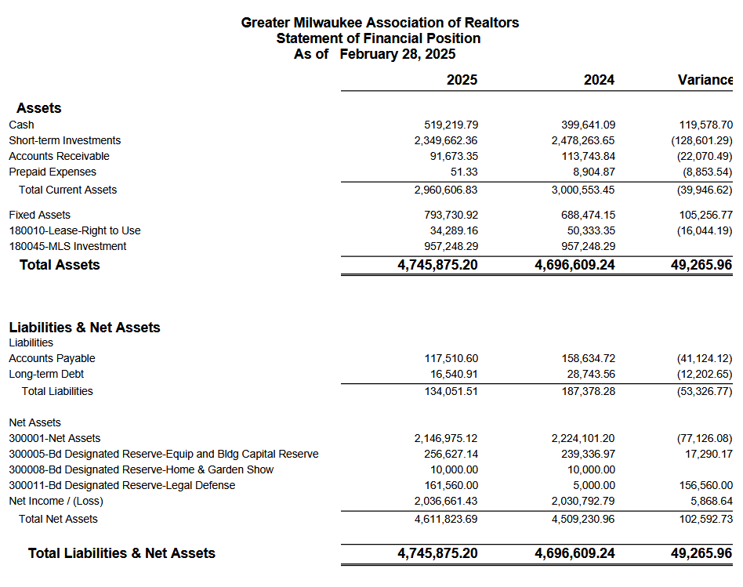

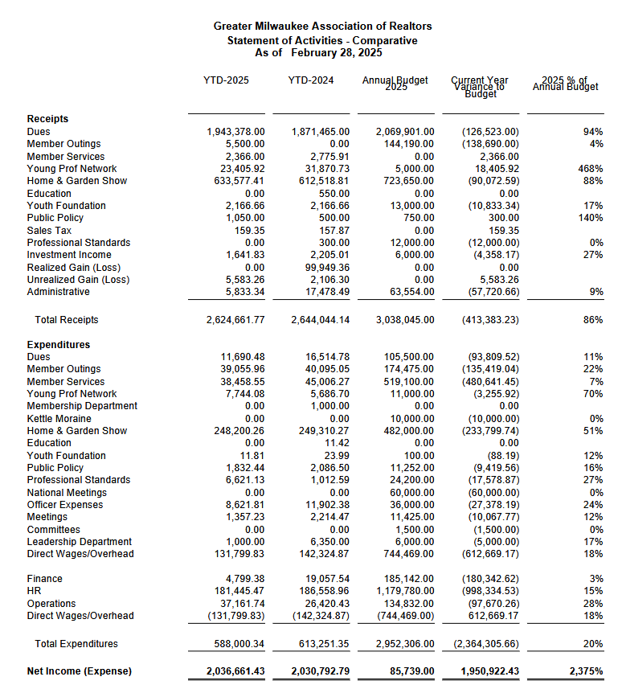
Statement of Activities

MEMORANDUM

To: GMAR Board of Directors

From: Mike Ruzicka, President

Re: President’s Report

Date: April 14, 2025

Discover Milwaukee p 34
Our purchase of Discover Milwaukee was completed on March 20th. We are now proceeding with executing a business plan we put together to promote the site and try to monetize it to some degree. Please review the business plan on page 34.

In short, we plan to position DiscoverMilwaukee.com to be an essential resource for people looking to relocate to Milwaukee with a robust social media plan, advertising strategy, and strong community engagement.

REALTOR® Safety p 38
John Gscheidmeier, Chair of the GMAR Safety Committee, and Scott Bush have been working hard on evaluating all the various components that go into making a decision on how the GMAR can bring Tether RE to members who want it in an affordable and equitable way.

Here are the highlights of a survey the GMAR conducted on Tether RE in March:

- Survey sent to 4,723 members, 413 responded (8.3%)
- 302 (73%) of respondents are interested in using a service like Tether RE
- 219 (53%) of respondents said they would pay $5/month for Tether RE
- 199 (48%) skipped the cost question (we can assume they would not be interested in paying anything)

The cost of offering Tether RE is varied. Here are our best options:

- If we pay for 1,000 agents, the cost is $4 per user = $4,000 per month ($48,000/Yr)
- If we pay for 2,000 agents, the cost is $3 per user = $6,000 per month ($72,000/Yr)
- Members would have to pay for reverse lookups ($0.25 per) and criminal background checks ($1.00 per) individually
- If we pay for all 5,000 agents, the cost is $1.25 per user = $6,250 per month ($75,000/Yr). This option would also include 4 reverse lookups and 4 criminal background checks

Here are the various options for the board to consider:

- The GMAR could offer Tether RE to 1,000, 2,000, or all 5,000 members for free. The BOD should discuss increasing dues by a commensurate amount to cover the costs for the various levels.
- The GMAR could let members know they can subscribe to the service on their own, no GMAR expense.
- The GMAR could offer to underwrite a portion of subscriptions, $1 or $2 per member, per month. Again, the BOD would discuss increasing dues to cover the costs.

Bylaws Changes Link in 4/11/25 BOD email
Last year, we had to delve into the GMAR’s bylaws to make sure we exchanged properties with MLS legally and had the correct authorization to take out a remodeling loan. During that analysis our attorney noticed some irregularities in our bylaws. For the most part it’s simply, “difficult for a casual reader to understand.”

Emily Selner, with Axley, reviewed our bylaws to make them easier to understand, and make sure they still comply with NAR’s mandated bylaws updates.

I will have a separate link available to you to download a draft of Ms. Selner’s draft. Ms. Selner will also join us via Zoom to review the updates and changes.

Here are a few changes of note:

Article 4 – Membership
A number of changes were made to this section. Most notably, removing various types of membership. On the National standards webpage, they have the language for the membership section and that did not include a lot of the affiliate members that were listed in the GMAR bylaws. We removed the affiliates that were not included in the national language

Article 7 – Professional Standards
This section was revised to include all of the terms that outline how you continue to maintain qualifications for membership. This section now includes all of the terms related to the continuing education requirements. We added this to the section that lists out the responsibilities of members to enforce the Code of Ethics. The Fair Housing Training in this paragraph is the new language that is required by NAR.

Article 11 – Officers and Directors
This section needs a close review. We made the most changes in this section because some of the terms were not clear. We revised the sections regarding the qualifications for officers/board members, process for elections, and removal of officers. As well as removing an additional outside-director position (appointed by the Chair-Elect).

SentriLock
We do not need to decide about the future of SentriLock right now, but we will have to make a decision by the next director’s meeting in July. Our current SentriLock contract comes to an end later this year, on September 30th. Here are our options:

      - Let the contract expire and not renew with SentriLock, and let members go back to using combination boxes.

      - Look at other competing systems to see if there is a better product for our members.

      - Renew our contract with SentriLock with new lockboxes included (similar to the program we entered into in 2018).

      - Renew just the SentriLock service Key Fee, which is the service associated with using the lockboxes, the software, and the SentriLock app.

In examining our options, our staff believes that if we choose option two, three, or four, rather than offer boxes to any member who feels they need one, we should allow them to purchase boxes (possibly at a subsidized cost). The reason being that over the course of our current contract, we have had a great deal of difficulty keeping track of the lockboxes in circulation in order to make sure we have enough for new and existing members who need them.

Additionally, the current lockbox inventory that exists could be parceled out to members by averaging the three prior years of listing (similar to how we did in 2018). Members would be allowed to own these boxes, and we would begin having new and existing members purchase new boxes from SentriLock as they need them.

Our current 2018 SentriLock lease is for 3,500 licenses. SentriLock charges GMAR $10.34/member, plus tax. That $10.34 covers leasing the physical boxes and the “key fee”. GMAR calculates $11.50/member for SentriLock, with the extra $1.16 going toward overhead and other expenses (i.e., battery replacement).

We have generally been under that 3,500 license mark, so we should examine lowering that in our renewal discussion.

SentriLock is offering two Key Fee options: 5 years for $8.38/license and 7 years for $7.99/license (plus 3.9% annual increases).

Strat Plan p 40
Our current strategic plan is below. We sent out a member survey on April 8th in advance of the directors’ meeting to inform the board of the opinions and problems of our members. I will provide a copy of the survey results at our meeting, and I would like to review them along with the priorities we’ve identified in the strategic plan to see if we need to adjust any component(s).

GMAR Building Remodel
The GMAR building remodeling project is essentially complete, as you will see. We are waiting to transfer our current construction loan into a commercial mortgage in the coming weeks.

Recurring Reports

GMAR Snapshot(s) P 46

2025 GMAR Organizational Chart P 48

2025 GMAR Board of Directors Roster P 49

2025 GMAR Calendar P 50

 Business Plan

Executive Summary
The GMAR will purchase and run the DiscoverMilwaukee.com (DM) website in order to promote the SE Wisconsin region to potential home buyers and to drive business to our members.
DiscoverMilwaukee.com is a powerful tool for the Greater Milwaukee Association of Realtors (GMAR) to fulfill its mission to “help members help their clients.” It does this by offering members an opportunity to connect with potential clients, showcasing the region's quality of life, and providing valuable information to individuals considering a move to Milwaukee. By acquiring DiscoverMilwaukee.com, GMAR is positioned to attract and acquire new clients for members who are relocating to Milwaukee and those looking to move within the metropolitan area – marking a proactive step toward fulfilling the association's mission, which traditionally begins after clients are identified.
Currently, the competition for DiscoverMilwaukee.com is minimal. VISIT Milwaukee focuses on tourism, while MMAC/M7 targets business recruitment in the area. A Google search for "move to Milwaukee" places DiscoverMilwaukee.com as the third result, reflecting its prominence.
The GMAR plans to fund DiscoverMilwaukee.com’s operational expenses through existing association funds, with an eye toward growing site revenue. The association aims to enhance the site’s visibility, traffic, and growth through a detailed social media and advertising strategy.
At the end of 2025, GMAR will assess the viability of DiscoverMilwaukee.com based on the outcomes of these initiatives.

Social Media Plan
- Housing & Relocation Resources
- Promote DiscoverMilwaukee.com: Highlight the website as the go-to relocation resource.
- Greater Milwaukee City & Neighborhood Series: Feature neighborhoods across Milwaukee, Waukesha, and Washington counties. Each post will address local amenities, affordability, and unique features.
- Cost of Living Breakdown: Visual content comparing Milwaukee to other cities on essentials like rent, groceries, and transportation.
- New Construction Highlights: Showcase new housing developments.
- School District Spotlights: Focus on family-friendly neighborhoods.
- Testimonials: Share quotes from locals and new residents to build credibility.
- Apartment & Housing Trends: Include data on rent and the best areas to live.
- Walkability & Transit Info: Promote walkable neighborhoods and public transit tips.
- Utilities Tips: Offer guidance for new residents setting up services like electricity, water, and waste.
- Lifestyle & Local Culture
- Local Events: Highlight ongoing community events, including street festivals, concerts, and markets.
- Hidden Gems: Feature lesser-known spots like unique coffee shops, parks, and murals.
- Milwaukee Lifestyle: Showcase the city’s lakefront living, biking culture, and brewery scene.
- Relocation Inspiration: Promote why people love living in Milwaukee—affordability, arts, and walkability.
- Food & Drink: Highlight the city's best brunch spots, breweries, and local eateries.
- Made in Milwaukee: Feature local businesses, artisans, and breweries.
- Healthcare Access: Share information on healthcare facilities like top hospitals and wellness centers.
- Educational & Visual Content
- “This Weekend in MKE”: Promote upcoming local events.
- Milwaukee Fun Facts: Share interesting facts (e.g., Milwaukee’s coastline vs. Miami's).
- Maps & Infographics: Provide useful resources like “Dog-Friendly Parks” or a “Brewery Trail” map.
- Video Content: Create engaging short-form content like walking tours, drone shots, and local interviews.
- Community & Collaborations
- Influencer Partnerships: Collaborate with local influencers and businesses to amplify content.
- Seasonal Content: Highlight seasonal attractions such as tulips in spring, winter lake walks, and summer fireworks.

Greater Milwaukee City & Neighborhood Series: Example Posts
- Glendale: Quiet, accessible with green spaces and Sprecher Brewery. Median home price: ~$275K. Rent: $1,100–$1,400.
  - Fun Fact: Home to Sprecher Brewery.
  - Hidden Gem: Kletzsch Park.
  - Vibe Check: Calm, suburban.
- Cudahy: Working-class community near the lake with a rich history. Median home price: ~$225K. Rent: ~$1,100–$1,200.
  - Fun Fact: Founded by Patrick Cudahy (the bacon magnate).
  - Hidden Gem: Sheridan Park with lake views.
  - Vibe Check: Quiet, close to the lake.
- Cedarburg: Historic charm with a vibrant arts scene. Median home price: ~$375K. Rent: ~$1,200–$1,600.
  - Fun Fact: Historic district listed on the National Register of Historic Places.
  - Hidden Gem: Cedar Creek Winery.
  - Vibe Check: Charming, walkable, festive.

Advertising & Revenue Plan
- Database Review: Analyze existing advertisers and assess their fit for digital opportunities.
- Develop Digital Ad Offerings: Create rotating banner ads, featured placements, and sponsor spots.
- Outreach to Advertisers: Engage with existing sponsors about digital-only options.
- Set Pricing: Establish pricing for digital sponsorships and create a pitch deck for potential sponsors.
- Revenue Generation: Explore affiliate marketing, sponsored content, and additional community partnerships to increase revenue.

Partner & Stakeholder Engagement
- Partnership Outreach: Collaborate with partners like MMAC, Visit Milwaukee, and key local sponsors such as We Energies.
- Community Collaborations: Build relationships with local influencers, non-profits, and businesses.
- Affiliate & Sponsored Content: Pursue opportunities for additional content partnerships and revenue.

Site Optimization & Growth
- Content Updates: Regularly refresh community and school sections.
- Email Newsletter: Launch a newsletter featuring weekly highlights, neighborhood spotlights, and relocation tips.
- Google Ads & Social Media Campaigns: Test ad strategies to boost site visibility.
- Site Performance Tracking: Use Google Analytics to monitor traffic and adjust strategies.
- Expansion: Look for opportunities to expand with features like drone videos, interactive maps, and city guides.

Conclusion
With a robust social media plan, a detailed advertising strategy, and strong community engagement, DiscoverMilwaukee.com is positioned to be an essential resource for people looking to relocate to Milwaukee. By focusing on content growth, partnerships, and site optimization, the GMAR can ensure that DiscoverMilwaukee.com continues to provide value for its members, attracting new clients while showcasing Milwaukee’s unique lifestyle and offerings. 2025 will be critical for evaluating the feasibility and sustainability of this project moving forward.

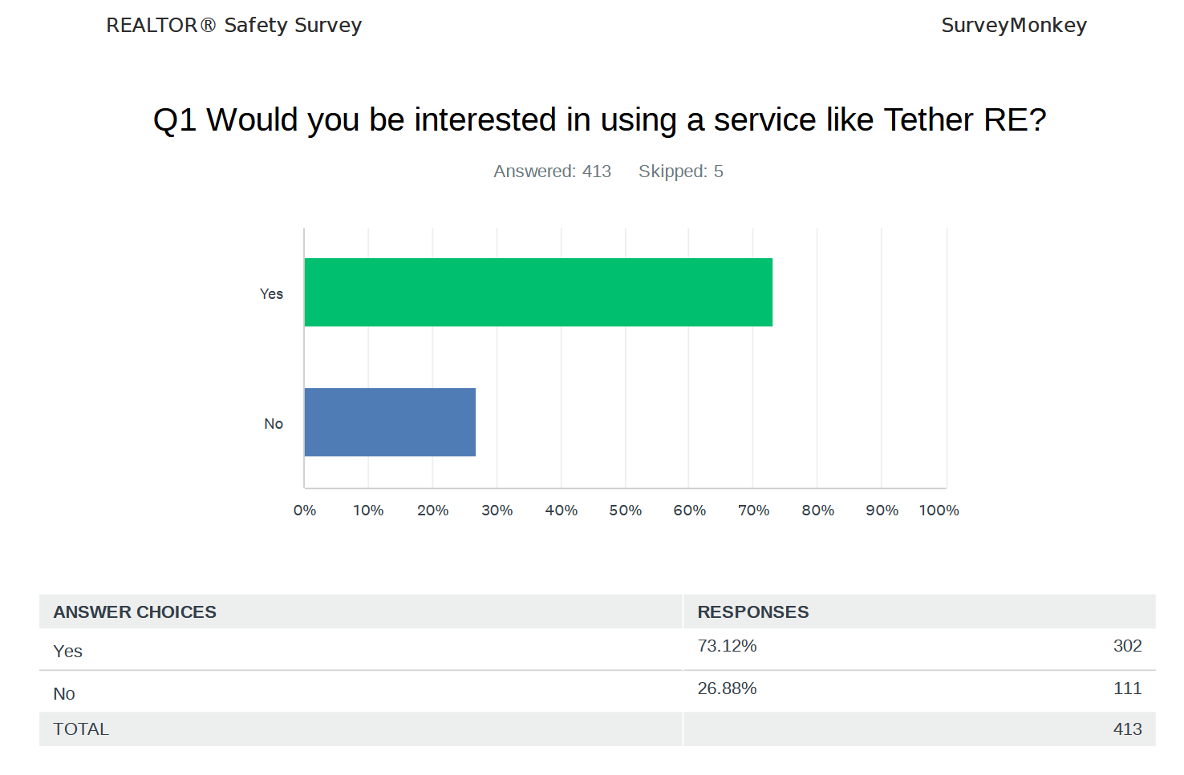

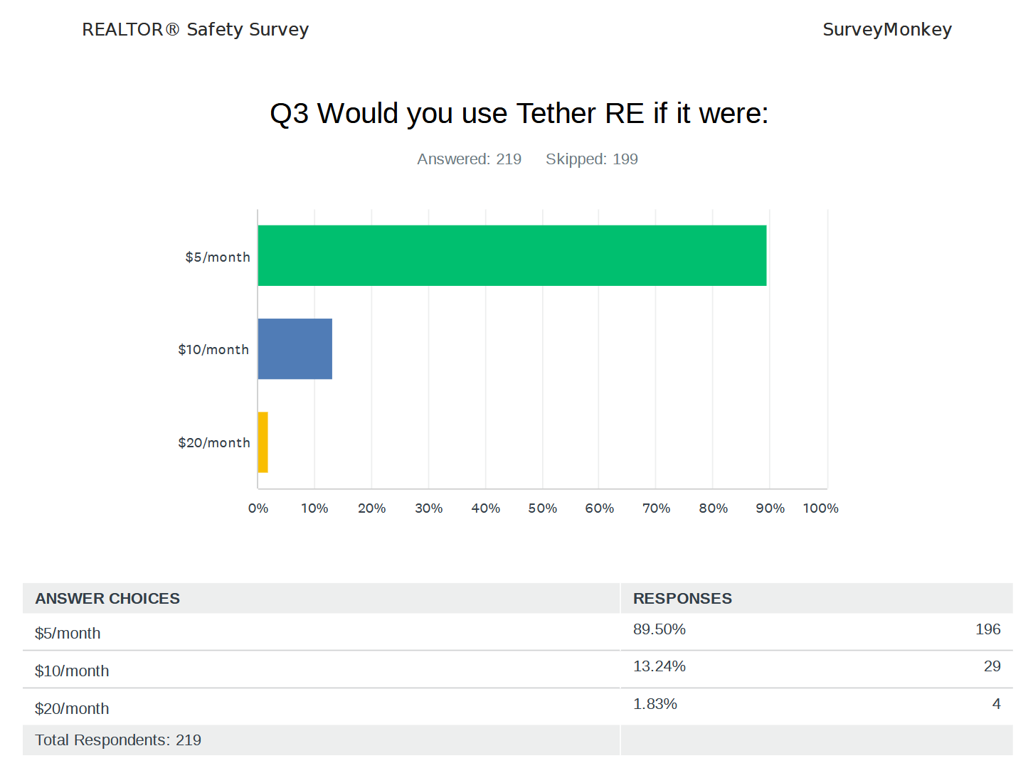
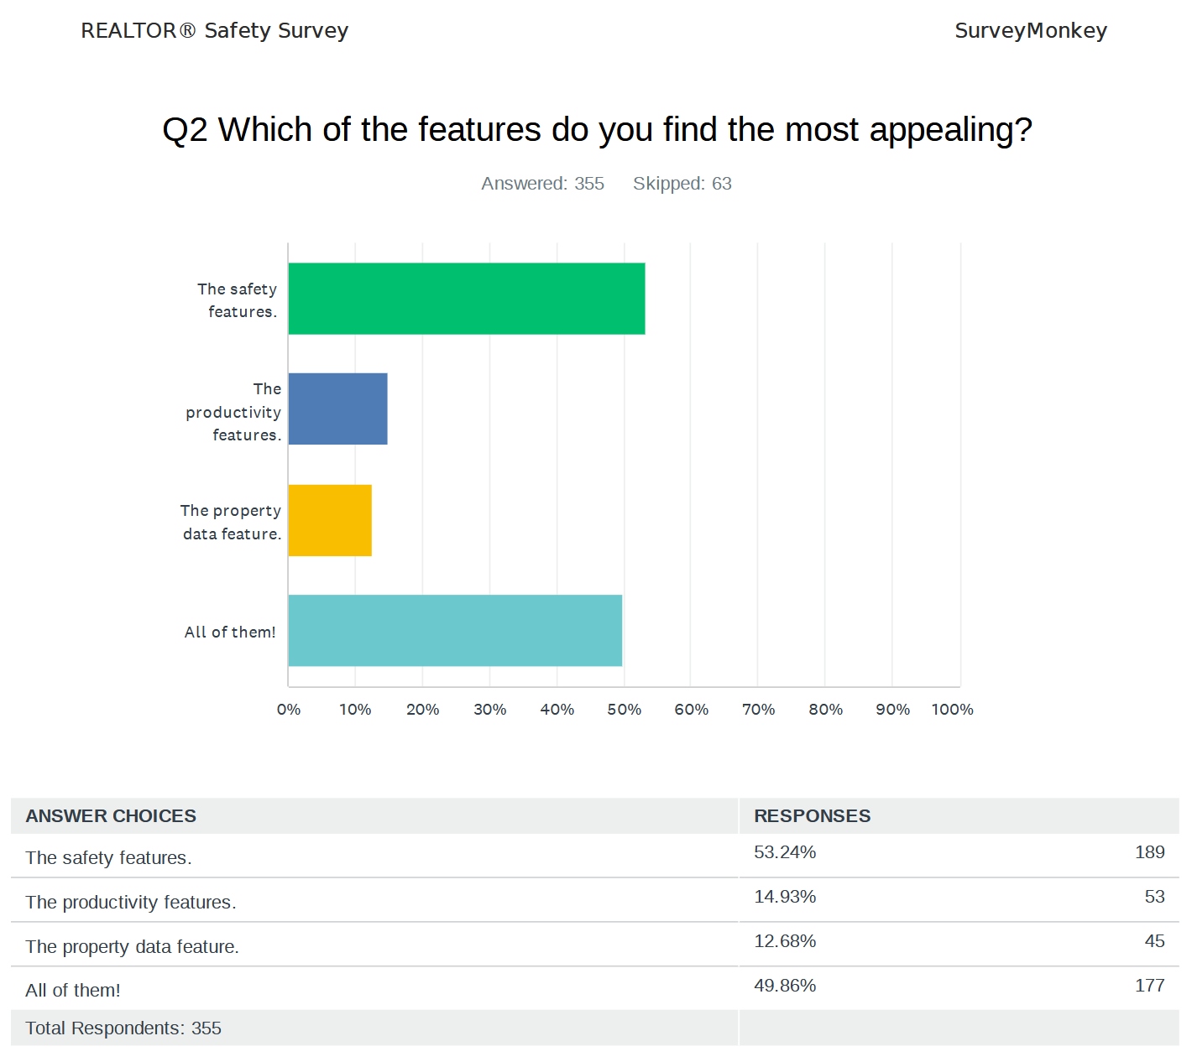

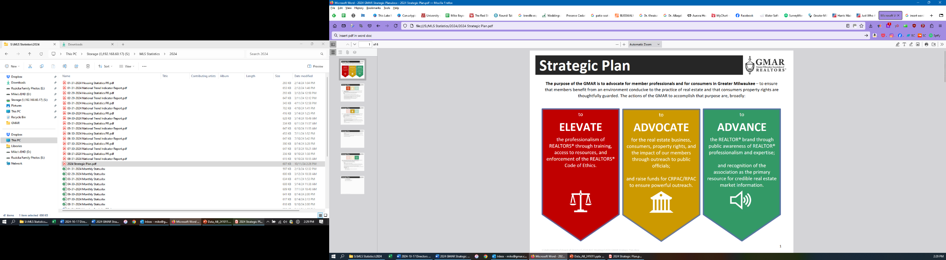

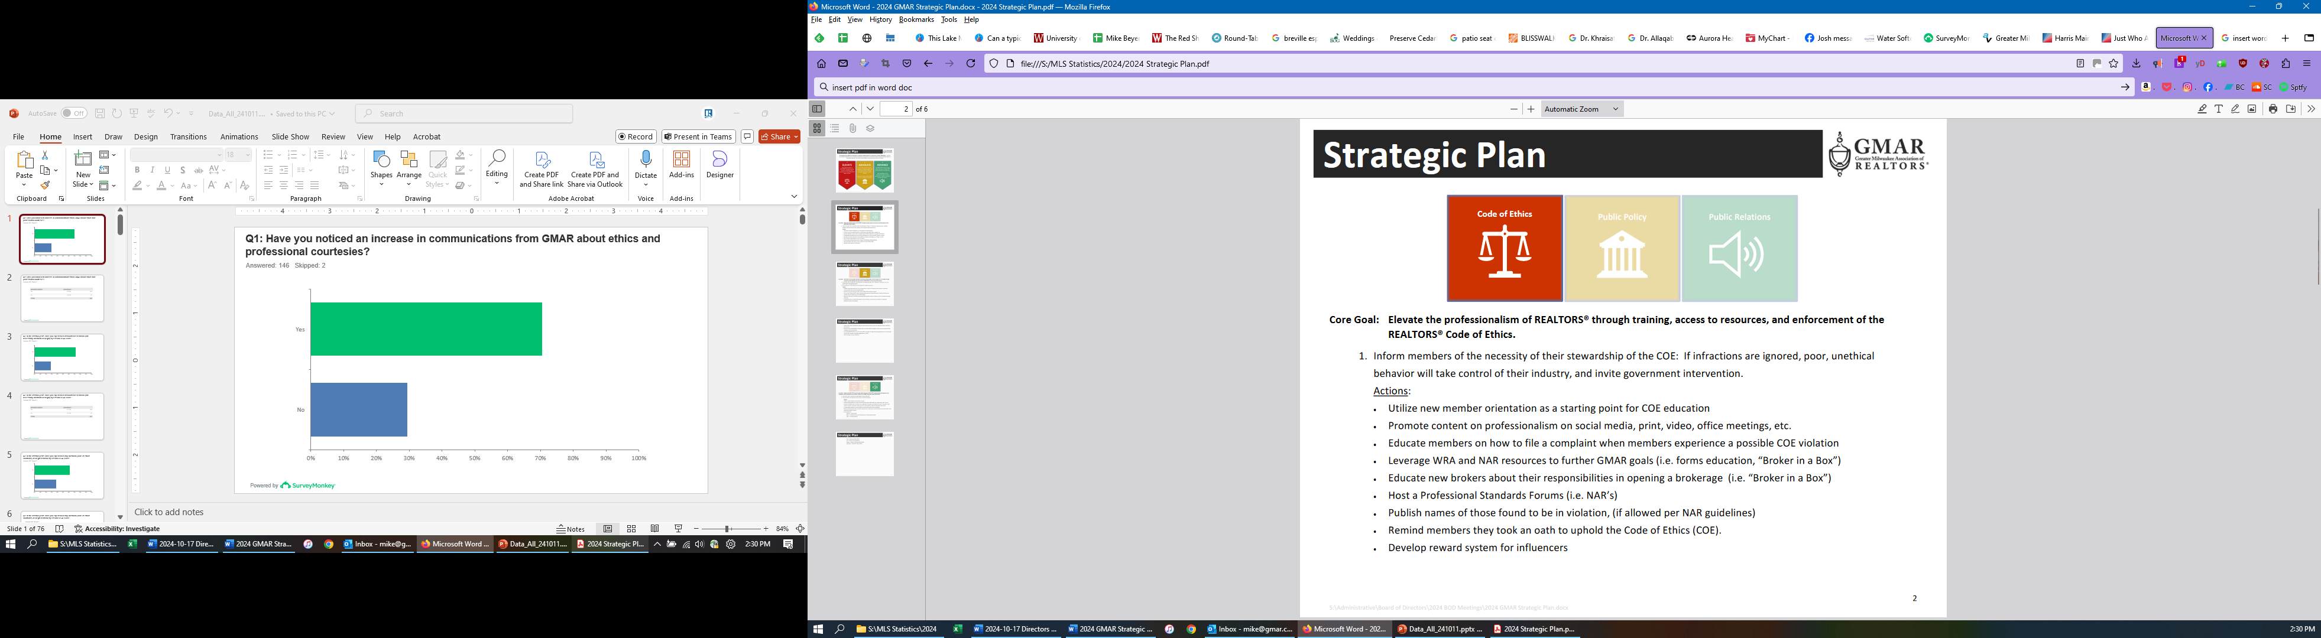

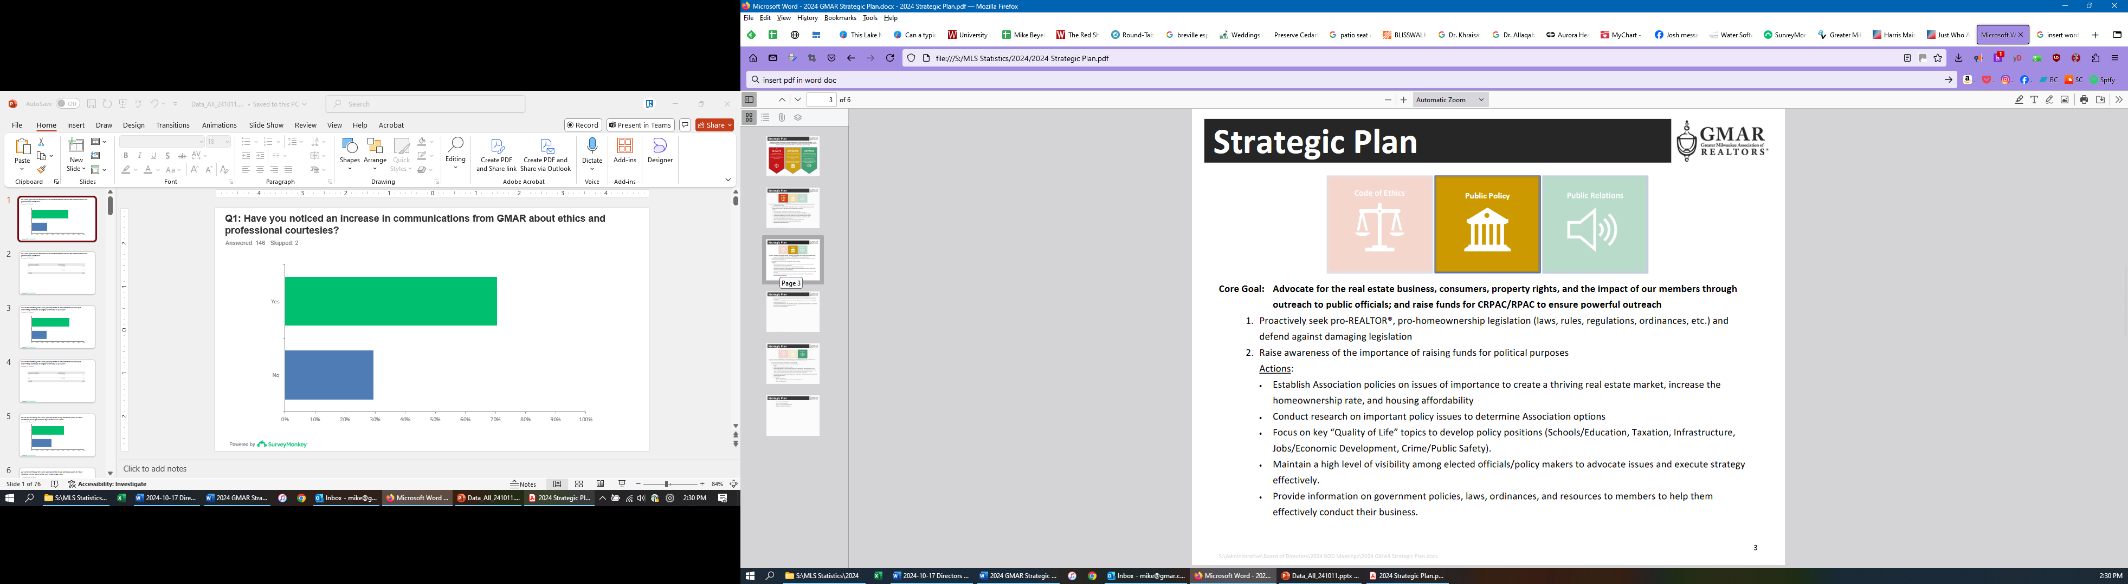

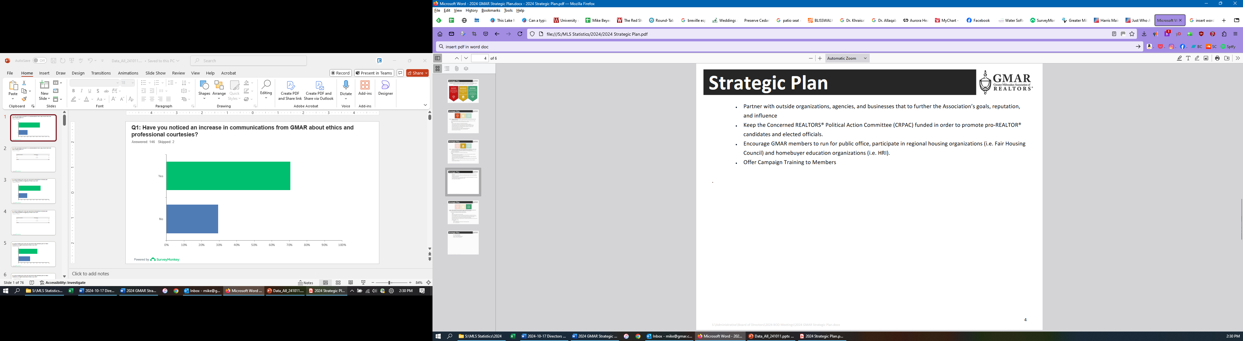

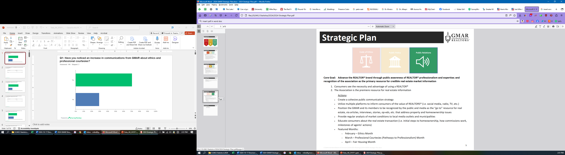

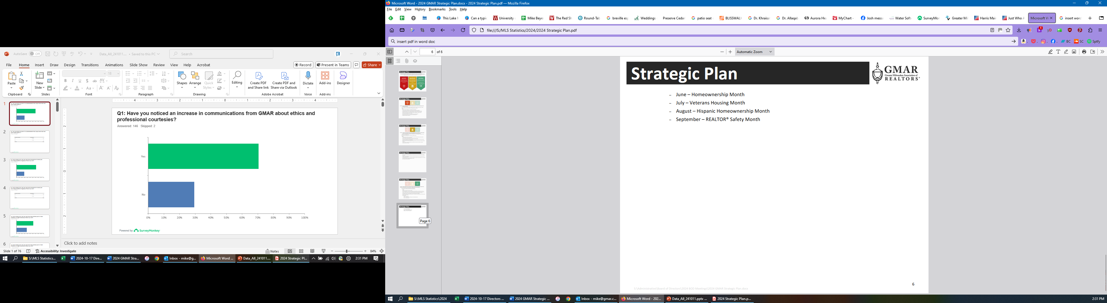

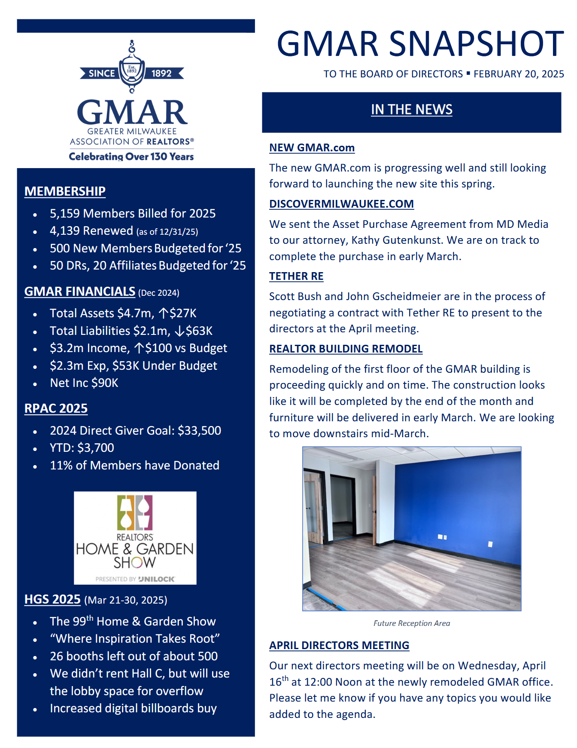
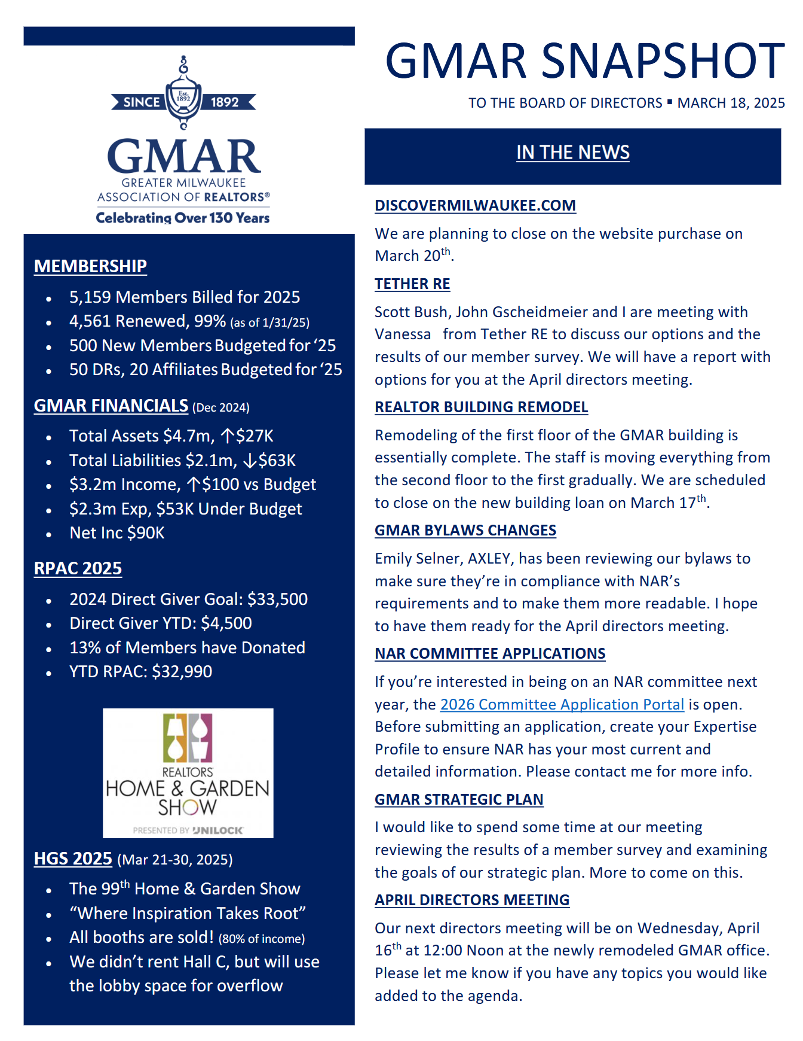

GMAR 2025 Organizational Chart

2025 GMAR Board of Directors

Terms expiring  12/31/2025 | Terms expiring  12/31/2026 | Terms expiring  12/31/2027
John Horning  Shorewest Realtors  17450 W North Avenue  Brookfield, WI 53045  O 262.827.4200 M 414.416.4505  jphorning@shorewest.com  M1: 090015743  (3yr term from Exec Roundtable) | Scott Klaas  Keller Williams Realty  2665 S Moorland Rd, Suite 104  New Berlin, WI 53151  O 262.696.9884 M 262.347.9329  sklaas@kw.com  M1: 090121392  (3yr term from Exec Roundtable) | M1:  (3yr term from Exec Roundtable)
Abby Hauke, Chairwoman  First Weber Inc.  2750 Golf Rd, Suite A  Delafield, WI 53018-2063  O 262.646.6800 M 262.468.6364  ahauke@firstweber.com  M1: 090148324  (3yr term from Exec Roundtable) | Tom McCormick, Chair-Elect  Exit Realty Horizons  1417 N Wauwatosa Ave., Ste 201  Wauwatosa, WI 53213-2646  O 414.771.7144 M 414.241.2272  tmccormick@exithorizonswi.com  M1: 090070736 | James Krickeberg (1st Term)  The Krickeberg Group, LLC  of Keller Williams Realty  2665 S Moorland Rd #104  New Berlin, WI 53151  M 262.442.4845  james.krickeberg@kw.com  M1: 090143038
Sarah Cole, Past Chair  Landmark Realty (2nd Term)  3800 S 97th St  Milwaukee, WI 53228  M 414.510.4903  colesarahb@gmail.com  M1: 090128495 | Jose Flores (1st Term)  First Weber Inc.  10521 W Layton Ave  Greenfield, WI 53228  O 414.543.7800 M 414.704.4400  josefloreshomes@gmail.com  M1: 0885500352 | Tonya Thomsen (1st Term)  Thomsen Team  N16W23233 Stone Ridge Dr, Suite 200  Waukesha, WI 53188  O 262.424.3138  Tonya@ModernRPwi.com  M1: 090075411
Shawn Govern, Secretary/Treasurer  Perfection Plus R E Services (1st Term)  3119 W Minnesota Ave  Franklin, WI 53132-8458  M: 414.617.7574  sgovern@wi.rr.com  M1: 090041059 | Sarah Venes (1st Term)  First Weber, Inc.  2750 Golf Rd, Suite A  Delafield, WI 53018-2063  O 262.646.6800 M 262.349.5083  venes@firstweber.com  M1: 090136786 | Tom Telderer (1st Term)  RE/MAX Lakeside - The Benson Group  5341 S 27th Street  Greenfield, WI, 53221  M: 414.881.0058  tom@bensongrouprealtors.com  M1: 090026568
Mark Kivley (2nd Term)  RE/MAX Lakeside  1200 E Capitol Dr Ste 200  Milwaukee, WI 53211  M 414.406.1840  kivleyteam@lakesiderealtors.com  M1: 090020696 | Dan Weber (1st Term)  Shorewest Realtors  2419 W. Washington St.  West Bend, WI 53095  M 262.689.5827  dweber@shorewest.com  M1: 090058736 | Theresa Dixon (1st Term)  Wisconsin Real Estate Group  250 S Executive Drive, Ste 225  Brookfield, WI 53005  theresa@wrgpros.com  M1: 090171629
Arthur Mays  Realty Among Friends LLC (1st Term)  8301 W Lisbon Ave  Milwaukee, WI 53222-3859  M: 414.975.7796  amays@realtyamongfriends.com  M1: 090051977 | Ryan Stefaniak (1st Term)  The Stefaniak Group LLC  2234 S 108th Street  Milwaukee, WI 53227  M 414.881.5034  stefaniakryan@gmail.com  M1: 090144065

Mike – 885500353
Marne – 090082562
Scott – 885500171

2025 Calendar

January
1 GMAR Fiscal Year begins
6 Schedule Member Focus Group
6 Send Out Member Survey (for BOD Mtg)
9 GMAR Executive Committee Meeting
10 Member Census/Top 10 Pick
14 MLS Stats Press Release
15 GMAR Financials / Update Dashboard
16 GMAR Board of Directors Meeting – 12:00 Noon
16 For BOD Mtg:
- Membership Stats & Graphs
- Top 10 Representative
- Conflict of Interest/Harassment Policy
16 Youth Foundation Paint & Wine Event
22-24 Inman Connect New York
23 GMAR Youth Foundation Board Meeting

February
12 MLS Stats Press Release
12 Public Policy Task Force Meeting
15 BOD Snapshot
15 GMAR Financials / Update Dashboard
20-21 WRA Board of Directors Meeting – Madison Club, Madison, WI
26 HousingWire Economic Summit – Dallas, TX

March
13 MLS BOD Meeting
12 MLS Stats Press Release
15 BOD Snapshot
15 GMAR Financials / Update Dashboard
21-30 99th REALTORS® Home & Garden Show – Wisconsin Expo Ctr, West Allis, WI

April
3 Schedule Member Focus Group
7 Send Out Member Survey (for BOD Mtg)
8 GMAR Past Chairmen/women Luncheon – Delafield Hotel
10 GMAR Executive Committee Meeting
14 MLS Stats Press Release
14 Brewers Bash – American Family Field, Milwaukee, WI
15 GMAR Financials / Update Dashboard
16 (Wednesday) GMAR Board of Directors Meeting – 12:00 Noon
17 REALTOR® & Government Day – Madison, WI
24 GMAR Youth Foundation Board Meeting
28 GMAR Audit – Wegner & Assoc.
29 Large Broker Meeting w/ NAR – Harley Davidson Museum, Milwaukee

May
1 RPAC Auction
14 MLS Stats Press Release
15 BOD Snapshot
15 Public Policy Task Force Meeting
15 GMAR Financials / Update Dashboard
21 Kettle Moraine REALTORS® Council RPAC FR
23 Deadline for NAR Committee Applications
31 – June 5 NAR REALTORS® Legislative Meetings – Washington, D.C.

June
12 MLS BOD Meeting
13 WRA Board of Directors Meeting
15 BOD Snapshot
15 GMAR Mid-Year Budget Review
15 GMAR Financials / Update Dashboard
25 WomenStrong GMAR Women’s Conference – Brookfield Conference Center
30 Schedule Summer Strategic Planning Session

July
1 GMAR BOD Candidate Applications available to members
1 Send Out Member Survey (for BOD Mtg)
2 GMAR Executive Committee Meeting
8 GMAR Board of Directors Mtg – Ironwood Golf Course
8 For BOD Mtg:
- Budget Revision
- Dues Rate for Following Year
8 GMAR Summer Golf Outing – Ironwood Golf Course
15 MLS Stats Press Release
15 GMAR Financials / Update Dashboard
17 GMAR Youth Foundation Board Meeting
31 Check in w/ Addendum A Committee
__ YPN White Party

August
11-12 NAR Leadership Summit – Chicago, IL (Chair-Elect)
12 MLS Stats Press Release
__ New GMAR Chair Orientation
- NAR Organization Assessment Checklist
__ Recruit Potential Board Directors
__ GMAR Nominating Committee Meeting
13 Public Policy Task Force Meeting
15 BOD Snapshot
15 GMAR Financials / Update Dashboard
31 Last day for GMAR BOD Candidates to submit Applications

September
1 Nominating Committee notification of BOD Candidates to membership
12 MLS Stats Press Release
15 BOD Snapshot
15 GMAR Financials / Update Dashboard
__ Veterans Committee Event
__ Kettle Moraine REALTORS® Council Wine Tasting – Terrace 167, Richfield, WI
__ CMLS Annual Conference
TBA WRA Convention

30 GMAR Board of Directors Write-In Candidate Deadline

October
1 Schedule Member Focus Group (Ask Exec/BOD about topics)
12-18 GMAR Board of Directors e-Election
14 MLS Stats Press Release
9 MLS BOD Meeting
9 GMAR Executive Committee Meeting
15 GMAR Financials / Update Dashboard
16 GMAR Board of Directors Meeting – 12:00 Noon
16 For BOD Mtg:
- Strategic Plan
- Bylaws Update
- Annual Budget
- MLS BOD Appointment(s)
- Executive Committee Election
16-17 WRA BOD Meeting
23 GMAR Youth Foundation Board Meeting

November
1 Complete NAR Core Standards Application
12 MLS Stats Press Release
12-17 NAR Convention – Houston, TX
15 BOD Snapshot
15 GMAR Financials / Update Dashboard
20 Public Policy Task Force Meeting

December
__ Chair’s Holiday Party & GMAR Annual Mtg – TBA
12 MLS Stats Press Release
__ New Director Orientation
__ GMAR Youth Foundation Annual Meeting
15 BOD Snapshot
15 GMAR Financials / Update Dashboard
31 GMAR Fiscal Year ends

