GMAR Board Of Directors
Tuesday, July 8, 2025 • 8:30 AM
Ironwood Golf Course • Sussex, WI

Meeting Agenda

Welcome & Introductions  Consent Agenda | P 7 | Approval | 8:30 AM
Reports  - Chairwoman, Abby Hauke  - Secretary/Treasurer  - 2025 Budget Adjustment  - May 2025 Financial Statements  - President’s Report  - Departments  - Professional Standards  - Government Affairs  - Membership  - Communications  - SentriLock  - Home & Garden Show  - Metro MLS, Inc. Update | P 20  P 22  P 25 | Information  Approval Approval  Approval  Approval  Information  Information  Information  Information  Information | 5 Min  5 Min  20 Min  10 Min  10 Min  10 Min  10 Min  10 Min  10 Min

Old Business
- None

New Business

None
Adjourn |  |  | 10:00 AM

Upcoming Meeting Dates

GMAR Directors Meeting • Thursday, October 16th 12:00 PM

* Indicates hard-copy information will be available at the Directors meeting. Updated: 7/7/2025 11:24 AM
Directors’ Policies & Responsibilities

Fiduciary Duty
As a Greater Milwaukee Association of REALTORS® (GMAR) director, you are a fiduciary of the GMAR. This means you have a special legal responsibility in connection with the administration, investment, and care of GMAR and its assets. This requires you to make careful, good-faith decisions in the best interest of GMAR. Your decisions must be made independently and free of any undue influence from any person, organization, or brokerage.

Conflict of Interest Policy
A member of any Greater Milwaukee Association of REALTORS® (GMAR) decision-making body has a conflict of interest whenever that member is a principal, partner, or corporate officer of a business providing, or being considered as a provider of, products or services to GMAR.

Members with a conflict of interest must immediately disclose such conflict of interest prior to participating in any discussions or vote of a GMAR decision-making body that pertains to the GMAR. Such members may not participate in any discussions related to the GMAR other than to respond to questions asked of them by other members of the body. A member may not vote on any matter in which the member has a conflict of interest.

Antitrust Policy
The Greater Milwaukee Association of REALTORS® (GMAR) is a 501(c)(6) non-profit corporation with members belonging to varying brokerages and business models. Whenever competing (or potentially competing) businesses gather, there is the risk of antitrust liability or of the appearance of anti- competitive activity. Penalties for violating antitrust laws can include huge damage awards and even criminal liability. Just defending an antitrust suit or being the object of an investigation by antitrust regulators comes with remarkably high costs. Liability for violations of the antitrust laws could accrue to the GMAR and also to members accused of participating in alleged anticompetitive activity.

Consequently, responsibility for compliance with competition laws lies with the GMAR, its members, and their leaders. This policy is thus intended to prevent any anti-competitive conduct by the GMAR; but it also aims to reduce even the appearance of anti-competitive conduct.

The GMAR is committed to compliance with all international, national, and state/provincial antitrust and competition laws. This commitment includes the following objectives:

- GMAR’s activities will increase competition among its members by providing information to them regarding effective business practices. The GMAR’s actions must not function to reduce competition.
- GMAR provides a forum for members to discuss their industry and understand developments within it; but the GMAR will not be a forum for members to develop collective action plans that would reduce competition.
- GMAR will adhere to the procedures described below to minimize the risk of even the appearance of anticompetitive conduct.

Procedures for formal meetings
The following procedures apply to all meetings of the Greater Milwaukee Association of REALTORS® (GMAR) board of directors, committees authorized by the Association, and member meetings conducted under GMAR auspices, whether the meetings are held face to face or via technological means. Individuals charged with chairing Metro MLS meetings should be familiar with this policy.

- Each meeting should be preceded by the publication of notice of the meeting to those eligible to attend it and an agenda identifying a business subject for discussion at that meeting.
- Any person who receives an agenda for a GMAR meeting should review it to identify any agenda item that might give rise to concerns about competition or collective action; such items, if any, should be referred to legal counsel for review before the meeting.
- The meeting agenda should be adopted at the beginning of each meeting, and the meeting should follow the agenda.
- At the beginning of each meeting, the chair or counsel should remind participants of this antitrust policy in such a manner as to ensure that participants understand the parameters for appropriate discussions.
- Subject to this policy, every eligible participant in any meeting should be encouraged and permitted to express his/her views on any issue subject to deliberation before a decision is made.
- In the event that a discussion is, or is likely to become, inconsistent with this policy, the meeting chair or counsel shall recommend suspension of the discussion until review under applicable competition law can be conducted; the minutes will note any such suspension.
- After each meeting, GMAR should cause minutes of the meeting to be prepared. These minutes should include a record of the resolutions adopted at the meeting; any objections raised by meeting participants to the subject matter of a meeting, and any other annotations contemporaneously advised by counsel or the meeting chair.
- Minutes of all meetings will be prepared by GMAR staff and reviewed by the Secretary/Treasurer before circulation.
- All board members and GMAR members are asked to comment promptly, in writing, on any minutes circulated in the event that there appears to be any error, omission, or item in need of revision.

Guidelines for discussions
The following guidelines apply to discussions in formal meetings as well as to informal discussions in “breakout sessions” and roundtables and even in social contexts associated with Greater Milwaukee Association of REALTORS® (GMAR) meetings. Of course, no listing of DOs and DON’Ts can be complete, and some items can permissibly be discussed even if they appear in some categories below. However, board members and GMAR members should consult with counsel before engaging in discussion of any of the types described here:
- An agreement, or activity appearing to evidence an agreement, to fix prices, limit product or service offerings, or allocate geographical territory or customers.
- An agreement, or activity appearing to evidence an agreement, to refuse to deal with any third party or parties, whether a vendor or supplier of products or services, or a customer or class of customers.
- An agreement, or activity appearing to evidence an agreement, to limit innovation, product choices, or research relating to any of the foregoing.
- Sharing of recent, current, or planned fee structures; or data regarding operating “input” costs, especially if such costs could affect service prices. This does not prevent the GMAR from gathering and aggregating certain kinds of historical pricing information, subject to counsel’s review.
- Any suggestion that GMAR or its members should take collective action to force a vendor or service provider to change its business models, prices, or service offerings.

ANTI-HARASSMENT POLICY
The Greater Milwaukee Association of REALTORS® does not tolerate harassment in the workplace. The GMAR expressly prohibits any form of unlawful discrimination and harassment based on race, color, religion, sex, sexual orientation, gender identity, national origin, age, disability, genetic information, military or veteran status, pregnancy, childbirth or related medical conditions, or status in any group protected by federal, state, or local law. This policy applies to all terms and conditions of employment, including but not limited to, hiring, training, promotion, discipline, compensation, benefits, and termination of employment. Further, this policy extends to all GMAR personnel, including officers, managers, administrators, supervisors, staff members, and co-workers, as well as the Board of Directors and members of the Board of Directors, vendors, contractors, customers, students, and suppliers.

Harassment Defined
Harassment includes unwelcome verbal, visual, or physical conduct creating an intimidating, offensive, or hostile work environment. Examples of harassment include verbal (including slurs, jokes, insults, epithets, gestures, or teasing), graphic (including offensive posters, symbols, cartoons, drawings, computer displays, or e-mails), or physical conduct (including physically threatening another, blocking someone’s way) that denigrates or shows hostility or aversion toward an individual because of any protected characteristic. Such conduct constitutes harassment when: (1) it has the purpose or effect of creating an intimidating, hostile, or offensive working environment; (2) it has the purpose of effect of unreasonably interfering with an individual’s work performance; or (3) it otherwise adversely affects an individual’s employment.

Sexual harassment is a form of harassment, and includes the following prohibited behaviors:
- Unwelcome sexual advances, requests for sexual favors, and all other verbal or physical conduct of a sexual or otherwise offensive nature, especially where:
- Submission to such conduct is made either explicitly or implicitly a term or condition of employment;
- Submission to or rejection of such conduct is used as the basis for decisions affecting an individual’s employment; or
- Such conduct has the purpose or effect of unreasonably interfering with an individual’s work performance or creating an intimidating, hostile, or offensive working environment.
- Offensive comments, jokes, innuendos, and other sexually oriented statements;
- Touching, such as rubbing or massaging someone’s neck or shoulders, stroking someone’s hair, or brushing against another’s body;
- Sexual suggestive touching;
- Grabbing, groping, kissing, or fondling;
- Violating someone’s “personal space”;
- Whistling;
- Lewd, off-color, sexually oriented comments or jokes;
- Foul or obscene language;
- Leering, staring, or stalking;
- Suggestive or sexually explicit posters, calendars, photographs, graffiti, or cartoons;
- Unwanted or offensive letters or poems;
- Sitting or gesturing sexually;
- Offensive e-mail or voice-mail messages;
- Sexually oriented or explicit remarks, including written or oral references to sexual conduct;
- Gossip regarding one’s sex life, body, sexual activities, deficiencies, or prowess;
- Questions about one’s sex life or experiences;
- Repeated requests for dates;
- Sexual favors in return for employment rewards, or threats if sexual favors are not provided;
- Sexual assault or rape;
- Any other conduct or behavior deemed inappropriate by the WRA. This list is illustrative only, and not exhaustive.

Reporting Harassment
It is the responsibility of the GMAR and each employee, vendor, customer, member, contractor, student, supplier, and board member to create an atmosphere free of harassment. In addition, it is the responsibility of each employee to respect the rights of their coworkers. If you experience or observe any hostile conduct or harassing behavior, you are required to immediately report the matter (orally or in writing, which is preferred) to the President/Chief Executive Officer, ideally within ten (10) days of the offending conduct. If the conduct involves the President/Chief Executive Officer, you can report the conduct to the Chairperson of the Board of Directors or GMAR leadership.

Complaints should be as detailed as possible, including the names of all individuals involved and any witnesses.

Investigations
Upon receipt of a complaint, the President/Chief Executive Officer will undertake a prompt and thorough investigation of the allegations. Where necessary and/or appropriate, GMAR will consult with legal counsel for assistance in conducting any investigation, especially where an investigation involves GMAR leadership or members of the Board of Directors.

While confidentiality can never be guaranteed, it shall be the policy of the GMAR that confidentiality will be maintained concerning the allegations and the investigation to the extent possible, and particularly when it is determined by WRA that any of the following factors are present:
• Witnesses need protection;
• Evidence is in danger of being destroyed; and/or
• Testimony is in danger of being fabricated or altered.

Employees who fail to cooperate with an investigation conducted pursuant to this Policy, or who breach confidentiality resulting in a threat to the integrity of the investigation, may be disciplined, up to and including termination.

If the investigation establishes that an individual has engaged in harassing, discriminatory, or other wrongful or inappropriate conduct, disciplinary or other corrective action, up to and including termination, will be taken against the offending employees.

The GMAR is committed to enforcing this policy against all forms of harassment. The effectiveness of our efforts depends largely on us being informed of any inappropriate workplace conduct. If harassing conduct is not reported, GMAR may not become aware of a possible violation of this policy and may not be able to take appropriate corrective action.

Retaliation Prohibited
The GMAR expressly prohibits any retaliation or other adverse action against any employee who makes a good faith complaint of discrimination, harassment, or retaliation, or participates in any investigation of such complaint in good faith.

Violations of this Policy
Any individual, regardless of position or title, whom GMAR determines has subjected an individual to harassment or retaliation in violation of this policy, will be subjected to disciplinary or other corrective action , up to and including termination of employment.

Administration of this Policy
The President/Chief Executive Officer is responsible for the administration of this policy. If you have any questions regarding this policy or questions about harassment that are not addressed in this policy, please contact the President/Chief Executive Officer.

All GMAR leadership and members of the Board of Directors shall be educated on this policy on an annual basis at the first meeting of the board of directors each year. The education will cover several topics including, but not limited to, definitions and examples of harassment, including sexual harassment, prohibited behaviors and consequences of engaging in prohibited behaviors, reporting procedures, and responding to reports of harassment.

Conduct Not Prohibited by this Policy
This policy is not intended to preclude or dissuade employees from engaging in legally protected activities/activities protected by state or federal law, including the National Labor Relations Act, such as discussing wages, benefits, or terms and conditions of employment, forming, joining, or supporting labor unions, bargaining collectively through representatives of their choosing, raising complaints about working conditions for their and their fellow employees' mutual aid or protection, or legally required activities.

GMAR Board Of Directors

Consent Agenda

Please note: if any director would like to consider an item in the Consent Agenda, please state that you would like to discuss the item when the Chair asks for a motion to approve the Consent Agenda.

- It is moved, seconded, and carried to approve the agenda of the Tuesday, July 8, 2025, meeting of the GMAR Board of Directors. p. 1

- It is moved, seconded, and carried to approve the minutes of the Board of Directors meeting from Wednesday, April 16, 2025. p. 8

- It is moved, second, and carried to approve of the 195 new members who have applied to become members of the GMAR and paid the appropriate fees. p. 14

GREATER MILWAUKEE ASSOCIATION OF REALTORS®
BOARD OF DIRECTORS MEETING MINUTES
Wednesday, April 16, 2025 • 12:00 PM
Metro MLS, Inc. • Wauwatosa, WI

- Call to Order
Chair Abby Hauke called the GMAR Directors meeting to order at 12:06 PM with a quorum present for the transaction of business.

Present: Abby Hauke, Chairwoman; Tom McCormick, Chair-Elect; Shawn Govern, Secretary/Treasurer; Sarah Cole, Past Chair; John Horning, Arthur Mays, Scott Klaas (Zoom), Jose Flores, Sarah Venes, Ryan Stefaniak, Dan Weber, James Krickeberg, Tonya Thomsen, Tom Telderer, Theresa Dixon

Staff Present: Mike Ruzicka, President; Scott Bush, VP Operations; Marne Stück, Government Affairs Director; Laura Crowley, Communications Director, Sharon Heilman, Dir of Lasting Impressions

Guest(s): Chris Carrillo, CEO of Metro MLS, Inc.

Excused: Mark Kivley

- Consent Agenda
- Approve the agenda of the April 16, 2025 meeting of the GMAR Board of Directors.
- Approve the minutes of the Board of Directors meeting from January 16, 2025.
- Approve of 487 new members who have applied to become members of the GMAR and paid the appropriate fees.

M/S/C unanimously, to approve the Consent Agenda.

- Reports
- Chairwoman’s Report
Ms. Hauke stated that the first quarter of the year was quiet. The Home & Garden Show was very well attended and looked great, and she was grateful for all of the media attention the show garnered. She said the luncheon of the GMAR’s past chairs, held a week earlier was very fun. She also bid farewell to Chris Carrillo, Metro MLS CEO who is moving to Texas to take a similar position in Dallas.

- Treasurer’s Report
- Mr. Ruzicka reported on the February financials.

Statement of Financial Position (Balance Sheet). As of February 28, 2025, GMAR had $2,868,882 in Cash & Investment Balances, down $9,023 compared to last year.

Accounts receivable were down $22,070 compared to last year. Prepaid expenses were down $8,854 compared to 2024. Fixed assets increased by $105,257. Total Assets were $4,745,875 which is up $49,266 compared to 2024.

On the Liability side, accounts payable were down $41,124 compared to last year. Overall, Total Liabilities were $134,052 which is down $53,327 compared to 2024.

GMAR has a Net Gain of $2,036,661 through February 28, 2025, up $5,869 from last year. Overall, Total Net Assets were $4,611,824; $102,593 higher than the same point in 2024.
Statement of Activities. Membership: Through February 2025, $1,943,378 was collected in dues. Last year through the end of February we collected $1,871,465 in dues, so dues are $71,913 ahead of last year at the same time. Renewals were down slightly with regards to membership numbers, but dues were increased by $40 in February 2024, so that increase being in effect for 2025 renewals more than made up for the membership drop and led to this increase in total dues collected. For 2025, GMAR had an 86% renewal based on number of members billed. New member budget for 2025: 500 REALTORS®, 50 DRs and 20 Affiliates. Through February, actual new members: 158 REALTORS®, 6 DRs and 2 Affiliates.

Promotions: Through February, Home and Garden Show income is $633,577 and expenses are $248,200 for a net gain of $385,377. These numbers will change significantly throughout the year. The budgeted net gain for the Show is $241,650.

Expenses related to Public Policy are mostly personnel costs, incurring expenditures primarily in Labor and Overhead. The majority of Professional Standards expenses are related to the fair housing ads.

The Leadership section includes expenditures for meetings, committees, officer expenses, strategic planning, NAR surveys and NAR meetings. The main expenses recorded through February were travel for meetings, meeting costs, memberships and sponsorships.

The Administrative section includes investment and rental income and expenses for professional fees, salaries, fringe benefits, building, insurance, occupancy, property taxes, general office expenses and depreciation.

The bottom line shows net income of $2,036,661. Last year net income was $2,030,793 for the same time period.

M/S/C to approve the unaudited Statement of Financial Position (Balance Sheet) and Statement of Activities as of February 28, 2025, and recommend placing it on file for audit.

- President’s Report
Mike Ruzicka reported the following in addition to his written memorandum to the Board of Directors:

- GMAR Bylaws
Emily Selner, with Axley Attorneys, joined the directors’ meeting via Zoom to present recommended changes to the GMAR’s bylaws in order to make them easier to understand, and make sure they comply with NAR’s mandated bylaws updates.

Last year, the association had to delve into its bylaws to make sure the MLS property exchange was legal and had the correct authorization to take out a remodeling loan. During that analysis the GMAR’s attorney noticed some irregularities in the bylaws that made them difficult for a casual reader to understand.

Mr. Ruzicka emailed the directors a link to download a draft of Ms. Selner’s proposed changes, both in a red-line draft form as well as an updated finished draft.

The changes focused on three main sections of the bylaws:

Article 4 – Membership
A number of changes were made to this section. Most notably, removing several types of membership. On the National standards webpage, they have the language for the membership section and that did not include a lot of the affiliate members that were listed in the GMAR bylaws. We removed the affiliates that were not included in the national language.

Article 7 – Professional Standards
This section was revised to include all of the terms that outline how you continue to maintain qualifications for membership. This section now includes all of the terms related to the continuing education requirements. We added this to the section that lists out the responsibilities of members to enforce the Code of Ethics. The Fair Housing Training in this paragraph is the new language that is required by NAR.

Article 11 – Officers and Directors
This section needs a close review. We made the most changes in this section because some of the terms were not clear. We revised the sections regarding the qualifications for officers/board members, process for elections, and removal of officers. As well as removing an additional outside-director position (appointed by the Chair-Elect).

Motion by Shawn Govern, second by Arthur Mays, and carried unanimously, to approve of the changes to the GMAR Bylaws as presented.

- REALTOR® Safety
The GMAR sent out a survey to evaluate members’ thoughts on a safety product like Tether RE. The survey was sent to 4,723 members and 413 responded (8.3% of the membership):

• 302 (73%) of respondents are interested in using a service like Tether RE
• 219 (53%) of respondents said they would pay $5/month for Tether RE
• 199 (48%) skipped the cost question (we can assume they would not be interested in paying anything)

Mr. Ruzicka laid out the options for the GMAR to offer Tether RE:

• For 1,000 agents, the cost is $4 per user = $4,000 per month ($48,000/Yr)
• For 2,000 agents, the cost is $3 per user = $6,000 per month ($72,000/Yr)
• For both 1,000 and 2,000 agents, members would have to pay for reverse lookups ($0.25 per) and criminal background checks ($1.00 per) individually
• If we pay for all 5,000 agents, the cost is $1.25 per user = $6,250 per month ($75,000/Yr). This option would also include 4 reverse lookups and 4 criminal background checks.

The directors discussed various possibilities including offering Tether to 1,000, 2,000, or all 5,000 members for free. The directors were not inspired to raise dues in order to pay for the service.

Discussion surrounded:
- Creating an enrollment period for the GMAR to gauge how many members would actually use the service, then the association could pay for that number of licenses.
- Allowing members to subscribe to the service on their own.
- Underwrite a portion of subscriptions, $1 or $2 per member, per month.

Mr. Ruzicka said he would talk to Tether RE and explore more options including a $5 fee for 500 members, for either the GMAR to pay for or for individual members to pay.

- SentriLock
Mr. Ruzicka stated that the GMAR does not need to decide about the future of SentriLock at this meeting but should by the July meeting, because the current 7-year contract expires on September 30, 2025.

He stated that the GMAR essentially has four options:

1. Let the contract expire and not renew with SentriLock, and let members go back to using combination boxes.
2. Look at other competing systems to see if there is a better product for our members.
3. Renew our contract with SentriLock with new lockboxes included (similar to the program we entered into in 2018).
4. Renew just the SentriLock service Key Fee, which is the service associated with using the lockboxes, the software, and the SentriLock app.

Mr. Ruzicka said that the staff believes that if we choose option two, three, or four, rather than offer boxes to any member who feels they need one, we should allow them to purchase boxes (possibly at a subsidized cost). The reason being that over the course of the current contract, the staff has had a great deal of difficulty keeping track of the lockboxes in circulation in order to make sure there are enough for new and existing members who need them.

He added that the current lockbox inventory could be parceled out to members by averaging the three prior years of listing (similar to how we did in 2018). Members would be allowed to own the boxes, and the association would begin instructing members to purchase new boxes from SentriLock as they need them.

Mr. Ruzicka explained that the current 2018 SentriLock lease was for 3,500 licenses. SentriLock charges GMAR $10.34/member, plus tax. That $10.34 covers leasing the physical boxes and the “key fee”. GMAR calculates $11.50/member for SentriLock, with the extra $1.16 going toward overhead and other expenses (i.e., battery replacement).

The GMAR has generally been under that 3,500 license mark, so it should examine lowering that in the renewal discussion. SentriLock has offered two Key Fee options: 5 years for $8.38/license and 7 years for $7.99/license (plus 3.9% annual increases).
Mr. Ruzicka handed out an analysis of the revenue and expenses of the current fee structure, and 7-year and 5-year models.

The consensus of the directors was to a) renew the SentriLock service Key Fee only, not to purchase a set of new boxes; b) check alternative lockbox firms; c) negotiate a deal for the GMAR to purchase more lockboxes from SentriLock.

Mr. Ruzicka said he would report back to the board at its next meeting.

- Member Survey
Mr. Ruzicka explained that a member survey was sent out in the weeks prior to the director’s meeting, but only 45 responses were collected. He said a new survey would be sent out in advance of the July meeting to collect member thoughts and opinions on several topics for the board to consider in the strategic plan.

- Discover Milwaukee
The purchase of DiscoverMilwaukee.com was completed on March 20th. Mr. Ruzicka asked the directors to review the business plan the staff had put together to promote the site and try to monetize it to some degree.

In short, the plan would position DiscoverMilwaukee.com to be an essential resource for people looking to relocate to Milwaukee with a robust social media plan, advertising strategy, and strong community engagement.

- GMAR Building Remodel
The GMAR building remodeling project is essentially complete. The current construction loan will be transferred to a commercial mortgage in the coming weeks.

- Department Reports

- Professional Standards
Scott Bush reported
  - Part of GMAR’s participation in Fair Housing Month involved an online presentation from Alexia Smokler, Attorney and Fair Housing expert and advocate from NAR .

  - GMAR’s vodcast, From the Park Bench, featured a Fair Housing discussion with Casey Clickner, Carrer Development Director with Shorewest Realtors.

  - Mr. Bush will work with WRA to develop a uniform policy regarding the GMAR’s citation policies and the WRA’s policy for the unauthorized access of property and giving out lockbox codes. The GMAR Board wants to keep the $5,000 fine citation. WRA currently has a $1,000 citation policy.

- Government Affairs
Marne Stück reported:

- On Common Ground Magazine for elected officials. This is a free, semi-annual magazine published by NAR. On Common Ground presents a wide range of views on smart growth issues, with the goal of encouraging dialog among REALTORS®, elected officials, and other interested citizens. Marne has submitted our list of elected officials in the Greater Milwaukee area to NAR and in turn they email the magazine directly to the list. They have done away with the hard copy of the magazine.

- Introductory meetings with new leaders:
      - Dr. Brenda Cassellis-MPS Superintendent of Schools (and MPS Board Members)
      - Alderman Alex Brower-3rd District City of Milwaukee Alderman

- REALTOR & Government Day is tomorrow! Marne reported that the bus is full to and from Madison. The 37 legislators from the Greater Milwaukee area have been contacted for our Capitol visits. You can still attend and register at the event.

- The Annual Kettle Moraine Council RPAC Auction will be held on May 1 at Lucky Shotz in Hartford from 5-8 pm

- Membership
- Communications
No report was given.

- Home & Garden Show
Mr. Ruzicka reported that the 2025 show had $576,390 in booth revenue and $46,200 in sponsorships. More income and the final expenses are yet to come to calculate a net revenue number. Joanna Tusing, the GMAR’s Director of Promotions, expects to net about $40,000 above the budget.

Additionally, the painted flowerpots were auctioned off for the GMAR’s Youth Foundation, raising $1,255.

Planning for the 2026 HGS, the association’s 100th, is beginning in May. Plans include expanding the show to all three halls, incorporating an “alumni garden” area and bringing back antique appraisals.

- Metro MLS, Inc.
Metro MLS CEO, Chris Carrillo, updated the directors on

- Clear Cooperation and possibly all NAR oversight of MLS policies may be a thing of the past.
- Thanked the directors for their counsel in the past and hopes to see everyone in the future.

- Old Business
- None

- New Business
- None

- Adjourn
Ms. Hauke thanked the directors for a productive meeting. The meeting adjourned at 2:00 PM

Respectfully Submitted,

Mike Ruzicka
President/CEO

_________________________________________
Shawn Govern
Secretary/Treasurer

New Member Report

195 New Members joined April 10, 2025 - June 29, 2025 for approval (DR's - 13, R's - 180, A's - 2)
Sally | Adams | Keller Williams Realty~MNS Wauwatosa
Matthew | Alane | Real Broker LLC - North Shore
Thomas | Aldridge | Keller Williams Realty Milw SW~New Berlin
Mohammad | Assad | EXP Realty, LLC~Middleton Greenway
Alexis | Bailey | Homestead Realty Inc
Martin | Ballon | Keller Williams Realty~MNS Wauwatosa
Teon | Banks | LPT Realty
Jennell | Beal | Lioness Realty LLC
Stephen | Betts | Shorewest, REALTORS~W North
Bethany | Bogart | Keller Williams Realty~MNS Wauwatosa
Jerid | Bohmann | 1st Class Real Estate Impact
Nicole | Bond-Allen | First Weber Inc~DLF
Sandra | Borucki | Shorewest, REALTORS~Germantown
Kailan | Boston | EXP Realty, LLC~MKE
Alex | Brendemihl | Keller Williams Realty~Milw N Shore
Diamond | Bridges | Keller Williams Realty~MKE
Stefanie | Carolina | Keller Williams Realty~MKE
Patti | Chasteen | Realty Executives Integrity~Hartland
Jason | Clark | Real Broker LLC
Chris | Clark | Grandview Realty
Frank | Contreras | Premier Point Realty LLC
Jillian | Coon | Keller Williams Realty~MKE
Andrew | Coppens | Compass Real Estate Wisconsin LLC~North Shore
Tina | Cross | Homestead Realty Inc
Naomi | Crowley | Gardner & Associates Real Estate
Jonell | Curtiss | The Kramer Group LLC
Amanda | Davis | Home Matters Realty
Tracey | Davis | Sasha & Associates Real Estate Services
Dalia | Delaney | Shorewest, REALTORS~Moreland
Barbara | Dillon | First Weber Inc~DLF
Carly | Doede | Homestead Realty~Wauwatosa
Eden | Doerr | Mindful Home Realty LLC
Bernetta | Dokes | NextHome My Way
Benjamin | Douglas | Keller Williams Realty Milw SW~New Berlin
Alysha | Duhigg | JMK Realty Group
Cindy | Dunst | Mahler Sotheby's International Realty
Christine | Eake | Venture Real Estate Goup LLC
Makayla | Eason | Keller Williams Realty~MKE
Katie | Eckman | Hyperion Realty
Alex | Edwards | EXP Realty, LLC~MKE
Jennifer | Englund | Down Home Real Estate Co
Hannah | Fenske | The Real Estate Co, Lake & Country Inc
Lisa | Fetzer | Berkshire Hathaway HomeServices Lake County Realty
Roberto | Figueroa | NextHome My Way
Angela | Flemister | Lannon Stone Realty LLC
Terrence | Foulk | Acora Homes
Heather | Gagliano | Keller Williams Realty Milw SW~New Berlin
Melissa | Gaglione | EXP Realty, LLC~MKE
Zenat | Gao | Keller Williams Realty Milw SW~New Berlin
Vanessa | Gomez Arias | First West Realty LLC
Victor | Gonzalez Rodriguez | Keller Williams Realty~MNS Wauwatosa
Wendy | Griffin | Keller Williams Realty-MKE
Amanda | Hall | Any House Realty LLC
Ashtyn | Harry | Keller Williams Realty~MNS Wauwatosa
Maxwell | Hart | Keller Williams Realty~Milw N Shore
Kelly | Hatton | Abundance Real Estate
Mary Beth | Haugen | Lake Country Home Realty LLC
Charlotte | Hayslett | IDeal Realty
Will | Heard | Home Team Real Estate Group LLC
Lara | Heffernan | Berg Elite Realty LLC
August | Herschede | Milwaukee Executive Realty
Hrang | Hnin | Fathom Realty, LLC
Nora | Holborow | Mahler Sotheby's International Realty
Shanitta | Horton
Kenneth | Humont | On the Level Inspection Service LLC
Rothea | Hunt | EXP Realty, LLC~MKE
Eric | Imholte | Keller Williams Realty Milw SW~New Berlin
Darryl | Jackson | NextHome My Way
Stephanie | Jahn | EXIT Realty Horizons
Lori | Jasicki | Fairway Independent Mortgage
Ana Gabriela | Jimenez Arvizu | Realty of America, LLC
Ollie | Jones | Shorewest, REALTORS~Downtown
Jackie | Jones | Premier Point Realty LLC
Anel | Jop-Cortes | Realty of America, LLC
Kayla | Jurkovich | Forward Realty Partners
Brittan | Keck | Keller Williams Realty-MKE
Sherry | Kelly | Equity Wisconsin Real Estate LLC
Samantha | Kendall | Fathom Realty, LLC
Mark | Klassen | Keller Williams Realty~MKE
Sarah | Klemm | Real Broker LLC - Milwaukee
Erin | Kluth | First Weber Inc~WK
Philip | Knapp | Keller Williams Realty Milw SW~New Berlin
Jordan | Knopp | Forward Realty Partners
Alexander | Kostner | CapWise Realty
Brenda | Kowalczyk | Realiteam Real Estate Group, LLC
Savannah | Kubow | First Weber Inc~West Bend
Jeffrey | Kult | Alan Realty LLC
Cindy | Kummer | Shorewest, REALTORS~OC
David | Larscheidt | Shorewest, REALTORS~New Berlin
Heather | Lee | LPT Realty
Katie | Lensmith | Shorewest, REALTORS~OC
Lee | Leslie | RE50 LLC
Stacy | Libby | Keller Williams Realty~MNS Wauwatosa
Wade | Liljegren | Realty Executives Integrity~Cedarburg
Rowan | Liljegren | Realty Executives Integrity~Cedarburg
Carola | Loepfe | Carola Loepfe
Imani | London | Homestead Realty Inc
Heather | Long | Williams & Associates Realty
Joseph | Loving | Shorewest, REALTORS~Germantown
Benjamin | Lowe | Western Estates Realty LLC
Gracelyn | Madritsch | Abundance Real Estate
Robert | Maldonado | Realty Dynamics
Kaitlyn | Mallum | Shorewest, REALTORS~South Metro
Anthony | Marcano-Torres | Homestead Realty Inc
Jennifer | Marcelle | First Weber Inc~Greenfield
Marquis | Marks | Shorewest, REALTORS~Downtown
Precious | Marney | Fathom Realty, LLC
Chantel | Massie | Shorewest, REALTORS~West Bend
Arianna | McCarthy | Fathom Realty, LLC
Allison | Meinhardt | Keller Williams Realty~MKE
Hans | Melges | MELGES Real Estate, LLC
Benecia | Mendez | Century 21 Affiliated~Wauwatosa
Nicholas | Mertens | Homestead Realty Inc
David | Mo | Premier Point Realty LLC
Mickelina | Moore | MELGES Real Estate, LLC
Alexis | Morgan | Realty Executives Integrity~Brookfield
Joseph | Moskal | Xcel Realty LLC
Katherine | Muellenbach | Compass Real Estate Wisconsin LLC~North Shore
Edward | Muisenga | JMK Realty Group
Trevor | Muth | First Weber Inc~BK
Kaylin | Neaves | Realty Executives Integrity~Brookfield
Brianna | Neitzel | EXP Realty, LLC~MKE
Kamryn | Nelson | Keller Williams Realty~MNS Wauwatosa
Sean | O'Dowd | Fathom Realty, LLC
Babatunde | Olusanya | Afreebhomes R.E. Brokerage
Megan | Pelletier | Redfin Inc
Jade | Phelps | Compass Real Estate Wisconsin LLC~North Shore
Anna | Pieper | Keller Williams Realty~Milw N Shore
Yonat | Piva | Keller Williams Realty~MKE
Ted | Polczynski | Full Service Realty LLC
Ashley | Prinz | Keller Williams Realty Milw SW~New Berlin
Ahmad | Qawi | Keller Williams Realty Milw SW~New Berlin
Isabella | Rades | JC Realtors
Gregary | Rand | Tim O'Brien Homes LLC
Gina | Randall | Keller Williams Realty Milw SW~New Berlin
Scott | Rasch-Holmes | Coldwell Banker Realty~BRK
Marquis | Rathell | Keller Williams Realty Milw SW~New Berlin
Ashante | Reed | Lannon Stone Realty LLC
Peter | Reinert | Keller Williams Realty~MKE
Aisha | Rent | Real Broker LLC
Natalia | Renteria | Real Broker LLC - Milwaukee
Sonia | Riecan | Shorewest, REALTORS~W North
Jeff | Ringger | Lannon Stone Realty LLC
Abigail | Robles | Homestead Realty Inc
ALEJANDRO | RODRIGUEZ | Keller Williams Realty~MNS Wauwatosa
Crisostomo | Rosario | EXP Realty, LLC~MKE
Tristan | Rouse | Keller Williams Realty~MKE
Daniela | Ruiz Posada | Realty of America, LLC
Joshua | Ruvin | Keller Williams Realty~MKE
Rene | Ryba | First Weber Inc~Mequon
Michael | Schaefer | Arrowood Builders, LLC
Chad | Scheifen | Encompass Realty~Lake Country
Ashleigh | Schimpf | EXP Realty, LLC~MKE
Rhiannon | Schmidt | Fathom Realty, LLC
Jeremiah | Schroeder | Keller Williams Realty~MKE
Susan | Shepherd | Real Broker LLC
Lashawn | Sherman | Elements Realty LLC
Raman | Sidhu | Realty Executives Integrity~Brookfield
Ryan | Siegler | RE/MAX Service First
Clayre | Smith | First Weber Inc~BK
Casimir | Soiney | Terapak Realty & Management
Alan | Sommer | JMK Realty Group
Lynoshka | Soto Cordero | Keller Williams Realty-MKE
Asiatic | Spencer | Equity Wisconsin Real Estate LLC
Dennis | Spielvogel | Keller Williams Realty Milw SW~New Berlin
Lorie | Stasik | EXP Realty, LLC~MKE
Tonia | Stavedahl | Coldwell Banker Realty~Downtown
Kaitlin | Stocks | Hanson & Co Real Estate
Hannah | Strukoff | EXP Realty, LLC~MKE
Gregory | Studzinski | Keller Williams Realty~MNS Wauwatosa
Nicholas | Syverson | Brilliant Real Estate Appraisal LLC
Lien | Tang | First Weber Inc~BK
Jesse | Tesch | Keller Williams Prestige Realty
Jon | Then | Epique Realty
Michelle | Thompson | First Weber Inc~MF
Bastian | Tock | Shorewest, REALTORS~West Bend
Kimberly | Tonn | Realty Executives Integrity~Brookfield
Norman | Torres | Keller Williams Realty Milw SW~New Berlin
Decimus | Torwood | Redfin Inc
Javar | Tucker | EXP Realty, LLC~MKE
Carly | Upmann | Shorewest, REALTORS~N Oakland
Shawn | Urban | EXP Realty, LLC~MKE
Jedediah | Vanden Bush | Shorewest, REALTORS~Downtown
Ivoree | Vaughn | Realty Executives Integrity~Brookfield
Axel | Villagran | NetWorth Realty of Milwaukee LLC
Susan | Vormann | Lannon Stone Realty LLC
Shellee | Vue | Homestead Realty Inc
Jeffery | Wallace | Pedal Realty LLC
Tara | Wallace | Pedal Realty LLC
Nicholas | West | Keller Williams Realty Milw SW~New Berlin
Aneisha | White | Keller Williams Realty~MNS Wauwatosa
Shakingna | Wilbourn | Buyers Vantage
Kalen | Wilder | NextHome My Way
Sunshine | Xiong | Keller Williams Realty~MNS Wauwatosa
Nicole | Zingale | First Weber Inc~Mequon

Membership categories: DR = Designated REALTOR®, R = REALTOR®, RN = REALTOR® No National; A = Affiliate,
AC = Affiliate Corporate, LAC = Local Affiliate Corporate, LACC = Local Affiliate Corporate Contact
*Includes former GMAR members who had to rejoin the GMAR as new members.

2025 GMAR Budget adjustment

We weathered the beginning of 2025 much better than expected. The GMAR’s two main sources of revenue are member dues, and the Home & Garden Show (HGS). Both were expected to be down in 2025, but much to our delight they outperformed initial expectations.

At the beginning of the year, the clouds on the horizon consisted of the NAR settlement, license renewals, higher dues, retirements, etc. So, we budgeted 2025 dues revenue to be a bit like 2024, trying to be as careful and conservative as possible.

Membership – A little history: In 2019 we raised dues from $207 to $380, in order to provide the SentriLock system to all members. In 2020 we lowered them to $350, and held steady for 2021. For 2022, we billed members $360. And for 2023 we increased dues $5 to $365 and stayed there for 2024. For 2025 we increased dues $40 to $405 (to create a dedicated legal action fund). We should discuss whether to keep the $40 increase for 2026.

In September 2024 we billed 5,269 members for FY 2025. We lowered the renewal forecast to 4,584 (87%) for 2025. Renewals came in $71,000 ahead of what we had estimated.

We estimated 500 new REALTOR® members for 2025, 50 Designated REALTORS® and 20 new Affiliate members. We have reached 61% of our new member goals as of April 30th.

The SentriLock system is a major expenditure in the Membership category, and we estimate spending $480,000 ($40,000/month) for the service. We are coming in just under that through May 31st.

Promotions – The Home & Garden Show (HGS) has recovered from the pandemic (after a two year hiatus in 2020 and 2021). It had a pretty solid 2022, better 2023, and the show netted over $300,000 in 2024. We budgeted net income of $241,400 for 2025 but ended up with $272,894.

Public Policy – The bulk of Public Policy expenses are personnel expenditures. Normal additional expenses include funds for a polls, RPAC, REALTOR® & Government Day, the NAR GAD Institute, and sponsorships (i.e., MMAC’s events in Washington DC and Madison).

Professional Standards – Similar to Public Policy, much of the expenditure in Professional Standards (PS) are personnel, but this year we are subscribing to WRA PS program. So half of all of the expenses associated with PS are covered by WRA.

Leadership – We did not add back the NAR Consumer surveys we had purchased in the past, but did add back the Milwaukee Bucks’ tickets for the 2025-2026 season. We have preserved travel to NAR and a few other real estate events.

Administration – We did add a $20,000 expense for a new website development and $20,000 for new computers for most of the staff. In the personnel category, we’re holding salary related expenses flat.

Currently the bottom line shows gross income of $3,101,127 with expenses of $3,022,826, for a net ending balance of $78,301 for FY 2025, compared to $45,739 in the original 2025 budget.
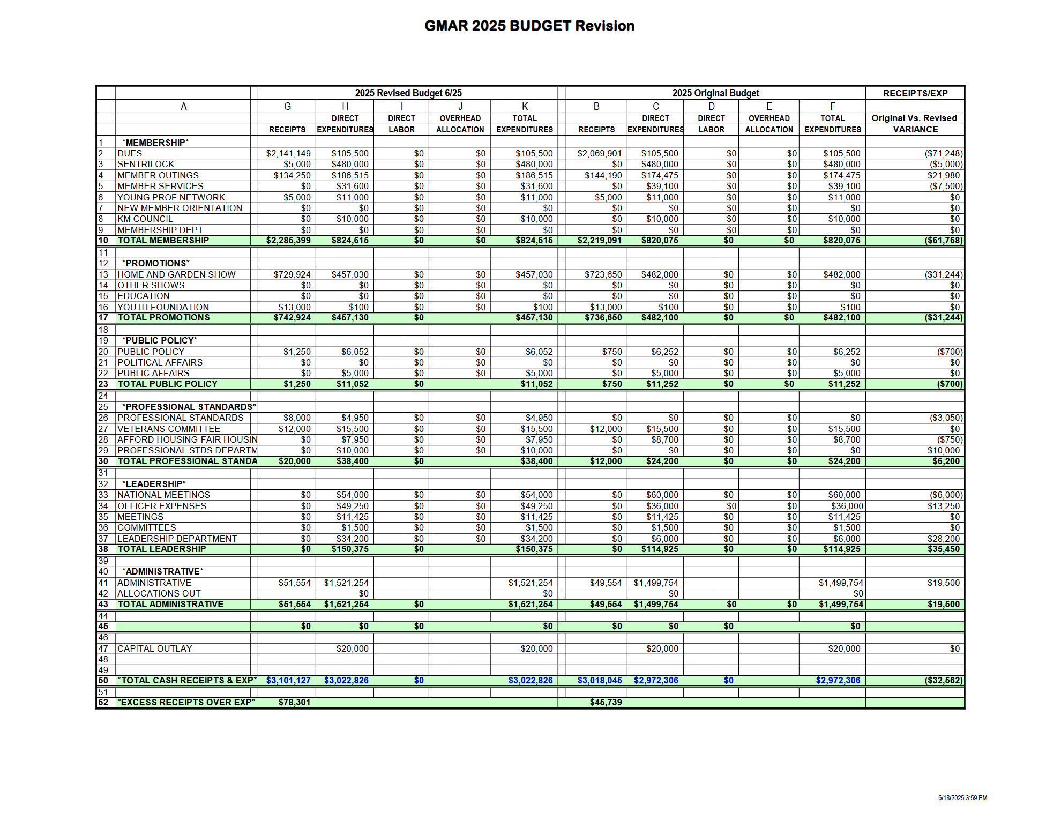
May 2025 Financial Statements

Statement of Financial Position
As of May 31, 2025, GMAR had $2,475,916 in Cash & Investment Balances, up $16,327 compared to last year. Accounts receivable were down $14,606 compared to last year. Prepaid expenses were down $16,065 compared to 2024. Fixed assets increased by $140,296.

Total Assets were $4,320,337 which is up $110,199 compared to 2024.

On the Liability side, accounts payable were up $21,964 compared to last year. Overall, Total Liabilities were $128,426 which is down $9,637 compared to 2024.

GMAR has a Net Gain of $1,619,620 through May 31, 2025, up $6,710 from last year. Overall, Total Net Assets were $4,191,910; $100,562 higher than the same point in 2024.

Statement of Activities
Membership: Through May 2025, $2,067,088 was collected in dues. Last year through the end of May we collected $1,966,518 in dues, so dues are $100,570 ahead of last year at the same time. Renewals were down slightly with regards to membership numbers, but dues were increased by $40 in February 2024, so that increase being in effect for 2025 renewals more than made up for the membership drop and led to an increase in total renewal dues collected. For 2025, GMAR had an 86% renewal based on number of members billed. New member budget for 2025: 500 REALTORS®, 50 DRs and 20 Affiliates. Through May, actual new members: 392 REALTORS®, 20 DRs and 6 Affiliates.

Promotions: Through May, Home and Garden Show income is $729,924 and expenses are $438,427 for a net gain of $291,497. These numbers will still change a bit throughout the next several months. The budgeted net gain for the Show is $241,650.

Expenses related to Public Policy are mostly personnel costs, incurring expenditures primarily in Labor and Overhead. The majority of Professional Standards expenses are related to the fair housing ads.

The Leadership section includes expenditures for meetings, committees, officer expenses, strategic planning, NAR surveys and NAR meetings. The main expenses recorded through May were travel for meetings, meeting costs, memberships, sponsorships, and Bucks tickets.

The Administrative section includes investment and rental income and expenses for professional fees, salaries, fringe benefits, building, insurance, occupancy, property taxes, general office expenses and depreciation.

The bottom line shows net income of $1,619,620. Last year net income was $1,612,910 for the same time period.
Statement of Financial Position (Balance Sheet)
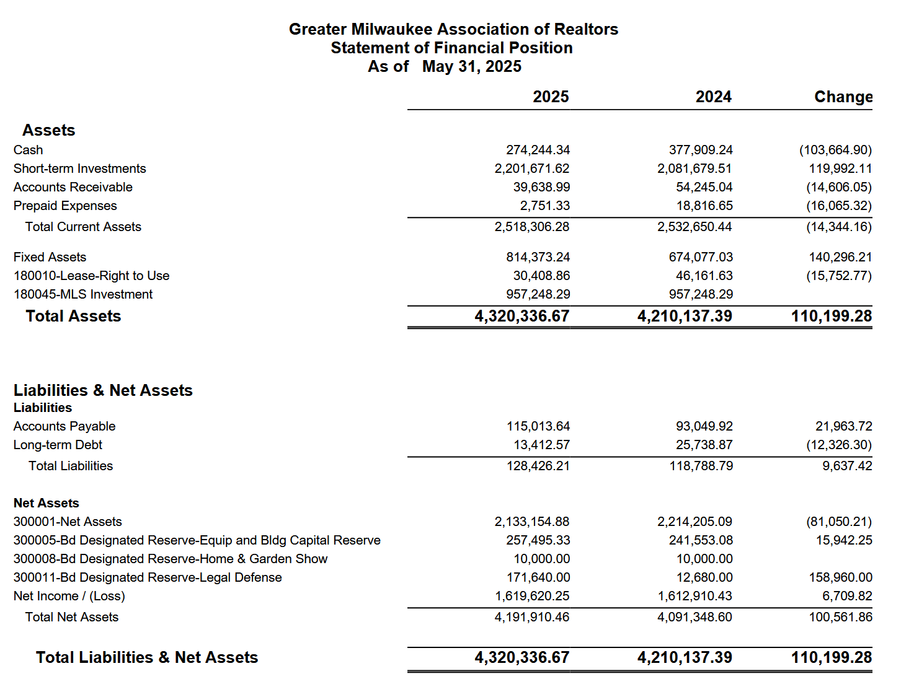

Statement of Activities
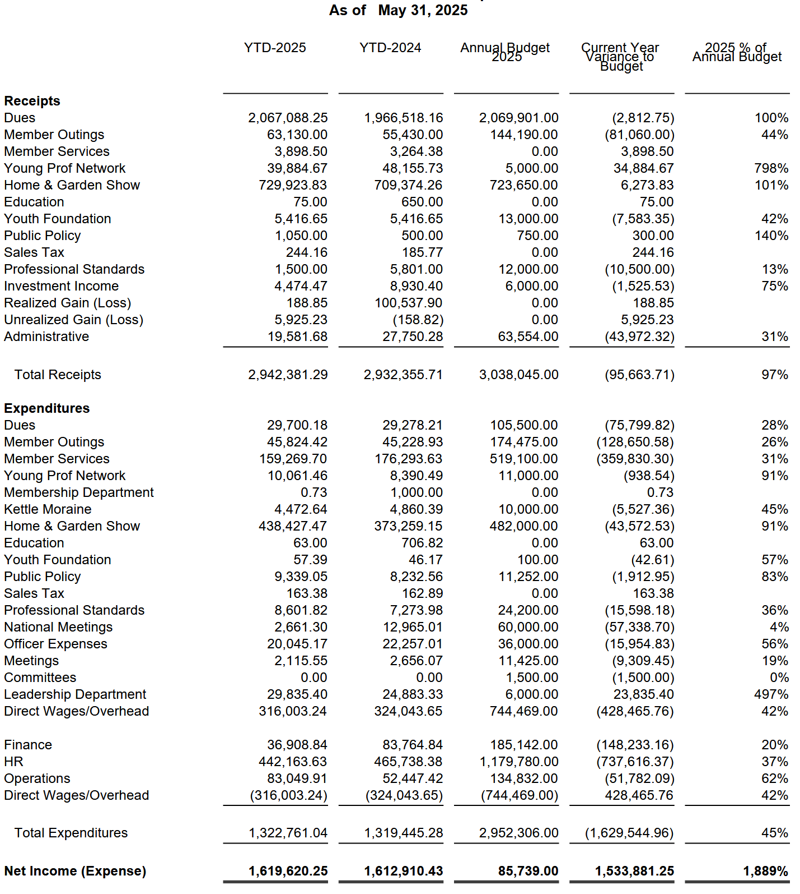

MEMORANDUM

To: GMAR Board of Directors

From: Mike Ruzicka, President

Re: President’s Report

Date: July 7, 2025

Discover Milwaukee p 28
We are now proceeding with executing the business plan we presented to the board at our April meeting. In short, we plan to position DiscoverMilwaukee.com to be an essential resource for people looking to relocate to Milwaukee with a robust social media plan, advertising strategy, and strong community engagement.

There are five main initiatives we are undertaking right now:
      - Updating the calendar, cleaning up some blurry images, and placing video on the site
      - Adding the city and neighborhood features
      - Developing an advertising campaign
      - Selling ad space on the site
      - Incorporating an MLS API so viewers can see potential homes, directing them to members

Tonya Thomsen, emailed me to point out that we have to be careful to avoid potential Fair Housing violations. The plan called for focusing on “family-friendly” neighborhoods, “working-class” communities, etc.

REALTOR® Safety/Tether RE p 32
At our last director’s meeting we discussed the results of a survey GMAR conducted on Tether RE and the consensus was that the GMAR should negotiate with Tether to provide the service to members, but there was no appetite to increase dues to provide it.

There was no consensus, however, on whether or not the association should pay for members’ fees, or part of the fees (the annual fee would be approximately $60/yr).

During the July 2nd Executive Committee meeting, the group suggested the GMAR negotiate a 500-agent deal for $5/mo ($60/yr), and the association promote it as a member discount (off the $10/mo regular price).

The cost of offering Tether RE is varied:

- If we pay for 500 agents, the cost is $5 per user = $2,500 per month ($30,000/Yr)
- If we pay for 1,000 agents, the cost is $4 per user = $4,000 per month ($48,000/Yr)
- If we pay for 2,000 agents, the cost is $3 per user = $6,000 per month ($72,000/Yr)
- Members would have to pay for reverse lookups ($0.25 per) and criminal background checks ($1.00 per) individually
- If we pay for all 5,000 agents, the cost is $1.25 per user = $6,250 per month ($75,000/Yr). This option would also include 4 reverse lookups and 4 criminal background checks

At the last directors meeting I outlined the various options for the board to consider:

- Offer Tether RE to 500, 1,000, 2,000, or all 5,000 members for free. The BOD should discuss increasing dues to cover the costs for the various levels.
- Let members know they can subscribe to the service on their own, no GMAR expense.
- Offer to underwrite a portion of subscriptions, $1 or $2 per member, per month. Again, the BOD would discuss increasing dues to cover the costs.

SentriLock P 34
Our current SentriLock contract comes to an end later this year, on September 30th, and the time has come for us to decide what to do next year. Based on our past discussions, the consensus of the directors appears to be to renew just the SentriLock Service Key (the service associated with using the lockboxes, the software, and the SentriLock app).

The current lockbox inventory would be parceled out to members this summer by averaging the three prior years of listing (like how we did in 2018). Members would be allowed to own these boxes, and we would then begin having members purchase new boxes as they need them.

Our current 2018-2025 SentriLock lease is for 3,500 licenses. Renewing just the Key Fee does not require us to guarantee a given number of licenses, but for budgeting purposes we would probably use 3,250 licenses.

We do need to discuss how much to charge for new boxes. The GMAR can buy boxes for $97 (500 boxes would cost $48,500). We are discussing charging members $110 +Tx = $116.16

During the July 2nd Executive Committee meeting, the directors asked about continuing with another lease program, so that the boxes would not cost members an additional $100+ which may lead to lower use in the future.

2026 Dues
We need to decide what to charge for dues in 2026. WRA will email dues bills by early September. For 2025 we increased dues $40 to $405 to create a dedicated legal action fund. That fund has $171,640 in it as of 5/31 and it may reach $180,000 by year end.

We should discuss whether to keep the $40 increase for 2026. On one hand we can argue to keep it, because you never have enough money for legal defense. However, on the other hand, a lot of members are not doing much business in the current market environment, and $40 decrease might be welcome.

The big question: Is a $40 decrease out of the total dues bill of $1,039 noticeable (GMAR $405.00 + WRA $433.00 + NAR $156.00 + $45)? Will members appreciate it, or just say “Meh!”

During the July 2nd Executive Committee meeting, the group advocated that the association reduce dues by even a few dollars and let members know of all the benefits they receive (i.e. Tether discount, SentriLock, etc.) for an affordable fee.

Strat Plan p 35
Our current strategic plan is below. We sent out a member survey on June 26th to inform the board of the opinions and problems of our members. I will provide a copy of the survey results at our meeting, and I would like to review them along with the priorities we’ve identified in the strategic plan to see if we need to adjust any component(s).

GMAR Building Remodel & Building Mortgage
The GMAR building remodeling project is essentially complete. We are waiting for US Bank to transfer our current construction loan into a commercial mortgage.

Badger Institute Housing Report
The right-leaning Badger Institute has published a compilation of its year-long research effort into how to make housing more attainable in Wisconsin. See the press release here, and the full report here: https://www.badgerinstitute.org/wp-content/uploads/2025/06/Badger-Institute-Housing-Research-060425.pdf

Recurring Reports

2025 GMAR Organizational Chart P 41

2025 GMAR Board of Directors Roster P 42

2025 GMAR Calendar P 43

 Business Plan

Executive Summary
The GMAR will purchase and run the DiscoverMilwaukee.com (DM) website in order to promote the SE Wisconsin region to potential home buyers and to drive business to our members.
DiscoverMilwaukee.com is a powerful tool for the Greater Milwaukee Association of Realtors (GMAR) to fulfill its mission to “help members help their clients.” It does this by offering members an opportunity to connect with potential clients, showcasing the region's quality of life, and providing valuable information to individuals considering a move to Milwaukee. By acquiring DiscoverMilwaukee.com, GMAR is positioned to attract and acquire new clients for members who are relocating to Milwaukee and those looking to move within the metropolitan area – marking a proactive step toward fulfilling the association's mission, which traditionally begins after clients are identified.
Currently, the competition for DiscoverMilwaukee.com is minimal. VISIT Milwaukee focuses on tourism, while MMAC/M7 targets business recruitment in the area. A Google search for "move to Milwaukee" places DiscoverMilwaukee.com as the third result, reflecting its prominence.
The GMAR plans to fund DiscoverMilwaukee.com’s operational expenses through existing association funds, with an eye toward growing site revenue. The association aims to enhance the site’s visibility, traffic, and growth through a detailed social media and advertising strategy.
At the end of 2025, GMAR will assess the viability of DiscoverMilwaukee.com based on the outcomes of these initiatives.

Social Media Plan
- Housing & Relocation Resources
- Promote DiscoverMilwaukee.com: Highlight the website as the go-to relocation resource.
- Greater Milwaukee City & Neighborhood Series: Feature neighborhoods across Milwaukee, Waukesha, and Washington counties. Each post will address local amenities, affordability, and unique features.
- Cost of Living Breakdown: Visual content comparing Milwaukee to other cities on essentials like rent, groceries, and transportation.
- New Construction Highlights: Showcase new housing developments.
- School District Spotlights: Focus on family-friendly neighborhoods.
- Testimonials: Share quotes from locals and new residents to build credibility.
- Apartment & Housing Trends: Include data on rent and the best areas to live.
- Walkability & Transit Info: Promote walkable neighborhoods and public transit tips.
- Utilities Tips: Offer guidance for new residents setting up services like electricity, water, and waste.
- Lifestyle & Local Culture
- Local Events: Highlight ongoing community events, including street festivals, concerts, and markets.
- Hidden Gems: Feature lesser-known spots like unique coffee shops, parks, and murals.
- Milwaukee Lifestyle: Showcase the city’s lakefront living, biking culture, and brewery scene.
- Relocation Inspiration: Promote why people love living in Milwaukee—affordability, arts, and walkability.
- Food & Drink: Highlight the city's best brunch spots, breweries, and local eateries.
- Made in Milwaukee: Feature local businesses, artisans, and breweries.
- Healthcare Access: Share information on healthcare facilities like top hospitals and wellness centers.
- Educational & Visual Content
- “This Weekend in MKE”: Promote upcoming local events.
- Milwaukee Fun Facts: Share interesting facts (e.g., Milwaukee’s coastline vs. Miami's).
- Maps & Infographics: Provide useful resources like “Dog-Friendly Parks” or a “Brewery Trail” map.
- Video Content: Create engaging short-form content like walking tours, drone shots, and local interviews.
- Community & Collaborations
- Influencer Partnerships: Collaborate with local influencers and businesses to amplify content.
- Seasonal Content: Highlight seasonal attractions such as tulips in spring, winter lake walks, and summer fireworks.

Greater Milwaukee City & Neighborhood Series: Example Posts
- Glendale: Quiet, accessible with green spaces and Sprecher Brewery. Median home price: ~$275K. Rent: $1,100–$1,400.
  - Fun Fact: Home to Sprecher Brewery.
  - Hidden Gem: Kletzsch Park.
  - Vibe Check: Calm, suburban.
- Cudahy: Working-class community near the lake with a rich history. Median home price: ~$225K. Rent: ~$1,100–$1,200.
  - Fun Fact: Founded by Patrick Cudahy (the bacon magnate).
  - Hidden Gem: Sheridan Park with lake views.
  - Vibe Check: Quiet, close to the lake.
- Cedarburg: Historic charm with a vibrant arts scene. Median home price: ~$375K. Rent: ~$1,200–$1,600.
  - Fun Fact: Historic district listed on the National Register of Historic Places.
  - Hidden Gem: Cedar Creek Winery.
  - Vibe Check: Charming, walkable, festive.

Advertising & Revenue Plan
- Database Review: Analyze existing advertisers and assess their fit for digital opportunities.
- Develop Digital Ad Offerings: Create rotating banner ads, featured placements, and sponsor spots.
- Outreach to Advertisers: Engage with existing sponsors about digital-only options.
- Set Pricing: Establish pricing for digital sponsorships and create a pitch deck for potential sponsors.
- Revenue Generation: Explore affiliate marketing, sponsored content, and additional community partnerships to increase revenue.

Partner & Stakeholder Engagement
- Partnership Outreach: Collaborate with partners like MMAC, Visit Milwaukee, and key local sponsors such as We Energies.
- Community Collaborations: Build relationships with local influencers, non-profits, and businesses.
- Affiliate & Sponsored Content: Pursue opportunities for additional content partnerships and revenue.

Site Optimization & Growth
- Content Updates: Regularly refresh community and school sections.
- Email Newsletter: Launch a newsletter featuring weekly highlights, neighborhood spotlights, and relocation tips.
- Google Ads & Social Media Campaigns: Test ad strategies to boost site visibility.
- Site Performance Tracking: Use Google Analytics to monitor traffic and adjust strategies.
- Expansion: Look for opportunities to expand with features like drone videos, interactive maps, and city guides.

Conclusion
With a robust social media plan, a detailed advertising strategy, and strong community engagement, DiscoverMilwaukee.com is positioned to be an essential resource for people looking to relocate to Milwaukee. By focusing on content growth, partnerships, and site optimization, the GMAR can ensure that DiscoverMilwaukee.com continues to provide value for its members, attracting new clients while showcasing Milwaukee’s unique lifestyle and offerings. 2025 will be critical for evaluating the feasibility and sustainability of this project moving forward.

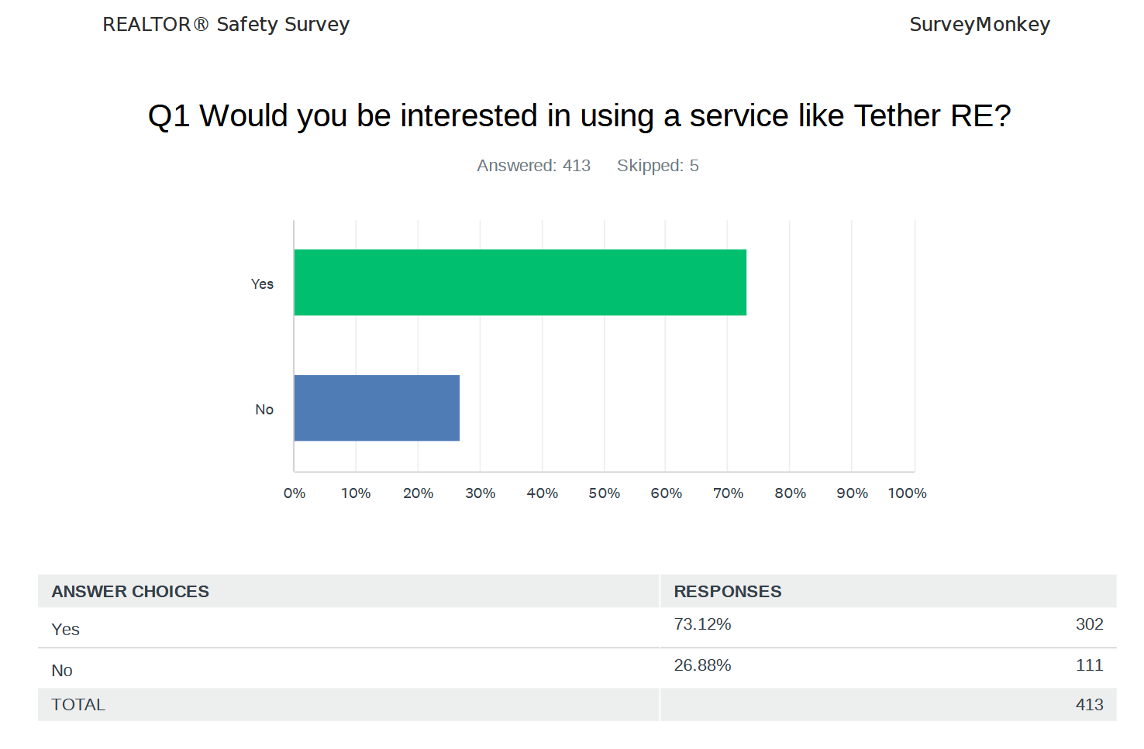

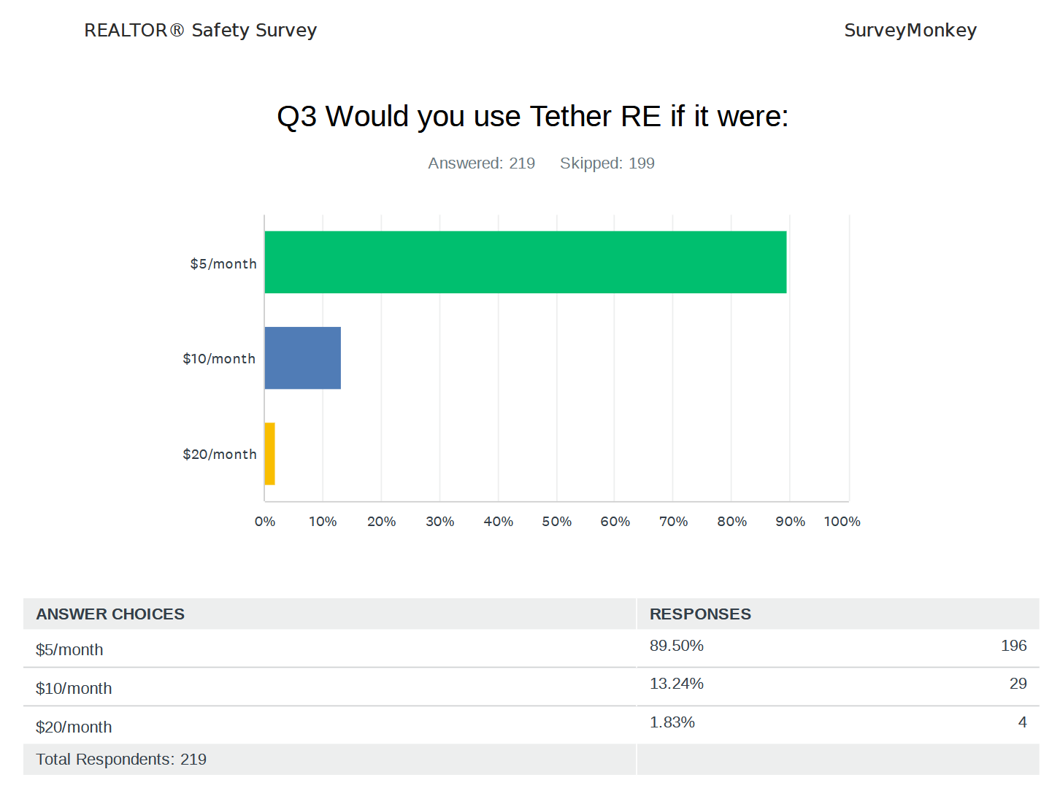
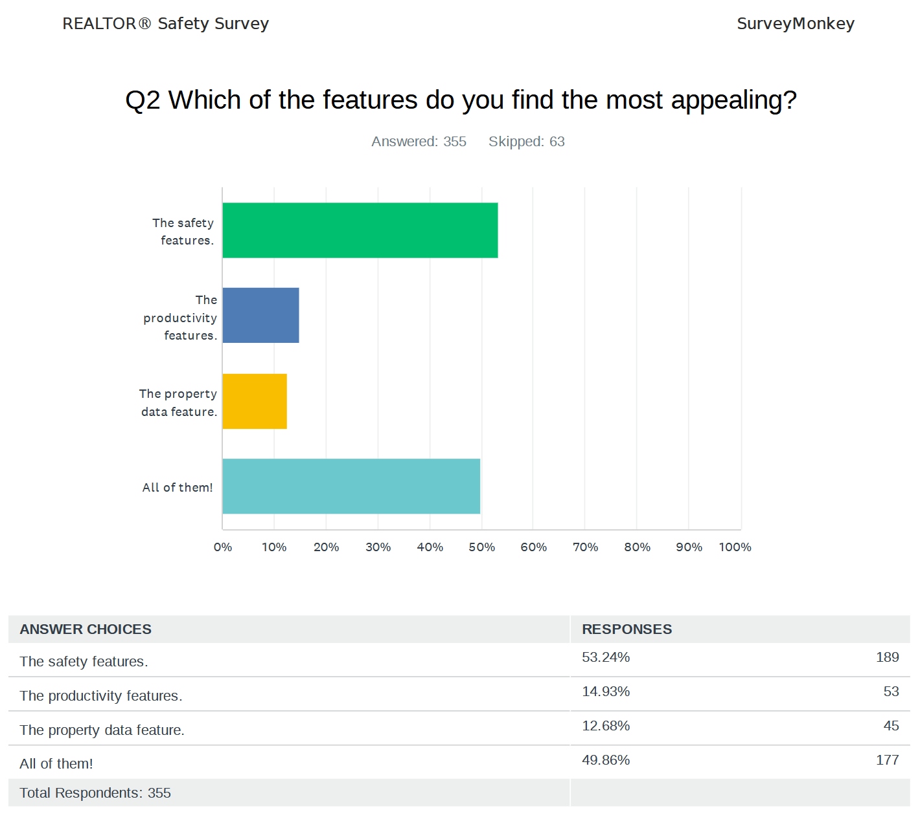

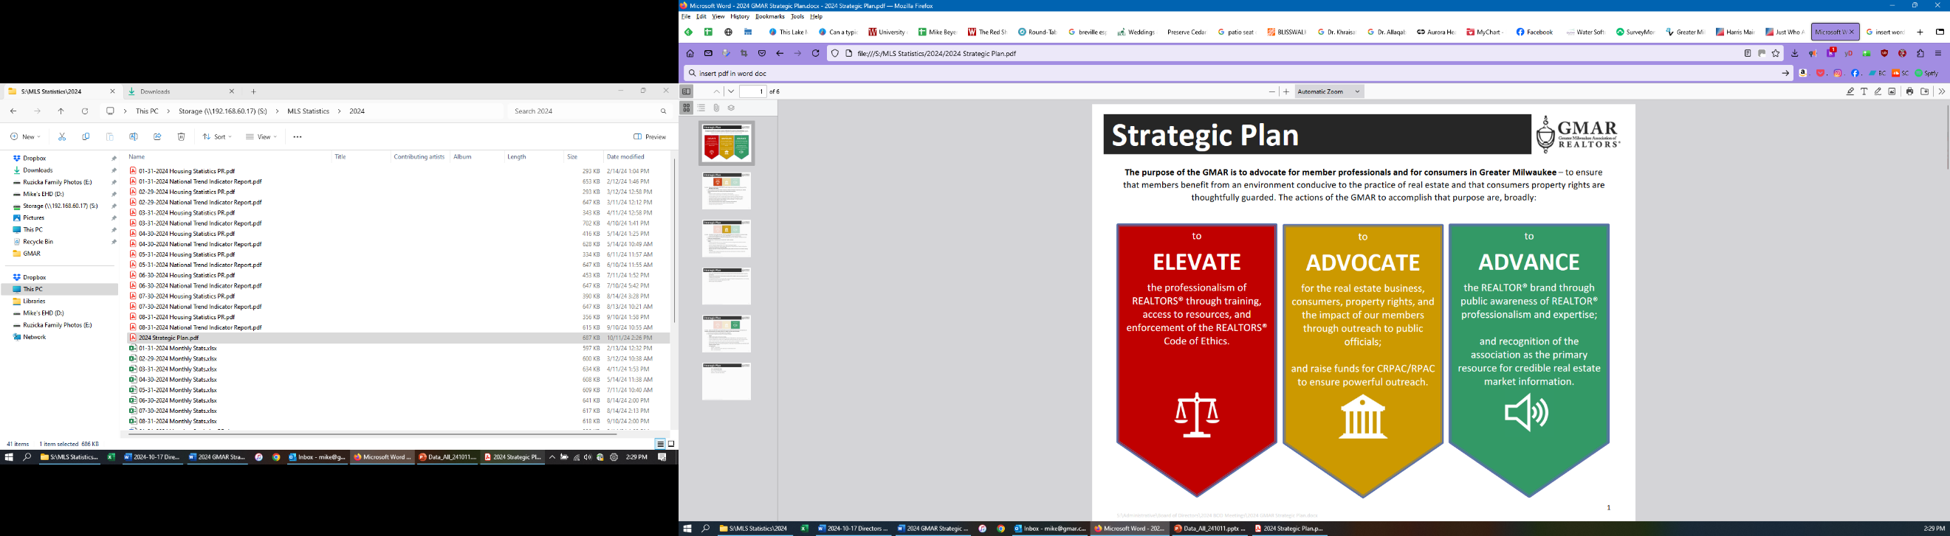

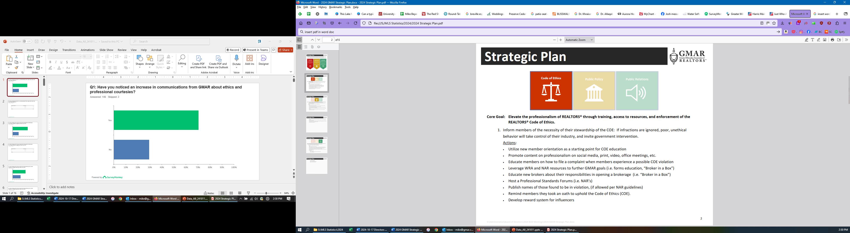

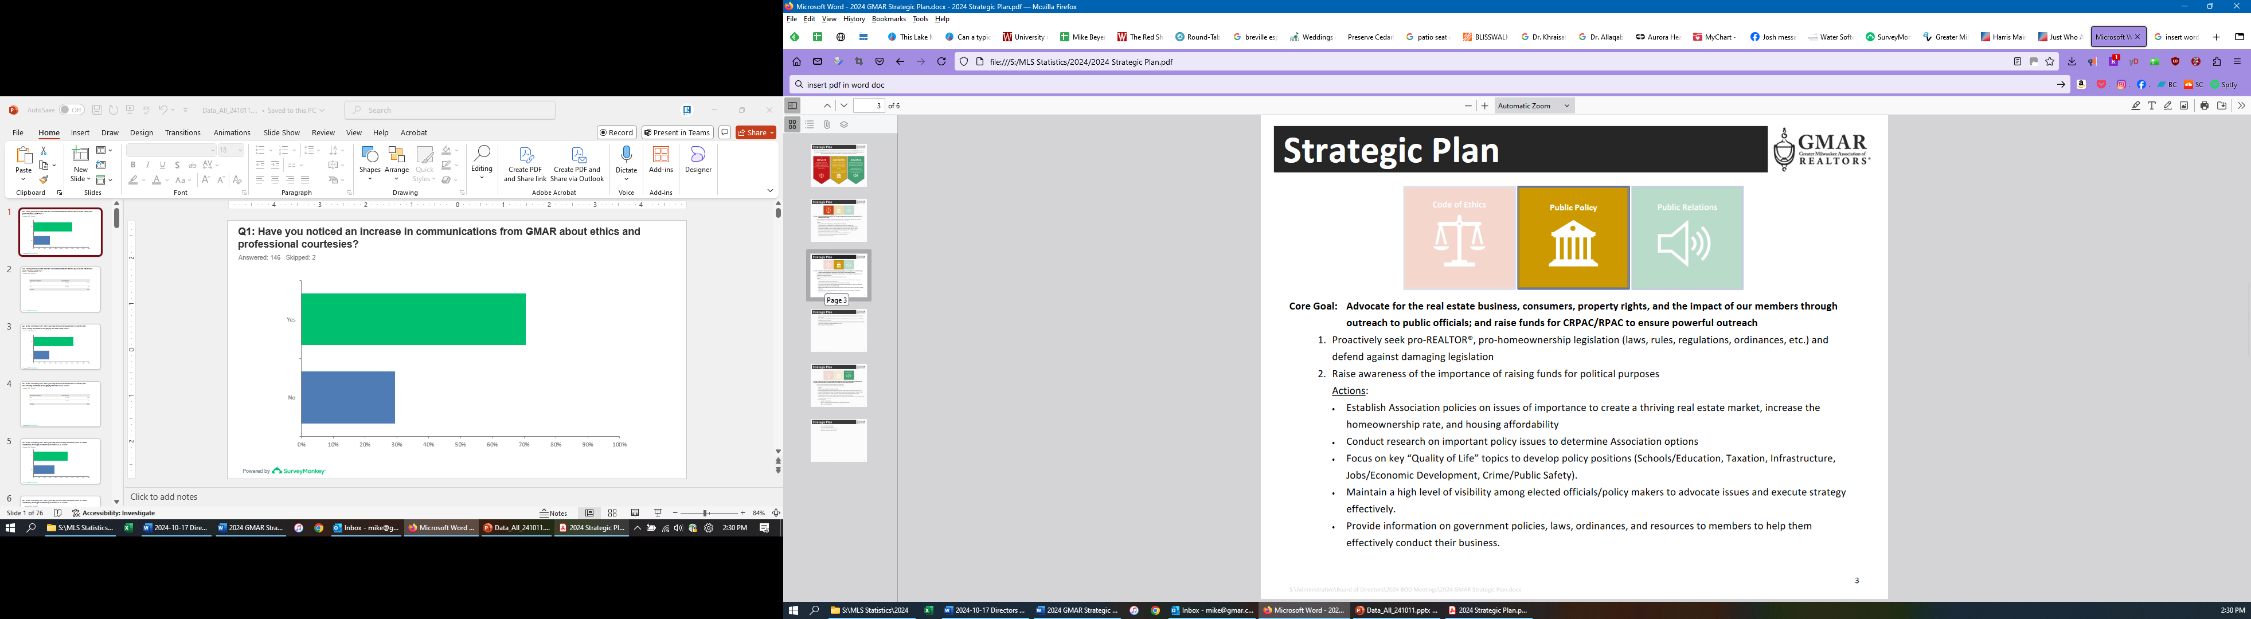

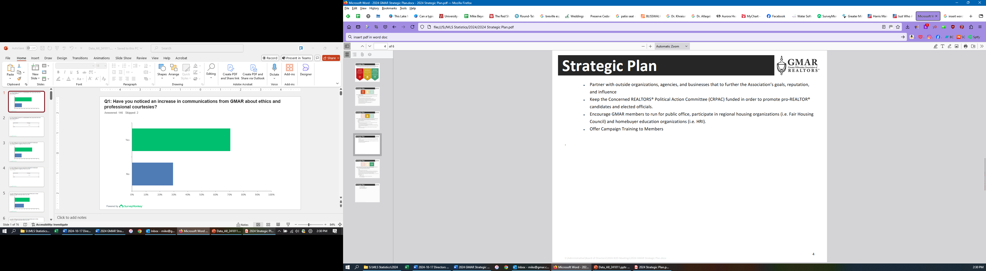

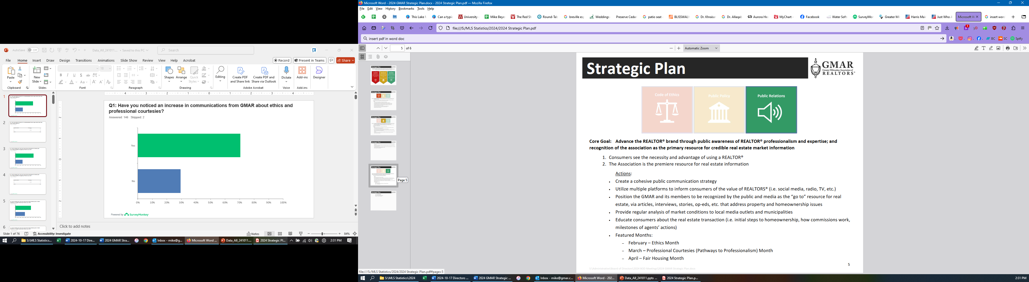

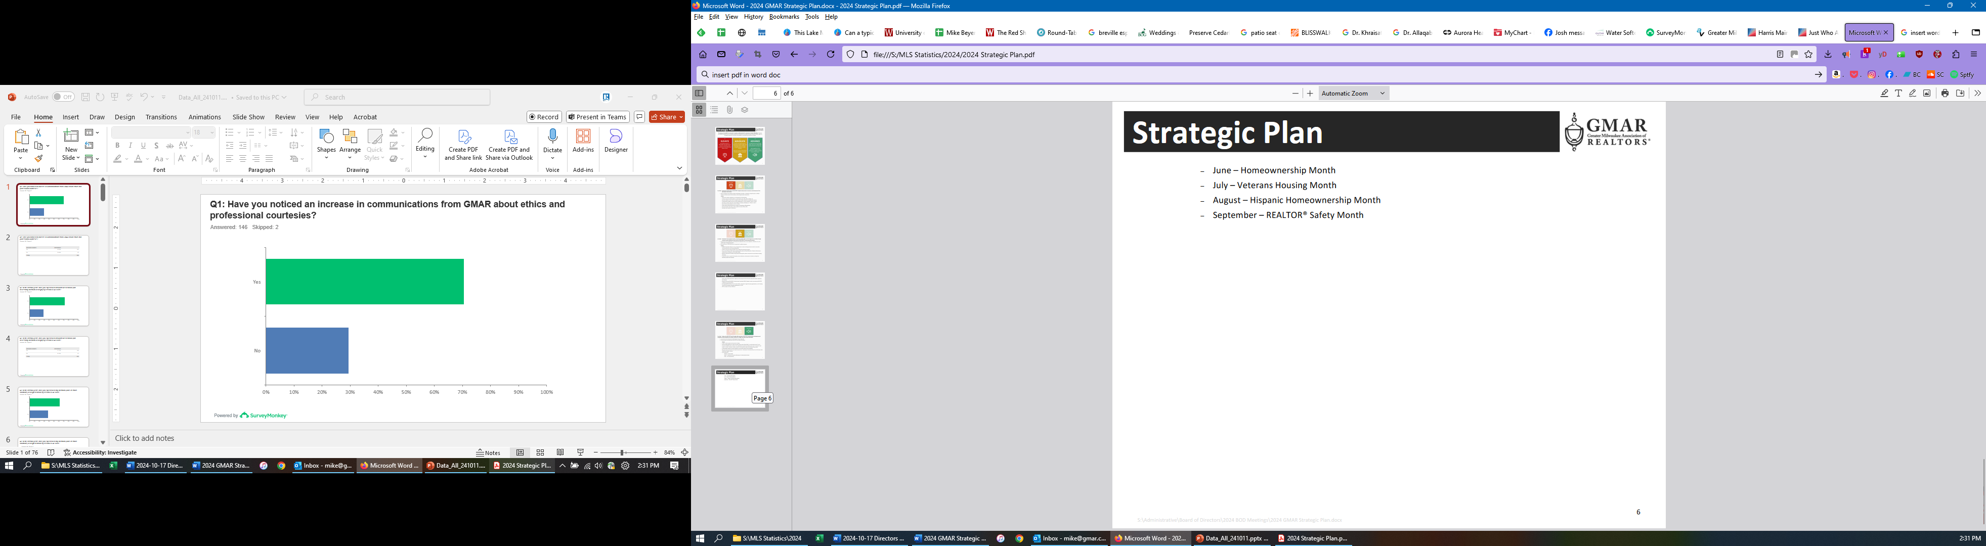

GMAR 2025 Organizational Chart

2025 GMAR Board of Directors

Terms expiring  12/31/2025 | Terms expiring  12/31/2026 | Terms expiring  12/31/2027
John Horning  Shorewest Realtors  17450 W North Avenue  Brookfield, WI 53045  O 262.827.4200 M 414.416.4505  jphorning@shorewest.com  M1: 090015743  (3yr term from Exec Roundtable) | Scott Klaas  Keller Williams Realty  2665 S Moorland Rd, Suite 104  New Berlin, WI 53151  O 262.696.9884 M 262.347.9329  sklaas@kw.com  M1: 090121392  (3yr term from Exec Roundtable) | Abby Hauke, Chairwoman  First Weber Inc.  2750 Golf Rd, Suite A  Delafield, WI 53018-2063  O 262.646.6800 M 262.468.6364  ahauke@firstweber.com  M1: 090148324  (3yr term from Exec Roundtable)
Sarah Cole, Past Chair  Landmark Realty (2nd Term)  3800 S 97th St  Milwaukee, WI 53228  M 414.510.4903  colesarahb@gmail.com  M1: 090128495 | Tom McCormick, Chair-Elect  Exit Realty Horizons  1417 N Wauwatosa Ave., Ste 201  Wauwatosa, WI 53213-2646  O 414.771.7144 M 414.241.2272  tmccormick@exithorizonswi.com  M1: 090070736 | James Krickeberg (1st Term)  The Krickeberg Group, LLC  of Keller Williams Realty  2665 S Moorland Rd #104  New Berlin, WI 53151  M 262.442.4845  james.krickeberg@kw.com  M1: 090143038
Shawn Govern, Secretary/Treasurer  Perfection Plus R E Services (1st Term)  3119 W Minnesota Ave  Franklin, WI 53132-8458  M: 414.617.7574  sgovern@wi.rr.com  M1: 090041059 | Jose Flores (1st Term)  First Weber Inc.  10521 W Layton Ave  Greenfield, WI 53228  O 414.543.7800 M 414.704.4400  josefloreshomes@gmail.com  M1: 0885500352 | Tonya Thomsen (1st Term)  Thomsen Team  N16W23233 Stone Ridge Dr, Suite 200  Waukesha, WI 53188  O 262.424.3138  Tonya@ModernRPwi.com  M1: 090075411
Mark Kivley (2nd Term)  RE/MAX Lakeside  1200 E Capitol Dr Ste 200  Milwaukee, WI 53211  M 414.406.1840  kivleyteam@lakesiderealtors.com  M1: 090020696 | Sarah Venes (1st Term)  First Weber, Inc.  2750 Golf Rd, Suite A  Delafield, WI 53018-2063  O 262.646.6800 M 262.349.5083  venes@firstweber.com  M1: 090136786 | Tom Telderer (1st Term)  RE/MAX Lakeside - The Benson Group  5341 S 27th Street  Greenfield, WI, 53221  M: 414.881.0058  tom@bensongrouprealtors.com  M1: 090026568
Arthur Mays  Realty Among Friends LLC (1st Term)  8301 W Lisbon Ave  Milwaukee, WI 53222-3859  M: 414.975.7796  amays@realtyamongfriends.com  M1: 090051977 | Dan Weber (1st Term)  Shorewest Realtors  2419 W. Washington St.  West Bend, WI 53095  M 262.689.5827  dweber@shorewest.com  M1: 090058736 | Theresa Dixon (1st Term)  Wisconsin Real Estate Group  250 S Executive Drive, Ste 225  Brookfield, WI 53005  theresa@wrgpros.com  M1: 090171629
Ryan Stefaniak (1st Term)
The Stefaniak Group LLC
2234 S 108th Street
Milwaukee, WI 53227
M 414.881.5034
stefaniakryan@gmail.com
M1: 090144065

Mike – 885500353
Marne – 090082562
Scott – 885500171

2025 Calendar

January
1 GMAR Fiscal Year begins
6 Schedule Member Focus Group
6 Send Out Member Survey (for BOD Mtg)
9 GMAR Executive Committee Meeting
10 Member Census/Top 10 Pick
14 MLS Stats Press Release
15 GMAR Financials / Update Dashboard
16 GMAR Board of Directors Meeting – 12:00 Noon
16 For BOD Mtg:
- Membership Stats & Graphs
- Top 10 Representative
- Conflict of Interest/Harassment Policy
16 Youth Foundation Paint & Wine Event
22-24 Inman Connect New York
23 GMAR Youth Foundation Board Meeting

February
12 MLS Stats Press Release
12 Public Policy Task Force Meeting
15 BOD Snapshot
15 GMAR Financials / Update Dashboard
20-21 WRA Board of Directors Meeting – Madison Club, Madison, WI
26 HousingWire Economic Summit – Dallas, TX

March
13 MLS BOD Meeting
12 MLS Stats Press Release
15 BOD Snapshot
15 GMAR Financials / Update Dashboard
21-30 99th REALTORS® Home & Garden Show – Wisconsin Expo Ctr, West Allis, WI

April
3 Schedule Member Focus Group
7 Send Out Member Survey (for BOD Mtg)
8 GMAR Past Chairmen/women Luncheon – Delafield Hotel
10 GMAR Executive Committee Meeting
14 MLS Stats Press Release
14 Brewers Bash – American Family Field, Milwaukee, WI
15 GMAR Financials / Update Dashboard
16 (Wednesday) GMAR Board of Directors Meeting – 12:00 Noon
17 REALTOR® & Government Day – Madison, WI
24 GMAR Youth Foundation Board Meeting
28 GMAR Audit – Wegner & Assoc.
29 Large Broker Meeting w/ NAR – Harley Davidson Museum, Milwaukee

May
1 RPAC Auction
14 MLS Stats Press Release
15 BOD Snapshot
15 Public Policy Task Force Meeting
15 GMAR Financials / Update Dashboard
21 Kettle Moraine REALTORS® Council RPAC FR
23 Deadline for NAR Committee Applications
31 – June 5 NAR REALTORS® Legislative Meetings – Washington, D.C.

June
12 MLS BOD Meeting
13 WRA Board of Directors Meeting
15 BOD Snapshot
15 GMAR Mid-Year Budget Review
15 GMAR Financials / Update Dashboard
25 WomenStrong GMAR Women’s Conference – Brookfield Conference Center
30 Schedule Summer Strategic Planning Session

July
1 GMAR BOD Candidate Applications available to members
1 Send Out Member Survey (for BOD Mtg)
2 GMAR Executive Committee Meeting
8 GMAR Board of Directors Mtg – Ironwood Golf Course
8 For BOD Mtg:
- Budget Revision
- Dues Rate for Following Year
8 GMAR Summer Golf Outing – Ironwood Golf Course
15 MLS Stats Press Release
15 GMAR Financials / Update Dashboard
17 GMAR Youth Foundation Board Meeting
31 Check in w/ Addendum A Committee
__ YPN White Party

August
11-12 NAR Leadership Summit – Chicago, IL (Chair-Elect)
12 MLS Stats Press Release
__ New GMAR Chair Orientation
- NAR Organization Assessment Checklist
__ Recruit Potential Board Directors
__ GMAR Nominating Committee Meeting
13 Public Policy Task Force Meeting
15 BOD Snapshot
15 GMAR Financials / Update Dashboard
31 Last day for GMAR BOD Candidates to submit Applications

September
1 Nominating Committee notification of BOD Candidates to membership
12 MLS Stats Press Release
15 BOD Snapshot
15 GMAR Financials / Update Dashboard
__ Veterans Committee Event
__ Kettle Moraine REALTORS® Council Wine Tasting – Terrace 167, Richfield, WI
__ CMLS Annual Conference
TBA WRA Convention

30 GMAR Board of Directors Write-In Candidate Deadline

October
1 Schedule Member Focus Group (Ask Exec/BOD about topics)
12-18 GMAR Board of Directors e-Election
14 MLS Stats Press Release
9 MLS BOD Meeting
9 GMAR Executive Committee Meeting
15 GMAR Financials / Update Dashboard
16 GMAR Board of Directors Meeting – 12:00 Noon
16 For BOD Mtg:
- Strategic Plan
- Bylaws Update
- Annual Budget
- MLS BOD Appointment(s)
- Executive Committee Election
16-17 WRA BOD Meeting
23 GMAR Youth Foundation Board Meeting

November
1 Complete NAR Core Standards Application
12 MLS Stats Press Release
12-17 NAR Convention – Houston, TX
15 BOD Snapshot
15 GMAR Financials / Update Dashboard
20 Public Policy Task Force Meeting

December
__ Chair’s Holiday Party & GMAR Annual Mtg – TBA
12 MLS Stats Press Release
__ New Director Orientation
__ GMAR Youth Foundation Annual Meeting
15 BOD Snapshot
15 GMAR Financials / Update Dashboard
31 GMAR Fiscal Year ends

