GMAR Board Of Directors
Wednesday, October 15, 2025 • 12:00 PM
GMAR Headquarters • Wauwatosa, WI

Meeting Agenda

Welcome & Introductions  Consent Agenda | P 7 | Approval | 12:00 PM
Reports  - Chairwoman, Abby Hauke  - Secretary/Treasurer  - 2026 Budget*  - August 2025 Financial Statements  - President’s Report  - Departments  - Professional Standards  - Government Affairs  - Membership  - Communications  - SentriLock  - Home & Garden Show  - Metro MLS, Inc. Update | P 16  P 18  P 21 | Information  Approval  Approval  Approval  Information  Information  Information  Information  Information  Information | 5 Min  5 Min  20 Min  10 Min  10 Min  10 Min  10 Min  10 Min  10 Min

Old Business
- None
New Business  Election of 2026 Executive Committee  Chair-Elect  Secretary/Treasurer |  | Approval  Approval | 5 Min  5 Min
Adjourn |  |  | 2:00 PM

Upcoming Meeting Dates

GMAR Directors Meeting • Thursday, January 16th 12:00 PM

2026 Calendar on Page 37

* Indicates hard-copy information will be available at the Directors meeting. Updated: 12/9/2025 4:35 PM
Directors’ Policies & Responsibilities

Fiduciary Duty
As a Greater Milwaukee Association of REALTORS® (GMAR) director, you are a fiduciary of the GMAR. This means you have a special legal responsibility in connection with the administration, investment, and care of GMAR and its assets. This requires you to make careful, good-faith decisions in the best interest of GMAR. Your decisions must be made independently and free of any undue influence from any person, organization, or brokerage.

Conflict of Interest Policy
A member of any Greater Milwaukee Association of REALTORS® (GMAR) decision-making body has a conflict of interest whenever that member is a principal, partner, or corporate officer of a business providing, or being considered as a provider of, products or services to GMAR.

Members with a conflict of interest must immediately disclose such conflict of interest prior to participating in any discussions or vote of a GMAR decision-making body that pertains to the GMAR. Such members may not participate in any discussions related to the GMAR other than to respond to questions asked of them by other members of the body. A member may not vote on any matter in which the member has a conflict of interest.

Antitrust Policy
The Greater Milwaukee Association of REALTORS® (GMAR) is a 501(c)(6) non-profit corporation with members belonging to varying brokerages and business models. Whenever competing (or potentially competing) businesses gather, there is the risk of antitrust liability or of the appearance of anti- competitive activity. Penalties for violating antitrust laws can include huge damage awards and even criminal liability. Just defending an antitrust suit or being the object of an investigation by antitrust regulators comes with remarkably high costs. Liability for violations of the antitrust laws could accrue to the GMAR and also to members accused of participating in alleged anticompetitive activity.

Consequently, responsibility for compliance with competition laws lies with the GMAR, its members, and their leaders. This policy is thus intended to prevent any anti-competitive conduct by the GMAR; but it also aims to reduce even the appearance of anti-competitive conduct.

The GMAR is committed to compliance with all international, national, and state/provincial antitrust and competition laws. This commitment includes the following objectives:

- GMAR’s activities will increase competition among its members by providing information to them regarding effective business practices. The GMAR’s actions must not function to reduce competition.
- GMAR provides a forum for members to discuss their industry and understand developments within it; but the GMAR will not be a forum for members to develop collective action plans that would reduce competition.
- GMAR will adhere to the procedures described below to minimize the risk of even the appearance of anticompetitive conduct.

Procedures for formal meetings
The following procedures apply to all meetings of the Greater Milwaukee Association of REALTORS® (GMAR) board of directors, committees authorized by the Association, and member meetings conducted under GMAR auspices, whether the meetings are held face to face or via technological means. Individuals charged with chairing Metro MLS meetings should be familiar with this policy.

- Each meeting should be preceded by the publication of notice of the meeting to those eligible to attend it and an agenda identifying a business subject for discussion at that meeting.
- Any person who receives an agenda for a GMAR meeting should review it to identify any agenda item that might give rise to concerns about competition or collective action; such items, if any, should be referred to legal counsel for review before the meeting.
- The meeting agenda should be adopted at the beginning of each meeting, and the meeting should follow the agenda.
- At the beginning of each meeting, the chair or counsel should remind participants of this antitrust policy in such a manner as to ensure that participants understand the parameters for appropriate discussions.
- Subject to this policy, every eligible participant in any meeting should be encouraged and permitted to express his/her views on any issue subject to deliberation before a decision is made.
- In the event that a discussion is, or is likely to become, inconsistent with this policy, the meeting chair or counsel shall recommend suspension of the discussion until review under applicable competition law can be conducted; the minutes will note any such suspension.
- After each meeting, GMAR should cause minutes of the meeting to be prepared. These minutes should include a record of the resolutions adopted at the meeting; any objections raised by meeting participants to the subject matter of a meeting, and any other annotations contemporaneously advised by counsel or the meeting chair.
- Minutes of all meetings will be prepared by GMAR staff and reviewed by the Secretary/Treasurer before circulation.
- All board members and GMAR members are asked to comment promptly, in writing, on any minutes circulated in the event that there appears to be any error, omission, or item in need of revision.

Guidelines for discussions
The following guidelines apply to discussions in formal meetings as well as to informal discussions in “breakout sessions” and roundtables and even in social contexts associated with Greater Milwaukee Association of REALTORS® (GMAR) meetings. Of course, no listing of DOs and DON’Ts can be complete, and some items can permissibly be discussed even if they appear in some categories below. However, board members and GMAR members should consult with counsel before engaging in discussion of any of the types described here:
- An agreement, or activity appearing to evidence an agreement, to fix prices, limit product or service offerings, or allocate geographical territory or customers.
- An agreement, or activity appearing to evidence an agreement, to refuse to deal with any third party or parties, whether a vendor or supplier of products or services, or a customer or class of customers.
- An agreement, or activity appearing to evidence an agreement, to limit innovation, product choices, or research relating to any of the foregoing.
- Sharing of recent, current, or planned fee structures; or data regarding operating “input” costs, especially if such costs could affect service prices. This does not prevent the GMAR from gathering and aggregating certain kinds of historical pricing information, subject to counsel’s review.
- Any suggestion that GMAR or its members should take collective action to force a vendor or service provider to change its business models, prices, or service offerings.

Anti-Harassment Policy
The Greater Milwaukee Association of REALTORS® does not tolerate harassment in the workplace. The GMAR expressly prohibits any form of unlawful discrimination and harassment based on race, color, religion, sex, sexual orientation, gender identity, national origin, age, disability, genetic information, military or veteran status, pregnancy, childbirth or related medical conditions, or status in any group protected by federal, state, or local law. This policy applies to all terms and conditions of employment, including but not limited to, hiring, training, promotion, discipline, compensation, benefits, and termination of employment. Further, this policy extends to all GMAR personnel, including officers, managers, administrators, supervisors, staff members, and co-workers, as well as the Board of Directors and members of the Board of Directors, vendors, contractors, customers, students, and suppliers.

Harassment Defined
Harassment includes unwelcome verbal, visual, or physical conduct creating an intimidating, offensive, or hostile work environment. Examples of harassment include verbal (including slurs, jokes, insults, epithets, gestures, or teasing), graphic (including offensive posters, symbols, cartoons, drawings, computer displays, or e-mails), or physical conduct (including physically threatening another, blocking someone’s way) that denigrates or shows hostility or aversion toward an individual because of any protected characteristic. Such conduct constitutes harassment when: (1) it has the purpose or effect of creating an intimidating, hostile, or offensive working environment; (2) it has the purpose of effect of unreasonably interfering with an individual’s work performance; or (3) it otherwise adversely affects an individual’s employment.

Sexual harassment is a form of harassment, and includes the following prohibited behaviors:
- Unwelcome sexual advances, requests for sexual favors, and all other verbal or physical conduct of a sexual or otherwise offensive nature, especially where:
- Submission to such conduct is made either explicitly or implicitly a term or condition of employment;
- Submission to or rejection of such conduct is used as the basis for decisions affecting an individual’s employment; or
- Such conduct has the purpose or effect of unreasonably interfering with an individual’s work performance or creating an intimidating, hostile, or offensive working environment.
- Offensive comments, jokes, innuendos, and other sexually oriented statements;
- Touching, such as rubbing or massaging someone’s neck or shoulders, stroking someone’s hair, or brushing against another’s body;
- Sexual suggestive touching;
- Grabbing, groping, kissing, or fondling;
- Violating someone’s “personal space”;
- Whistling;
- Lewd, off-color, sexually oriented comments or jokes;
- Foul or obscene language;
- Leering, staring, or stalking;
- Suggestive or sexually explicit posters, calendars, photographs, graffiti, or cartoons;
- Unwanted or offensive letters or poems;
- Sitting or gesturing sexually;
- Offensive e-mail or voice-mail messages;
- Sexually oriented or explicit remarks, including written or oral references to sexual conduct;
- Gossip regarding one’s sex life, body, sexual activities, deficiencies, or prowess;
- Questions about one’s sex life or experiences;
- Repeated requests for dates;
- Sexual favors in return for employment rewards, or threats if sexual favors are not provided;
- Sexual assault or rape;
- Any other conduct or behavior deemed inappropriate by the WRA. This list is illustrative only, and not exhaustive.

Reporting Harassment
It is the responsibility of the GMAR and each employee, vendor, customer, member, contractor, student, supplier, and board member to create an atmosphere free of harassment. In addition, it is the responsibility of each employee to respect the rights of their coworkers. If you experience or observe any hostile conduct or harassing behavior, you are required to immediately report the matter (orally or in writing, which is preferred) to the President/Chief Executive Officer, ideally within ten (10) days of the offending conduct. If the conduct involves the President/Chief Executive Officer, you can report the conduct to the Chairperson of the Board of Directors or GMAR leadership.

Complaints should be as detailed as possible, including the names of all individuals involved and any witnesses.

Investigations
Upon receipt of a complaint, the President/Chief Executive Officer will undertake a prompt and thorough investigation of the allegations. Where necessary and/or appropriate, GMAR will consult with legal counsel for assistance in conducting any investigation, especially where an investigation involves GMAR leadership or members of the Board of Directors.

While confidentiality can never be guaranteed, it shall be the policy of the GMAR that confidentiality will be maintained concerning the allegations and the investigation to the extent possible, and particularly when it is determined by WRA that any of the following factors are present:
• Witnesses need protection;
• Evidence is in danger of being destroyed; and/or
• Testimony is in danger of being fabricated or altered.

Employees who fail to cooperate with an investigation conducted pursuant to this Policy, or who breach confidentiality resulting in a threat to the integrity of the investigation, may be disciplined, up to and including termination.

If the investigation establishes that an individual has engaged in harassing, discriminatory, or other wrongful or inappropriate conduct, disciplinary or other corrective action, up to and including termination, will be taken against the offending employees.

The GMAR is committed to enforcing this policy against all forms of harassment. The effectiveness of our efforts depends largely on us being informed of any inappropriate workplace conduct. If harassing conduct is not reported, GMAR may not become aware of a possible violation of this policy and may not be able to take appropriate corrective action.

Retaliation Prohibited
The GMAR expressly prohibits any retaliation or other adverse action against any employee who makes a good faith complaint of discrimination, harassment, or retaliation, or participates in any investigation of such complaint in good faith.

Violations of this Policy
Any individual, regardless of position or title, whom GMAR determines has subjected an individual to harassment or retaliation in violation of this policy, will be subjected to disciplinary or other corrective action , up to and including termination of employment.

Administration of this Policy
The President/Chief Executive Officer is responsible for the administration of this policy. If you have any questions regarding this policy or questions about harassment that are not addressed in this policy, please contact the President/Chief Executive Officer.

All GMAR leadership and members of the Board of Directors shall be educated on this policy on an annual basis at the first meeting of the board of directors each year. The education will cover several topics including, but not limited to, definitions and examples of harassment, including sexual harassment, prohibited behaviors and consequences of engaging in prohibited behaviors, reporting procedures, and responding to reports of harassment.

Conduct Not Prohibited by this Policy
This policy is not intended to preclude or dissuade employees from engaging in legally protected activities/activities protected by state or federal law, including the National Labor Relations Act, such as discussing wages, benefits, or terms and conditions of employment, forming, joining, or supporting labor unions, bargaining collectively through representatives of their choosing, raising complaints about working conditions for their and their fellow employees' mutual aid or protection, or legally required activities.

GMAR Board Of Directors

Consent Agenda

Please note: if any director would like to consider an item in the Consent Agenda, please state that you would like to discuss the item when the Chair asks for a motion to approve the Consent Agenda.

- Reappoint MLS directors Joe Horning, Dave Schmidt, Jr. and Tammy Maddente, for a (3) three-year term.

- It is moved, seconded, and carried to approve the agenda of the Wednesday, October 15, 2025, meeting of the GMAR Board of Directors. p. 1

- It is moved, seconded, and carried to approve the minutes of the Board of Directors meeting from Tuesday, July 8, 2025. p. 8

- It is moved, second, and carried to approve of the 196 new members who have applied to become members of the GMAR and paid the appropriate fees. p. 11

GREATER MILWAUKEE ASSOCIATION OF REALTORS®
BOARD OF DIRECTORS MEETING MINUTES
Wednesday, July 8, 2025 • 8:30 AM
Ironwood Golf Course • Sussex, WI

- Call to Order
Chair Abby Hauke called the GMAR Directors meeting to order at 8:35 AM with a quorum present for the transaction of business.

Present: Abby Hauke, Chairwoman; Tom McCormick, Chair-Elect (via Zoom); Shawn Govern, Secretary/Treasurer; Sarah Cole, Past Chair; John Horning, Arthur Mays, Scott Klaas, Jose Flores, Mark Kivley, Ryan Stefaniak, Dan Weber, James Krickeberg, Tonya Thomsen, Theresa Dixon

Staff Present: Mike Ruzicka, President; Scott Bush, VP Operations; Marne Stück, Government Affairs Director; Joanna Tusing, Director of Promotions; Laura Crowley, Communications Director, Sharon Heilman, Dir of Lasting Impressions

Guest(s): Chris Lambrou, CEO of Metro MLS, Inc.; Jenny Tarkowski, Wegner CPAs

Excused: Sarah Venes, Tom Telderer

- Consent Agenda
- Approve the agenda of the July 8, 2025 meeting of the GMAR Board of Directors.
- Approve the minutes of the Board of Directors meeting from April 16, 2025.
- Approve of 195 new members who have applied to become members of the GMAR and paid the appropriate fees.

M/S/C unanimously, to approve the Consent Agenda.

- Reports
- Chairwoman’s Report
Ms. Hauke informed the directors of some of the topics that were addressed at the NAR Legislative Meetings June 3rd-5th. Topics included capital gains taxes, the supply of homes on the market and what the federal government can do to address it, first-time buyers’ use of IRA savings for downpayments, and independent contractor status.

She also thanked everyone who attended the WomenStrong event on June 25th for their support of the event.

- Treasurer’s Report
- 2024 GMAR Audit – Mrs. Tarkowski reported on the GMAR’s 2024 audit, which is only in draft form at this time. She stated that the GMAR would have received an “Unqualified Opinion” except the Metro MLS audit has not been completed. Auditing standards in the US require the consolidation of wholly owned subsidiaries in the parent organization’s financials.

Mr. Ruzicka stated that he would suggest the GMAR wait until the Metro MLS audit is complete and submit it to Wegner CPAs, so they can provide an unqualified opinion later this year. A consensus of the directors agreed.

- 2025 Budget Adjustment – Mr. Ruzicka provided an explanation of the 2025 Budget Adjustment.

Membership – In September 2024 5,269 members were billed for FY 2025. Renewal forecast was lowered to 4,584 (87%) for 2025. Renewals have come in $71,000 ahead of what was estimated.

Estimated 500 new REALTOR® members for 2025, 50 Designated REALTORS® and 20 new Affiliate members. Reached 61% of the new member goals as of April 30th.

The SentriLock system is a major expenditure in the Membership category, and the association estimated spending $480,000 ($40,000/month) on the service. GMAR is coming in just under that through May 31st.

Promotions – The Home & Garden Show (HGS) has recovered from the pandemic (after a two-year hiatus in 2020 and 2021). It had a pretty solid 2022, better 2023, and the show netted over $300,000 in 2024. Budgeted net income of $241,400 for 2025, but ended up with $272,894.

Public Policy – The bulk of Public Policy expenses are personnel expenditures. Normal additional expenses include funds for a poll, RPAC, REALTOR® & Government Day, the NAR GAD Institute, and sponsorships (i.e., MMAC’s events in Washington DC and Madison).

Professional Standards – Similar to Public Policy, much of the expenditure in Professional Standards (PS) are personnel, but this year the association is subscribing to WRA PS program. Half of all of the expenses associated with PS are covered by WRA.

Leadership – GMAR did not add back the NAR Consumer surveys we had purchased in the past but did add back the Milwaukee Bucks’ tickets for the 2025-2026 season. Preserved travel to NAR and a few other real estate events.

Administration – Added $20,000 expense for a new website development and $20,000 for new computers for most of the staff. Holding salary-related expenses in personnel flat.

Currently the bottom line shows gross income of $3,101,127 with expenses of $3,022,826, for a net ending balance of $78,301 for FY 2025, compared to $45,739 in the original 2025 budget.

M/S/C to approve the Adjusted GMAR Budget for 2025.

- May 2025 Financials – In the interest of time Mr. Ruzicka did not provide a verbal report on the May financials. He informed the directors that they have a copy of the May financials in their Directors Report.

- President’s Report
Mike Ruzicka reported the following in addition to his written memorandum to the Board of Directors:

- SentriLock – Mr. Ruzicka stated that during the Executive Committee (EC) meeting, the EC asked about continuing with another SentriLock lease program, similar to the current program. They were worried that by requiring members to purchase new boxes – costing in excess of $115 each – members would elect to use combination boxes.

Mr. Ruzicka provided the directors with a spreadsheet depicting various ownership and lease scenarios for SentriLock. The directors agreed with the EC’s concern over the use of SentriLock declining if members were required to purchase boxes individually.

After a lengthy exchange of ideas on the topic and its impact of GMAR dues for 2026, a motion was made, seconded, and passed unanimously to: A) proceed with a new SentriLock lease; B) increase member dues going to the GMAR general fund by $5/member ($370 total); and C) reduce the amount dedicated to the Legal Defense Fund by $10/member ($30 total), resulting in total dues of $400 for 2026, a decrease of $5 from 2025.

- REALTOR® Safety
Mr. Ruzicka started the discussion about Tether by asking what the intent of the directors was at the April 16, 2025, meeting, regarding whether the service would be offered to members for free (paid by GMAR) or if they wanted members to pay for it individually.

Mr. Bush stated that he was able to negotiate a $5 discounted fee for GMAR members, but the GMAR would have to guarantee at least 500 members. The maximum exposure the GMAR would face would be $30,000.

Based on a survey the GMAR conducted earlier in 2025, Mr. Ruzicka stated that he would assume more than 1,000 members would take advantage of the service at a $5/month fee ($60/year) level.

Several directors expressed their desire for the GMAR to pay for the service, because of the importance of REALTOR® safety, rather than individuals pay for it.

After several directors expressed their opinions, a motion was made, seconded, and unanimously approved to proceed with offering Tether to members for a $5/month fee ($60/year) for 2026. The board will re-evaluate the service in 2026 to determine whether the GMAR should offer it at no cost to members, realizing that it would involve a dues increase.

- Department Reports

- Professional Standards
Scott Bush reported:
  - After the first six months of the WRA /GMAR Professional Standards administration agreement, things are running smoothly.

  - Mr. Bush will set up an administrative rule hearing process for Sentrilock violations. The Code of Ethics citation policy now falls under the WRA jurisdiction.

- Metro MLS, Inc.
Metro MLS CEO, Chris Lambrou, updated the directors on:

- MLS’ Delayed listings are available in FlexMLS Portal and Subscriptions.
- MLS will only accept the Metro MLS forms for Delayed and Office Exclusive listings
- MLS is closely watching the ongoing national battels on CCP (Clear Cooperation Policy) but nothing has changed on MLS policy.
- Fraudulent Vacant Land listings are on the rise. Mr. Lambrou urged the directors to have their agents verify the proper owner when listing vacant land listings.
- MLS is launching a contract trainers program later this year. They will be making a call out to licensed WI real estate practitioners to apply. The concept is still in the drafting phase but the goal is to pay agents per class to train on MLS products and services.

- Old Business
- None

- New Business
- None

- Adjourn
Ms. Hauke thanked the directors for a productive meeting. The meeting adjourned at 10:05 AM

Respectfully Submitted,

Mike Ruzicka
President/CEO
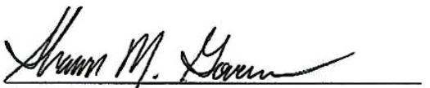
Shawn Govern
Secretary/Treasurer

New Member Report

196 New Members joined July 1, 2025 - October 6, 2025 for approval (R's - 187, A's - 9)

FIRST | LAST | COMPANY
Anthony | Acosta | Keller Williams Realty~MKE
Jennifer | Adams | List2Sell LLC
Adam | Alkhatib | Epique Realty
William | Alt | First Weber Inc~BK
Madison | Altendorf-Massie | Keller Williams Realty~MKE
Isaiah | Amateau | NetWorth Realty of Milwaukee LLC
Amani | Anderson | Keller Williams Realty~MKE
John | Anderson | Lannon Stone Realty LLC
Juan | Angel Romero | Coldwell Banker Realty~Downtown
Najirah | Arif | RE/MAX Lakeside-South
Brenda | Arnett | Venture Realty LLC
William | Awve | Venture Real Estate Goup LLC
Edgar | Ayala Fonseca | Fathom Realty, LLC
Heidi | Baier | Coldwell Banker HomeSale Realty
Mark | Barnard | Shorewest, REALTORS~West Bend
Graham | Barnes | Epique Realty
Lisa | Battikha | Homestead Realty Inc
Jamie | Beardsley | The Wisconsin Real Estate Group
Brett | Beaudoin | Forward Realty Partners
Jack | Behrend | Tim O'Brien Homes Inc
Shanquil | Bey | Acquire Realty LLC
Bridget | Boelter | Shorewest, REALTORS~Downtown
Lakeisha | Booth | Berkshire Hathaway HomeServices Metro Realty
Otha | Bowman | ADT Realty
Brooke | Boyle-Schneider | Roberts Homes and Real Estate
Peggy | Bristol | Boss Realty, LLC
John | Brown | Priority Title Corp
Jennifer | Brusso | Johnson Realty & Associates LLC
Amy | Buchanan | APEX REALTORS
Richard | Burback | Burback REALTORS
Dina | Burks | Estately, Inc.
Michelle | Castillo | RE/MAX Service First
Anna | Chmura | Keller Williams Realty Milw SW~New Berlin
Hannah | Cole | Shorewest, REALTORS~Brookfield
Elliot | Cox | Keller Williams Realty-MKE
Conor | Crilly | Lannon Stone Realty LLC
Darkis | Davis | Cherry Home Realty LLC
Gracie | Davitz | EXP Realty, LLC~MKE
Keijo | Day | Coldwell Banker Realty~West Bend
Brad | Deangelis | Homestead Realty Inc
David | Dedrick | Dedrick Homes
Victor | Delgado | RE/MAX Lakeside-South
Harry | Devitt | Lannon Stone Realty LLC
Carrie | Douglas | Keller Williams Realty Milw SW~New Berlin
Aetna | Dudley | Ogden & Company, Inc.
Margaret | Duenas | Keller Williams Realty~MKE
Ashley | Dunton | Cherry Home Realty LLC
Tameika | Edwards | Shorewest, REALTORS~Moreland
Timi | Emmer | KWS Realty (Kathy Wolf and Sons Realty)
David | Etzel | Johnson Realty & Associates LLC
Marcia | Faulkner | Compeer Financial
Luke | Fillback | LandGuys, LLC of Wisconsin
Cheryl | Fitzgerald | Priority Title Corp
Carey | Fowler | Keller Williams Realty~Milw N Shore
Marlyn | Franco | Real Broker LLC
Shane | Franke | Homestead Realty Inc
Nellie | Gaecke | First Weber Inc~DLF
Andrew | Garcia | Lannon Stone Realty LLC
Amy | Gervasi | Priority Title Corp
Zachary | Gesteland | Coldwell Banker Realty~Racine
Jilian | Gibas | EXIT Realty HGM
Jeremy | Gonzalez | First Weber Inc~Mequon
Brady | Granquist | Compeer Financial
Mykisha | Gray | Keller Williams Realty~MNS Wauwatosa
Yolanda | Haire | Keller Williams Realty~MKE
Keeosha | Harrison | Coldwell Banker Realty~Mequon
Daniel | Harrison | NetWorth Realty of Milwaukee LLC
R. Timothy | Harron | Harron Realty
Brett | Heglund | Keller Williams Realty~MKE
Kristy | Held | Epique Realty
Jacob | Hendricks | Coldwell Banker Realty~Downtown
Ka Fruit | Her | EXP Realty, LLC~MKE
Marisela | Hernandez | Homestead Realty Inc
Maria | Herrera | Realty of America, LLC
Coretta | Herring | Any House Realty LLC
John | Herschede | Milwaukee Executive Realty
Phillip | Hogans | Wiley Realty Group
Gavin | Holzman | Expert Realty
Marlon | Hood | Realty Executives Integrity~Brookfield
Madeline | Horton | Keller Williams Realty Milw SW~New Berlin
Dylan | Howard | Shorewest, REALTORS~Downtown
Lebaan | Ismail | Redfin Corporation
Micole | Jackson | Acquire Realty LLC
Alyssa | Jankowski | EXP Realty, LLC~MKE
Brionna | Jobe | Real Broker LLC
Bailee | Johnson | Realty Executives Integrity~Brookfield
Katherine | Juchemich | Arkenstone Real Estate Experts
Sheryl | Kelly | Keller Williams Realty~MNS Wauwatosa
Karl | Kessler | Homestead Realty Inc
Theofania | Konstantakis | Boardwalk Realty LLC
Jennifer | Koppelman | First Weber Inc~MF
Warren | Krahn | EXIT Realty HGM
Ester | Kremserova | EXP Realty, LLC~MKE
Sathyapriya | Krishnasamy | EXP Realty, LLC~MKE
Danielle | Kurz | Keller Williams Realty~MKE
Catherine | Laev | Real Broker LLC
Melissa | Laird | Ogden & Company, Inc.
Daniel | Lasota | SUV Properties LLC
Tin | Lay | Realty of America, LLC
Mark | Levold | Keller Williams Realty~MKE
Christy | Librizzi | Premier Point Realty LLC
Sara | Lindner | Epique Realty
Michael | Lolio | NetWorth Realty of Milwaukee LLC
Sofia | Lopez | Shorewest, REALTORS~N Oakland
Jessica | Lopez | Keller Williams Realty~MKE
Haofan | Lu | Shorewest, REALTORS~N Oakland
Grayson | Mair | NetWorth Realty of Milwaukee LLC
Jessica | Major | Real Broker LLC
Carolyn | Manske | Manske Realty Company, LLC
Gregory | Maryarski | Epique Realty
Michael | Matrick | Keller Williams Realty~MKE
Kenyatta | Matthews | Homestead Realty Inc
Evelyn | Matthews | Shorewest, REALTORS~N Oakland
Oscar | Mazaba-Ostos | Realty of America, LLC
Elyssa | McNello | EXP Realty, LLC~MKE
Sonia | Mcphan | LPT Realty
James | Meador | NetWorth Realty of Milwaukee LLC
Dana | Metcalf | Keller Williams Realty~MKE
Lori | Miller | Compass Real Estate Wisconsin LLC~North Shore
Elizabeth | Miller | Keller Williams Realty~MKE
Jose | Mont | Buyers Vantage
Michelle | Moore | Homestead Realty Inc
Geanna | Mulvihill | Redfin Corporation
Ali | Mustafa | Realty of America, LLC
Raymond | Navarro | Redfin Inc
Zachary | Nguyen | Realty of America, LLC
Briar | Nobel | Keller Williams Realty Milw SW~New Berlin
Michala | O'Connell | First Weber Inc~WK
Jan | Oelke | Relics Rentals
Amy | Oleszak | Keller Williams Realty Milw SW~New Berlin
Christine | Ortwein | Shorewest, REALTORS~N Oakland
Prashanth | Parameswaran | Shorewest, REALTORS~South Metro
Jill | Passler | Shorewest, REALTORS~Burl
Jerrell | Patterson | EXP Realty, LLC~MKE
Sierra | Pecor | Keller Williams Realty~MKE
Jocelyn | Perez | NetWorth Realty of Milwaukee LLC
Victoria | Peters | North Water Realty LLC
Lila | Petersen | Homestead Realty Inc
Matthew | Pfaff | Shorewest, REALTORS~New Berlin
Jasmine | Pleet | Realty One Group Haven
Rayanna | Poppe | Lake Country Flat Fee
Carissa | Porth | Lannon Stone Realty LLC
Jedrek | Preciado | EXP Realty, LLC~MKE
Danna | Preciado Vela | EXP Realty, LLC~MKE
Charles | Przislicki | Keller Williams Realty Milw SW~New Berlin
Aishwarya | Rajasekaran | First Weber Inc~MF
Paige | Rand | Shorewest, REALTORS~Mukwonago
Bianca | Reddick | Keller Williams Realty Milw SW~New Berlin
Denna | Reed | Keller Williams Realty Milw SW~New Berlin
Thomas | Reid | First Weber Inc~WK
Teanna | Robinson | Redfin Corporation
Isaac | Robles | Homestead Realty Inc
Joncarlo | Rodriguez | Keller Williams Realty-MKE
Elizabeth | Rodriguez | Realty One Group Luminous
Hector | Rodriguez | Shorewest, REALTORS~Downtown
Adrian | Ross | EXP Realty, LLC~MKE
Brooke | Rotaru | Shorewest, REALTORS~West Bend
Heather | Sadler | Green Door Realty & Property Management
Erin | Salm | Homestead Realty Inc
Natalia | Santiago | Coldwell Banker Realty~Downtown
Adel | Sarsour | Keller Williams Realty Milw SW~New Berlin
Jennifer | Schmaling | Keller Williams Realty~MKE
Saylor | Schultz | Keller Williams Realty~Milw N Shore
Kelly | Schwegel | Shorewest, REALTORS~OC
Kelly | Schwegel
Maryana | Servetnyk | Century 21 Affiliated~Wauwatosa
Gurpreet | Shergill | Century 21 Benefit Realty
Tracy | Shilobrit | Coldwell Banker Realty~BRK
Brian | Smith | Keller Williams Realty Milw SW~New Berlin
Penelope | Smith | Lake Vida LLC
Rafael | Soto | Coldwell Banker Realty~Downtown
Robert | Sprengel | RE/MAX Forward
Charlie | Stalle | Keller Williams Realty~MKE
Rick | Stalle | Keller Williams Realty~MKE
Lana | Stankovic | Shorewest, REALTORS~South Metro
Anthony | Stolp | Real Broker LLC
Peter | Suhm | Real Broker LLC - Milwaukee
Veronica | Szigeti | Keller Williams Realty Milw SW~New Berlin
Guy | Tamim | First Weber Inc~Mequon
Scott | Thistle | Provident Real Estate, LLC
Jeanne | Van Oss | Century 21 Benefit Realty
Madison | Verdun | Keller Williams Realty-MKE
Shanarea | Walker | Keller Williams Realty~MKE
Cathy | Walker-Harris | First Weber Inc~NPW
Aldred | Walters | EXP Realty, LLC~MKE
Jaden | Watson | Venture Real Estate Goup LLC
Brandon | Westmoreland | Keller Williams Realty~MKE
Aimee | Wiedmeyer | First Weber Inc~West Bend
Jennifer | Williams | Realty Executives Integrity~Brookfield
Ronald | Williams | EXIT Realty HGM
Kirstin | Windle | EXP Realty, LLC~MKE
Deanna | Witt | Lannon Stone Realty LLC
Leondra | Wohner | Gardner & Associates Real Estate
Andrea | Wojcinski | First Weber Inc~DLF
Rebecca | Zelm | Homestead Advisors
Ryan | Zimmerman | Riverwest Realty Milwaukee

Membership categories: DR = Designated REALTOR®, R = REALTOR®, RN = REALTOR® No National; A = Affiliate,
AC = Affiliate Corporate, LAC = Local Affiliate Corporate, LACC = Local Affiliate Corporate Contact
*Includes former GMAR members who had to rejoin the GMAR as new members.

2026 GMAR Budget

We are waiting for WRA to input some components of the GMAR’s budget, so I will have a completed budget to hand out to the board at our meeting. Below is a preliminary explanation of the budget.

We weathered the beginning of 2025 much better than expected. The GMAR’s two main sources of revenue are member dues, and the Home & Garden Show (HGS). Both were expected to be down in 2025, but much to our delight they outperformed initial expectations.

2026 is similar in that we aren’t sure what to expect for renewals, new members and the Home & Garden Show. So, we are approaching the new year cautiously, trying to be as careful and conservative financially as possible.

Membership – A little history: In 2019 we raised dues from $207 to $380, in order to provide the SentriLock system to all members. In 2020 we lowered them to $350, and held steady for 2021. For 2022, we billed members $360. And for 2023 we increased dues $5 to $365, staying there for 2024. For 2025 we increased dues $40 to $405 (to create a dedicated legal action fund). And for 2026 we decreased dues to $400 (dedicating $30 to the legal action fund).

WRA is calculating what we can expect for our dues income. Regarding new members we are copying 2025, estimating 500 new REALTOR® members, 50 Designated REALTORS® and 20 new Affiliate members.

The SentriLock system is a major expenditure in the Membership category, and we estimate spending $490,000 ($40,755/month) for the service.

Promotions – The Home & Garden Show (HGS) has recovered from the pandemic (after a two year hiatus in 2020 and 2021). It had a pretty solid 2022, better 2023, and the show netted over $300,000 in 2024. We budgeted net income of $241,400 for 2025 but ended up with $272,894. For 2026, our 100th anniversary, we’re budgeting $242,000.

Public Policy – The bulk of Public Policy expenses are personnel expenditures. Normal additional expenses include funds for a polls, RPAC, REALTOR® & Government Day, the NAR GAD Institute, and sponsorships (i.e., MMAC’s events in Washington DC and Madison).

Professional Standards – Similar to Public Policy, much of the expenditure in Professional Standards (PS) are personnel, and we are again subscribing to WRA PS program for 2026.

Leadership – We did not add back the NAR Consumer surveys we had purchased in the past, but did keep the Milwaukee Bucks’ tickets for the 2025-2026 season. We have increased expenses related to travel to NAR and a few other real estate events due to inflation.

Administration – We did add a $23,000 expense for a new building mortgage and $10,000 for new computers/software for some staff. In the personnel category, we’re holding salary related expenses flat.

GMAR Budget Spreadsheet

* To be handed out at the Directors meeting.
August 2025 Financial Statements

Statement of Financial Position
As of August 31, 2025, GMAR had $2,186,051 in Cash & Investment Balances, up $239,874 compared to last year.

Accounts receivable were down $2,502 compared to last year. Prepaid expenses were down $16,342 compared to 2024. Fixed assets increased by $328,989.

Total Assets were $4,208,092 which is up $534,598 compared to 2024.

On the Liability side, accounts payable were up $20,946 compared to last year. Long-term debt increased by $377,808 due to the loan taken out to remodel the GMAR offices. Overall, Total Liabilities were $506,819 which is up $398,754 compared to 2024.

GMAR has a Net Gain of $1,128,983 through August 31, 2025, up $41,992 from last year. Overall, Total Net Assets were $3,701,273; $135,844 higher than the same point in 2024.

Statement of Activities
Membership: Through August 2025, $2,143,984 was collected in dues. Last year through the end of August we collected $2,029,034 in dues, so dues are $114,950 ahead of last year at the same time. Renewals were down slightly with regards to membership numbers, but dues were increased by $40 in February 2024, so that increase being in effect for 2025 renewals more than made up for the membership drop and led to an increase in total renewal dues collected. For 2025, GMAR had an 86% renewal based on number of members billed. Revised new member budget for 2025: 590 REALTORS®, 30 DRs and 14 Affiliates. Through August, actual new members: 570 REALTORS®, 28 DRs and 11 Affiliates.

Promotions: Through August, Home and Garden Show income is $727,285 and expenses are $457,076 for a net gain of $270,209. While probably close to final, these numbers will still change a bit throughout the next few months. The budgeted net gain for the Show is $241,650.

Expenses related to Public Policy are mostly personnel costs, incurring expenditures primarily in Labor and Overhead. The majority of Professional Standards expenses are related to the fair housing ads.

The Leadership section includes expenditures for meetings, committees, officer expenses, strategic planning, NAR surveys and NAR meetings. The main expenses recorded through August were travel for meetings, meeting costs, memberships, sponsorships, and Bucks tickets.

The Administrative section includes investment and rental income and expenses for professional fees, salaries, fringe benefits, building, insurance, occupancy, property taxes, general office expenses and depreciation.

The bottom line shows net income of $1,128,983. Last year net income was $1,086,991 for the same time period.
Statement of Financial Position (Balance Sheet)
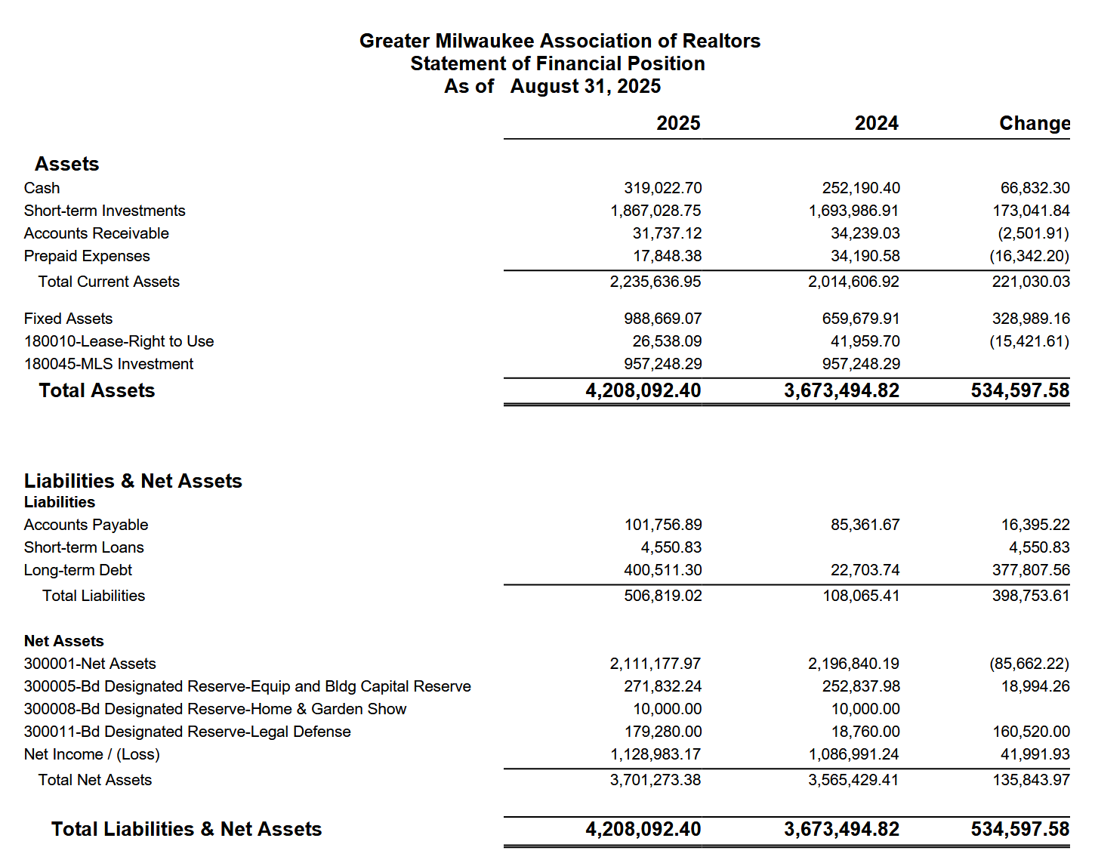

Statement of Activities
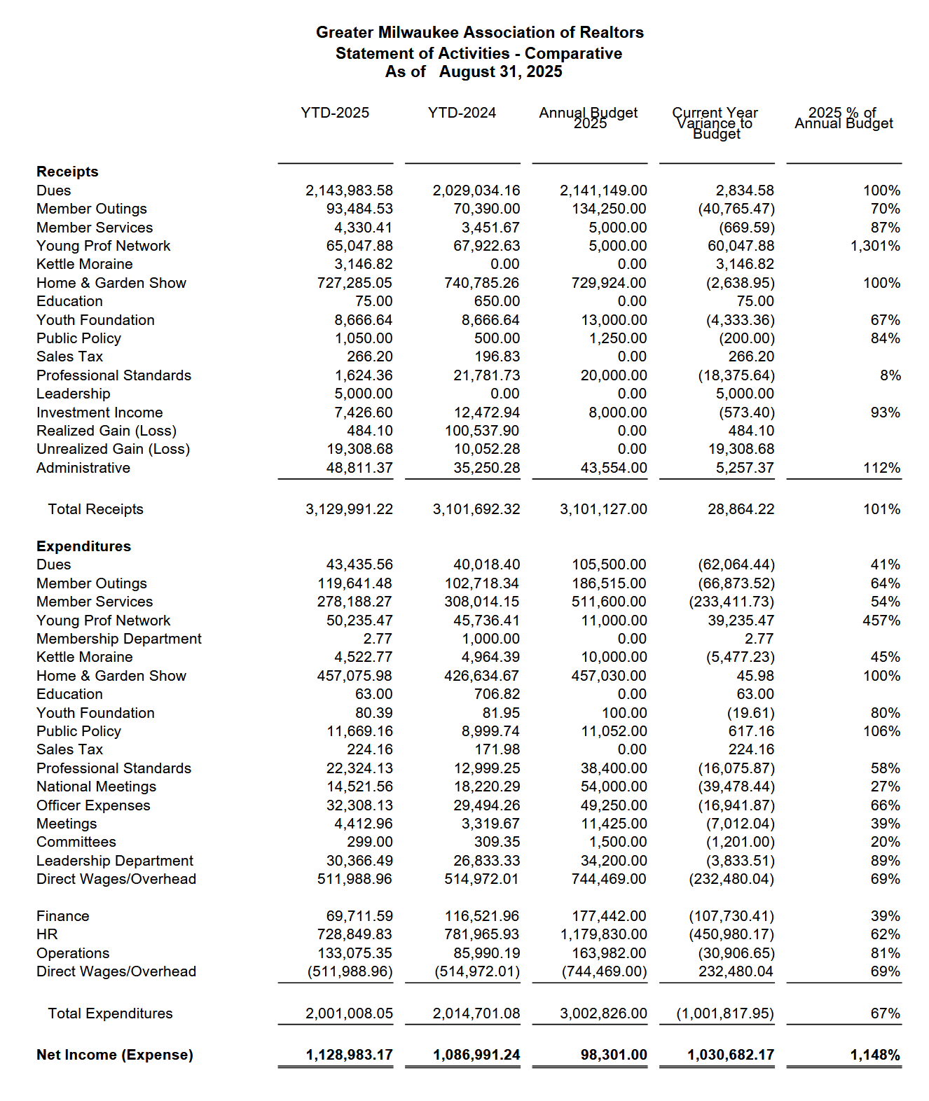

MEMORANDUM

To: GMAR Board of Directors

From: Mike Ruzicka, President

Re: President’s Report

Date: December 9, 2025

2025 GMAR Board of Directors Election
The GMAR Board of Directors election was held from October 5th – 11th. Ballots were sent out to all members on October 5th. I will have the results at the directors meeting for approval.

Discover Milwaukee
We had hoped to have the DiscoverMilwaukee.com website fully functional and full of ads by now. However, the project has faced some setbacks due to poor communication with the web design firm.

Our goals are still attainable: to position DiscoverMilwaukee.com to be an essential resource for people looking to relocate to Milwaukee with a robust social media plan, advertising strategy, and strong community engagement. But we need to move quickly before we lose momentum among advertisers.

The site is designed in the Druple language, which we knew was outdated and the web firm we inherited with the side, Keystone Click, assured us they could update it and make it more user friendly. Our rep with Keystone Click dropped the ball several times over the summer.

Our plan is to get the site updated in the existing Druple language ASAP, sell ads on it, and pushing it out through social media channels. Once that happens and it starts generating some revenue we will plan on expanding its reach, ideally adding more robust advertising.

In about 12-18 months we will look at having the site revised in Wordpress, which is a more contemporary website language and more user-friendly, allowing us to update it ourselves. We will send out RFPs once we get to this point, rather than rely on Keystone Click.

REALTOR® Safety/Tether RE
Our target date of October 1st as start date for Tether RE was pushed back to October 15th, and now to November 3rd.

We initially had to delay because of some technical issues relating to how to process member payments. Now members will be able to pay for the service and it will be recorded directly in their membership record.

The second delay is the result of Tether RE wanting to host a membership-wide Zoom training session. We have been promoting Tether via social media and email telling members that more information would be coming. I believe we only identified a Oct 1 start date in one email.

In keeping with Tether RE’s pattern of roll outs, we will communicate and urge members to subscribe and sign up for the Nov 3rd Zoom session.

SentriLock
We signed an extension of our current SentriLock contract to end on 12/31/2025, and a new one beginning 1/1/2026 for seven years providing us with 9,000 new boxes.

As the Board decided at the July 8th meeting, we entered into a full lockbox replacement agreement, which will provide new boxes to any member who wishes to use them.

SentriLock will run the show as far as issuing new boxes. They will hand out boxes at a multi-day event (7-10 days) at an off-site venue with SentriLock & GMAR Staff on hand. They will coordinate directly with members and have them sign up to pick up/drop-off boxes and take training on the new ones.

GMAR will determine the number of boxes to provide each member based on a formula of the average number of listings a member has had over the last 3 years. That is the basis we used in 2018 to distribute boxes. If a member feels they need more, we can give one or two to them, however we want to be very careful handing boxes out as generously as we did in 2018.

Also, we have to be stricter in holding members accountable for lockboxes they have “lost” in the past. Some members have misplaced, lost, forgotten… up to three-quarters of the lockboxes they were issued. We’re contemplating various policies to implement that, generally, will limit the number of boxes we hand out during the conversion in January for those with egregious losses.

Strat Plan p 24, 26
Our current strategic plan is below. We should update it to reflect any new developments in the market or among our members. I have included a copy of the results of two focus groups the association conducted in August below as well.

Also, I reviewed the members surveys we sent out over the last few years, here are some trends I noticed:
- Consistently around 80% of our members say they are aware of the GMAR’s ethics and professional courtesies programs and communications.
- About 60% experience discourteous behavior from other members. The most common form was a lack of communication.
- Roughly 30% of members say they experienced unethical behavior. Although some characterize discourteous behavior for unethical behavior, based on how egregious the rudeness was.

The need for broker supervision is a consistent theme and has been for years. This may be an area for the GMAR to make inroads to better member behavior.

A few additions to the strategic plan include:
- Administer an Ethics Test, Pathways to Professionalism Test, and SentriLock Test to new members
- Educate members on Fair Housing
- Advocate for more state funding for local government rather than relying on property taxes
- Advocate for more single-family and condo development vs. apartment construction

Recurring Reports

2025 GMAR Organizational Chart P 31

2025 GMAR Board of Directors Roster P 32

2025 GMAR Calendar P 33

2026 GMAR Calendar P 37

GMAR Focus Group Results
August 26 & 27, 2025

Current Market Challenges
- Low inventory causing a lengthy buying process
- Buyers still have to act fast for homes under ~$400K, but buyers in the $500K+ market are taking a little longer (a week) to
- Buyer pool is large
- Seller expectations are too high, if a home doesn’t sell in a few days they are freaking out
- The market is slower, which is to be expected at this time of year
- Prices seem to be leveling off
- Affordability is a big problem [Q: Are GMAR and WRA working on affordability?]
- Fluctuating interest rates are not a critical problem, people who are in the market have a monthly payment and they are looking for a house that meets their ability to pay
- Near future market will be relatively stable with some mild fluctuations
- Misinformation in the marketplace, some buyers believe waiting for interest rates go lower and/or housing prices to come down, is real
- Cash buyers win out
- Many agents believe the new affordable/first-time buyer threshold has grown to $450,000
- VA Loans (and FHA) is misunderstood by most agents
- VA appraisals show no consistency
- NAR Settlement hasn’t been a problem, the bright side is that clients understand compensation better

Association Services and Benefits
- ShowingTime vs. Aligned Showings – why not more seamlessness between them?
- One participant liked CubiCasa enough to mention it.
- Too many REALTORS® operating in the market

- Professionalism
  - Need to improve professionalism among members.
  - Need to work on inter-agent communication, some are not getting back to colleagues
  - Rude, unprofessional behavior
  - Brokers need to take more responsibility for their agents

- Communications:
  - Discussion about how to best communicate with members. Members are frustrated by email is saturation, getting dozens, even hundreds, of messages each day
  - Social media seems to be hit or miss to reach members.
  - Suggested that GMAR use texting monthly to highlight what the association is doing
  - Communication methods seem to fall along generational lines (generally, younger in favor of texting, older want email)

Technology and Innovation
- Members are using AI heavily already to market properties among younger agents
- AI is viewed as a tool to help them, no one believes AI will replace the personal relationship REALTORS® create with buyers and sellers
- AI will have major impacts on affiliated industries like lending and inspections, however
- Very favorable opinions on Tether RE, SentriLock is mixed

Other
Looking for a Leadership Academy-type of training. [Perhaps allow wider access to WRA’s Leadership webinars/videos.]
One example of a builder not agreeing to a verbal commitment for compensation

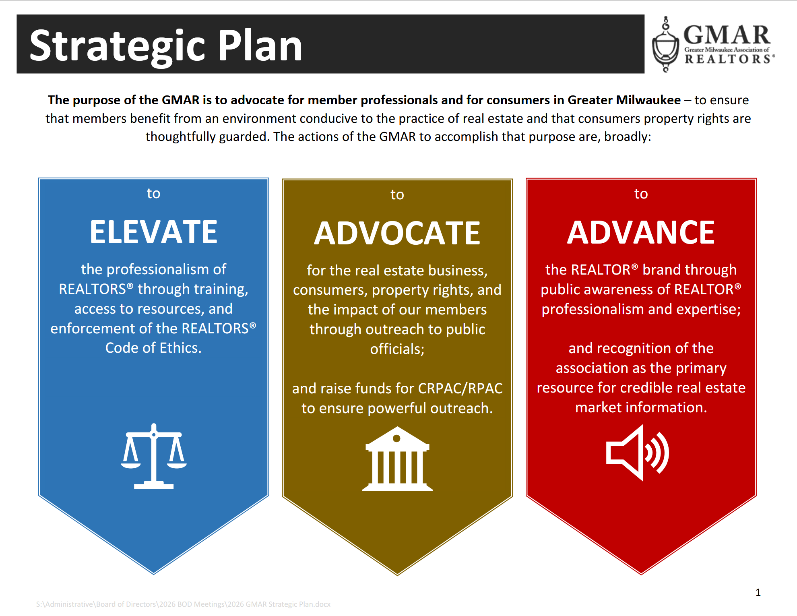
.
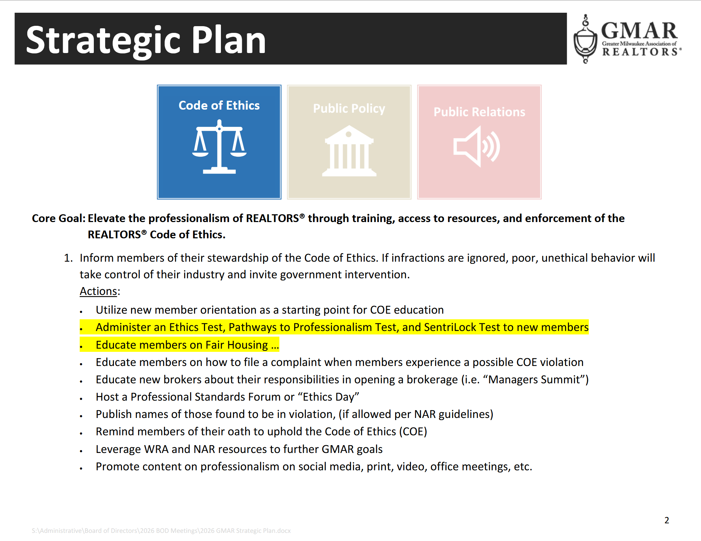

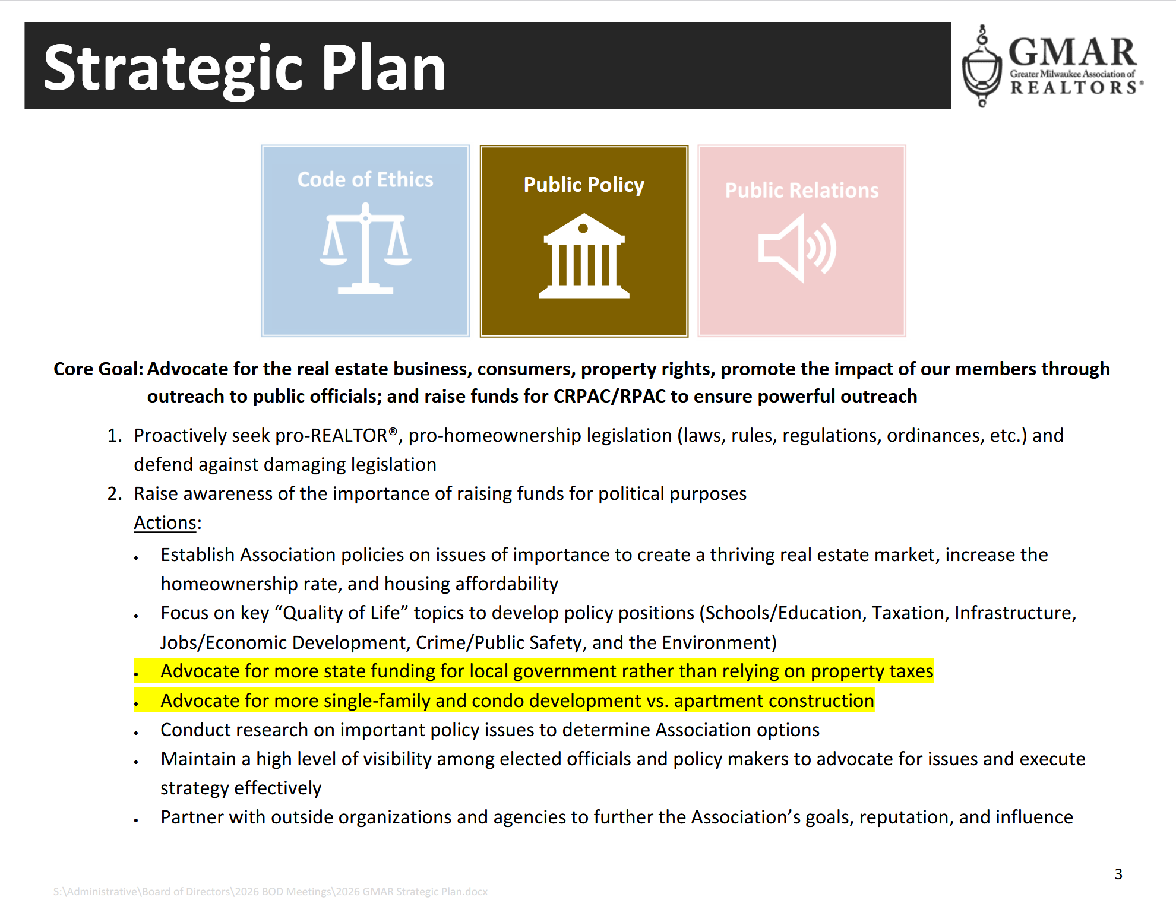

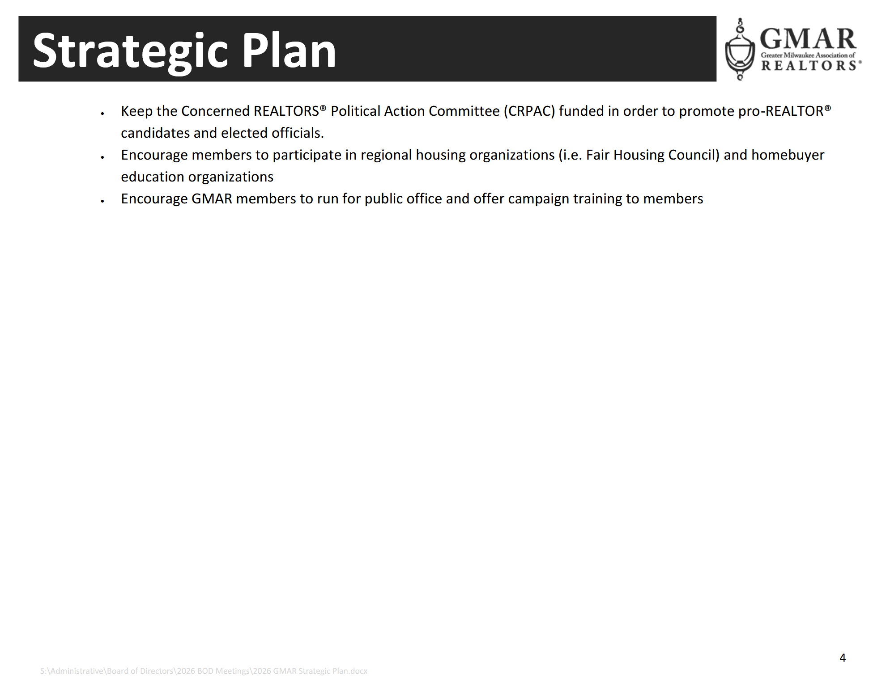

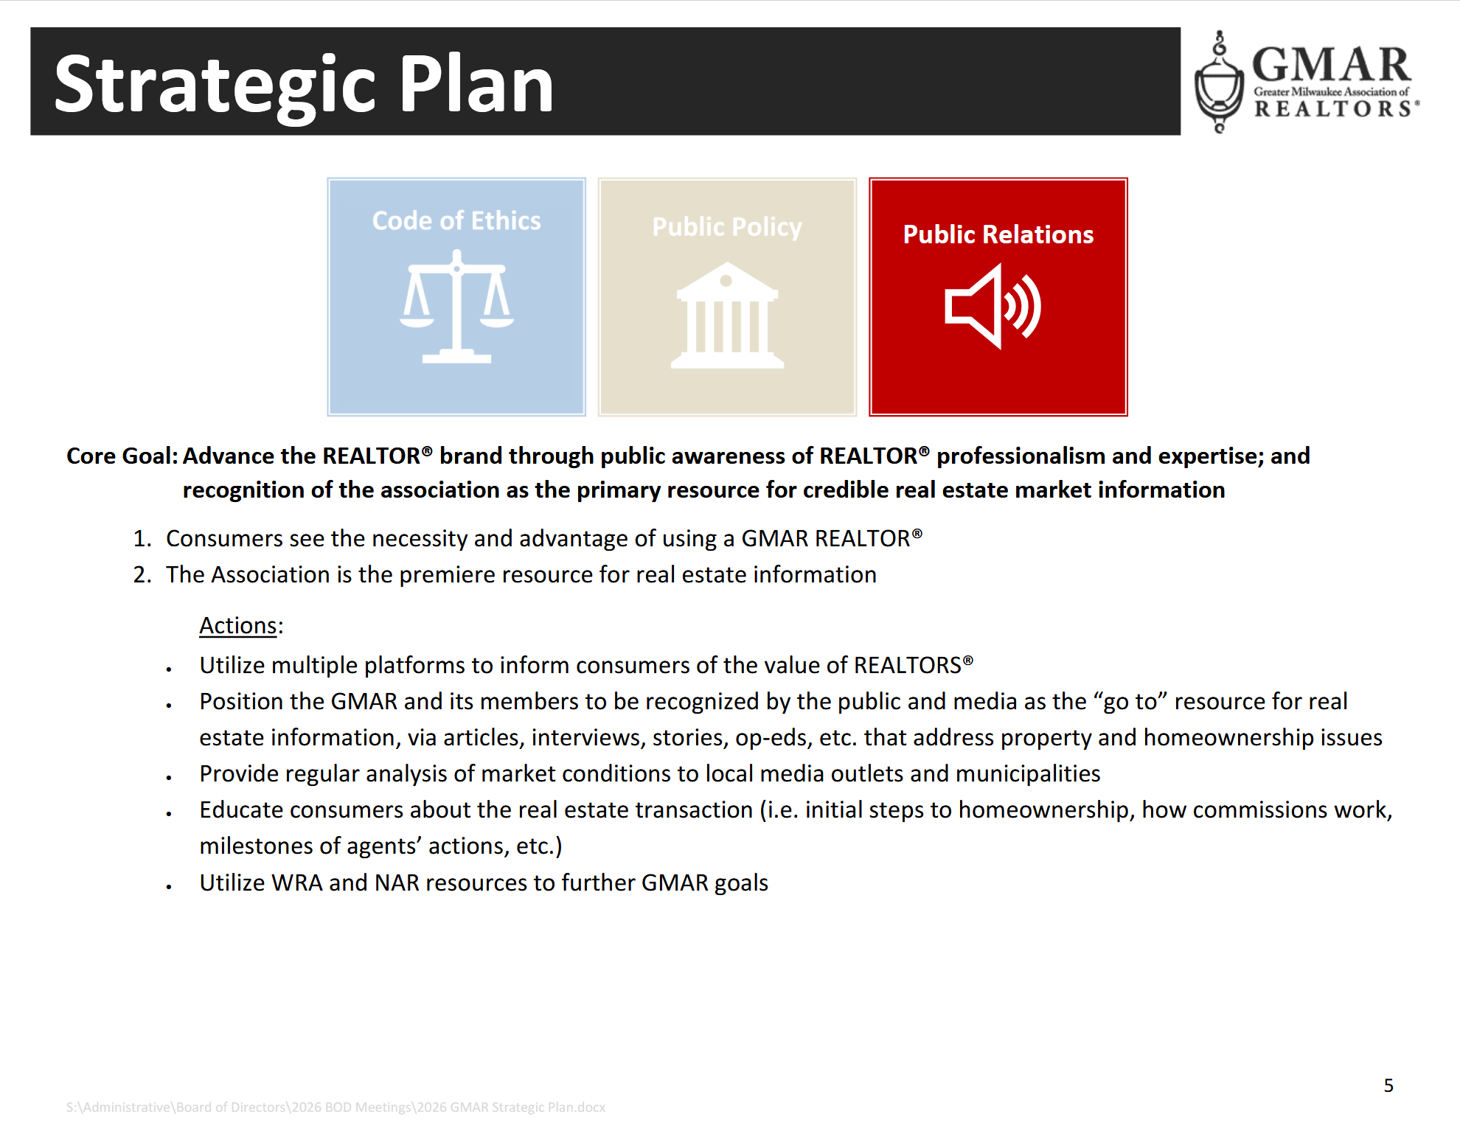
GMAR 2025 Organizational Chart

2025 GMAR Board of Directors

Terms expiring  12/31/2025 | Terms expiring  12/31/2026 | Terms expiring  12/31/2027
John Horning  Shorewest Realtors  17450 W North Avenue  Brookfield, WI 53045  O 262.827.4200 M 414.416.4505  jphorning@shorewest.com  M1: 090015743  (3yr term from Exec Roundtable) | Scott Klaas  Keller Williams Realty  2665 S Moorland Rd, Suite 104  New Berlin, WI 53151  O 262.696.9884 M 262.347.9329  sklaas@kw.com  M1: 090121392  (3yr term from Exec Roundtable) | Abby Hauke, Chairwoman  First Weber Inc.  2750 Golf Rd, Suite A  Delafield, WI 53018-2063  O 262.646.6800 M 262.468.6364  ahauke@firstweber.com  M1: 090148324  (3yr term from Exec Roundtable)
Sarah Cole, Past Chair  Landmark Realty (2nd Term)  3800 S 97th St  Milwaukee, WI 53228  M 414.510.4903  colesarahb@gmail.com  M1: 090128495 | Tom McCormick, Chair-Elect  Exit Realty Horizons  1417 N Wauwatosa Ave., Ste 201  Wauwatosa, WI 53213-2646  O 414.771.7144 M 414.241.2272  tmccormick@exithorizonswi.com  M1: 090070736 | James Krickeberg (1st Term)  The Krickeberg Group, LLC  of Keller Williams Realty  2665 S Moorland Rd #104  New Berlin, WI 53151  M 262.442.4845  james.krickeberg@kw.com  M1: 090143038
Shawn Govern, Secretary/Treasurer  Perfection Plus R E Services (1st Term)  3119 W Minnesota Ave  Franklin, WI 53132-8458  M: 414.617.7574  sgovern@wi.rr.com  M1: 090041059 | Jose Flores (1st Term)  First Weber Inc.  10521 W Layton Ave  Greenfield, WI 53228  O 414.543.7800 M 414.704.4400  josefloreshomes@gmail.com  M1: 0885500352 | Tonya Thomsen (1st Term)  Thomsen Team  N16W23233 Stone Ridge Dr, Suite 200  Waukesha, WI 53188  O 262.424.3138  Tonya@ModernRPwi.com  M1: 090075411
Mark Kivley (2nd Term)  RE/MAX Lakeside  1200 E Capitol Dr Ste 200  Milwaukee, WI 53211  M 414.406.1840  kivleyteam@lakesiderealtors.com  M1: 090020696 | Sarah Venes (1st Term)  First Weber, Inc.  2750 Golf Rd, Suite A  Delafield, WI 53018-2063  O 262.646.6800 M 262.349.5083  venes@firstweber.com  M1: 090136786 | Tom Telderer (1st Term)  RE/MAX Lakeside - The Benson Group  5341 S 27th Street  Greenfield, WI, 53221  M: 414.881.0058  tom@bensongrouprealtors.com  M1: 090026568
Arthur Mays  Realty Among Friends LLC (1st Term)  8301 W Lisbon Ave  Milwaukee, WI 53222-3859  M: 414.975.7796  amays@realtyamongfriends.com  M1: 090051977 | Dan Weber (1st Term)  Shorewest Realtors  2419 W. Washington St.  West Bend, WI 53095  M 262.689.5827  dweber@shorewest.com  M1: 090058736 | Theresa Dixon (1st Term)  Wisconsin Real Estate Group  250 S Executive Drive, Ste 225  Brookfield, WI 53005  M 414.322.1975  theresa@wrgpros.com  M1: 090171629
Ryan Stefaniak (1st Term)
The Stefaniak Group LLC
2234 S 108th Street
Milwaukee, WI 53227
M 414.881.5034
stefaniakryan@gmail.com
M1: 090144065

Mike – 885500353
Marne – 090082562
Scott – 885500171

2025 Calendar

January
1 GMAR Fiscal Year begins
6 Schedule Member Focus Group
6 Send Out Member Survey (for BOD Mtg)
9 GMAR Executive Committee Meeting
10 Member Census/Top 10 Pick
14 MLS Stats Press Release
15 GMAR Financials / Update Dashboard
16 GMAR Board of Directors Meeting – 12:00 Noon
16 For BOD Mtg:
- Membership Stats & Graphs
- Top 10 Representative
- Conflict of Interest/Harassment Policy
16 Youth Foundation Paint & Wine Event
22-24 Inman Connect New York
23 GMAR Youth Foundation Board Meeting

February
12 MLS Stats Press Release
12 Public Policy Task Force Meeting
15 BOD Snapshot
15 GMAR Financials / Update Dashboard
20-21 WRA Board of Directors Meeting – Madison Club, Madison, WI
26 HousingWire Economic Summit – Dallas, TX

March
13 MLS BOD Meeting
12 MLS Stats Press Release
15 BOD Snapshot
15 GMAR Financials / Update Dashboard
21-30 99th REALTORS® Home & Garden Show – Wisconsin Expo Ctr, West Allis, WI

April
3 Schedule Member Focus Group
7 Send Out Member Survey (for BOD Mtg)
8 GMAR Past Chairmen/women Luncheon – Delafield Hotel
10 GMAR Executive Committee Meeting
14 MLS Stats Press Release
14 Brewers Bash – American Family Field, Milwaukee, WI
15 GMAR Financials / Update Dashboard
16 (Wednesday) GMAR Board of Directors Meeting – 12:00 Noon
17 REALTOR® & Government Day – Madison, WI
24 GMAR Youth Foundation Board Meeting
28 GMAR Audit – Wegner & Assoc.
29 Large Broker Meeting w/ NAR – Harley Davidson Museum, Milwaukee

May
1 RPAC Auction
14 MLS Stats Press Release
15 BOD Snapshot
15 Public Policy Task Force Meeting
15 GMAR Financials / Update Dashboard
21 Kettle Moraine REALTORS® Council RPAC FR
23 Deadline for NAR Committee Applications
31 – June 5 NAR REALTORS® Legislative Meetings – Washington, D.C.

June
12 MLS BOD Meeting
13 WRA Board of Directors Meeting
15 BOD Snapshot
15 GMAR Mid-Year Budget Review
15 GMAR Financials / Update Dashboard
25 WomenStrong GMAR Women’s Conference – Brookfield Conference Center
30 Schedule Summer Strategic Planning Session

July
1 GMAR BOD Candidate Applications available to members
1 Send Out Member Survey (for BOD Mtg)
2 GMAR Executive Committee Meeting
8 GMAR Board of Directors Mtg – Ironwood Golf Course
8 For BOD Mtg:
- Budget Revision
- Dues Rate for Following Year
8 GMAR Summer Golf Outing – Ironwood Golf Course
15 MLS Stats Press Release
15 GMAR Financials / Update Dashboard
17 GMAR Youth Foundation Board Meeting
31 Check in w/ Addendum A Committee
__ YPN White Party

August
11-12 NAR Leadership Summit – Chicago, IL (Chair-Elect)
12 MLS Stats Press Release
__ New GMAR Chair Orientation
- NAR Organization Assessment Checklist
__ Recruit Potential Board Directors
__ GMAR Nominating Committee Meeting
13 Public Policy Task Force Meeting
15 BOD Snapshot
15 GMAR Financials / Update Dashboard
31 Last day for GMAR BOD Candidates to submit Applications

September
1 Nominating Committee notification of BOD Candidates to membership
12 MLS Stats Press Release
15 BOD Snapshot
15 GMAR Financials / Update Dashboard
__ Veterans Committee Event
__ Kettle Moraine REALTORS® Council Wine Tasting – Terrace 167, Richfield, WI
__ CMLS Annual Conference
TBA WRA Convention

30 GMAR Board of Directors Write-In Candidate Deadline

October
1 Schedule Member Focus Group (Ask Exec/BOD about topics)
12-18 GMAR Board of Directors e-Election
14 MLS Stats Press Release
9 MLS BOD Meeting
9 GMAR Executive Committee Meeting
15 GMAR Financials / Update Dashboard
16 GMAR Board of Directors Meeting – 12:00 Noon
16 For BOD Mtg:
- Strategic Plan
- Bylaws Update
- Annual Budget
- MLS BOD Appointment(s)
- Executive Committee Election
16-17 WRA BOD Meeting
23 GMAR Youth Foundation Board Meeting

November
1 Complete NAR Core Standards Application
12 MLS Stats Press Release
12-17 NAR Convention – Houston, TX
15 BOD Snapshot
15 GMAR Financials / Update Dashboard
20 Public Policy Task Force Meeting

December
__ Chair’s Holiday Party & GMAR Annual Mtg – TBA
12 MLS Stats Press Release
__ New Director Orientation
__ GMAR Youth Foundation Annual Meeting
15 BOD Snapshot
15 GMAR Financials / Update Dashboard
31 GMAR Fiscal Year ends

2026 Calendar

January
1 GMAR Fiscal Year begins
2 Schedule Member Focus Group
___ SentriLock Training & Turn-In
5 Send Out Member Survey (for BOD Mtg)
8 GMAR Executive Committee Meeting
10 Member Census/Top 10 Pick
14 MLS Stats Press Release
15 GMAR Financials / Update Dashboard
15 GMAR Board of Directors Meeting – 12:00 Noon
For BOD Mtg:
- Membership Stats & Graphs
- Top 10 Representative
- Conflict of Interest/Harassment Policy
22 GMAR Youth Foundation Board Meeting

February
3-5 Inman Connect New York
10 HousingWire Economic Summit – Dallas, TX
10 REALTOR® & Government Day – Madison, WI
12 MLS Stats Press Release
15 GMAR Financials / Update Dashboard
17 Spring Primary Election Day
18 GMAR Public Policy Task Force Meeting
___ GMAR Past Chairmen/women Luncheon – TBA
___ WomenStrong GMAR Women’s Conference

March
___ MLS BOD Meeting
12 MLS Stats Press Release
15 GMAR Financials / Update Dashboard
20-29 100th REALTORS® Home & Garden Show – Wisconsin Expo Ctr, West Allis, WI

April
1 Directors Apply for NAR Committees
2 Schedule Member Focus Group
6 Send Out Member Survey (for BOD Mtg)
7 Spring General Election Day
9 GMAR Executive Committee Meeting
15 MLS Stats Press Release
___ Brewers Bash – American Family Field, Milwaukee, WI
15 GMAR Financials / Update Dashboard
16 GMAR Board of Directors Meeting – 12:00 Noon
___ GMAR Youth Foundation Board Meeting
___ GMAR Audit – Wegner & Assoc.
30 RPAC Auction

May
11 MLS Stats Press Release
15 GMAR Financials / Update Dashboard
19 GMAR Public Policy Task Force Meeting
___ Kettle Moraine REALTORS® Council RPAC FR
22 Deadline for NAR Committee Applications

June
___ MLS BOD Meeting
13-18 NAR REALTORS® Legislative Meetings – Washington, D.C.
15 BOD Snapshot
15 GMAR Mid-Year Budget Review
15 GMAR Financials / Update Dashboard
30 Schedule Summer Strategic Planning Session

July
1 GMAR BOD Candidate Applications available to members
2 Send Out Member Survey (for BOD Mtg)
___ GMAR Executive Committee Meeting
___ GMAR Board of Directors Mtg – Ironwood Golf Course
For BOD Mtg:
- Budget Revision
- Dues Rate for Following Year
___ GMAR Summer Golf Outing – Ironwood Golf Course
14 MLS Stats Press Release
15 GMAR Financials / Update Dashboard
___ GMAR Youth Foundation Board Meeting
31 Check in w/ Addendum A Committee
___ YPN A Night in White Party

August
11 Fall Primary Election Day
13 MLS Stats Press Release
___ New GMAR Chair Orientation
- NAR Organization Assessment Checklist
- Recruit Potential Board Directors
___ GMAR Nominating Committee Meeting
15 GMAR Financials / Update Dashboard
19 GMAR Public Policy Task Force Meeting
24-25 NAR Leadership Summit – Chicago, IL (Chair-Elect)
31 Last day for GMAR BOD Candidates to submit Applications

September
1 Nominating Committee notification of BOD Candidates to membership
14 MLS Stats Press Release
15 GMAR Financials / Update Dashboard
___ Veterans Committee Event
___ CMLS Annual Conference
___ WRA Convention

30 GMAR Board of Directors Write-In Candidate Deadline

October
1 Schedule Member Focus Group
11-17 GMAR Board of Directors e-Election
13 MLS Stats Press Release
___ MLS BOD Meeting
8 GMAR Executive Committee Meeting
15 GMAR Financials / Update Dashboard
15 GMAR Board of Directors Meeting – 12:00 Noon
For BOD Mtg:
- Strategic Plan
- Bylaws Update
- Annual Budget
- MLS BOD Appointment(s)
- Executive Committee Election
___ GMAR Youth Foundation Board Meeting

November
- Complete NAR Core Standards Application
3 Fall General Election Day
12 MLS Stats Press Release
4-8 NAR Convention – New Orleans, LA
15 GMAR Financials / Update Dashboard
19 GMAR Public Policy Task Force Meeting

December
___ Chair’s Holiday Party & GMAR Annual Mtg – TBA
14 MLS Stats Press Release
___ New Director Orientation
___ GMAR Youth Foundation Annual Meeting
15 GMAR Financials / Update Dashboard
31 GMAR Fiscal Year ends

