March 11, 2026

For Immediate Release
Contact: Mike Ruzicka
414.778.4929 or 414.870.1874
mike@gmar.com

February Home Sales Up 2.9%

Highlights
- Sales Were Up 2.9% in February
- February Listings Up 16.3%
- Metro Prices Up 9.5% With Average Sale Price of $407,818

February Sales
County | 2025 | 2026 | % Change
Milwaukee | 551 | 572 | 3.8%
Waukesha | 244 | 261 | 7.0%
Ozaukee | 50 | 63 | 26.0%
Washington | 92 | 68 | -26.1%
Metro Area | 937 | 964 | 2.9%
Sheboygan | 76 | 76 | 0.0%
Racine | 126 | 152 | 20.6%
Kenosha | 101 | 104 | 3.0%
Walworth | 72 | 73 | 1.4%
SE WI Area | 1,312 | 1,369 | 4.3%
February Listings
County | 2025 | 2026 | % Change
Milwaukee | 818 | 954 | 16.6%
Waukesha | 321 | 396 | 23.4%
Ozaukee | 85 | 101 | 18.8%
Washington | 133 | 127 | -4.5%
Metro Area | 1,357 | 1,578 | 16.3%
Sheboygan | 87 | 84 | -3.4%
Racine | 192 | 181 | -5.7%
Kenosha | 100 | 138 | 38.0%
Walworth | 107 | 152 | 42.1%
SE WI Area | 1,843 | 2,133 | 15.7%
Market Summary
Home sales for February were up 2.9% in Metropolitan Milwaukee compared to February 2025.

964-unit sales in February is a solid month. Most of these sales were negotiated in December and January, which is one of the slowest periods for the market overall.

Through February, economic conditions in the Metropolitan area were good, however, recent world events could impact the market going forward.
Inventory has been on the rise for over two years, increasing in 24 of the last 32 months. But that has not been enough to meet demand.

Listings are continuing to move in a positive direction with Milwaukee, Waukesha, and Ozaukee Counties all increasing by double digits.

Inventory has been on the rise for over two years, rising in 24 of the last 32 months. But that has not been enough to meet demand.

The graph on the opposite page (Listings On A Slow Climb) shows what happened to listings in early 2022 when interest rates began to rise. Using a trailing 12-month calculation, listings peaked in February 2022, and as the mortgage market increased rates, listings dropped 28% by July 2023.

Keep in mind the conditions in February 2022 were already characterized by low listings and inventory, and were inadequate to meet buyer demand at that time. Falling an additional 28% just made buying a home more vexing for buyers.

Since then, listings have come back 12% - a positive sign, but frustratingly slow.

For February, the Metropolitan market remained a seller’s market with 2.6 months of inventory. Homes were on the market an average of 38 days in February, up from 35 days a year earlier.

The Metropolitan Milwaukee area needed an additional 4,775 units in February to reach anything that could be considered a balanced market (six months of supply).

Reaching that six-month threshold is important because it provides a wider selection for buyers to choose from, moderates price inflation and offers more time for buyers to decide on a home.
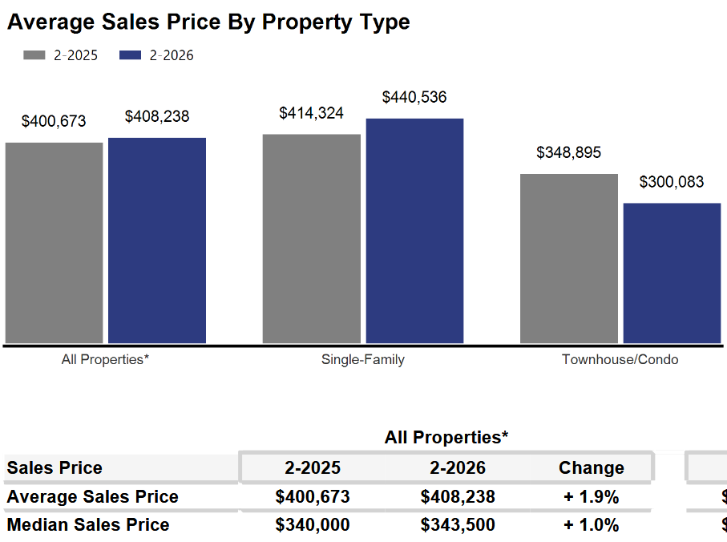
In February, average prices rose 1.9% from February ’25 to an average price of $408,238.

As we have been highlighting for several years – REALTORS® have had an exceedingly tough time helping home buyers find ownership opportunities in the form of condominiums and single-family houses.

There is a significant, long-term danger if we do not create additional supply in the form of single-family and condominium units. Thousands of would-be homeowners will be forced into rental units, unable to save for a down payment and foregoing the opportunity to build wealth through a home’s equity – as well as all the other benefits of homeownership.

This will result in problems decades down the road when families do not have enough home equity to tap into for college expenses, to remodel their home, or for emergencies.

Where to go
Buyers should seek the counsel of a REALTOR® in determining their best housing options, and sellers need a REALTORS® expert advice in making correct marketing decisions for their home.

The Greater Milwaukee Association of REALTORS® is a 5,500-member strong professional organization dedicated to providing information, services, and products to help REALTORS® help their clients buy and sell real estate. Data for this report was collected by Metro MLS, Inc., a wholly owned subsidiary of GMAR.

* Sales and Listing figures differ between the “Monthly Stats” and quarter or year-end numbers, because the collection of Monthly Stats ends on the 10th of each month, whereas quarters are a continuous tally to 12/31. For example, if a sale occurred on the 29th of the month, but an agent does not record the sale until the 5th of the next month, that sale would not be included in the sales figures of the reported month (or any subsequent month’s total) but would be added to the quarterly and annual total sales figures.

** All references to the “metropolitan” area denotes the four counties of Milwaukee, Waukesha, Ozaukee, and Washington Counties. The “region” or “Southeast Wisconsin” refers to the four metropolitan counties (Milwaukee, Waukesha, Ozaukee, and Washington), plus Racine, Kenosha, and Walworth Counties, to the south.

* * * * *

Seasonally adjusted inventory tells us how many months it would take to sell the existing homes on the market. The seasonally adjusted inventory level for February was 2.6 months. Subtracting listings that have an “active offer” from those available for sale (about 80% of listings with an offer sell) yields 2,985 listings, which equals 1.2 months of inventory.

With 3,640 current listings providing 2.6 months of inventory, the market would need an additional 4,775 units to push inventory to six months. Six months of inventory is considered a “balanced” market. If inventory falls below six months, the market favors sellers, and when inventory exceeds six months, it is a buyer’s market.

