February 12, 2026

For Immediate Release
Contact: Mike Ruzicka
414.778.4929 or 414.870.1874
mike@gmar.com

January Home Sales Down 9.9%

Highlights
- Sales Were Down 9.9% in January
- January Listings Were Up 2.4%
- Metro Prices Up 9.5% With Averaging Sale Price of $407,818

January Sales
County | 2025 | 2026 | % Change
Milwaukee | 533 | 453 | -15.0%
Waukesha | 229 | 232 | 1.3%
Ozaukee | 66 | 57 | -13.6%
Washington | 80 | 76 | -5.0%
Metro Area | 908 | 818 | -9.9%
Sheboygan | 63 | 71 | 12.7%
Racine | 131 | 116 | -11.5%
Kenosha | 89 | 78 | -12.4%
Walworth | 69 | 63 | -8.7%
SE WI Area | 1,260 | 1,146 | -9.0%
January Listings
County | 2025 | 2026 | % Change
Milwaukee | 827 | 843 | 1.9%
Waukesha | 326 | 367 | 12.6%
Ozaukee | 100 | 82 | -18.0%
Washington | 116 | 110 | -5.2%
Metro Area | 1,369 | 1,402 | 2.4%
Sheboygan | 85 | 77 | -9.4%
Racine | 192 | 170 | -11.5%
Kenosha | 124 | 107 | -13.7%
Walworth | 136 | 111 | -18.4%
SE WI Area | 1,906 | 1,867 | -2.0%
Market Summary
Home sales for January were down 9.9% in Metropolitan Milwaukee compared to January 2025.

It is hard to determine any trend for the year, because January is one of the lowest sales months of the year, accounting for 5.1% of annual sales over the last decade.

However, given current economic conditions (i.e. employment, interest rates, inventory, etc.) 2026 looks as if it will be a continuation of 2025.
… inventory has been rising over the last two plus years, increasing in 23 of the last 31 months. But hardly enough to satisfy demand.

Listings have moved in a more positive direction with Milwaukee and Waukesha Counties increasing 1.9% and 12.6%, respectively.

In fact, inventory has been rising over the last two plus years, increasing in 23 of the last 31 months. But hardly enough to satisfy demand

The Metropolitan market remains a seller’s market with 2.4 months of inventory. Homes were on the market an average of 37 days in January, up one day (36 days) from a year earlier.

The Metropolitan Milwaukee area needed an additional 5,050 units in January to reach anything that could be considered a balanced market (six months of supply).

Reaching that 6-month threshold is important because it provides a wider selection for buyers to choose from, moderates price inflation and offers more time for buyers to decide on a home.
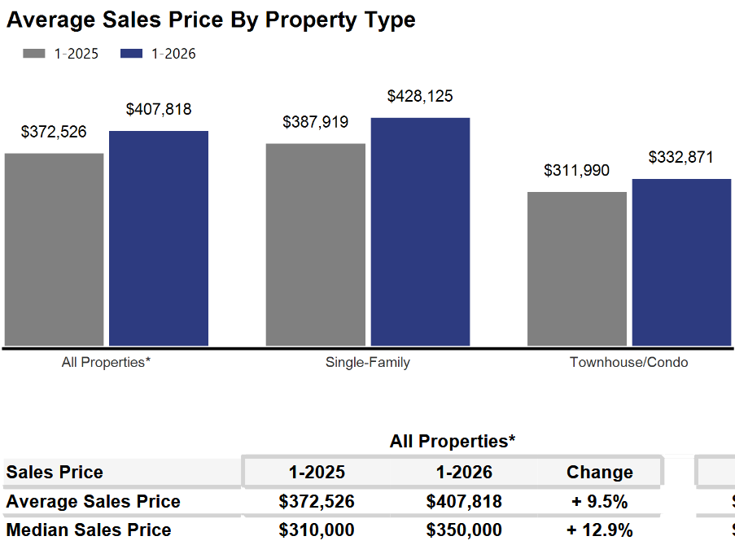
The absorption of available units is pushing prices up. In January, average prices rose 9.5% from January ’25 to an average price of $407,818.


As we have been highlighting for several years – REALTORS® have had an exceedingly tough time helping home buyers find ownership opportunities in the form of condominiums and single-family houses.

There is a significant, long-term danger if we do not create additional supply in the form of single-family and condominium units. Thousands of would-be homeowners will be forced into rental units, unable to save for a down payment and foregoing the opportunity to build wealth through a home’s equity – as well as all the other benefits of homeownership.

This will result in problems decades down the road when families do not have enough home equity to tap into for college expenses, to remodel their home, or for emergencies.
Where to go
Buyers should seek the counsel of a REALTOR® in determining their best housing options, and sellers need a REALTORS® expert advice in making correct marketing decisions for their home.

The Greater Milwaukee Association of REALTORS® is a 5,500-member strong professional organization dedicated to providing information, services, and products to help REALTORS® help their clients buy and sell real estate. Data for this report was collected by Metro MLS, Inc., a wholly owned subsidiary of GMAR.

* Sales and Listing figures differ between the “Monthly Stats” and quarter or year-end numbers, because the collection of Monthly Stats ends on the 10th of each month, whereas quarters are a continuous tally to 12/31. For example, if a sale occurred on the 29th of the month, but an agent does not record the sale until the 5th of the next month, that sale would not be included in the sales figures of the reported month (or any subsequent month’s total) but would be added to the quarterly and annual total sales figures.

** All references to the “metropolitan” area denotes the four counties of Milwaukee, Waukesha, Ozaukee, and Washington Counties. The “region” or “Southeast Wisconsin” refers to the four metropolitan counties (Milwaukee, Waukesha, Ozaukee, and Washington), plus Racine, Kenosha, and Walworth Counties, to the south.

* * * * *

Seasonally adjusted inventory tells us how many months it would take to sell the existing homes on the market. The seasonally adjusted inventory level for January was 2.4 months. Subtracting listings that have an “active offer” from those available for sale (about 80% of listings with an offer sell) yields 2,669 listings, which equals 1.2 months of inventory.

With 3,408 current listings providing 2.4 months of inventory, the market would need an additional 5,050 units to push inventory to six months. Six months of inventory is considered a “balanced” market. If inventory falls below six months, the market favors sellers, and when inventory exceeds six months, it is a buyer’s market.

