May 18, 2026

For Immediate Release
Contact: Mike Ruzicka
414.778.4929 or 414.870.1874
mike@gmar.com

April Home Sales Up 11.0%

Highlights
- Sales Increase Double Digits for Second Month in a Row
- Metro Prices Up 2.3%, Average of $431,483
- Supply Improving, But Much More Still Needed

February Sales
County | 2025 | 2026 | % Change
Milwaukee | 780 | 871 | 11.7%
Waukesha | 376 | 430 | 14.4%
Ozaukee | 92 | 98 | 6.5%
Washington | 136 | 137 | 0.7%
Metro Area | 1,384 | 1,536 | 11.0%
Sheboygan | 81 | 91 | 12.3%
Racine | 207 | 196 | -5.3%
Kenosha | 125 | 145 | 16.0%
Walworth | 136 | 122 | -10.3%
SE WI Area | 1,933 | 2,090 | 8.1%
February Listings
County | 2025 | 2026 | % Change
Milwaukee | 1,073 | 1,405 | 30.9%
Waukesha | 600 | 598 | -0.3%
Ozaukee | 123 | 139 | 13.0%
Washington | 155 | 242 | 56.1%
Metro Area | 1,951 | 2,384 | 22.2%
Sheboygan | 109 | 128 | 17.4%
Racine | 284 | 288 | 1.4%
Kenosha | 202 | 207 | 2.5%
Walworth | 194 | 207 | 6.7%
SE WI Area | 2,740 | 3,214 | 17.3%

Market Summary
Home sales were up by double digits for the second straight month in April. Sales last month were 11.0% ahead of April of 2025.

An 11.0% increase in sales is an enormous jump but we do need to temper our excitement, because we are in a post-3% interest rate world. When interest rates rose from around 3% to 6% in mid-2022, sales dropped 18.6% by 2023.

The market is slowly climbing its way back to the inventory and sales levels of early 2022.

Sales were solid in all four metropolitan counties. The 1,536 sales in April were the highest for the month since 2022, before rates went up.

The fact that inventory is increasing organically now is an encouraging sign of the health of the market.

Milwaukee and Waukesha Counties, the engines of the regional housing market, were especially strong with growth of 11.7% and 14.4%, respectively.

However, for years the real news has been on the listing side. The 2,384 new listings in April were the highest for April since 2021, when the market was red-hot due to the impact the pandemic had on the market.

At that time, the pandemic had revved up prices leading to large increases in listings due to profit gains. The fact that inventory is increasing organically now is an encouraging sign of the health of the market.

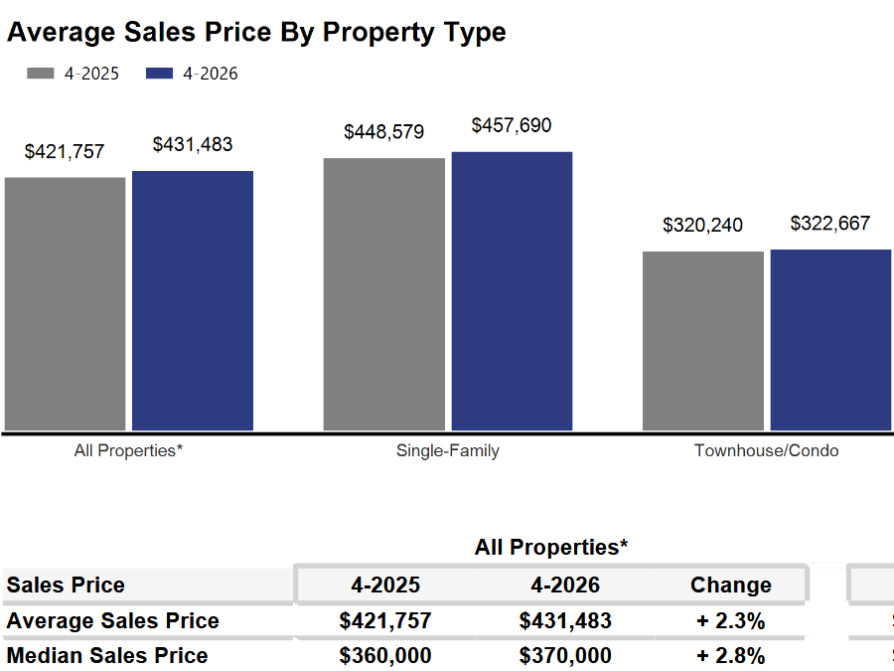
While more new listings were welcome news, the increase was absorbed into the market right away, with no relief on pricing.

We can tell that by looking at the “days on market” (DOM), the time between when a listing contract is signed to when a seller accepts an offer.


In April 2026, DOM was 26 days compared to 22 days in 2025. DOM equal to six-months would be 180 days.

Due to additional listings being absorbed into the market almost immediately, there is no downward pressure on prices. Prices in the four-county area were up 2.3% through the first quarter.

With prices increasing and DOM extremely low, we can tell there is strong demand for homes. The current market has no shortage of buyers; instead, buyers are competing for too few listings.

The only effective way to ease current market conditions is to increase housing supply.

Additional supply would help slow the pace of price increases though it would not cause prices to decline.

The market needed more than 8,000 total units to meet demand and allow price growth to moderate. However, in April there were only 4,541 active listings resulting in a 3,960 unit deficit.

Where to go
Buyers should seek the counsel of a REALTOR® in determining their best housing options, and sellers need a REALTORS® expert advice in making correct marketing decisions for their home.

The Greater Milwaukee Association of REALTORS® is a 5,500-member strong professional organization dedicated to providing information, services, and products to help REALTORS® help their clients buy and sell real estate. Data for this report was collected by Metro MLS, Inc., a wholly owned subsidiary of GMAR.

* Sales and Listing figures differ between the “Monthly Stats” and quarter or year-end numbers, because the collection of Monthly Stats ends on the 10th of each month, whereas quarters are a continuous tally to 12/31. For example, if a sale occurred on the 29th of the month, but an agent does not record the sale until the 5th of the next month, that sale would not be included in the sales figures of the reported month (or any subsequent month’s total) but would be added to the quarterly and annual total sales figures.

** All references to the “metropolitan” area denotes the four counties of Milwaukee, Waukesha, Ozaukee, and Washington Counties. The “region” or “Southeast Wisconsin” refers to the four metropolitan counties (Milwaukee, Waukesha, Ozaukee, and Washington), plus Racine, Kenosha, and Walworth Counties, to the south.

* * * * *

Seasonally adjusted inventory tells us how many months it would take to sell the existing homes on the market. The seasonally adjusted inventory level for April was 3.2 months. Subtracting listings that have an “active offer” from those available for sale (about 80% of listings with an offer sell) yields 3,699 listings, which equals 1.3 months of inventory.

With 4,541 current listings providing 3.2 months of inventory, the market would need an additional 3,960 units to push inventory to six months. Six months of inventory is considered a “balanced” market. If inventory falls below six months, the market favors sellers, and when inventory exceeds six months, it is a buyer’s market.

