June 11, 2026

For Immediate Release
Contact: Mike Ruzicka
414.778.4929 or 414.870.1874
mike@gmar.com

May Home Sales Up 6.3%

Highlights
- Sales Increased for the Fourth Month in a Row
- Metro Prices Up 6.6%, Average of $450,393
- Supply Improving, But Much More Still Needed

May Sales
County | 2025 | 2026 | % Change
Milwaukee | 965 | 1,006 | 4.2%
Waukesha | 474 | 513 | 8.2%
Ozaukee | 110 | 115 | 4.5%
Washington | 162 | 185 | 14.2%
Metro Area | 1,711 | 1,819 | 6.3%
Sheboygan | 83 | 96 | 15.7%
Racine | 239 | 206 | -13.8%
Kenosha | 151 | 147 | -2.6%
Walworth | 148 | 118 | -20.3%
SE WI Area | 2,332 | 2,386 | 2.3%
May Listings
County | 2025 | 2026 | % Change
Milwaukee | 1,242 | 1,293 | 4.1%
Waukesha | 673 | 692 | 2.8%
Ozaukee | 146 | 146 | 0.0%
Washington | 232 | 204 | -12.1%
Metro Area | 2,293 | 2,335 | 1.8%
Sheboygan | 152 | 142 | -6.6%
Racine | 260 | 314 | 20.8%
Kenosha | 221 | 224 | 1.4%
Walworth | 212 | 216 | 1.9%
SE WI Area | 3,138 | 3,231 | 3.0%

Market Summary
Home sales continued their strong showing for a fourth straight month in May. Sales last month were 6.3% ahead of May of 2025.

May sales were also 6.1% ahead of May 2024. In fact, last month was the best May the Milwaukee market has seen since 2022 - just before interest rates increased; an encouraging sign the market has recovered from the shock of rising interest rates four years ago.

… the best May the Milwaukee market has seen since 2022 - just before interest rates increased…

The only reason sales have been able to climb is because listings have increased. There is so much demand pressure in the market that as soon as listings enter MLS there is immediate activity.

The 2,335 new listings in May were the highest for May since 2022, again, before they took a pause due to rising interest rates.

We can gauge the demand and absorption of listings by examining the “days on market” (DOM); the time between when a listing contract is signed to when a seller accepts an offer.

In May 2026, DOM was 20 days compared to 21 days in 2025. DOM equal to six-months would be 180 days.
The fact that DOM decreased by one day is not as significant as the fact that both are in the twenties.

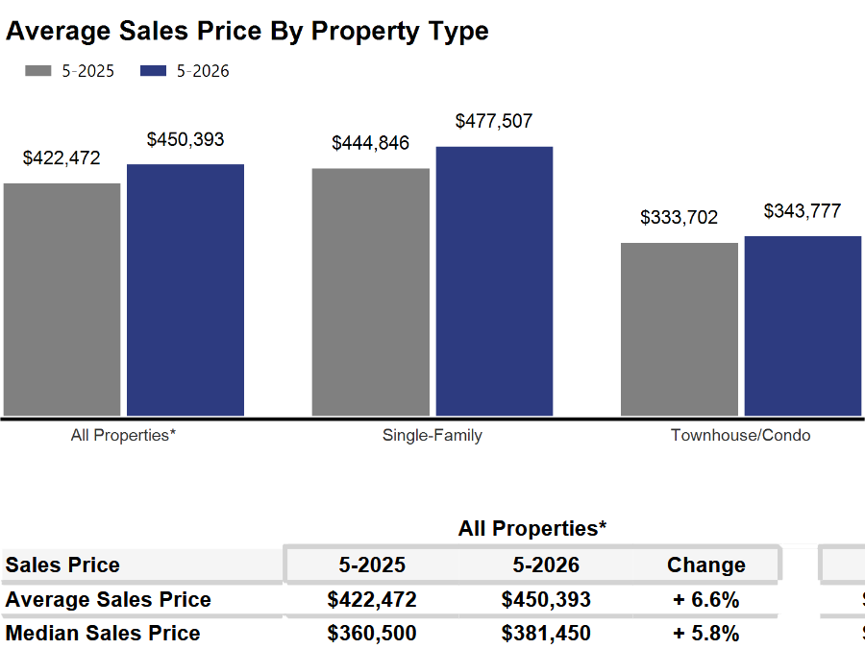
Due to additional listings being absorbed into the market almost immediately, there is no downward pressure on prices. Prices in the four-county area were up 6.6% in May to $450,393.


With prices increasing and DOM extremely low, we can tell there is strong demand for homes. The current market has no shortage of buyers; instead, buyers are competing for too few listings.

The only effective way to ease current market conditions is to increase housing supply. Additional supply would help slow the pace of price increases though it would not cause prices to decline.

The market needed more than 8,000 total units to meet demand and allow price growth to moderate. However, in May there were only 4,835 active listings resulting in a 3,735-unit deficit.

Where to go
Buyers should seek the counsel of a REALTOR® in determining their best housing options, and sellers need a REALTORS® expert advice in making correct marketing decisions for their home.

The Greater Milwaukee Association of REALTORS® is a 5,500-member strong professional organization dedicated to providing information, services, and products to help REALTORS® help their clients buy and sell real estate. Data for this report was collected by Metro MLS, Inc., a wholly owned subsidiary of GMAR.

* Sales and Listing figures differ between the “Monthly Stats” and quarter or year-end numbers, because the collection of Monthly Stats ends on the 10th of each month, whereas quarters are a continuous tally to 12/31. For example, if a sale occurred on the 29th of the month, but an agent does not record the sale until the 5th of the next month, that sale would not be included in the sales figures of the reported month (or any subsequent month’s total) but would be added to the quarterly and annual total sales figures.

** All references to the “metropolitan” area denotes the four counties of Milwaukee, Waukesha, Ozaukee, and Washington Counties. The “region” or “Southeast Wisconsin” refers to the four metropolitan counties (Milwaukee, Waukesha, Ozaukee, and Washington), plus Racine, Kenosha, and Walworth Counties, to the south.

* * * * *

Seasonally adjusted inventory tells us how many months it would take to sell the existing homes on the market. The seasonally adjusted inventory level for May was 3.4 months. Subtracting listings that have an “active offer” from those available for sale (about 80% of listings with an offer sell) yields 3,781 listings, which equals 1.4 months of inventory.

With 4,835 current listings providing 3.4 months of inventory, the market would need an additional 3,735 units to push inventory to six months. Six months of inventory is considered a “balanced” market. If inventory falls below six months, the market favors sellers, and when inventory exceeds six months, it is a buyer’s market.

