August 11, 2026

For Immediate Release
Contact: Mike Ruzicka
414.778.4929 or 414.870.1874
mike@gmar.com

July Home Sales Up 12.5%

Highlights
- Sales Increased for the Sixth Month in a Row
- Metro Average Prices Flat at $462,528
- Supply Improving Slowly, Slightly Ahead of a Year Earlier

July Sales
County | 2025 | 2026 | % Change
Milwaukee | 929 | 1020 | 9.8%
Waukesha | 529 | 574 | 8.5%
Ozaukee | 107 | 143 | 33.6%
Washington | 145 | 186 | 28.3%
Metro Area | 1,710 | 1,923 | 12.5%
Sheboygan | 128 | 131 | 2.3%
Racine | 206 | 234 | 13.6%
Kenosha | 157 | 190 | 21.0%
Walworth | 146 | 143 | -2.1%
SE WI Area | 2,347 | 2,621 | 11.7%
July Listings
County | 2025 | 2026 | % Change
Milwaukee | 1226 | 1358 | 10.8%
Waukesha | 617 | 673 | 9.1%
Ozaukee | 121 | 130 | 7.4%
Washington | 223 | 232 | 4.0%
Metro Area | 2,187 | 2,393 | 9.4%
Sheboygan | 131 | 129 | -1.5%
Racine | 327 | 321 | -1.8%
Kenosha | 209 | 218 | 4.3%
Walworth | 201 | 199 | -1.0%
SE WI Area | 3,055 | 3,260 | 6.7%

Market Summary
Home sales continued their strong showing for a sixth straight month in July. Sales last month were a heady 12.5% over of July of 2025. July sales were also 11.6% ahead of July 2024.

Sales are effectively moving in lockstep with listings. As more listings come online, those homes are purchased in short order. There is significant demand pressure in the market and as soon as a listing enters MLS it is viewed immediately.

Last month was the best July the Milwaukee market has seen since 2022, just as interest rates were going up from historic lows.

Last month was the best July the Milwaukee market has seen since 2022, just as interest rates were going up from historic lows.

We can gauge the demand and absorption of listings by examining the “days on market” (DOM); the time between when a listing contract is signed to when a seller accepts an offer.

In July 2026, DOM was 19 days compared to 20 days in 2025. DOM equal to six-months would be 180 days. The fact that DOM decreased by one day is not as significant as the fact that both are so far below 180 days.

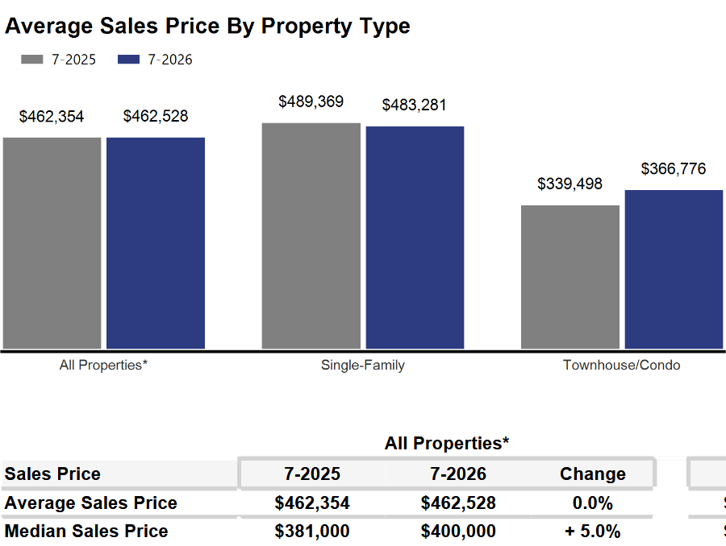
Due to additional listings being absorbed into the market almost immediately, there is no downward pressure on prices.

Prices in the four-county area were flat at $462,528.

With high prices and low DOM, we can tell there is strong demand for homes. The current market has no shortage of buyers; instead, buyers are competing for too few listings.

The only effective way to ease current market conditions is to increase housing supply.

Additional supply would help slow the pace of price increases though it would not cause prices to decline.

The market needed more than 8,000 total units to meet demand and allow price growth to moderate. However, in July there were only 4,969 active listings resulting in a 3,750-unit deficit.

Where to go
Buyers should seek the counsel of a REALTOR® in determining their best housing options, and sellers need a REALTORS® expert advice in making correct marketing decisions for their home.

The Greater Milwaukee Association of REALTORS® is a 5,500-member strong professional organization dedicated to providing information, services, and products to help REALTORS® help their clients buy and sell real estate. Data for this report was collected by Metro MLS, Inc., a wholly owned subsidiary of GMAR.

* Sales and Listing figures differ between the “Monthly Stats” and quarter or year-end numbers, because the collection of Monthly Stats ends on the 10th of each month, whereas quarters are a continuous tally to 12/31. For example, if a sale occurred on the 29th of the month, but an agent does not record the sale until the 5th of the next month, that sale would not be included in the sales figures of the reported month (or any subsequent month’s total) but would be added to the quarterly and annual total sales figures.

** All references to the “metropolitan” area denotes the four counties of Milwaukee, Waukesha, Ozaukee, and Washington Counties. The “region” or “Southeast Wisconsin” refers to the four metropolitan counties (Milwaukee, Waukesha, Ozaukee, and Washington), plus Racine, Kenosha, and Walworth Counties, to the south.

* * * * *

Seasonally adjusted inventory tells us how many months it would take to sell the existing homes on the market. The seasonally adjusted inventory level for July was 3.4 months. Subtracting listings that have an “active offer” from those available for sale (about 80% of listings with an offer sell) yields 4,040 listings, which equals 1.7 months of inventory.

With 4,969 current listings providing 3.4 months of inventory, the market would need an additional 3,750 units to push inventory to six months. Six months of inventory is considered a “balanced” market. If inventory falls below six months, the market favors sellers, and when inventory exceeds six months, it is a buyer’s market.

