September 14, 2026

For Immediate Release
Contact: Mike Ruzicka
414.778.4929 or 414.870.1874
mike@gmar.com

August Home Sales Down 2.3%

Highlights
- August’s Pause in Sales Not Unusual
- Metro Average Prices Jumped 11% to $497,552
- Supply Still Improving Slowly

August Sales
County | 2025 | 2026 | % Change
Milwaukee | 844 | 827 | -2.0%
Waukesha | 514 | 538 | 4.7%
Ozaukee | 92 | 109 | 18.5%
Washington | 191 | 130 | -31.9%
Metro Area | 1,641 | 1,604 | -2.3%
Sheboygan | 125 | 128 | 2.4%
Racine | 247 | 228 | -7.7%
Kenosha | 162 | 148 | -8.6%
Walworth | 157 | 143 | -8.9%
SE WI Area | 2,332 | 2,251 | -3.5%
August Listings
County | 2025 | 2026 | % Change
Milwaukee | 1,188 | 1,169 | -1.6%
Waukesha | 528 | 584 | 10.6%
Ozaukee | 108 | 151 | 39.8%
Washington | 186 | 217 | 16.7%
Metro Area | 2,010 | 2,121 | 5.5%
Sheboygan | 99 | 144 | 45.5%
Racine | 262 | 311 | 18.7%
Kenosha | 200 | 233 | 16.5%
Walworth | 193 | 181 | -6.2%
SE WI Area | 2,764 | 2,990 | 8.2%

Market Summary
Home sales took a pause in August after six months of increases. However, the 2.3% drop in sales was part of a streak the Milwaukee market has seen each August for the last 5 years.

For whatever reason, buyers have taken the month of August off, but brokers are not worried. The end of summer is often full of vacations, preparing for a new school year, and enjoying the few last days of the season.

…the 2.3% drop in sales was part of a streak the Milwaukee market has seen each August for the last 5 years.

The good news is that listings are still increasing. Through August the Milwaukee market saw a much- needed 6.1% increase in listings. Bringing the year-to-date total to 11,982, compared to 11,298 a year earlier.

When sales pause and listings increase the market usually experiences a decline in prices and longer days on market. However, we are not in that kind of market. There is still significant demand among buyers and as soon as a listing enters MLS it attracts attention.

We can gauge demand and absorption of listings by examining the “days on market” (DOM); the time between when a listing contract is signed to when a seller accepts an offer.

The DOM in August 2025 and in 2026 was 19 days. DOM equal to six-months would be 180 days. The fact that DOM is flat and so far, below 180 days tells us that when a new listing goes online it is viewed, toured, and has an offer in short order.

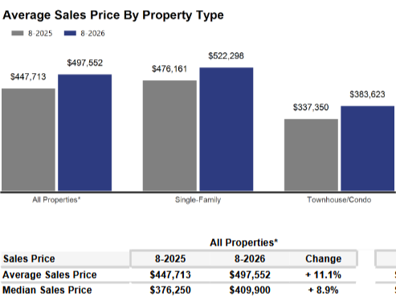
Additionally, when listings are absorbed into the market almost immediately, there is no downward pressure on prices.

Prices in the four-county area were up sharply, to $497,552, an 11.1% gain.

Despite August’s pause in sales, the low DOM and price increase are indicative of strong demand.


The only effective way to ease current market conditions is to increase housing supply.

Additional supply – in the form of condominiums, townhomes, and single-family houses – would help slow the pace of price increases though it would not cause prices to decline.

The market needed more than 8,800 total units to meet demand and allow price growth to moderate. However, in August there were only 4,991 active listings and a 3,830-unit deficit.

Where to go
Buyers should seek the counsel of a REALTOR® in determining their best housing options, and sellers need a REALTORS® expert advice in making correct marketing decisions for their home.

The Greater Milwaukee Association of REALTORS® is a 5,500-member strong professional organization dedicated to providing information, services, and products to help REALTORS® help their clients buy and sell real estate. Data for this report was collected by Metro MLS, Inc., a wholly owned subsidiary of GMAR.

* Sales and Listing figures differ between the “Monthly Stats” and quarter or year-end numbers, because the collection of Monthly Stats ends on the 10th of each month, whereas quarters are a continuous tally to 12/31. For example, if a sale occurred on the 29th of the month, but an agent does not record the sale until the 5th of the next month, that sale would not be included in the sales figures of the reported month (or any subsequent month’s total) but would be added to the quarterly and annual total sales figures.

** All references to the “metropolitan” area denotes the four counties of Milwaukee, Waukesha, Ozaukee, and Washington Counties. The “region” or “Southeast Wisconsin” refers to the four metropolitan counties (Milwaukee, Waukesha, Ozaukee, and Washington), plus Racine, Kenosha, and Walworth Counties, to the south.

* * * * *

Seasonally adjusted inventory tells us how many months it would take to sell the existing homes on the market. The seasonally adjusted inventory level for August was 3.4 months. Subtracting listings that have an “active offer” from those available for sale (about 80% of listings with an offer sell) yields 4,003 listings, which equals 1.7 months of inventory.

With 4,991 current listings providing 3.4 months of inventory, the market would need an additional 3,830 units to push inventory to six months. Six months of inventory is considered a “balanced” market. If inventory falls below six months, the market favors sellers, and when inventory exceeds six months, it is a buyer’s market.

